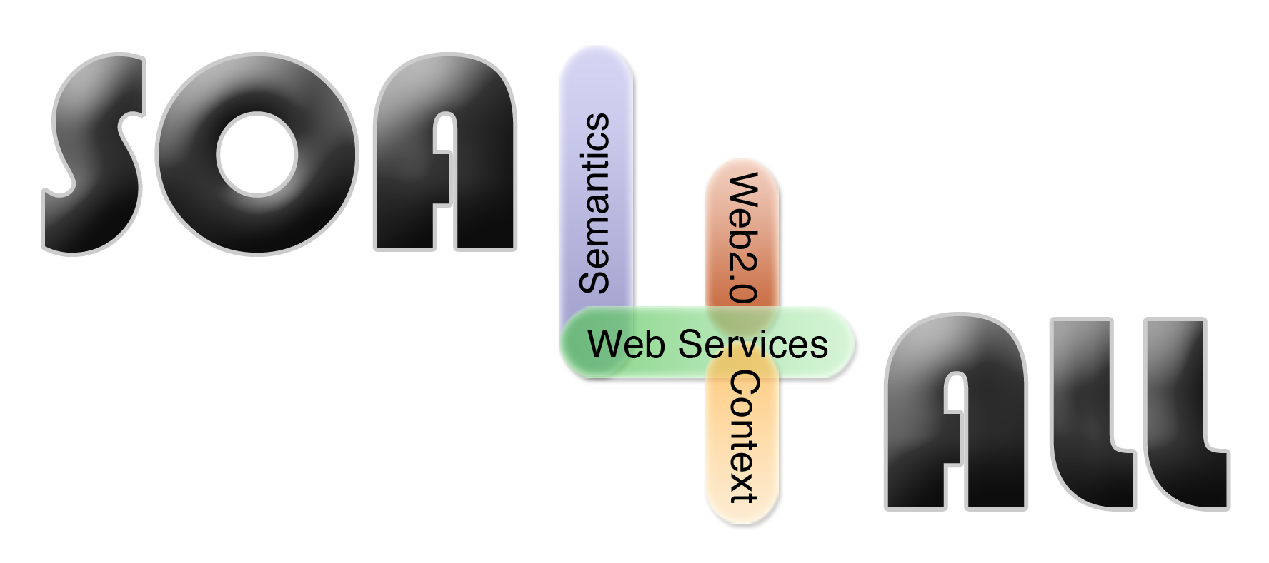
Project Number: | 215219
Project Acronym: | SOA4ALL
Project Title: | Service Oriented Architectures for All
Instrument: | Integrated Project
Thematic Priority: | Information and Communication Technologies
D2.4.1 Prototype Setup Documentation
“Readme”
D2.4.1 First Demonstrator & Interface Specification
Activity: |  | Activity 2 - Core Research and Development
Work Package: |  | WP 2 - SOA4All Studio
Due Date: |  |  | M12
Submission Date: |  |  | 15/04/2008
Start Date of Project: |  |  | 01/03/2008
Duration of Project: |  |  | 36 Months
Organisation Responsible of Deliverable: |  |  | TIE
Revision: |  |  | 1.0
Author(s): |  | Sven Abels (TIE)

Project co-funded by the European Commission within the Seventh Framework Programme (2007-2013)
Dissemination Level
PU | Public | X

Version History
Version | Date | Comments, Changes, Status | Authors, contributors, reviewers
1.0 | 15/04/2008 | Release Version | Sven Abels (TIE)

Table of Contents

Version History 2
Table of Contents 3
List of Figures 3
Executive summary 4
1. Introduction 5
1.1 Purpose and Scope 5
1.2 Structure of the document 5
2. Requirements & Preparations 6
2.1 For Users 6
2.2 For Administrators 6
2.2.1 Java 6
2.2.2 Tomcat 6
3. Installation (Deployment) 7
4. Execution 8
5. References 9

List of Figures
Figure 1: the D2.4.1 Dashboard 8

Executive summary
This document complements D2.4.1 First Demonstrator & Interface Specification Specification of the task 2.4 SOA4All Studio UI and Infrastructure Services and describes the software implementation of the first D2.4.1 prototype. This document is included as part of the zip file that contains the first prototype software including all necessary files and instructions to install and run the prototype on Windows, Linux, MacOS or any other operating system that supports Java based software.

Introduction

Purpose and Scope
In order to increase the usability of SOA4All, it is of significant importance to ensure a low entrance barrier for potential users. One way of achieving this is the provision of one holistic user interface instead of providing separate user interfaces for each work package. The SOA4All consortium therefore decided to provide a common core user interface (UI) framework which forms the base for UI implementations and which will be implemented by developments in all work packages. This ensures a common look and feel among all developments and will allow easy navigation between SOA4All components.
This common framework is covered by task 2.4 and is documented in deliverable 2.4. This task is called the “SOA4All Studio UI and Infrastructure Services”. Task 2.4 has been started in Month 9 of the project after restructuring the work packages and subtasks. It covers those parts of the SOA4All Studio that have formerly been described in an extra deliverable, called “DX-UI: Holistic User Interface”.
The idea of task 2.4 is to provide core elements that will help other work packages to provide their results in a holistic look & feel. This means that task 2.4 provides a set of services that can be used by other work packages or tasks. Those services cover two essential parts:

- The first one are infrastructure services (e.g. common management mechanisms for things such as storing preferences/settings)
- The second one are graphical elements such as defining a holistic design or providing graphical widgets (e.g. charting components).

The WAR file that is found in the /bin directory is the result of the 2.4.1 work and it's accomplished with some modules from other tasks all being integrated with the 2.4.1 Dashboard.
This document complements D2.4.1 First Demonstrator & Interface Specification Specification of the task 2.4 SOA4All Studio UI and Infrastructure Services and describes the software implementation of the first D2.4.1 prototype. This document is included as part of the zip file that contains the first prototype software including all necessary files and instructions to install and run the prototype on Windows, Linux, MacOS or any other operating system that supports Java based software.

Structure of the document
The rest of this document is structured as follows:
- Section 2 is covering the requirements of the first prototype
- Section 3 is covering the setup (installation) of the software
- Section 4 is briefly describing how to access the prototype.
Please note that this document is kept as short as possible on purpose. It’s only purpose is to guide readers though the installation of the prototype. For any functional descriptions and technical descriptions, please refer to the D2.4.1 deliverable.

Requirements & Preparations

For Users
Users do not need to install anything to use SOA4All. The only thing that they need is a modern Web Browser such as Firefox or the Internet Explorer. Based on this, they may simply invoke the SOA4All application by calling the web address. It is not necessary to install any plugins.

The D2.4.1 results are temporary available for testing purposes at:
http://coconut.tie.nl:8080/soa4all
However, they will be moved to the official SOA4All website in the process of the development.

For Administrators

Java
All SOA4All developments are based on the Java programming language. As such, a Java Runtime Environment is required. Java can be downloaded for all modern operating systems including Windows, Linux and MacOS.
The 2.4.1 prototype requires Java 1.5 or newer. The latest version may be downloaded at http://java.sun.com

Tomcat
As SOA4All is a web based solution, the D2.4.1 prototype is available as a web application. As such, the Tomcat server (6.0 or newer) installation is required in order to setup the prototype. Tomcat is available at the following website:
http://tomcat.apache.org

Installation (Deployment)
Installation of the 2.4.1 prototype is very easy. Please ensure that Java 1.6 and Tomcat 6.0 have been downloaded and installed on your system.
Afterwards, copy the soa4all-dashboard.war file which you find in the bin directory of this ZIP file into the folder webapps of your Tomcat installation.
Once you have done this, please start Tomcat. This will automatically install all SOA4All files for you.

Execution
After installing the SOA4All 2.4.1 prototype, open a web browser and navigate to the following URL:
http://localhost:8080/soa4all-dashboard
This will show you the welcome screen of the SOA4All Dashboard application, which allows you to access the SOA4All studio.
Please note that this WAR file only contains the D2.4.1 results which means that some services that are coming from other work packages will not be working as they rely on other servers to be installed on your system.
For any questions, please refer to sven.abels@tieGlobal.com

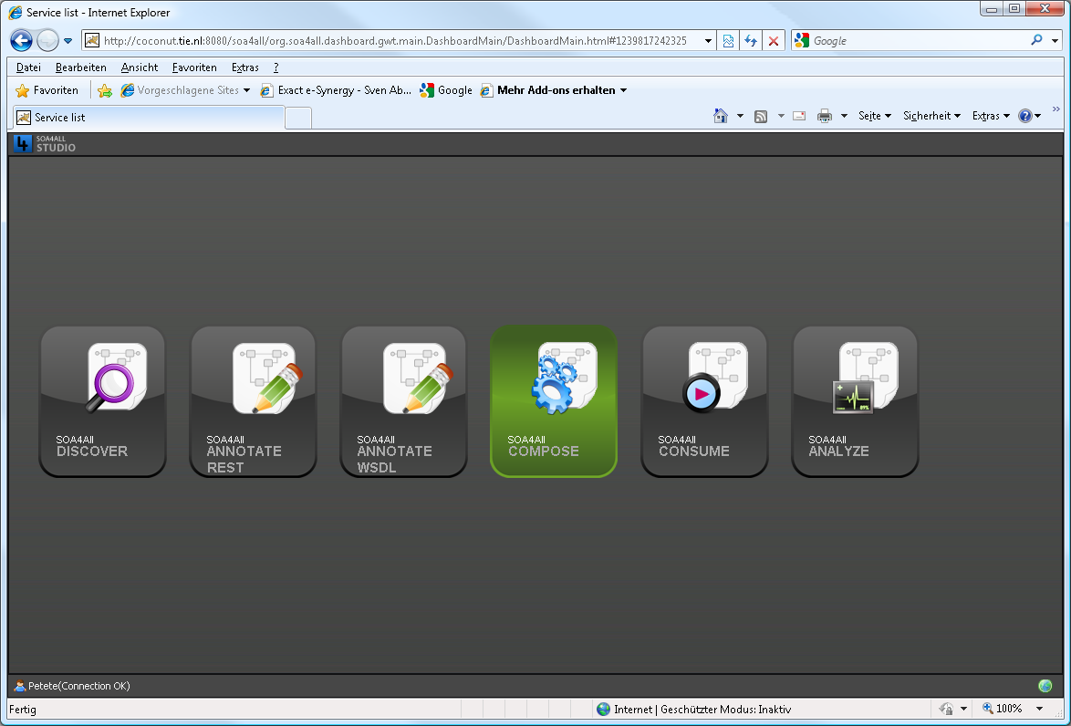
Figure 1: the D2.4.1 Dashboard

References
- SOA4ALL Consortium: D2.4.1 First Demonstrator & Interface Specification, SOA4All Studio UI and Infrastructure Services, 2009.
- SOA4All Project Team: DX UI – Holistic User Interface, Extra Deliverable, 2008

