
Project Number: | 215219
Project Acronym: | SOA4ALL
Project Title: | Service Oriented Architectures for All
Instrument: | Integrated Project
Thematic Priority: | Information and Communication Technologies
Annex I
D6.4.1 First Prototype Of Service Composition and Adaptation Environment

Activity: |  | Activity 2 - Core Research and Development
Work Package: |  | WP 6 - Service Construction
Due Date: |  |  | M12
Submission Date: |  |  | 13/04/2008
Start Date of Project: |  |  | 01/03/2008
Duration of Project: |  |  | 36 Months
Organisation Responsible of Deliverable: |  |  | ATOS
Revision: |  |  | 1.0
Author(s): |  | Jesús Gorroñogoitia (ATOS)

Project co-funded by the European Commission within the Seventh Framework Programme (2007-2013)
Dissemination Level
PU | Public | X

Version History
Version | Date | Comments, Changes, Status | Authors, contributors, reviewers
1.0 | 06/04/2008 | Release Version | Jesús Gorroñogoitia (ATOS)

Table of Contents

Version History 2
Table of Contents 3
List of Figures 3
Executive summary 4
1. Introduction 5
1.1 Purpose and Scope 5
1.2 Structure of the document 5
2. Design Time Composer prototype. Installation and Configuration 6
3. Design Time Composer prototype. Software description 7
4. Design Time Composer prototype. Description of tests execution. 10
Annex A. Design Time Composer prototype. LPML models visualizer installation. 15
4.1 Installation under Windows 15
4.2 Installation under Linux 16
5. References 17

List of Figures
Figure 1 Design Time Composer and LPML API projects content 7
Figure 2 Design Time Composer directory structure details 8
Figure 3 LightweightProcessModellingLanguageAPI directory structure 9
Figure 4 Design Time Composer execution (blackboard viewer shown) for WP7 V1 and V2 scenarios 11
Figure 5 WP7 process template for the registration scenario 12
Figure 6 WP7 V1 process model design solution (partial view) 13
Figure 6 WP7 V2 process model design solution (partial view) 14

Executive summary
This document complements D6.4.1 Specification and First Prototype of Service Composition and Adaptation Environment and describes the software implementation of the first Design Time Composer prototype. This document is included as part of the zip file that contains the first Design Time Composer prototype software, source code, installation and configuration facilities, execution and testing facilities.

Introduction

Purpose and Scope
The goal of this deliverable is to complement D6.4.1 Specification and First Prototype of Service Composition and Adaptation Environment by describing the software implementation of the first Design Time Composer prototype. We refer the reader to D6.4.1 for details about the prototype architecture and design. This deliverable is included as part of the zip file, Annex I to D6.4.1.zip, which contains the first Design Time Composer prototype software, source code, installation and configuration facilities, execution and testing facilities.

Structure of the document
We structure the deliverable into the following sections: section 2 describes the procedure for installing and configuring the prototype software, section 3 describes the Design Time Composer prototype software structure and source code, section 3 describes the procedure to test and execute the Design Time Composer prototype with some test scenarios taken form WP7, Annex A describes the procedure for installing a Lightweight Process Modelling Language (LPML) models viewer, created for debugging and demo purposes.

Design Time Composer prototype. Installation and Configuration
Design Time Composer prototype software is included in Annex I to D6.4.1.zipfile (where this document is also included).
Optional pre-requirements for a complete installation of the prototype are:
- Eclipse Ganymede (http://www.eclipse.org/ganymede/): it is used to analyze, compile and execute the prototype and demos. This is optional, since the zip file includes the compiled binaries, jar files and execution scripts.
- LPML visualizer: It is included in the zip file. For installation instructions see Annex A. This visualizer is used by the demos for visualizing the input process template, the intermediate generated process models and the output process model, transforming the LPML model, serialized as RDF/S into a SVG graphical notation, which can be opened by any SVG viewer. The graphical notation used by this viewer is neither the T2.6 LPML Graphical notation nor a BPM notation. It has only been conceived for debugging and demo purposes within this first prototype. Once the T2.6 Process Editor is available, those models will be visualized within this Editor using the T2.6 LPML graphical format. We have created a transformation engine between the LPML RDF/S format and the format required by the Perl SVG generator included within our visualizer.
- SVG Viewer: LPML process models created by the Design Time Composer prototype can be visualized by any SVG viewer, for instance the Adobe SVG Viewer (http://www.adobe.com/svg/viewer/install/main.html), which can be installed as plugin of any Web Browser: Firefox, IExplorer, etc.
- Web Browsers: they are used combined with the SVG Viewer to show LPML process models. The Linux version of our Design Time Composer prototype uses Firefox, while the Windows version can used both or any other SVG viewer.
The prototype installation procedure is as follows:
- Unzip D6.4.1-P in a directory, hereafter referred as %DTComposer_HOME%.
- %DTComposer_HOME% contains this document and two Eclipse projects:
  - DesignTimeComposer: this project contains the Design Time Composer prototype
  - LightweightProcessModellingLanguageAPI: this project contains the LPML API required by the Composer to manage the models as JavaBeans and to serialize and de-serialize LPML models into/from RDF/S files stored in the repository (this current prototype uses the file system as repository).
- [Linux] Make executable all the scripts (*.sh) in directories %DTComposer_HOME%/ DesignTimeComposer and %DTComposer_HOME%/ DesignTimeComposer/scripts.
- The software is ready to be used with the provided test scripts. Optionally it can be imported in Eclipse for further development, analysis, debugging, testing, etc. within this IDE. The procedure is as follows:
  - Select in Eclipse the menu File/import…, General/Existing Projects into workspace. Next.
  - Check Select Root Directory, click on Browse and locate %DTComposer_HOME%. Select Design Time Composer project and accept. Finish.
  - Repeat the same procedure with LightweightProcessModellingLanguageAPI project

Design Time Composer prototype. Software description
This section describes the DesignTimeComposer and LightweightProcessModellingLanguageAPI projects through some Eclipse IDE snapshots.
As described in the installation section, Annex I to D6.4.1.zipcreates both projects directories after being unzipped. Next picture shows the content of both projects in the Eclipse Package Explorer
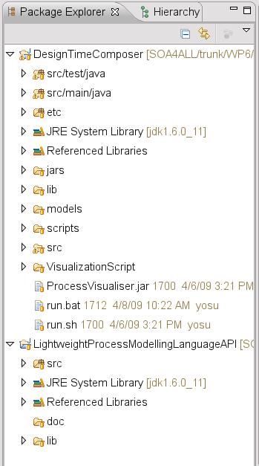
Figure 1 Design Time Composer and LPML API projects content
DesignTimeComposer project is organized as follows:
- src/test/java/ contains the classes implementing the available test cases for the generation of WP7 V1 (DesignComposerDemonstrationA.java) and V2 (DesignComposerDemonstrationB.java). There are scripts available in the scripts directory within the same purpose.
- src/main/java/ contains the Composer source code.
- etc/ contains the Spring configuration file to customize the Composer blackboard and agents and the Drools rules files for the available DesingModificationAgents.
- jars/ contains the DesingTimeComposer jar file
- lib/ contains third party dependencies: Spring, Drools, Lucene, Prefuse. Dependencies on LPML API, Jena and JenaBean are managed through the project classpath configuration.
- models/ contains the LPML input process template, serialized as RDF/S file. Output LPML process models will be stored within this directory as RDF/S as well.
- models/template contains the used LPML process templates.
- scripts/ contains the required scripts to execute the demos and transforming models into SVG format

See below some pictures showing details of some directories:
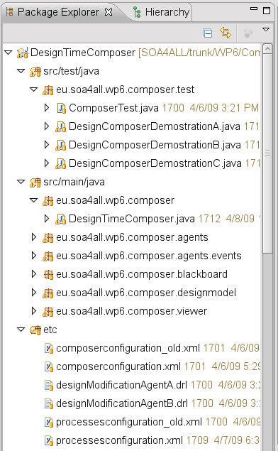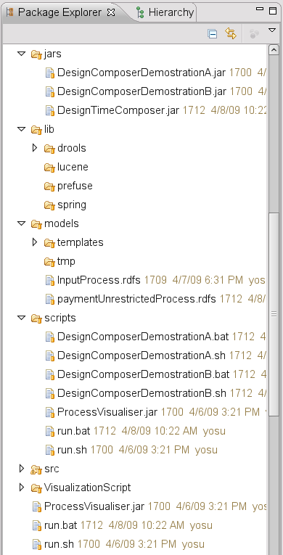
Figure 2 Design Time Composer directory structure details

LightweightProcessModellingLanguageAPI project is organized as follows:
- src/ contains the API source code
- lib/ contains the third party jar dependencies: Jena and Jenabean
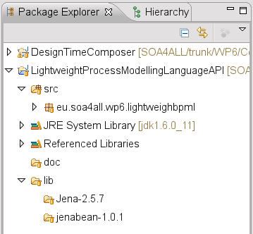
Figure 3 LightweightProcessModellingLanguageAPI directory structure

LightweightProcessModellingLanguageAPI uses Jena (http://jena.sourceforge.net/) and JenaBean (http://code.google.com/p/jenabean/) to realize LPML models (JavaBean in memory) into RDF/S files and viceversa. This is done through the RDFSMapper.java class. Currently, LightweightProcessModellingLanguageAPI support the LPML specification described in D6.3.1
DesignTimeComposer uses the following technologies:
- Spring framework (http://www.springsource.org/) to implement the blackboard and specialized agents
- JBoss Drools (http://www.jboss.org/drools/) to implement the Design Modification Agents’ knowledge bases, described as a set of domain specific rules.
- LPML API to manage LPML models in memory (as JavaBeans) and to save/load them from the repository as RDF/S files.
The current prototype of DesignTimeComposer implements three domain-specialized DesignModificationAgents whose knowledge bases are described through Drools rules in files etc/knowledgebaseA|B|C.drl. Those agents support the Goal-Template adapter operator as described in D6.4.1.

Design Time Composer prototype. Description of tests execution.
This prototype is accompanied with some tests that have been created to analyse and asses the Design Time Composer behaviour and features. Those tests implement some scenarios taken from WP7.
The first WP7 V1 scenario receives as input a LPML process template that describes the abstract registration process. This process is not constrained concerning the payment method.
The second WP7 V2 scenario receives as input the same LPML process template that describes the abstract registration process, but constrains the payment method to a credit-card payment method.
The result is a further developed LPML process model where the original template tasks, described by composite goals have been expanded with domain specialized process templates, whose activities are described by concrete service invocations. In case of V1 the payment method is unrestricted and therefore not bound to a concrete service activity, while in case of V2, a payment with credit card method is selected.
The input process template is load from %DTComposer_HOME%/DesignTimeComposer/models/inputProcess.rdfs and the LPML process model result is stored with the same directory.
Tests can be executed within the Eclipse IDE or within a command line/explorer window:
- Within Eclipse IDE:
  - WP7 V1: select in the PackageExplorer view the src/test/java/eu.soa4all.wp6.composer.test.DesignComposerDemonstrationA.java, right click, Run As/Java Application
  - WP7 V2: select in the PackageExplorer view the src/test/java/eu.soa4all.wp6.composer.test.DesignComposerDemonstrationB.java, right click, Run As/Java Application
- Within a command line/explorer window: go to %DTComposer_HOME%/DesignTimeComposer/scripts directory
  - WP7 V1: execute DesignComposerDemonstrationA.bat (.sh)
  - WP7 V2: execute DesignComposerDemonstrationB.bat (.sh)
By default, both demos open a blackboard Viewer (its installation is described in Annex A). This behaviour can be switched off by modifying the Boolean true parameter in DesignComposerDemonstrationA|B.bat|sh scripts or in the main method of DesignComposerDemonstrationA|B.java classes. In this latter case, the Composer processes the input model and creates the output model. In the former case, the Composer processes the input model as well, but also shows a dynamic representation of the blackboard, which shows the reasoning paths, the intermediate models created and the Goal-Template Adapter operators applied in the transition between to two adjacent models. To facilitate the blackboard visualization, the current Design Time Composer prototype includes a 1-second pause after posting each process model design. This behaviour persists even when the blackboard viewer has been switched off (this will be fixed in new releases).
Next picture show a snapshot of DesignComposerDemonstrationA (left-side) and DesignComposerDemonstrationB blackboards (right-side):
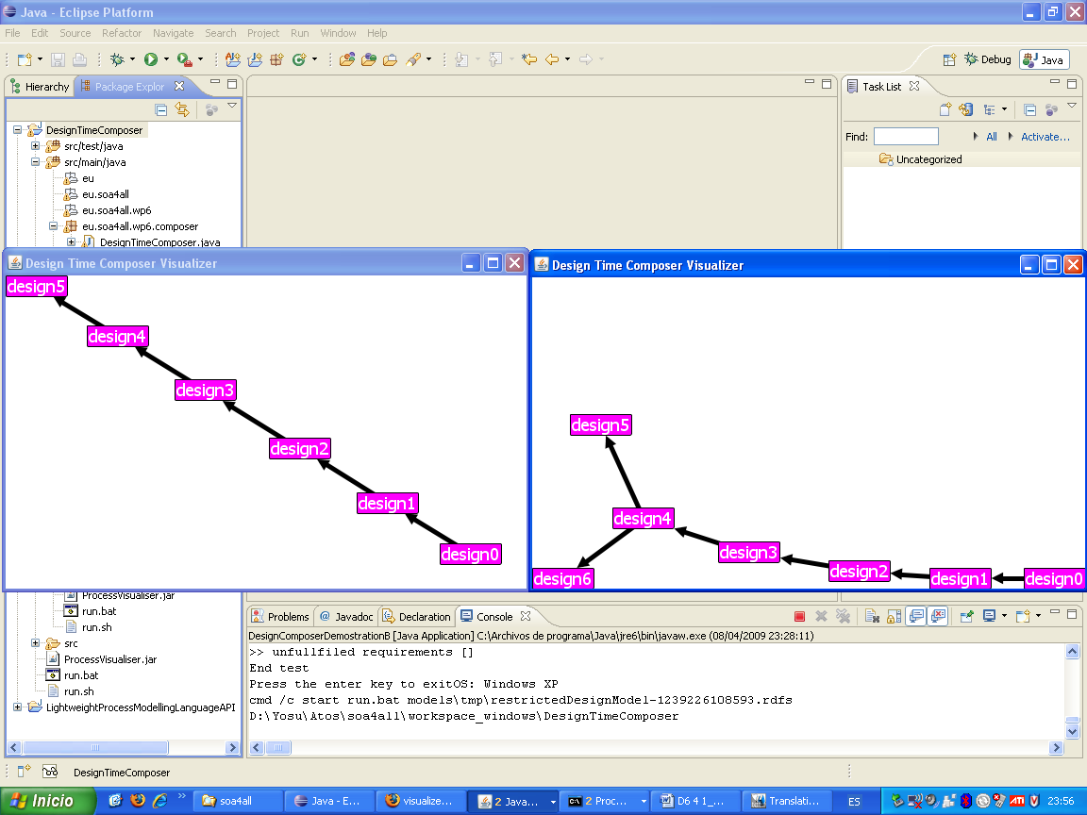
Figure 4 Design Time Composer execution (blackboard viewer shown) for WP7 V1 and V2 scenarios
Hovering the mouse over the arrow that describes the transition between two models, the blackboard viewer shows the rule applied (Goal-Template Adapter, as described in D6.4.1). Hovering the mouse over each design box (design X), the blackboard viewer shows the assignment set and the specification set of each process model design (see D6.4.1 for details).

Clicking on one process model design the Composer viewer invokes the LPML SVG Viewer, which retrieves the selected process model from the repository (in RDF/S format), translates it into the required format for SVG processing and creates a SVG file. Depending on the OS (Linux|Windows), Firefox (Linux) or the default Windows SVG viewer (i.e. IExplorer) are invoked to open and show the SVG file. In Windows the reader may be asked to select a proper SVG from a list.
Next figures show the input template and a portion (since they don’t fit in the screen with a readable scale) of the generated process models for WP7 V1 and V2 scenarios.
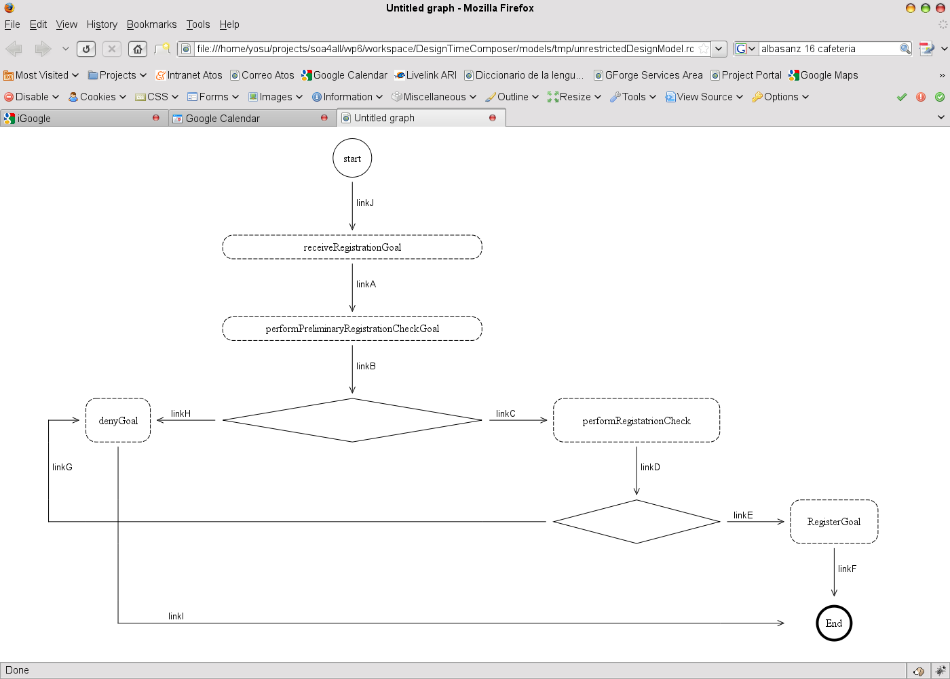
Figure 5 WP7 process template for the registration scenario
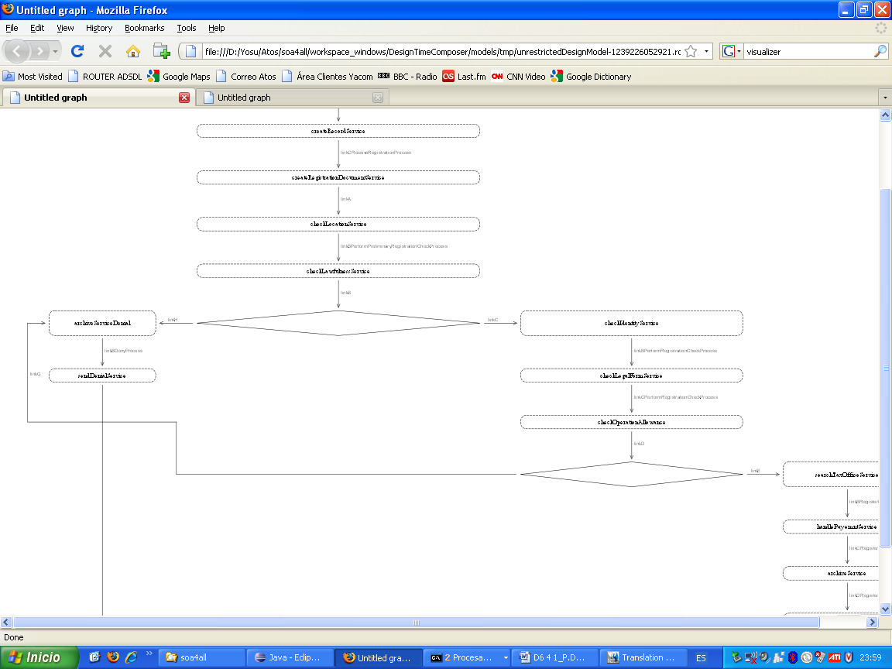
Figure 6 WP7 V1 process model design solution (partial view)
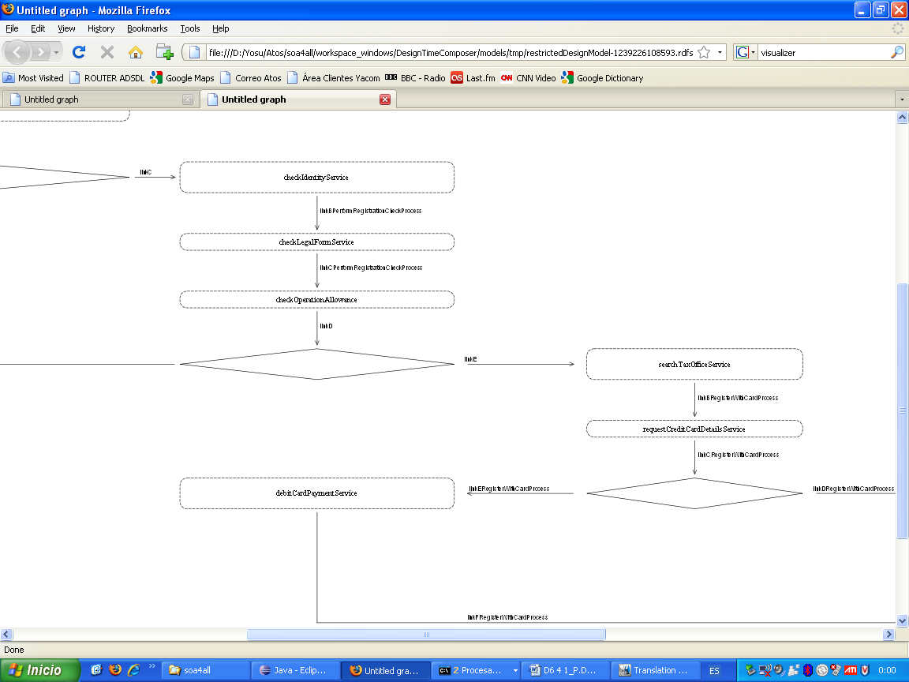
Figure 7 WP7 V2 process model design solution (partial view)

- Design Time Composer prototype. LPML models visualizer installation.
Design Time Composer prototype includes a facility which translates the LPML process models, in RDF/S format into a SVG graphical format. That facility requires the installation of the following Perl scripts.
All required packages for installation are in zip file "%DTComposer_HOME%/ visualisation_script 0.1.zip". Unzip it in a directory, hereafter referred as %VisualizationScript_HOME%. Go to %VisualizationScript_HOME%/installations/ and follow next paragraph instructions.

Installation under Windows

Steps:

1. Install perl
Execute perl installer: ActivePerl-5.10.0.1004-MSWin32-x86-287188.msi and follow instructions.

2. Install nmake
From directory "installations/nmake" copy all files (NMAKE.EXE and NMAKE.ERR) to the Perl bin directory (usually C:\Perl\bin).

3. Install Image-Info library (required by script)
Unpack file "Image-Info-1.28.tar.gz"
Open console window (cmd.exe) and enter the directory with unpacked files
type following commands in that order:

perl Makefile.pl
nmake
nmake test
nmake install

4. Install Graph-Easy
Unpack file "Graph-Easy-0.64.tar.gz"
Open console window (cmd.exe) and enter the directory with unpacked files type following commands in that order:

perl Makefile.pl
nmake
nmake test
nmake install

5. Install Graph-Easy additional libraray (for SVG output)
Unpack file "Graph-Easy-As_svg-0.23.tar.gz"
Open console window (cmd.exe) and enter the directory with unpacked files type following commands in that order:

perl Makefile.pl
nmake
nmake test
nmake install

Installation under Linux
Requirements: Make package installed.

Steps:

1. Install Image-Info library (required by script)
Unpack file "Image-Info-1.28.tar.gz"
Open console window (cmd.exe) and enter the directory with unpacked files type following commands in that order:

perl Makefile.pl
make
make test
make install

2. Install Graph-Easy
Unpack file "Graph-Easy-0.64.tar.gz"
Open console window (cmd.exe) and enter the directory with unpacked files type following commands in that order:

perl Makefile.pl
make
make test
make install

3. Install Graph-Easy additional libraray (for SVG output)
Unpack file "Graph-Easy-As_svg-0.23.tar.gz"
Open console window (cmd.exe) and enter the directory with unpacked files type following commands in that order:

perl Makefile.pl
make
make test
make install

References
- SOA4ALL Consortium: D3.2.1 Specification Of Lightweight, Context-aware Process Modelling Language, 2009.
- SOA4ALL Consortium: D3.4.1 Specification and First Prototype Of Service Composition and Adaptation Environment, 2009.

