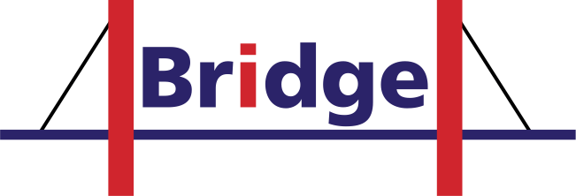

Bilateral Research and Industrial Development Enhancing and Integrating GRID Enabled Technologies
Project no.: 045609

Bridge

International cooperation on Grid Technologies – IST Call 6
Specific target research project

Deliverable

D.0.7 Final Activity Report

Start date of project: 1 January 2007 Duration: 26 months
Due date of deliverable: 28 February 2009
Actual submission date: 14 April 2009

Lead contractor for this deliverable: Fraunhofer-Gesellschaft
Revision: 1.0

Project co-funded by the European Commission within the Sixth Framework Programme (2002-2006)
Dissemination level
PU | Public
PP | Restricted to other programme participant (including the Commission Services)
RE | Restricted to a group specified by the consortium (including the Commission Services)
CO | Confidential, only for members of the consortium (including the Commission Services) | X

Revision history

Date | Version | Author | Modification
30 March 2009 | 0.1 | Yvonne Havertz | First wrap-up
04 April 2009 | 0.2 | Yvonne Havertz | Work on all chapters
12 April 2009 | 0.3 | Yvonne Havertz | Integration of input by partners
14 April 2009 | 1.0 | Gilbert Kalb | Final Editing

Copyright

Copyright © 2009 Fraunhofer Gesellschaft and other members of the Bridge consortium

Table of contents
1 Executive Summary 5
2 Project objectives 6
2.1 Short Overview on BRIDGE 6
2.2 BRIDGE Project Objectives 6
2.3 BRIDGE Application Scenarios 7
2.4 Research Activities 7
2.5 Measurable Technical Objectives 11
2.6 Contribution to Standards 12
2.7 Dissemination of Knowledge 13
3 BRIDGE participants list 14
4 Project Achievements per Applications 15
4.1 Objectives and Milestones 15
4.2 WP1: Basic Grid Infrastructure 15
4.2.1 Objectives 15
4.2.2 Description of work 16
4.2.3 Achievements during the first project year 18
4.2.4 Achievements during the second project year 22
4.2.5 Overall achievements and outlook 25
4.3 WP2: Aerospace Activity 25
4.3.1 Objectives 25
4.3.2 Description of work 26
4.3.3 Achievements during the first project year 30
4.3.4 Achievements during the second project year 35
4.3.5 Overall deviations for WP2 achievements during the second project year 41
4.3.6 Overall achievements and outlook 41
4.4 WP3: Meteorological Application 42
4.4.1 Objectives 42
4.4.2 Description of work 45
4.4.3 Achievements during the first project year 46
4.4.4 Achievements during the second project year 50
4.4.5 Overall achievements and outlook 53
4.4.6 Future Research Directions 54
4.5 WP4: Pharmaceutical Application 55
4.5.1 Workpackage Summary 55
4.5.2 Achievements during the first project year 59
4.5.3 Achievements during the second project year 64
4.5.4 Overall achievements and outlook 69
4.5.5 Future Research Directions 70
4.6 WP5: Information Disseminations and Take-up of Results 71
4.6.1 Workpackage Sumamry 71
4.6.2 Achievements during the first project year 72
4.6.3 Achievements during the second project year 79
4.6.4 Outlook 83
5 Conclusion 84
6 Exploitation and Dissemination of Knowledge 88
6.1 WP1 Grid Infrastructure 88
6.1.1 Exploitation Activities from BUAA 88
6.1.2 Exploitation Activities from IT Innovation 88
6.2 WP2 Aerospace Application 89
6.2.1 Exploitation 89
6.2.2 Dissemination of Knowledge 91
6.3 WP3 Meteorological Application 92
6.3.1 Exploitation 92
6.3.2 Dissemination of Knowledge 93
6.4 WP4 Pharmaceutical Application 95
6.4.1 Exploitation 95
6.4.2 Dissemination of Knowledge 96
7 Appendix 98
Annex 1: Overview Bridge deliverables PM1 – PM26 98

- Executive Summary

This summary provides a brief overview of the Final Activity Report’s structure.

Section 2 comprises the overall objectives of BRIDGE as in the initial Description of Work and briefly summarizes the results of the BRIDGE Application Activities. Grid Solution Portfolio, the Complex Application Cases, Dissemination of Knowledge in BRIDGE.

Section 3 lists the BRIDGE partners.

Section 4 describes the project achievements per workpackages, i.e. detailing the achievements per workpackages – starting with the state-of-the-art (including the objectives) at the beginning of the project, describing the work performed and the final deployment and closure.

Section 5 provides an overall conclusion.

Section 6 provides a short summary of the BRIDGE exploitation by results and the dissemination of information for the BRIDGE Application Activities.

The appendix in section 7 lists all BRIDGE deliverables for the whole project duration.

.

- Project objectives

  - Short Overview on BRIDGE
BRIDGE (Bilateral Research and Industrial Development Enhancing and Integrating GRID Enabled Technologies) is an EU FP6 STREPS project addressing bilateral research and industrial development between EU and China for Enhancing and Integrating GRID Enabled Technologies. The project consortium consists of 13 partners, 7 from EU and 6 from China. Among them, there are major industrial partners like EADS in Europe and AVIC II in China. Major organizations in Grid research such as Fraunhofer SCAI in Germany, IT Innovation in the United Kingdom, and Beihang University in China are playing active roles in the project.
Bridge demonstrates the benefits of GRID technology for international cooperation, in particular between Europe and the target country China.
By joint research efforts of European and Chinese research teams, the Bridge project aims at enhancing the Grid technology for both scientific and industrial applications. Bridge is based on and further extends previous research and development achievement of European and Chinese projects. It addresses major technical issues, which result from the far distance of the collaborating partners as well as from the conflicting goal of intense collaboration and protection of intellectual property rights.
Major research and development activities conducted by Bridge are interoperability between grid middleware GRIA and CNGrid GOS (GOS for short) and grid enabled showcase applications.

  - BRIDGE Project Objectives
The BRIDGE (Bilateral Research and Industrial Development Enhancing and Integrating GRID Enabled Technologies) projects aims at demonstrating the benefits of GRID technology for international cooperation, in particular between Europe and the target country China.

- To demonstrate the benefits of GRID technology for international cooperation
- To develop, enhance and interconnect European and Chinese GRID middleware technology
- To set up integrated GRID test bed using European and Chinese middleware components for application demonstration
- To set up joint application show cases using distributed workflow and data access technology
- To disseminate the results of the project to industrial and academic communities
- To provide a software platform supporting distributed product and process developments, which respects and protects intellectual property rights

CNGRID and SIMDAT have been major ongoing projects in China as well as in the European Community. Both projects aim at the improvements of existing grid infrastructures driven by concrete application use cases. BRIDGE will develop an interoperability interface between the CNGRID and SIMDAT infrastructure, which allows in particular the execution of distributed workflows as well as access to distributed data repositories. Remote access to specific analysis services will allow the actual and controlled usage of these analysis services for product and process development without disclosing all details.

Three application scenarios will be used to demonstrate the application of several GRID technologies in co-operative design and simulation and data access between European and Chinese partners.

  - BRIDGE Application Scenarios
Application Scenario 1: Simulation and Design in Aerospace Industries
Implementation of a distributed optimization workflow for multidisciplinary airplane wing designs using simulation modules from EADS in simulating that acoustic functional behaviour and AVIC II for the simulation of aeroelastic and aerodynamic functional performance.

Application Scenario 2: Environmental Disaster Prediction
The scenario is a distributed retrieval system for weather prediction results. The project should provide some resources for mutual access of a data base repository containing simulation results.

Application 3: Drug Discovery
The scenario is a distributed docking workflow involving docking tools from Chinese participants as well as docking tools from European participants aiming at an improved result by combining results of several docking tools for the same targets.

  - Research Activities
To achieve the above objectives, the following research activities were detailed to be performed in the project:

Cross platform workflows. Applications that will be deployed over SIMDAT and CNGrid platforms will use heterogeneous service components provided by the current Grid middleware distributions, i.e., GRIA for SIMDAT and CNGrid GOS for CNGrid. Though based on the same middleware Web Services, GRIA and CNGrid GOS differ in mechanisms of virtual organization, security, and quality of service. How to compose a workflow which consists of components from different software infrastructure and can be executed on different Grid platforms is still unknown. In BRIDGE different interoperability and inter-operation approaches including client federation and gateway between services will be investigated and tested to achieve cross platform workflows.

Cross platform policy management. Policy management is an essential issue to Grid infrastructure interoperability between different industrial domains. GRIA supports dynamic contextualised security which is designed to enforce business processes associated with B2B collaborations. The objective is to support minimal authorisation and administration with explicit trust decision points and value exchange between participants. CNGrid GOS uses a Grid community concept to enforce security based on mutual agreement between resource providers and users. A centralised Grid operator manages users, resources; security polices and provides resource access authorization to the end users. In order to allow SIMDAT and CNGrid users to access data processing and storage services on each platforms, interoperability mechanisms for initiating trust relationships, managing security policies, and maintaining access rights will be investigated and developed.

Cross platform data processing and storage. Executing applications using GRIA and CNGrid GOS involves access to the heterogeneous data resources maintained and provided by different Grid infrastructures. GRIA and CNGrid GOS both provide a distributed file-compute capability although the service interface specifications are different. GRIA also provides an OGSA-DAI service, which enables access and manipulation of heterogeneous databases whereas CNGrid GOS does not. Enhancements to the current data processing and storage services are necessary to achieve transparent heterogeneous data access and processing.

Grid resource monitoring and management. Effective resource monitoring and management are the basis of delivering required quality of services and performing meta-scheduling over heterogeneous and distributed resources. The BRIDGE project will investigate methodologies and mechanisms for integrated monitoring and management of resources across GRIA and CNGrid GOS platforms. The current resource monitoring and management mechanisms supported by GRIA and CNGrid GOS will be analysed. Resource monitoring and management services will be enhanced that provide access to resource information at an appropriate level of abstraction for meta-scheduling whilst still conforming to the operational requirements of participating organisations.

Grid QoS. The Quality of Services (QoS) issue will be addressed by this project. GRIA supports Service Level Agreement (SLA) to deliver certain level of QoS guarantee. CNGrid GOS currently provides very limited QoS control, mainly the best effort approach. Some QoS mechanism will be added to CNGrid GOS. Compatibility and conformance study on QoS supported by GRIA and CNGrid GOS will be conducted. New mechanisms, which enable QoS control across SIMDAT and CNGrid, will be studied to support applications deployed across these two platforms.

Grid applications
The results from the above research activities will be verified by typical application show cases from selected application domains. Aerospace, pharmaceutical and meteorological applications will be developed over Grid test bed formed by SIMDAT and CNGrid supported infrastructure.

By conducting the above research work and developing show case applications, the BRIDGE project will make its contribution to the Grid technology, especially in Grid interoperability and inter-operation. It will enable European and Chinese scientists and engineers to cooperate on key Grid technology research and Grid applications over heterogeneous Grid platforms, i.e., SIMDAT and CNGrid. Important enhancement will be added to the current Grid software infrastructures, significant progress will be made in technologies such as workflow over heterogeneous Grid platforms, Grid security, dynamic management and monitoring of distributed heterogeneous resources, Grid QoS controls, and Grid business model. The demonstration applications developed by this project will not only verify the effectiveness of adopting Grid technology, but also improve and promote the applications in the specific domains.

State-of-the-art
The state-of-the-art in Grid systems is characterized by web service-based infrastructures aiming to support inter-domain business collaboration alongside more traditional academic and scientific application deployments. Grid technologies have moved from second-generation services based on low-level bespoke protocols (Globus Toolkit 2.X, Unicore) to web service based services using open standards (GT4, GRIA, OMII, gLite, CNGrid, CROWN). Grid technologies today are typically compliant with basic web service standards (WS-I) providing interoperability at the core protocol and message security layers but standards for higher-level Grid functionality remains a matter for debate. In 2004, The Globus Alliance with IBM and others launched a new collection of standards called the “Web Services Resource Framework” (WSRF), part of which (concerned with notification) was later decoupled to become “WS-N”. These proposals were made directly to OASIS (not GGF), built on existing and emerging Web Service standards, and are seen as a key step that allows convergence between Web Services and the Grid.

WSRF on its own does not provide interoperability although limited integration between Globus and Unicore is being explored (UniGrids). More complex scenarios required by dynamic federation of information and computational resources currently require all participants to use the same Grid infrastructure software. This is not feasible unless collaboration is restricted to a closed community whose members are known a priori. Other initiatives such as the GGF OGSA working groups are tackling architectural issues through the development of profiles on existing web service and Grid specifications. However, no OGSA compliant Grid infrastructures exist today because the specifications are still immature, remain volatile and do not address the needs of business users for operational security and inter-domain management. Thus the Grid is falling well short of its potential and the challenge of standardising the Grid programming model and associated management services is therefore still unfulfilled. Most Grid infrastructures and Grid specification initiatives are grounded in the academic community and do not focus on the needs of dynamic business collaborations. Grid systems such as gLite, Globus, CNGrid, have a VO model that represents a persistent manifestation of the collaboration, exercising control and optimising for the community based on mutual agreement between resource providers and users. This has proved successful for large scale academic research collaborations but has yet to be adopted by industry, as participants have to place trust in the VO rather than the organisation providing the services.

In latest generation of EU projects (SIMDAT, NextGRID, BREIN, BEinGRID), business application sectors are driving the evolution of Grid technology through the specification of scenarios that require uniform and location-independent access to persistent and supported heterogeneous IT assets that are under different ownership or control. These projects are addressing the challenges by major advancements in Grid management services to support operational security and business objective requirements. A new-style Grid operation model is emerging, as supported by GRIA and NextGRID experiments, that reflects business models found in the real world and enables more flexible Peer-to-Peer (P2P) collaboration architectures based on distributed management principles. Businesses can now create trusted bi-lateral relationships and negotiate service level agreements for provision of applications, information, computation and storage resources depending upon their position in the value chain.

The new Grid operation model requires interoperability specifications to reflect a higher-level of management for business service provision rather than community-based access to low-level resources. Current EU projects are influencing initiatives such as OGSA so that future specifications incorporate the needs of business. For industrial companies seeking to participate in international cooperation an interoperable infrastructure supporting strict but flexible export policies remains critical.

China has started its research on Grid technology since 1999. The National High-tech R&D program (863 program) of China is the major national research program supporting activities in this field. A pioneer project, National High Performance Computing Environment, was conducted from 1999 to 2000. A high performance computing environment consisting of several high performance computing centres was established as the major achievement of that project, which has evolved into the China National Grid (CNGrid) supported by the 863 key projects during the period of 2002 to 2005. CNGrid currently consists of 8 Grid nodes across China. The aggregated computing power is 18TFlops. The major computing resources include Dawning 4000A (10.2 TFlops) in Shanghai and DeepComp 6800 (5.324 TFlops) in Beijing. The total storage capacity exceeds 200TB.

CNGrid GOS is the Grid software supporting the operation of CNGrid and Grid applications. It provide basic system level functions including job services (batch job submission and scheduling) , Grid information services (description, publishing, discovery, and access of Grid information), data services (global data view maintenance, uniform access, and file transfer), management (user management, system monitoring and accounting), and security services (authentication, authorization, single entry sign-on, access control, and security policies maintenance). A grid user environment based on a XML-like language, called GSML, is available.

Planed architecture of CNGrid GOS

Several new concepts and mechanisms are proposed and implemented by CNGrid GOS. It supports virtual organization by layered structure composed of Grid processes and Grid communities. The Grid community, namely Agora, provides interface between users, resources and authentication and authorization services. Grid process called Grip, a counterpart of the process in traditional operating systems, is adopted in CNGrid GOS. Grip accesses actual resources with reduced and uniformed APIs on behalf of the end user. It supports multiple resources binding at all layers with different semantics. Full lifecycle support is provided to Grip. A mapping between effective, virtual, and physical address spaces is used to decouple the application logic from the physical resources. With this mapping, change to the low level resources will not affect the upper layer user application code. A Grid portal engine (GPE) built on servlet is developed to provide HTTP interface for the Web application developers. It hides Grip manipulation and SOAP invocation details from the end user. Also privilege management is done by GPE according to roles in the Agora where the user logs in.

A set of applications are supported by CNGrid GOS and running on CNGrid. Those applications are selected from different areas including scientific research, resource and environment, advanced manufacture and public services in order to demonstrate the feasibility of Grid technology in supporting wide rage of applications.

The aviation manufacture Grid AviGrid was developed by AVIC II of China for distributed design, simulation, testing and manufacture of aircrafts. The major purpose to this application is to facilitate sharing of expensive CAD software and computing resources within AVIC II. Data exchange and sharing are achieved by defining universal data formats and by using data dictionary. Topological structure optimization of the aircraft is carried out by running genetic algorithm based optimization program on the aggregated computing resources in AviGrid.

New drug discovery Grid DDG is another CNGrid application which was developed by Shanghai Institute of Materia Medica. This application uses Grid technology to speed up the process of developing a new drug. Extensive computer simulation is executed on computers in DDG in a P2P mode using open source and commercial chemical compounds databases. DDG significantly improves the accuracy of compound screening and shortens the period of new drug discovery.
China meteorological application Grid CMAG was developed by China Meteorology Research Institute. CMAG is used as a platform for collaborative development of a new weather prediction model called GRAPES. About 10 high performance computers and clusters are integrated by CMAG. Besides supporting the development of the new weather prediction model, CMAG also provides time and location specific weather forecasting services to areas where the digital weather forecasting capability is not available.

  - Measurable Technical Objectives
WP1: Basic Integrated Grid Infrastructure
Objective 1 - after 12 month
A Grid interoperability strategy is established for GRIA, CNGrid GOS and potentially other Grid middleware. A prototype infrastructure composed of interoperable GRIA and CNGrid GOS at the job submission level is deployed. Showcase applications developed by WP2, WP3 and WP4 can start their trial deployment over the infrastructure. Results of preliminary experiment on cross domain workflow are reported.

Objective 2 - after 18 month
Stable implementation of interoperable Grid services in accordance with the interoperability design strategy is released and integrated with workflow technologies supporting BRIDGE application domains, especially aerospace and pharmacy applications. Showcase applications deployed on the infrastructure.

WP2: Aviation Application - Objective 3 - after 26 month
A fully working prototype software tool set along with associated documentation demonstrating and quantifying the benefits of the utilization of international heterogeneous GRID infrastructures and Analysis Services.

WP3: Meteorology Application - Objective 4 - after 24 month
The implementation and deployment of GRID enabled services at CMA and ECMWF, allowing researchers worldwide to discover and retrieve data from the TIGGE databases, as well as the provision of simple analysis services, such as statistical computations, to be performed at the data location.

WP4: Pharmaceutical Application - Objective 5 - after 24 month
Developing a fully working prototype of a grid-based software platform and tools for virtual screening applications operating over an international heterogeneous GRID, and demonstrating the success of the platform through conducting a "proof of concept" scientific experiment for identifying potential lead candidate drugs against Bird Flu /Dengue Fever / Malaria.

WP5: Information, Dissemination and Take-up of Results - Objective 6 - after 24 month
Disseminate all results from the BRIDGE project in as soon as they exist through publications, press releases, workshops and presentations. Coordinating and packaging the individual exploitation activities of the project partners. Creating a BRIDGE Project Outcome Package. Acting as contact point for feedback and requests from industry and other interested parties.

  - Contribution to Standards
Standards are crucial to Grid interoperability. Commercial IT and application domain standards are key, Community-based standards of GGF play a key role, but interoperability with commercial products will also involve working with other bodies relevant to Web Services, etc. We will track and influence standards developments in bodies including ETSI, W3C, OASIS and GGF. Partners will engage directly with these bodies as appropriate. BRIDGE standardisation goals are to demonstrate effective use of open standards and to track and influence standards developments in e. g. OASIS and W3C, via e. g. OGF and ETSI. The University of Southampton and the University of Beihang are active in W3C and in GGF.

At the heart of many Grid projects is GRIA, which is Grid middleware developed by IT Innovation to enable commercial use of the Grid in a secure, interoperable and flexible manner. GRIA is free and open source.
- The University of Southampton is active in W3C and GGF.
- They are also engaging with the new ETSI Grid Standardisation Group.
- They are constantly evaluating new interoperability specifications so that they can align GRIA developments with key standards and specifications. For example, IT Innovation is developing an industrial Grid profile within SIMDAT from specs such as WS-Addressing, WSRF, WS-N, WSDM, JSDL, OGSA-BES, OGSA-DAI. In NextGRID they are working on dynamic security with specifications such as WS-Trust, WS-Federation, SAML, XACML, WS-Security, and WS-Policy.
- IT Innovation is already very active within the technical working groups through current projects (NextGRID, SIMDAT), For example, they chair "TG6 Security and Trust" and participate in other technical working groups (architecture, data, workflow/SLA) and will engage with the new business models group. They will intend to continue their technical engagement with new projects BREIN, Edutain@GRID and BRIDGE.

The partners in the meteorology activity are committed to use and promote standards such as GRIB for encoding and transmitting gridded data (WMO FM 92-VIII Ext. GRIB) and BUFR (WMO FM 94 BUFR) for any other binary data. Metadata catalogues will follow the ISO 19115:2003 standard, which defines the schema required for describing geographic information and services and provides information about the identification, the extent, the quality, the spatial and temporal schema, spatial reference, and distribution of digital geographic data. BRIDGE will provide a reference implementation for the World Meteorological Organisation (WMO) for the future WMO Information System. Project partners CMA, DWD and ECMWF are active members of the WMO expert groups that define such standards.

Beihang’s effort in standardization is mainly on participating activities of international standardization body on Grid, such as OGF (GGF). Their major interest is on resource management and monitoring. Special issues in standards might be raised in interoperability of Grid middleware. Beihang University will jointly work on those issues with our EU partners and propose necessary standards to the standardization body

BRIDGE will put special emphasis on standardisation and the participation a major European and Chinese Grid initiative will put BRIDGE in a very specific position. However, a period of 24 months is too short for the actually driving standards. BRIDGE will develop two deliverables at month 6 and at month 24, which actually details the planned contributions to standards and also integrates the actual white papers/reference documents, which have been made available to standardisation processes.

  - Dissemination of Knowledge
One major focus of BRIDGE will be to raise public awareness – this has been handled as part of the information dissemination activities of BRIDGE.

The projects information dissemination activities on global project level have targeted mainly an audience, which is also beyond a grid specific research community. In particular, press releases and project flyer have highlighted the advances achieved for a non-specialized audience. Since BRIDGE has partners form China and Europe, it will serve both communities. BRIDGE has also aimed at supporting mutual understanding of society, culture, and different technical approaches.

Among the ambitious objectives of BRIDGE have been to accelerate the uptake of existing Grid techniques and architectures and to demonstrate the benefits of GRID technology for international cooperation, and development, enhancement and interconnection of European and Chinese GRID middleware technology.

During the first project year the focus of Information Dissemination was on support of the partners and creating
- a BRIDGE Logo as the visual identity of the project,
- a standard layout of BRIDGE presentation for usage by all partners
- a BRIDGE trademark that had been registered for BRIDGE on European and Chinese level
- a BRIDGE project flyer summarizing the objectives, plans and potential benefits of the project. This flyer has been distributed to all partners for further distribution.

With the BRIDGE prototypes being deployed and evaluated mainly during the second project year, major information dissemination activities were carried after PM 12 using the results as a “starting point” for information dissemination activities on all levels.

During the run-time the BRIDGE partners presented the project at conferences and workshops all over China and Europe, and internally. Either BRIDGE as a whole or the Application Activities’ Workpackages were presented.

All presentations were usually well attended and a lot spin-off contacts were made.

The uptake of BRIDGE press releases – both in Europe and China - was very good.

BRIDGE Information Dissemination will continue well beyond the project’s duration.

- BRIDGE participants list

Parti-cipant  Role | Parti-cipant Num-ber | Participant name | Participant short name | Country | Date enter project | Date exit project
CO | 1 | Fraunhofer Gesellschaft e.V. | FhG/SCAI | Germany | M 1 | M 26
CR | 2 | LMS International N.V. | LMS | Belgium | M 1 | M 26
CR | 3 | University of Southampton, IT Innovation | IT Innovation | United Kingdom | M 1 | M 26
CR | 4 | European Centre for Medium-Range Weather Forecasts | ECMWF | United Kingdom | M 1 | M 26
CR | 5 | Deutscher Wetterdienst | DWD | Germany | M 1 | M 26
CR | 6 | EADS Centre Commun de Recherche | EADS | France | M 1 | M 26
CR | 7 | InforSense UK Ltd. | InforSense | United Kingdom | M 1 | M 26
CR | 8 | Computer Network Information Center | CNIC, CAS (Chinese Academy of Sciences) | China | M 1 | M 26
CR | 9 | Beihang University | Beihang Uni | China | M 1 | M 26
CR | 10 | China Aviation Industry Corporation II | AVICII | China | M 1 | M 26
CR | 11 | National Meteorological Center, China | NMIC | China | M 1 | M 26
CR | 12 | Institute for Materia Medica, CAS (Chinese Academy of Sciences) | IMM, CAS | China | M 1 | M 26
CR | 13 | NeoTrident Technology LTD | NeoTrident | China | M 1 | M 26

Project Achievements per Applications

  - Objectives and Milestones
The actual work of BRIGE has been structured according to the following Milestones:

BRIDGE is an application oriented project and therefore the structure according towards the applications is dominating. Each of the application areas forms a separate work package. For each of the application sectors one or several complex applications demanding grid technology for their solution have been identified. They are described in detail in the introduction of the application activities of this section and have been summarized in Part B.1.

The prototypes for solving these complex applications are developed in several stages at the sites of the end-users involved in the project. For this purpose several grids will be realized during the course of the project.

M1: (PM3) Interoperability requirements stated, interoperation schemes examined and approach selected, Prototypes specified in detail.
M2: (PM6) Grid infrastructure design completed
M3: (PM12) Prototype infrastructure deployed, starting support for cross-domain applications. One interoperability prototype can be demonstrated
M4: (PM18) First overall set of interoperability prototypes
M5: (PM26) Final overall set of interoperability prototypes

  - WP1: Basic Grid Infrastructure

Objectives
The objectives of WP 1 were detailed in the initial DoW:

The aim of this work package is to develop interoperable Grid infrastructures (GRIA and CNGrid GOS enabled) supporting secure and distributed cooperation between European and Chinese industrial and academic communities.

In the BRIDGE project, a set of show case applications, aerospace, meteorological, and pharmaceutical applications, will be deployed on GRIA and CNGrid GOS enabled Grid infrastructures. Specific needs from these applications include transparent access to Grid resources, distributed inter-domain workflows, meta-scheduling of data processing and storage tasks on different Grid infrastructures, monitoring and management of SLA, and policy management. These requirements should be satisfied to enable secure and effective applications over heterogeneous Grid infrastructures.

Interoperability between GRIA and CNGrid GOS infrastructures will be achieved by federating services using a combination of decentralised Gateways and services based on standardised interfaces. Certain standardization at the service level will be defined. Some adaptor modules to achieve adaptation between GRIA and CNGrid GOS services will be developed and added to GRIA and CNGrid GOS. Gateway between GRIA and CNGrid GOS services will be developed to achieve interoperation between Grids. A scenario of applications over the interoperable Grid infrastructures is depicted in the following figure

While GRIA and CNGrid are the middleware that BRIDGE will make interoperable, the developments will be done in a generic way taking into account the evolution of middleware technologies and interoperability specifications over the duration of the project. Best-practices and lessons learnt shall be identified and published so that interoperability with other middleware is easier to achieve.

Corresponding to the application requirements, the interoperability and interoperation issues to be addressed include data processing and storage, process state management, policy management, resource and capacity management, resource discovery, and meta-scheduling.

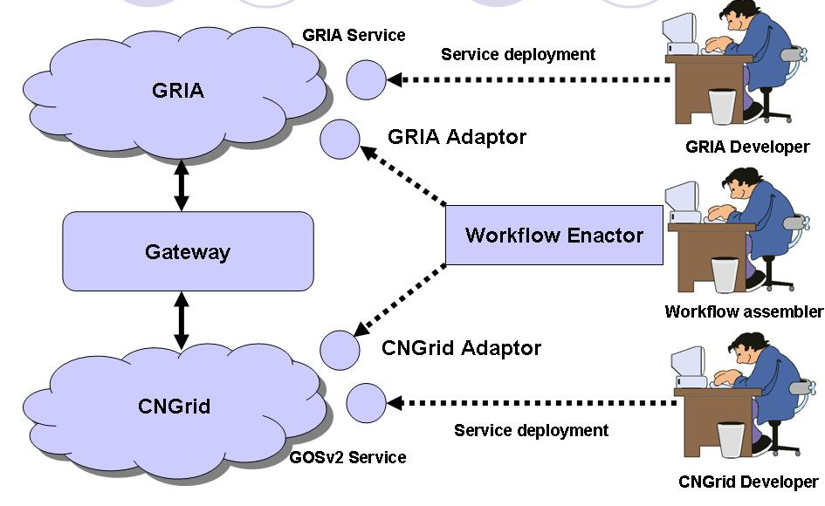
Applications scenario over interoperable Grid infrastructures

Description of work
This work package focuses on the development of interoperable Grid infrastructures (CNGrid, GRIA) supporting secure and managed distributed collaborations between Chinese and European industrial and academic communities, whilst satisfying the specific needs of the target application sectors for transparent access to Grid resources: distributed inter-domain workflows, meta-scheduling of data processing and storage tasks on different Grid infrastructures, monitoring and management of SLA, and policy management.
CNGrid and GRIA have significant similarities in the services provided for data processing and storage but important differences in their approaches to Grid management. Interoperability between will be achieved by federating services using a combination of decentralised Gateways (disparate approaches) and services based on standardised interfaces (analogous approaches), which is depicted in the figure “General approach”. There are six interoperability areas to be considered:
- process state management assigning and conveying state information associated with long running processes using contextualised web services
- data processing and storage executing computational jobs, requesting data transfer and storage
- resource and capacity management deciding how to provision service considering service providers resource constraints
- resource discovery discovering information about available resources, services and data
- meta-scheduling determining where Grid tasks should run according to user specified constraints
- policy management initiating trust relationships, managing security policies, and maintaining access rights

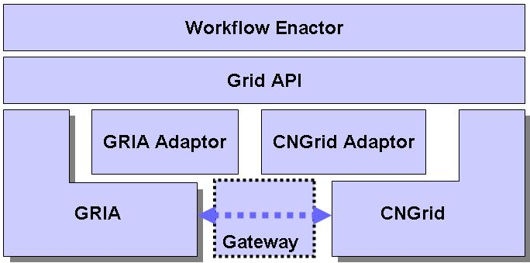

General approach to achieve interoperable Grid infrastructures

Process state management
Grid application characteristics (long running jobs and large data transfers) require mechanisms for conveying state information during message exchanges between providers and consumers. CNGrid and GRIA service providers assign identifiers to processes (GRIP, PBAC) associated with stateful resources (accounts, SLA’s, jobs and data) that are then accessed using contextualised web services. CNGrid complies with WS-I, passing session ids as service arguments, whereas GRIA uses WS-Addressing endpoint references in the message header, as defined by WSRF. In situations, such as data federation, where we decide to achieve service interoperability through adoption of agreed specifications, a common way to contextualise services will also be decided. We will also study the use of process state in GRIA and CNGrid to determine similarities in approach, benefits to individual Grid actors and potential influence on other architecture initiatives (OGSA), which do not explicitly support Grid processes.

Data processing and storage
The execution of applications and access to distributed data by workflow tools requires data processing and storage services. CNGrid and GRIA provide a file-compute execution model supporting the integration of legacy applications and various backend queuing systems (OpenPBS, Condor, LSF, and Sun GridEngine). Workflow and data processing services require the ability to federate data transfer operations between CNGrid and GRIA, minimising the need for large data transfers co-ordinated by a central actor. Considering the similarities between capabilities and availability of appropriate specifications (OGSA-DAI, OGSA-BES, JSDL, UDAP), we will investigate how data federation can be supported through the adoption of standard interfaces.

Resource management, QoS and meta-scheduling
Resource management and monitoring are the basis for QoS control, meta-scheduling, and operational management of the Grid infrastructures. GRIA and CNGrid adopt resource management and monitoring approaches appropriate to their distinct VO models. CNGrid operates a “resource sharing” VO where a Grid operator runs central services that exercise control and optimise for a community. The resource information is used by the Grid operator to understand the status of the combined services provided by many organisations. In GRIA, service providers are potentially in competition with no shared goals so participants cannot be expected to optimise for a community. Resource providers continue to manage their own resources, but in accordance with service level agreements negotiated with consumers based on a capacity model representing the offered resources (applications, information, clusters, storage).
We will investigate various approaches for interoperability between management and monitoring strategies used by GRIA and CNGrid for the purpose assigning resources and cross-domain meta-scheduling. One approach would be to deploy common services with each infrastructure that expose resource information at an appropriate level of abstraction for the management services. Another approach would be to translate resource information models (GRIA SLA, CNGrid Scheduling policy) between each infrastructure using the Gateway.
Interoperable resource information will form the basis for cross-domain meta-scheduling. The meta-scheduler will perform data processing and storage scheduling over GRIA and CNGrid services in terms of QoS. CNGrid adopts a three layer address space (EVP) for resource management and decoupling high-level services from low-level implementations. This addressing abstraction will allow users to specify logical services that are dynamically mapped to physical CNGrid or GRIA services at runtime. Service discovery is important to support meta-scheduling and workflow composition activities. A mechanism mapping service discovery in GRIA and CNGrid GOS will be provided.

Policy management
Inter-domain sharing of resources, capabilities and know-how for collaborative applications requires dynamic management user access and enforcement of organisation security policies. The challenge here is that CNGrid and GRIA implement different solutions for supporting virtual organisations (VO). CNGrid provides a persistent VO model with centralised policy enforcement services based on AGORA principles. GRIA supports business-to-business collaborations characterised by the federation of resources under user control based on e-Commerce principles. In GRIA, bi-lateral relationships are created based on negotiated service level agreements; in this case, the VO does not own resources or provide VO level management services but allows resources to be managed by the organisations that own them, according to their own interests.

Although the VO models are different, the underlying security technologies are similar, both Grids use the same web service containers, comply with the WS-I Basic Security Profile, X509 authentication credentials and use SAML security tokens for authorisation. We will provide policy management services for federation between CNGrid and GRIA based on industry specifications (WS-Trust/WS-Federation) supporting the establishment of trust relationships and exchange of security tokens that need to be presented by clients at the point of use. The benefits of this approach is that access control information can be dynamically managed by organisations according to local policies (CNGrid’s VO wide policy or GRIA’s organisation level policy) rather than relying on multiple static access control lists mapping between domains credentials and local operating system user accounts.

Achievements during the first project year
Progress during the first year in WP1 has included a successful kick-off meeting at IT Innovation and three technical deliverables, including a software prototype, that has laid the foundation for interoperability between the GOSv2.1 and GRIA 5.2 middleware as well as satisfying the interoperability requirements of the application work packages.

To achieve these results, WP1 leads a collaboration task to coordinate communication between application work package partners to ensure that interoperability requirements were fully captured. Since many partners in this project are located in China, this meant that regular communication was essential.

External concertation has also been achieved during the first year with WP1 partners attending the Grid Interoperability Now working group at OGF20 in Manchester and OGF21 in Seattle. WP1 has also contributed to an ECHOGRID workshop panel session in Beijing during November 2007. WP1 plans to attend future working group meetings and collaborate in novel interoperability strategies with other projects.

Future work in WP1 during the final year of the project will include completing a stable version of the interoperation architecture, building on feedback from application work packages. WP1’s final deliverable will document the best practises captured during the project so that we can disseminate the successes of the Bridge interoperation model to the wider community.

Technical outcome
Technical outcomes in the first year included three deliverables as set out in the DoW:
Deliverable D1.1 “Report on Interoperability Requirements and Interoperation Schemes”;
- Deliverable D1.2 “Report on Grid Infrastructure Interoperability Design”;
- Deliverable D1.3 “Prototype Implementation of Interoperable Grid Services “.

The first two captured the interoperability requirements of the application work packages and defined a multi-phase interoperability architecture for achieving transcontinental workflows between middleware supplied by WP1. In addition, these deliverables completed both Task 1.1 and Task 1.2. The third deliverable documented the prototype implementation of the first phase of the interoperation architecture.

Application work packages have now taken the first prototype implementation and have integrated it with their respective applications. Further details can be found in Deliverable D2.3 “Phase 1 Prototype – Software and Description. The technical outcome of WP1 is implementation of interoperability between CNGrid GOS and SIMDAT GRIA. In deliverable D1.2 we have described an incremental approach to interoperation between GOSv2.1 and GRIA 5.1, which is split into four phases. After the first year, we have finished the phase 1 and begin to work on phase 2.

Phase 1 Summary
The goal of Phase 1 was to implement “wrapper” mode and provide the basic components that are necessary during the interoperability between CNGrid GOS and GRIA. The end of Phase 1 was to releases a prototype that proves “wrapper” mode which can be effectively used in the interoperability scenario.

The figure shows the deployment which is based on the “wrapper” mode. We can see that the client needs only to interact with the GRIA Server. The GRIA server will convert the received requests to corresponding GOS requests.

Phase 1 Prototype Deployment
In the “wrapper” mode based deployment in Figure 4, CNGrid GOS BES Job Service is encapsulated as a normal GRIA service. The workflow or GRIA clients can interact with CNGrid GOS using GRIA Client API without any modifications.

To achieve this purpose, we mainly worked on the following two aspects:

- Data Level interoperability between GRIA and CNGrid GOS
GRIA and CNGrid GOS use different data transfer mechanisms. GRIA use “Data Stager” to provide data service, which employs HTTP (without security) and HTTPS (with security). GOS utilizes Apache open source project VFS as its core component of data transfer. It extends the interface of VFS to support different data transfer protocols, providing uniform interface to the application in the upper layer.

We have added functionalities to the GOS VFS component, providing data transfer support to GRIA data service. In order to avoid conflict with Apache VSF default HTTP data transfer module, we name the protocol supporting data transfer to GRIA as “http” and “https”. When GOS wants to communicate with GRIA, it first sends the request to its VFS component. VFS talks to the underlying protocol. When considering data transfer, security is a major issue, GRIA uses PKI to protect data, so we add HTTPS support to the VFS, solving the security problem.

The complete process of data service in Phase 1

- Batch Job Interoperability between GRIA and CNGrid GOS
GRIA and CNGrid GOS use different job processing mechanisms. GRIA uses self-defined format file to describe job to be executed with the support of GRIA Data Service, while GOS utilizes JSDL language to describe grid batch jobs, using VFS to transfer data. The main goal of WP1 is to implement job interoperation between GRIA and CNGrid GOS.

To implement batch job interoperability, GRIA uses a wrapper mode to cover the job service of GOS in phase 1. GRIA needs an adaptor in the middle to submit the job to BES service of GOS. We have developed a client API of GOS batch service, which is used by the GRIA job service. The end users submit jobs to the GRIA job service. The GRIA job service decides whether to forward the job to GOS or execute it locally. If the former case, GRIA calls GOS client API to submit the job to the GOS BES service. On request, GOS first gets data from the GRIA data service, then executes the job, finally uploads result data to the designated data stager.

The Wrapper mode based Interoperability Framework

Phase 2 Summary
Phase1 implements “wrapper” mode based GRIA/CNGrid GOS interoperability. In phase2, we will allow user to talk directly to GRIA and CNGrid GOS services. The output of one service can be used as input of the other, as depicted in the following graph:

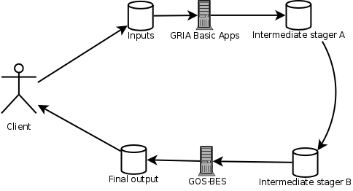

System design of Phase 2
It is normal that the output of Service A is the input of Service B. The current data interoperability solution may cause unnecessary data transfer operation which will cause many problems if large volume data need to be transferred and add unnecessary load to the GRIA/GOS interoperability Gateway.

Achievements during the second project year
Service-oriented infrastructures support global collaboration in different ways. Various incompatible management topologies, business processes, security policies and messaging structures exist. Most have evolved to meet the needs of specific sectors and adapting infrastructures to new policies and processes is a major challenge. BRIDGE focused on interoperability between GRIA and GOS middleware. GRIA is designed to support B2B collaborations through commercial service provision across organisational boundaries whereas GOS aims to support efficient management of Internet-scale access to distributed heterogeneous resources. These objectives may seem similar but the range of possible underlying technology choices for distributed workflows, planning and scheduling of data processing and storage tasks, monitoring and management of SLAs, and policy management is large.

GRIA and GOS do have significant similarities in core message level protocols and the services provided for data processing and storage but there are important differences in approaches to management of business relationships. BRIDGE achieved interoperability by federating services using a combination of adaptive client interfaces (disparate approaches) and services based on standardised interfaces (analogous approaches).
The final interoperability framework was described in D1.4 and delivered in various incremental software releases between PM15 and PM24 through close cooperation between IT Innovation, BUAA and the application partners. The lessons learnt from the BRIDGE were documented on D1.5 at PM26.

BRIDGE brought together technologists, engineers and scientists from across the globe to examine issues of collaboration and interoperability. The project demonstrated that by balancing the use of standards with adaptable service-oriented infrastructures can support global collaboration and interoperability for inter-domain Grid applications. BRIDGE’s success is only a beginning for the Internet of Services. The reliance on service-oriented systems will dramatically increase as society and the enterprise endeavour to meet the social, political, environmental and economic challenges of the next decade. Collaboration and interoperability will provide the foundation for success and BRIDGE has made an important step in that direction

There are six interoperability areas that have been research and developed by IT Innovation and BUAA:
- Task 1.3: process state management assigning and conveying state information associated with long running processes using contextualised web services
- Task 1.4: data processing and storage executing computational jobs, requesting data transfer and Storage
- Task 1.5 resource and capacity management deciding how to provision service considering service providers resource constraints
- Task 1.6: policy management initiating trust relationships, managing security policies, and maintaining access rights

Task 1.3: Grid application characteristics (long running jobs and large data transfers) require mechanisms for conveying state information during message exchanges between providers and consumers. GOS and GRIA service providers assign identifiers to processes (GRIP, PBAC) associated with stateful resources (accounts, SLA’s, jobs and data) that are then accessed using contextualised web services. CNGrid complies with WS-I, passing session ids as service arguments, whereas GRIA uses WS-Addressing endpoint references in the message header, as defined by WSRF. Interoperation was achieved using an adaptive client interface that translated identifiers in job submission requests from a common API to the necessary SOAP level messages.

Task 1.4: The execution of applications and access to distributed data by workflow tools requires data processing and storage services. GOS and GRIA provide a file-compute execution model supporting the integration of legacy applications and various backend queuing systems (OpenPBS, Condor, LSF, and Sun GridEngine). Workflow and data processing services require the ability to federate data transfer operations between GOS and GRIA, minimising the need for large data transfers co-ordinated by a central actor. We analysed relevant interoperability specifications (OGSA-DAI, OGSA-BES, JSDL, HTTPS) and capabilities implemented in both GOS and GRIA. OGSA-BES was not considered a suitable specification for interoperability as key port types were undefined. This was a view held by all major Grid vendors at a recent Grid Interoperability Now panel at OGF 21. Interoperation was achieved using a combination of specifications (JSDL, HTTPS) and adaptation for submission/monitoring/control protocols.

Task 1.5: Resource management and monitoring are the basis for QoS control, meta-scheduling, and operational management of the Grid infrastructures. GRIA and GOS adopt resource management and monitoring approaches appropriate to their distinct VO models. GOS operates a “resource sharing” VO where a Grid operator runs central services that exercise control and optimise for a community. The resource information is used by the Grid operator to understand the status of the combined services provided by many organisations. In GRIA, service providers are potentially in competition with no shared goals so participants cannot be expected to optimise for a community. Resource providers continue to manage their own resources, but in accordance with service level agreements negotiated with consumers based on a capacity model representing the offered resources (applications, information, clusters, storage). Interoperation of VO models was achieved by regarding a GOS Grid operator as a single service provider and maintaining bi-lateral relationships between consumers and Chinese providers.

Metascheduling is used to dynamically dispatch the client batch job processing request to the proper target computing resource in the runtime. Metascheduling plays a key role in integrating computing resource scattered across the Internet to form an integrated computing environment. Condor ClassAd, EGEE WMS etc are the most widely used Metascheduling mechanisms. CNGrid consists of ten different grid sites across China, and the Metascheduling mechanism is very important for choosing the proper grid site for batch job execution. And this mechanism works inside the CNGrid GOS and GOS users can choose the specified GOS node or delegate the Metascheduling mechanism to choose the proper GOS node for batch job execution. The Metascheduling mechanism in CNGrid utilizes the real-time resource status collected by the CNGrid Monitor System. The Metascheduling mechanism is used only during the batch job dispatching process. The CNGrid infrastructure is free to use for all the registered users, the scheduling is mainly based on the resource usage and its purpose is to achieve load balance. In the BRIDGE project context, the application sectors use workflow to assemble the services deployed in GOS and GRIA. End users don’t need to care about the Metascheduling mechanism used inside the CNGrid GOS.

Task 1.6: Inter-domain sharing of resources, capabilities and know-how for collaborative applications requires dynamic management of user access and enforcement of organisation security policies. The challenge was that GOS and GRIA implement different solutions for supporting policy management and enforcement in virtual organisations (VOs). GOS provides a persistent VO model with centralised policy enforcement services based on AGORA principles. GRIA supports business-to-business collaborations characterised by the federation of resources under user control based on e-Commerce principles. In GRIA, bi-lateral relationships are created based on negotiated service level agreements; in this case, the VO does not own resources or provide VO level management services but allows resources to be managed by the organisations that own them, according to their own interests. Our analysis showed that although the VO models are different, the underlying security technologies are similar, both Grids use the same Web Service containers based on Axis 1.4, comply with the WS-I Basic Security Profile, X509 authentication credentials and use SAML security tokens for authorisation. Interoperation was achieved using a combination of Web Service specifications (WS-I Basic Security Profile, WS-Trust) and an adaptive client API to execute middleware specific workflows over token services to allow consumers to obtain the necessary security tokens to permit access to services. The benefits of this approach is that access control information can be dynamically managed by organisations according to local policies (CNGrid’s VO wide policy or GRIA’s organisation level policy) rather than relying on multiple static access control lists mapping between domains credentials and local operating system user accounts.

An initial implementation of the interoperability framework was delivered at PM15 with regular updates from PM15 to PM24 based on feedback from application partners. The final Grid middleware developments from BRIDGE were integrated into GRIA 5.3.1 and released open source on www.gria.org at PM24. To help developments at the critical integration phase during Summer 2008, Yongjian Wang from BUAA visited IT Innovation for 1 month funded by the EchoGrid programme.

All lessons learnt from the BRIDGE interoperability research where documented in D1.5. In this report we tried to identify the common trends, ideas and motivations that enable us to make projections for the future and identify areas of interest for interoperability. GRIA and GOS both supported a number standards before the BRIDGE project began, and during the project support for common standards was improved to simplify the implementation of the client applications used to validate the BRIDGE infrastructure. Despite this, there were still differences between GRIA and GOS, and these were handled through the development of the BRIDGE “Adaptive API”, which provides a common interface to workflow authors at the client side. We recognised that future interoperability depends on support for the emerging Web standards, and that implementing support for all of these is not feasible unless the middlewares can be migrated to newer technology stacks that are actively maintained. We have begun the process of rebasing the GRIA code on to the Apache CXF framework, while taking care to maintain SOAP-level compatibility in order to ensure a smooth upgrade process. We believe that this approach is critical to the maintenance of large-scale distributed systems such as the Grid where components are written and maintained by different parties with their own schedules and priorities and appetite for stability or features.

Overall achievements and outlook
BRIDGE brought together technologists, engineers and scientists from across the globe to examine issues of collaboration and interoperability. IT Innovation and BUAA have together been able to deliver a powerful and consistent infrastructure which has allowed the BRIDGE application partners to collaborate effectively in running integrated application workflows that utilise Grid resources across Europe and China. The project demonstrated that by balancing the use of standards with adaptability service-oriented infrastructures can support global collaboration and interoperability for inter-domain Grid applications. BRIDGE’s success is only a beginning for the emerging Internet of Services. The reliance on service-oriented systems will dramatically increase as society and the enterprise endeavour to meet the social, political, environmental and economic challenges of the next decade. Collaboration and interoperability will provide the foundation for success and BRIDGE has made an important step in that direction.

  - WP2: Aerospace Activity

Objectives
The objectives of WP 2 were detailed in the initial DoW:
The aims of the Aerospace Applications work package is to set-up and demonstrate in operation a distributed workflow for optimization that includes at least two simulation modules. A total of five GRID Service will be developed and set-up during the course of the project. Each Service will be located and compute on different sites, three of the Services being located in the EU, while two Services being located in China. The Acoustic Simulation Service is delivered by EADS. The Aeroelastic Simulation Service is delivered by AVIC-II. Each service executes on computing platforms owned and operated by EADS and AVIC-II respectively. The Workflow Service and the Design of Experiment Service is provided by LMS. The Workflow Service allows for the encapsulation of the computational workflow and the execution of the workflow in a distributed environment. The Design of Experiment Service provides the means for generating the multiple design alternatives in providing the Meta-Modelling Service with data. The Meta-Modelling Service provides a high fidelity condensed representation of the analysis model as defined by the workflow. The Meta-Modelling Service is provided by FhG-SCAI. The Meta-Modelling Service contains a distributed computation schema, running on the FhG-SCAI computer clusters. The Optimization Service will be provided by AVIC II and Beihang University. The Optimization Service will operate on the Meta-Model modules provided by FhG-SCAI, and execute at FhG-SCAI computer clusters. Each of the partners brings unique know-how for the corresponding service. In completing the workflow, each of the Simulation Service will be equipped with its own Meshing Service. The necessity for this arises from the need that each Simulation Service requires specific mesh representation. The specific mesh representation contains Intellectual Property [IP] that has to remain the property of the Simulation Service providers.

The above will be demonstrated with the use of a modified aeroplane wing, for the purposes of the project and in allowing complete disclosure of the geometry to all consortium members. The initial geometry will be supplied by AVIC-II and will be distributed to the Simulation Services as IGES, or STEP files.

The GRID enabling of all elements will be with the utilization of GRIA as middleware. An examination of the utilization of two separate GRID middleware infrastructures, one provided by GRIA and one provided by CNGRID will also be carried out during the project and conclusions either on the success or requirements for making such a schema successful will be delivered.

The following figure provides an early view of the Simulation Services along with the topology of the overall implementation and workflow execution scheme.

Schematic GRID Enabled Implementation

Description of work
The target is to set up a distributed workflow for optimization, which includes simulation modules from EADS and AVIC II on a more generic test case. The EADS modules would be executed on EADS platforms, the AVIC II modules on their platform. For the description of the workflow OPTIMUS from LMS would be used. LMS responsibility (together with their Chinese office) would be also to get the prototype running. FhG-SCAI would contribute the Meta modelling components and modules for the distributed computation of Meta modules. The scenarios would be the primary test case for the development on the basis infrastructures.

The following tasks will be carried out during the project.

Definition of the overarching workflow (optimization workflow), and application scenario (inputs, outputs, overall workflow, definition of optimization scenario)

The aerospace product development business is becoming rapidly a “globalized” business with partners spanning the globe (example Boeing and the risk-sharing-partnerships). Industrial partners are more and more involved in multiple projects that involve the collaboration of multiple entities, usually not connected through the same company structure, but supplying each other with specific services. Depending on the consortia, they may be simultaneously partners and/or competitors. This dual role has to be specifically addressed by the simulation middleware and infrastructure in order to protect its IPR. In this Work-Package the BRIDGE consortium members will set up and demonstrate a clear case that provides a concrete example on how the GRID is enabling this collaboration while protecting the IP of each contributing member. The common input will be the geometry definition of an aerospace structure. The Simulation scenario will be captured by an overarching Workflow tool that utilizes GRIA enabled Simulation Services. Geometry modifications will be made according to the needs of an optimization scenario that will optimize several Acoustic and Aeroelasticity functional performance of the aerospace structure. The Optimization will be performed based on Meta-Models in order to accelerate the optimization process.

Definition of the Analysis Services
The Workflow Service will allow for the definition of a GRIA Service enabled Workflow that captures and federates the Simulation Services to complete the optimization task. It will provide for the execution of the workflow in a distributed manner on the individual compute-infrastructure of EADS and AVIC-II. It will further encapsulate the FhG-SCAI Meta-Modelling Service and the Optimization Service provided by AVIC II.

The acoustic service is made of the following components:
- a meshing component (optional)
  - inputs: geometry (IGES, STEP), meshing constraints
  - output: surface mesh
- a pre-processing tool
  - inputs: surface mesh
  - output: degrees of freedom (dof)
- the acoustic solver
  - inputs: geometry definitions, boundary conditions
  - output: raw result on the surface
- post-processing tool
  - inputs: far/near field geometry location, raw result
  - output: expected physical result (pressure, noise level)

Steps 2, 3 & 4 when linked together can be seen as the acoustic service.

Steps 1 & 3 provide great added value in the process. The meshing component is able to generate very large meshes (>100 M cells) while the acoustic solver is able to solve such computationally intensive problems thanks to the multipole method.

In similar manner an Aero-elastic Simulation Service will be provided by AVIC-II. This service will provide the means for the qualification of the aerospace structure in terms of aero-elastic attributes.

The aero-elastic program is HAJIF-II developed by China Aviation Industry and it has been used in some aircraft development. It will provide the aero-elastic service in this project.
The aero-elastic service is made of the following components:
- a structure meshing function
- geometry definition
- meshing constraints (boundary condition)
- element and material properties
- a aerodynamic surface panel mesh input
  - surface panel mesh
- the aircraft flight parameter inputs
  - flight condition parameters (high, temperature speed etc.)
  - the analysis goal (flutter or static aero-elastic analysis)
- results output
  - aero-elastic results
  - the structure vibration model

The Design of Experiment Service allows for the automatic generation of several design alternatives based on statistical methodologies. The characteristic is the ability to intelligently scan the design space with the least possible number of design alternatives while providing the maximum of information. The DOE Service in conjunction with the Meta-Modelling Service allow for the definition of quick to evaluate mechanisms to be utilized by the Optimization Service. The ability to define and iterate on the creation of the Meta-Models based on each individual Simulation Service is one of the clear innovations of the proposed approach.

The Optimization Service is highlighted in the schematic below. The evaluation of the Aero-elastic Simulation Service or Acoustic Simulation Service will be made as specified above through the utilization of the FhG-SCAI provided Meta-Modelling Service. The system will run on Grid platform, which is supported by several clusters in deferent locations. The basis of the Optimization Service is a Genetic Algorithm that utilizes and internal Meta-Modelling mechanism to accelerate the convergence and reduce the number of needed evaluations.

Optimization Service Description

Implementation of GRID Enabled Analysis Services
A GRIA enabled Workflow encapsulation and execution framework as provided by extensions to the commercially available OPTIMUS software will be made under this project. With this we will be able to both capture and execute Simulation based workflows that contain the Acoustic and Aero-elastic Simulation Services as well as integrate the Optimization and Meta-Modelling Services. GRIA is used as the enabling GRID Middleware.

The surface meshes for the acoustic and aero-elastic simulation service as well as the acoustic and aeroelastic simulation services will be grid enabled thanks to the GRIA middleware.

Beihang University has developed a LSF function GRID to support the Genetic Algorithm Optimization system to support the paralleled computation. Beyond a GRIA enabled Optimization Service will be implemented

Implementation of GRID enabled Analysis level workflow and Overarching Optimization Workflow
An extend version of OPTIMUS from LMS will be used to encompass the task of integrating the complete workflow under a consistent framework. OPTIMUS will also be used as the main mechanisms for the execution of the workflow in an optimization loop. OPTIMUS is a generic Workflow definition, capture and federation tool, allowing the creation of “simulation” based workflows along with Workflow execution mechanisms. The extensions to be performed under the auspices of the BRODGE project involve the complete enabling of GRID Services based workflows and the extensions necessary to integrate the AVIC-II and Beihang developed optimization methodology.

The following table analyzes the potential risks and contingencies regarding WP2

Risk | Level | Contingencies
Difficulties in setting-up the overarching workflow involving the international cooperation and services provided by multiple partners | Med | Define multiple levels and interconnect in intermediate levels. Understand and contain any potential IT related pitfalls
Deficiencies in interconnecting multiple GRID Middleware driven/wrapped applications | Med | Close collaboration amongst partners and WP1 team.
Availability of performing GRID Infrastructure in sufficient time frame | Low | Close collaboration with WP1 for avoidance of interoperability

The following table defines the relation to SIMDAT and lists the synergies and dependencies, so as to define how redundancies are avoided.
SIMDAT Topic | Synergies | Dependencies
GRID Enablement of Workflow and DOE Service (as in OPTIMUS) | Common architecture with BRIDGE in concerning GRIA developments | Completed in SIMDAT PM24 (before the start of BRIDGE) (no risk)
Acoustic Analysis Service | Common utilization of the service | In service already within SIMDAT Aerospace Activity (no risk)
Overall sharing of know-how and standardization efforts | Common participation in SIMDAT and BRIDGE | No risk

In order to define the starting point for thee research of the WP2 project activity, the following table defines the pre-existing software.

Software | Main characteristics
Workflow definition and enactor service and DOE service (OPTIMUS) (Provided by LMS) | GRID (GRIA) enabled Workflow definition and enactor  Web Service Enabled Design of Experiment (DOE) Engine
Acoustic Analysis Service (Provided by EADS) | GRID Enabled Acoustic Simulation Service
Aero-Elastic Service (Provided by AVIC-II) | GRID Enabled Aeroelastic Simulation Service
Meta-Modelling Service (Provided by FhG-SCAI) | Response Surface Meta-Modelling Service  To be used in conjunction with the DOE service
Optimization Service (GAO) (Provided by Beihang University) | Numerical Optimization Service to be used in conjunction with the Meta-Modelling Service

Achievements during the first project year
Work has progressed according to the plan demonstrated by the delivery of the PM12 WP2-Prototype software. The first Prototype has met the expectations and goals set in the BRIDGE DoW. Main activities during the first 12 months of the project concentrated on:
- the set-up of the aerospace activity with the specification of the Aerospace Scenario,
- the definition of the tasks and actors in detail as carried out during the first 12 months of the project,
- the definition of the timeline and related activities to Milestone 2.1 with the delivery of the Aerospace Simulation Services delivery,
- the definition of the timeline to Milestone-2.2 at PM12 with a working prototype,
- installation, first level training and deployment of the Workflow tool OPTIMUS at AVIC-II and BUAA (July 2007),
- the definition and implementation of the relevant and necessary analysis services for inclusion of the overall Aerospace Scenario Workflow,
- four on-site working group technical meetings between AVIC-II, BUAA and LMS in May 2007, July 2007, August 2007, and in November 2007,
- two overall WP2 team members face to face meetings (kick-off meeting (UK), 6 months update meeting (Beijing)),
- the delivery of the PM12 First Aerospace Prototype software implementation.

A risk assessment has been completed and followed in detail in order to minimize any risks associated with the delivery of the final prototype. The activities are focused in the area of the completion of the integration of the defined analysis services, the extension of the aerospace workflow to operate across the multiple locations (Belgium, China, France, and Germany) and the fine tuning of the execution scheme.

Technical outcome
During the first twelve months of the project the technical outcome consists of the complete definition of the prototype subject, the prototype geography, the GRID interoperability schemas, and the technical means necessary to achieve it. GRID-infrastructure and interoperability requirements have been determined and coordinated with the WP1 work-package.

The technical outcome of WP2 is integration of several geographically distributed services using Optimus provided by LMS Ltd to form an aircraft optimization tool.

Prototype Implementation
The next figure presents the basic system architecture of our prototype system. It is based on the Phase 1 release of WP1 to implement GRIA/GOS interoperability, so the LMS Optimus interacts only with GRIA and knows nothing about CNGrid GOS.

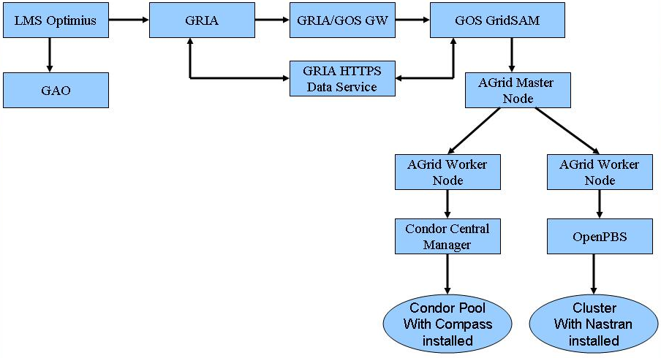
Basic System Architecture of the AeroPrototype

The basic system architecture consists of mainly six components:

- LMS Optimus and GAO:
- LMS Optimus is a workflow engine and used to drive the aerospace process;
- GAO is the algorithm used in WP2.
- GRIA,GRIA/GOS GW:
- A full installation of GRIAv5.2;
- GRIA/GOS GW is WP1 Phase 1’s release.
- GOS GridSAM:
- Extends GOS GridSAM’s plug-in mechanism and provides a web service job manager which is used to interact with AGrid master Node;
- AGrid Master Node
- AGrid Master Node is in charge of parsing client request, and downloading/uploading data files;
- Schedules client request to proper AGrid Worker Node.
- AGrid Worker Node for Condor
- Some applications in WP2 can only run in Windows environment such as Compass. In order to integrate the Windows-based software, we have set up a condor pool composed of machines from BUAA’s lab; The AGrid Worker Node can receive job process requests from the master node, submits jobs to the condor pool, monitors job status and uploads result file to target locations.
- AGrid Worker Node for OpenPBS
- Some applications in WP2 can run in Linux environment such as Nastran. The AGrid Worker Node can receive job process requests from the master node, submits jobs to OpenPBS, monitors job status and uploads result file to target locations.

Experimental Environment Set up
The Aerospace Application has set up an experimental environment to test the functionalities of our prototype. Figure 9 presents the machines involved in this experimental environment.
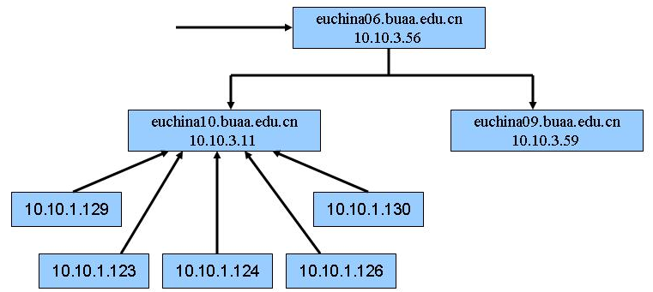
Experimental Environment Set up

The next table details the machines used in Experimental Environment
IP Address | OS | Components installed | Location
euchina06.buaa.edu.cn  10.10.3.56 | Linux Scentific4.0.8 | GRIA, GRIA/GOS GW, GOS GridSAM,  AGrid Master Node | Beihang University, Beijing, China
euchina10.buaa.edu.cn  10.10.3.11 | Linux Scientific 4.0.8 | AGrid Worker Node for Condor Pool | Beihang University, Beijing, China
euchina09.buaa.edu.cn  10.10.3.59 | Linux Scientific 4.0.8 | AGrid Worker Node for OpenPBS, Nastran | Beihang University, Beijing, China
10.10.1.123 | Windows XP sp2 | Condor node, Compass | Beihang University, Beijing, China
10.10.1.124 | Windows XP sp2 | Condor node, Compass | Beihang University, Beijing, China
10.10.1.126 | Windows 2003 | Condor node, Compass | Beihang University, Beijing, China
10.10.1.129 | Windows XP sp2 | Condor node, Compass | Beihang University, Beijing, China
10.10.1.130 | Windows XP sp2 | Condor node, Compass | Beihang University, Beijing, China

LMS’s achievements during the first project year
LMS is the work-package leader. LMS together with the AVIC-II have worked over the first twelve months of the project to define the prototype and to identify the overall architecture, specifications and technology needs (first six months), and the mostly focused on the implementation of the prototype during the second six months of the first twelve month period. LMS has held a total of four on-site meeting at AVIC-II (China) to detail the prototype, and complete the implementation of the first prototype.

LMS has worked on researching and developing the methods to enable OPTIMUS to work with GRIA and in creating the initial infrastructure and in supporting GOS as the GRID middleware software.

OPTIMUS has been provided and installed at AVIC-II and BUAA, and complete on-site training on the utilization is conducted in early July.

LMS presented Bridge in the Symposium on Grids in Science and Business, Gent, Belgium, June 12, 2007.

FhG/SCAI-NUSO’s achievements during the first project year
FhG/SCAI-NUSO has implemented a batch version of its metamodelling software DesParO, including major additional developments and innovations like an automatic refinement of the model and the interpolation of large amounts of CFD data. The basic batch program is provided as a GRIA service to the Bridge partners.

Metamodelling is a means to conduct or support the simultaneous optimization of several criteria in a very fast manner. To achieve this goal, numerical simulations like e.g. aerodynamics or acoustic simulations are considered as a mapping of design parameters to optimization criteria. In the case of the overall aerospace design scenario parameters mainly describe the wing position, while criteria are certain values obtained from the acoustic and aeroelastic simulations. Such mappings from parameter to criterion space are usually smooth and thus can be very efficiently interpolated from discrete values that have been obtained from time-consuming simulations. Once the surrogate model has been constructed, it can be evaluated for new sets of parameters interactively. Predictions as to optimum values can then be made within seconds, whereas the numerical simulations would maybe have taken weeks to calculate. Only this enables the optimization to be conducted within a realistic timeframe. For any evaluated criterion a robust tolerance can be estimated, so that the user has a quality prediction, i.e. an envelope, at hand.

Metamodelling has been provided as batch software for Bridge, thus transferring the expert experience FhG/SCAI-NUSO has obtained within this area. FhG/SCAI-NUSO has also provided this batch version as a GRIA service to all Bridge partners, running on hardware at FhG/SCAI. The service consists of two sub-services. The first sub-service allows for metamodel creation from parameter and criterion sets and outputs a metamodel to be evaluated by the user through the second sub-service. This allows a seamless integration into the workflow definition for the overall aerospace scenario of the Bridge project and thus contributes to the design of experiments. Input and output has been defined by FhG/SCAI-NUSO and communicated to all involved partners.

To support the genetic algorithm that carries out the overall optimization, an addition has been implemented that uses the tolerance estimation conveyed together with criterion evaluation to automatically suggest simulation runs that would refine the metamodel. This addition will assure the accuracy of all metamodel predictions and thus assure the validity of metamodelling for the given scenario.

During the last quarter of 2007 it has become apparent that the aerospace scenario would strongly benefit from a certain further use that metamodelling can provide. Metamodelling can be used to interpolate between several files of bulky FEM data as recent research at FhG/SCAI-NUSO suggests. Since the most time-consuming calculation in the aerospace scenario are aerodynamics simulations, FhG/SCAI-NUSO has agreed to additionally develop an interpolation specifically targeted at the large amounts of CFD data resulting from these costly computations. Originally, only the criteria resulting from the acoustic service should have been supported by metamodelling. FhG/SCAI-NUSO has therefore extended metamodelling for the interpolation of large amounts of CFD data, defined an input and output format for these data, and created the respective batch tools. CFD data has to be provided to the extended version of metamodelling via an additional binary file. Number of nodes and geometric connectivity may not change between different aerodynamic simulations. This extension, though already implemented by the end of 2007, has not yet been provided as a GRIA service.

Deviations
Due to the major change of requirements discussed in the above paragraph, additional development has been conducted by FhG/SCAI-NUSO. All necessary extensions have been completed, but not yet provided to the Bridge partners as a GRIA service.

EADS’s achievements during the first project year
EADS has participated in the definition of the prototype. EADS has made progress according to the plan on creating the acoustic GRID Service.

Beihang University’s achievements during the first project year
Beihang University has played a determinant role in the definition of the prototype along with AVIC-II and LMS. This work has resulted in the complete definition of the prototype in terms of topology, geographic definition and complete detailed technical description. Beihang University has worked according to the plan in developing the necessary infrastructure to support the prototype.

During the first year of Bridge project, Beihang team collaborates closely with AVIC-II to work on the aerospace activities. The work can be categorized into two different kinds:
- Work together with AVICII to fulfil the WP2 requirements
- Analyse application requirements;
- Design prototype system;
- Development, test the prototype system.

Experimental Environment Set up
- Aerospace set up experimental environment for WP2 applications.

Other Activities during the first year include:
- Regular Face-to-Face Conferences with AVIC-II
- Five Face-to-Face conferences are held during the past year;
- During development phase, we work closely with Prof. Degang Cui and Mr. Chen Wenyuan from ACVIC-II.
- Participation of the first project workshop held in Beijing in the October
- Helped to prepare the present slides;
- Helped to prepare the demonstration.

AVIC II STC’s achievements during the first project year
The activity of AVIC II STC in the first 12 month is the following:

Activities of AVIC II STC in the first 12 month:
- Developed the optimization concept and detail design for aeronautical application based on the Bridge DoW;
- Developed the CATIA geometry model for the wing and body of a passenger aircraft. Created the aerodynamic analysis model and aeroelastic analysis model based the CATIA model;
- Improved the Genetic Optimization Algorithm (GOA) system to run in CNGrid with multi-clusters service.
- Integration of the LMS workflow management system with GOA and deployed application services in Beijing on two clusters;
- Testing the pilot application on two clusters of AVIC II STC and BUAA.
Progress of AVIC II STC in the First 12 Month:
- Definition of the aeronautical application;
- Creating the geometry and analysis models;
- Improving the GAO services and aeroelastic services;
- Integration of GAO with LMS workflow management system;
- Testing the pilot application in multi-cluster environment in China.

Achievements during the second project year
Given the objectives of the aerospace scenario in the DOW, the activities carried out during the second project year to reach and, in some cases, exceed the objectives set in the description of work have been split in two different phases. In the first phase, demonstrated during the first review meeting, the aerospace scenario has achieved the implementation of analysis services based on Grid technologies as supplied by GRIA and CNGrid/GOS and has been described in the D2.2 document. The interoperability schemas developed in WP1 have been deployed in the Phase I prototype and described in the D2.3 document to achieve the needs of the overall optimization workflow. In the second phase, the prototype integrated five out of seven Analysis Services for optimization purposes and executed the genetic optimization procedure. The aerospace Phase II prototype used the results of the Phase I prototype to generate the meta-modeling services and the extended workflow definitions to accomplish GRID interoperability and deployment across the EU and China.

Another important achievement of the WP2 aerospace scenario has been the cooperation between different aerospace partners across the globe, allowing the fruitful exchange of information and technology to enable interoperability of analysis services and specific aspects of the aerospace analyses. In particular, the three dissemination and exploitation meeting held in China and the technology cooperation between the partners (e.g. LMS and EADS, SCAI and AVIC) have contributed to the successful achievement of the WP objectives and the realization of the aerospace prototype. This prototype effectively represents a complex aerospace scenario that can be addressed by taking advantage of the BRIDGE technologies.
Thus, during the second year of the BRIDGE project, the Aerospace applications workpackage has focused on the completion of the workflow to include five of the seven analysis services developed (as described in D2.3 and D2.4) and has aligned the development to the new GRID Interoperability schemas developed in WP1. This constitutes an effective communication, computational and testbed framework that has demonstrated to be effective in addressing complex aerospace simulation problems and to solve them efficiently over cross-continental GRID networks, especially between Europe and China.

LMS’ achievements during the second project year
Within the current reporting period, LMS has managed the work package activities and contributed to the topics of the WP2 application by cooperating with Beihang University for the workflow integration. Also, a considerable effort has been spent to cooperate with all the WP2 partners to identify, understand and assess the difficulties related to the Phase 2 prototype. LMS has driven the process to create a recovery plan in order to reach the objectives described in the DOW and achieve the successful deployment of the aerospace prototype.
Four persons from LMS have been involved in the activities of the BRIDGE project: Nick Tzannetakis, Joost Van de Peer, Roberto d'Ippolito and Jiyun Jiang.

The major contribution of LMS in the aerospace WP has been on the workflow service to integrate the simulation services developed and allow the execution of the genetic optimization process. The simulation services participate collaboratively in the overall aerospace design process and the big challenge addressed in this scenario lied in the multiple level optimization design that is driven by the genetic algorithm. This structure is more complex than traditional optimization design and has required a substantial modification of the LMS OPTIMUS framework to include multi-level workflows and the integration of the different analysis services. This multi-level workflow is illustrated in the figure below.
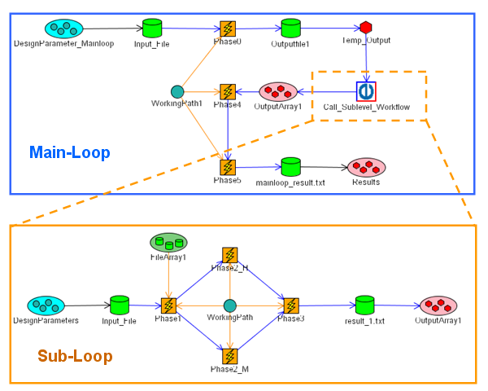
Multiple Level OPTIMUS Workflow

As shown in the figure, OPTIMUS provided the main mechanisms for the execution of the grid-enabled workflow in the optimization loops. With specific extensions of OPTIMUS to its workflow definition, capture and federation features, the creation of “simulation” based workflows for the BRIDGE project was made possible. OPTIMUS executed the workflow in a distributed manner on the individual grid infrastructure of China and Europe, integrating the aerodynamic service, aeroelastic service, acoustic service, Meta-Modeling service and genetic algorithm optimizer to form the complete optimization application.

FhG/SCAI-NUSO’s achievements during the second project year
As stated in the Annex I the role of FhG SCAI was to provide the Meta model Grid service for integration into the overall optimisation workflow covering services from China and Europe. FhG SCAI has contributed to all tasks and deliverables of WP2 as planned.

A meta-model (surrogate model) has been built from the data computed at EADS. This meta-model allows to reduce the computing times for the very expensive Acoustic Analysis in the optimization workflow. Fraunhofer SCAI was involved in the full computational chain for acoustics from the very beginning to ensure all requirements would be met that are necessary for a meta-model to approximate the computations with good quality.

Fraunhofer SCAI cooperated closely with all workpackage partners to determine an appropriate parameterization of the problem and suggested a design of experiments of which the meta-model construction would benefit. Outliers of the acoustics data were removed by threshold, and meta-model construction as well as evaluation procedures were implemented as services on SCAI hardware using the interoperable service-architecture provided by WP 1. Additional services offer a possible automatic assistance to generate input data to improve the model if necessary.

The services also provide additional error bounds are given so that the uncertainty of the approximation (due to scatter and sparse distribution of the experiments) can be quantified.

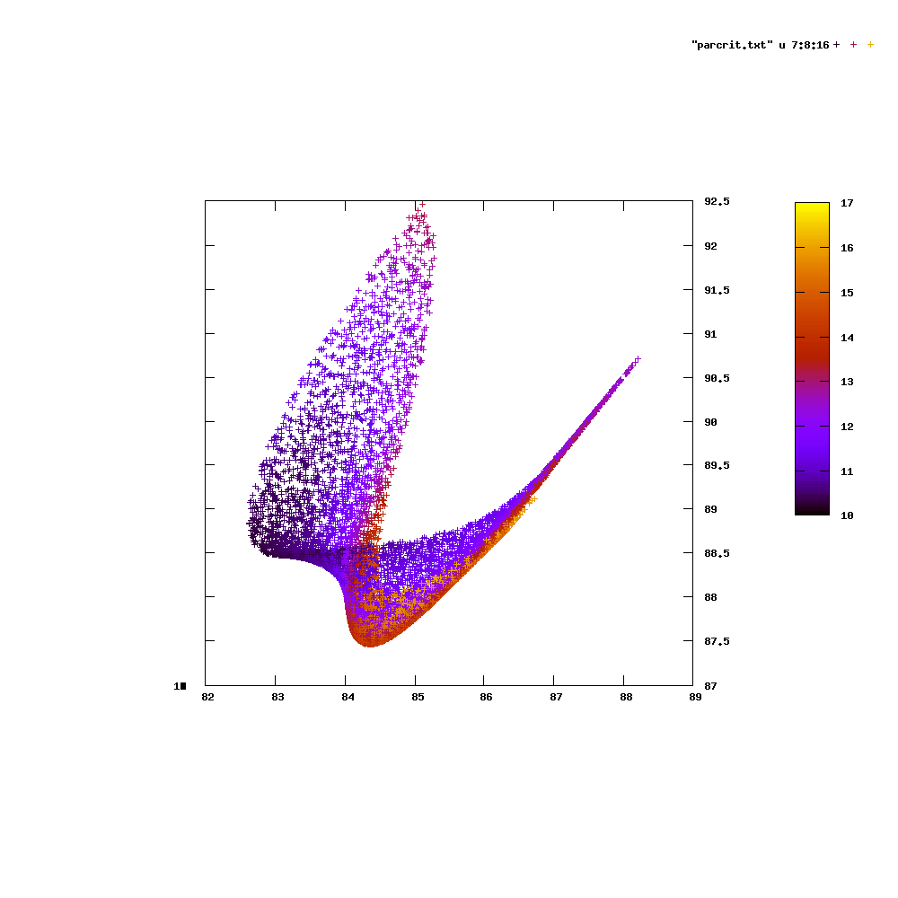
Two noise levels (horizontal and vertical axis) that are obtained by varying two positional parameters, all other parameters and the frequency fixed, uncertainty indicated by colour

The work performed matches the objectives and targets of WP2. The work of FhG SCAI required much more effort than originally planned due to the scatter of the acoustic results in initial phases of the project.

Deviations at SCAI NuSo:
In the context of the development work it turned out, that the numerical simulations for the aerospace example had to be repeated several times. The reason was, that the original results showed a lot of scatter. These problems caused a delay of the respective deliverable and an extension of the project for WP2. It also caused a lot of additional work in repeated generation of the metamodels, additional trips to China and a lot of discussions on phone, in order to find an appropriate solution. Finally all issues could be solved.

EADS’ achievements during the second project year
Planned Objectives
- To build an acoustic service for the aerospace workflow.
- Develop a simulation to serve in building an acoustic response model to support the execution of a workflow based on the aerospace (WP2) use case.

Building an Acoustic Service
This activity is primarily an internal activity carried out within EADS. The steps taken to build the acoustic services are as follows:
- Writing program scripts to tie together various software modules and perform data translation between the software modules within the acoustic simulation workflow.
- Coordinate with EADS staff to prepare compute clusters to run the acoustics simulation.
- Deploy a GRIA service to wrap the execution of the acoustic simulation.
- Provide BUAA/AVIC a testcase to execute the acoustic service remotely.

Building an Acoustic Response Model
The activity is part of an effort to develop a simulation platform to perform multi-disciplinary optimization to find the best wing configuration(s) during an aircraft landing procedure. Part of the workflow involves building an acoustic model to find the noise response for any given wing configuration. The general steps for building model is as follows:
- To generate flow fields from unsteady CFD simulation.
This part of the work is carried out by BUAA/AVIC.

- Generation acoustics source (monopole/dipole) data from CFD flow fields.
This part consists of two software modules that had to be built from scratch as a collaborative effort between EADS and BUAA/AVIC. The first module performs some mathematical operations to transform the aerodynamic flow field into acoustic sources using the Lighthill equation and its corresponding Lighthill tensor. Initial discussions on this activity took place in conjunction with the BRIDGE review meeting held in March 2008. Through several iterations, which included discussions on defining the data formats of acoustic data, validation of calculations, this module was completed in July 2008.

The second part is the FFT module which transforms acoustic sources in varying in space-time, deriving the acoustic source terms in space over a range of frequencies. This work was done over a period of one month and was completed in July 2008.

- Acoustic analysis
The acoustic analysis module generates the noise response for different wing configurations supplied by AVIC. Several simulation runs were carried for different aircraft wing geometry configurations and acoustics frequencies.

One major challenge faced in this part large amount of computing resources to produce the acoustic results within a reasonable timeframe. Each simulation for a given frequency and aircraft wing geometry configuration will take about 3 hours to complete on a 32-node cluster. The computing resources required to run the simulation were provided by both EADS (32 nodes) and SCAI (16 nodes). A total 7 months, from July to January 2008, was required generate the acoustics noise datasets. This included re-launching the various simulation modules when modifications to the newly implemented software modules had to be made due to errors in the acoustics source dataset as well as errors in the CFD results. An additional challenge was the download time required to transfer the data files from BUAA//AVIC partners to EADS partners. Since the size of CFD datasets are significantly larger than the acoustic sources datasets, the latter were generated from BUAA/AVIC compute farm. This cooperation had significantly improved productivity between the various partners due to time saved on data transfers.

- Post Analysis
The work done is this section was a collaborative effort with SCAI and LMS. The results of the acoustics noise were summarized and compiled into an excel file before disseminating the results to the entire work package partners for review. A key issue that emerged from this activity part was to find the right method to convert the acoustics noise results into sound pressure levels (SPL). After several rounds of conference calls, the formula for calculating the SPL was finally agreed upon by all partners. The initial results showed unreasonably high SPL values for several wing configurations. The action taken on this problem was to rerun the acoustics simulation for 40 wing configurations on one frequency index. This necessitated the acoustic analysis redone as well. The final results were then used by SCAI to generate the acoustic response model.

Beihang University’s achievements during the second project year
Beihang University is in charge of the following actions in WP2, and also contribute to all the tasks and Deliverables of WP2 as planned.
- Provide the network connectivity link between China and European
- Support the HAJIF-II program which can only run in the Windows platform by the Condor pool
- Maintain a grid computing environment for HAJIF-II service to support the optimization
- Integrate with the OPTIMUS engine provided by the LMS to run the distributed optimization process.

T2 is the special network link between China and European which is provided by CERNET NIC, Tsinghua University and used for scientific research. We have applied for a one year free usage during the runtime of the BRIDGE project. This network link can be used until end of September 2009.

CNGrid Grid environment consists of Linux-based high performance machine, but the HAJIF-II program can only run on a Windows platform. Condor pool is used to support the HAJIFF-II program. We set up two Condor pools in China, one in Beihang University and the other in CVIC-II STC. The Condor pool in Beihang University consists of about 40 Windows-based computing nodes which are virtualized by Xen hypervisor in a Linux machine. The Condor pool in Beihang University has run stable for half a year since October 2008, and 300, 000 HAJIF-II jobs have been preceded.

Beihang University is in charge of maintaining a Grid computing environment to support the HAJIF-II service, and also support the adaptive client API with the help of WP1.

The OPTIMUS engine is deployed at Beihang University and used to drive the overall optimization process and the services involved including the meta-model service at FhG SCAI, Germany, and the HAJIF-II service in China. The acoustic service provided by EADS is computed in the off-line mode and the results are used to train the meta-model service. The meta-model service is used in the on-line mode as a replacement of the acoustic service. The overall optimization has been run for about five times since October, 2008.

AVIC II STC’s achievements during the second project year
The contribution of AVIC II STC can be outlined as follows:
- AVIC II STC has proposed the scenario for the Aerospace Application of WP2 and provided all the necessary details of a representative aircraft wing model.
- AVIC II STC has developed an automatic model generator to create the FEM model and Aerodynamic model, each following the wing flap position modified based on the design of experiment for the meta-model creation.
- AVIC II STC has developed an unsteady aerodynamic CFD analysis software to provide the flow pressure field for EADS aero acoustic analysis. This activity as exceeded the objectives set in the DOW and has constituted a major effort of AVIC II STC towards the accomplishment of WP2 objectives originally planned. In fact, the development of the unsteady aerodynamic CFD software has been an unforeseen but essential link to the acoustic software for EADS.
- AVIC II STC has also provided WP2 wing optimization using Genetic Algorithm Optimisation and NNA, which is developed in house and has been based on the following service running in GRIA/GOS platform:
  - Optimus
  - Meta-model
  - HAJIF II

AVIC II STC has also run the optimisation procedure, driven by the genetic algorithm and executed by the LMS multilevel workflow service. The optimisation results have reached the expected results by reducing the wing flap noise to 0.7 db and by increasing the lift of 0.035 compared with the original positions and angles of the flaps.
Details of the functionalities and the results of the genetic optimisation process are described in D2.4.

As a result of the activities done by AVIC II STC in WP2, the following items have been delivered to the BRDIGE consortium:
- automatic model generator
- unsteady aerodynamic analysis software
- update of the Genetic Algorithm Optimisation and NNA to get more functions, running in GRAI/GOS platform

Overall deviations for WP2 achievements during the second project year
With respect to the original planning for BRIDGE WP2, many unforeseen issues have raised since the last review meeting in Leuven. In particular:
- A more detailed investigation of the aeroacoustic computation requirements unveiled the necessity to compute unsteady computational fluidodynamics before the actual aeroacoustic computations. This required more time both to setup an appropriate CFD solver and to run the computations.
- As a consequence, the necessary steps to build meta-model A, to be used in the genetic optimisation loop, were delayed due to the technical problems raised to address the more complex CFD computations.
- An analysis of the preliminary aeroacoustic results obtained showed some possible inconsistencies in the acoustic response. In particular, some flap configurations part of the design of experiment planned for the creation of the meta model, showed very different acoustic responses although being very similar geometrically. This required more time to investigate the root causes of these differences.
In order to solve all the above mentioned aspects, more time than expected was needed. During numerous telcos held between WP2 partners in the period between September and November 2008, a solution strategy has been elaborated to complete the whole process in the shortest time possible. This strategy (recovery plan) had been formalized into a roadmap that allowed the completion of the planned activities with some delay with respect to the original schedule. In particular, due to the computational time needed and the necessary preparation, an extension of 2 months for WP2 has been asked. This extended time allowed the proper convergence of all the necessary results, the completion of the optimisation processes and the preparation of the planned deliverables for this work package with the inclusion of the final results.

Overall achievements and outlook
During the second project year, there have been three research areas addressed during the implementation of the aerospace scenario based on the computational infrastructure developed in WP1. These are:
- Task 2.4: Implementation of GRID enabled Analysis level workflow and Overarching Optimization Workflow
- Task 2.5: Prototype refinement and documentation
- Task 2.6: Results exploitation
Task 2.4: In this task the orchestration of the services developed in the previous period in task 2.3 has been put in action with the completion and deployment of the multilevel workflow to drive the analysis and optimisation of the aerospace application scenario testcase. The OPTIMUS toolkit from LMS has been extended to support multi level workflows, necessary for the completion of the this task, and has been used to integrate the different analysis services under a consistent framework. This task has been successfully completed by deploying and executing the Phase II workflow, as described in more details in deliverable D2.4. The research challenges faced in this aspect relate to the smooth execution and the integration of the analysis services across international boundaries and multiple execution clusters. This has involved the interoperability of the developed Analysis Services with two separate GRID infrastructures (GRIA and CNGRID). For this task, the successful coordination of two separate GRID infrastructures has been achieved and constitutes the major result for this activity.
Task 2.5: This task addresses the finalization of the application prototype developed in Task 2.4 to accommodate any changes necessitated from the first deployment. In this view, the deployment of the application in two phases has been adopted and detailed in deliverable D2.3 (for Phase I) and D2.4 (for Phase II). A complete documentation and description of the functionalities of the prototype has been provided and constitutes the main result of this task.
Task 2.6: The creation of a detailed exploitation plan for the services developed to setup and deploy the aeronautic prototype has been worked out and implemented with several dissemination meetings soon after the first review project review meeting. In particular 3 dissemination meetings of the aeronautic application prototype have been setup in China to demonstrate the capabilities of the infrastructure and to address the different technologies used to potential users in China. This has created awareness and the proper conditions for a future, post project commercial trajectory of the BRIDGE technologym specifically tailored for the aeronautic application. The detailed exploitation plan and the exploitation activities already completed at the various phases of the aeronautic prototype deployment (Phase I and II) constitute the major result of the activities carried out in this task and completely meet the original objectives of this workpackage.

In summary, the Aerospace Phase II prototype has been completed and deployed, utilizing analysis and workflow services based on the GRIA and CNGrid/GOS middleware implementations. The GRID interoperability interface developed by WP1 has been utilized to achieve the seamless integration of multiple analysis services across the EU and China with success. Computation resource management has been achieved by the development of additional mechanisms based on Condor and PBS in support of various operating systems.
The development of all analysis services has been completed, and five of them have been deployed in the Phase II prototype.
Thus, during the second year of the BRIDGE project, the Aerospace applications workpackage has focused on the completion of the workflow to include all the analysis services developed (as listed in Section 1 – Introduction and shown in Error: Reference source not found) and has aligned the development to the new GRID Interoperability schemas developed in WP1. This constitutes an effective communication, computational and testbed framework that has demonstrated to be effective in addressing complex aerospace simulation problems and to solve them efficiently over cross-continental GRID networks, especially between Europe and China.

  - WP3: Meteorological Application

Objectives
The objectives of WP 1 were detailed in the initial DoW:

This work package focuses on the development of grid-based access to the European and Chinese copies of a TIGGE database, a multi-terabyte data repository containing near-real-time global model outputs from numerical weather prediction centres worldwide.

Background
Many parts of the world have recently experienced high-impact meteorological events which have disrupted national services, damaged or destroyed infrastructure and resources, and have resulted in the loss of human life. Examples are:

- In 2001 over 1000 people died in Algeria as a result of mudslides and flooding caused by torrential downpours. Over 100 mm of rain fell in a few hours over central Algiers, the equivalent to what is normally received in a month.

- The flooding in Prague (Czech Republic, 2002) led to 200,000 people being evacuated from their homes, with 90 people killed across central and Eastern Europe.

- In Arles (France, 2003) 30,000 people were evacuated as a result of severe flooding, seven people loosing their lives.

- The summer of 2003 was the warmest on record in many parts of Western Europe. An estimated 20,000 people including at least 10,000 in France, and some 2,000 each in Italy and the UK died as a result of physiological stress brought on by an extreme heat wave during the hottest part of the summer.

- 140 million people were affected by flooding when over 60% of Bangladesh was flooded in 2004. 600 people died with over 1 million acres of crops destroyed.

- Hundreds of people were killed when Hurricane Katrina made landfall near New Orleans, Louisiana, in August 2005. Early estimates of the total damage go as high as $200 billion.

Two major research challenges of the 21st century are to reduce and mitigate natural disasters and to realise the societal and economic benefits of improved weather forecasts. A large international research project, THORPEX (THe Observing system Research and Predictability Experiment) started in 2004 in response to these challenges.

THORPEX will provide the research underpinning the World Meteorological Organisation’s Multi- Hazard Prevention Strategy to halve the number of deaths due to meteorological, hydrological and climate-related natural disasters over the next 15 years. THORPEX will contribute to the development of a future truly integrated Global Interactive Forecast System that will form the basis for the weather component of a Global Early Warning and Response System for multi-hazard prevention. The GIFS will provide appropriate risk management tools for decision makers of all nations.

The key component of the GIFS will be the THORPEX Interactive Grand Global Ensemble (TIGGE). Ensembles are sets of forecasts made from slightly perturbed initial conditions to capture uncertainties stemming from the initial conditions themselves and model errors. The basic components of TIGGE will be global ensembles run to around 14 days, including those run currently at a number of operational centres. These will be collected in near real time and stored in a common format in a number of central data servers for access by researchers in operational centres and the academic communities. This will facilitate research on combination and inter-comparison of different systems; it will become straightforward, for example, to compare the value of multi-model ensembles with those based on perturbations of a single model. Easy access to long series of data is necessary for applications such as bias correction and the optimal combination of ensembles from different sources.

There is an expectation of further significant improvements in numerical weather prediction systems over the next decade. Higher resolution models will provide more detail for small-scale severe weather events. Continued improvements to the observing network including new satellite instruments, more data from aircraft, improved radar systems and the use of targeted observations will provide better initial conditions which are critical for short and medium range forecasting. The improvement of network technology, infrastructure and grid technology is essential for the efficient use of these vast amounts of data.

THORPEX is a 10-year research project with very ambitious goals. All THORPEX programme activities (THORPEX development and implementation) will be funded through voluntary contributions of Governments participating in THORPEX. Hence, the programme is a voluntary effort aiming at delivering significant societal benefits.

The first phase of the TIGGE project, which is the construction of three identical databases, one in the America, one in Asia and one in Europe, has recently started. These databases will be fed in near real-time from the outputs of global ensemble prediction systems (EPS) run several times a day in operational numerical weather prediction centres, in Australia, Brazil, Canada, China, Japan, Korea, the UK, and the USA and at ECMWF. More providers are expected later in the project; in particular centres running high resolution limited area models (LAMs).

ECMWF will host the European copy of the TIGGE database, while the China Meteorological Administration (CMA) will host the Asian copy. The volume added to each of the databases is initially estimated at 230 GB per day.

The BRIDGE project provides to opportunity to address the next phase of the TIGGE development, which is to provide access to these databases to research users throughout the world. The Meteorological application within BRIDGE will consist in providing GRID services that interface to the databases at ECMWF and CMA. The main challenges will come from the sheer volumes of data involved: methods will have to be found to allow an efficient usage of these data while minimising transfers. This will certainly imply the creation of analysis services that will be run close to the data and the management of the resources required to fulfil several large simultaneous requests.

The envisaged Meteorological application would be a significant contribution to TIGGE project whilst at the same time assessing and promoting available European Technology for this high profile international research programme and the resulting future Global Interactive Forecasting System.

The NMIC team is currently working on the collective digital weather prediction and new weather forecasting model development. Meteorological data including historical data is required in developing the new model, new algorithms, and the application system for experimental and for verification purposes. China Meteorological Application Grid is used as a collaborative research platform. In the BRIDGE project the NMIC team will work on the databases interface, distributive access mechanism, and data delivery services in order to achieve effective sharing of meteorological data among NMIC of China, ECMWF, and DWD in the context of the TIGGE WMO project.

The CNIC of CAS has extensive experiences in data access, data integration, and data grid middleware. They have developed a scientific data Grid under the support of CNGrid. They will contribute to this work package in the following aspects: heterogeneous and distributive data integration by means of metadata approach; data access mechanism and middleware for accessing heterogeneous and distributed databases, development of Grid enabled data retrieval services, deployment of data retrieval services onto the meteorological application platform. The interoperability of the CNIC environment developed by CNIC and the distributed environment developed by ECMWF in close collaboration with NMIC will be a major challenge and will provide a prototype for interoperability solutions on the data access layer.

Meteorology application scenario
The atmosphere is a chaotic system, and as a result, small errors in our estimate of the current state can grow to have a major impact on the subsequent forecast. Because of the limited number of observations available and the uneven spread of these around the globe, there is always some uncertainty in our estimate of the current state of the atmosphere. In practice this limits detailed weather prediction to about a week or so ahead.

Accepting the findings from chaos theory about the sensitivity of the prediction to uncertainties in the initial conditions, it is becoming common now to run in parallel a set, or ensemble, of predictions from different but similar initial conditions. Ensemble Prediction Systems (EPS) provides a practical tool for estimating how these small differences could affect the forecast.

In an EPS, a weather prediction model is run several times from slightly different initial conditions. To take into account the effect of uncertainties in the model formulation, each forecast is made using slightly different model equations.

The several scenarios can be combined into an average forecast (the ensemble-mean) or into a small number of alternative forecasts (the clusters), or they can be used to compute probabilities of possible future weather events.

The aim of the TIGGE project is to combine the output of EPS produced worldwide into a “Grand EPS”.

By their very nature, EPS produce very large amount of data (ECMWF runs 51 different forecast twice a day, generating over 100 Gb of data and more than 500,000 different meteorological fields).

The aim meteorology application is to provide a GRID enabled framework to efficiently combine distributed EPS outputs while minimising data transfers.

This framework should be generic enough so it can be used on a different set of data. This will be validated by offering access to deterministic model outputs available from DWD.

Description of work
1 – Distributed data access
GRIA will be installed at ECMWF and GOS will be installed at NMIC. Using respectively each of the middleware, both partners will provide access to their part of the TIGGE database.

In order to provide an efficient service on the GRID, some of the work will have to focus on the architecture that lies behind the GRID services.

The problems faced in these projects are the following:

- Every week, around a terabyte of data will be added to the database, therefore most of the available data will have to reside on tape, implying that a majority of the data requests will have to be fulfilled asynchronously

- Two kinds of user access are originally expected: retrievals of large amount of real-time global data (e.g. all data from on day, for the globe) and retrievals of long time-series of data for a single geographical location. These two access patterns are orthogonal to each other and will generate very different load on the system.

- Single data retrieval will require vast amount of resources: tape drives to extract the data, disk space to stage them, CPU to format them and network bandwidth to transfer them. As the system is expected to serve several users simultaneously, resource contention will have to be addressed.

The work involved will be to see how the limited amount of computing resources (disk, network bandwidth, etc.) can be managed to serve efficiently multiple requests of very large amounts of data.

2 – Distributed analysis services
All applications of EPS are based on some sort of statistical processing done on all available ensemble members. In the context of BRIDGE, that means that such applications will have to access data that is located in part at ECMWF and in part at NMIC.

The work will consists in the definition and implementation of a collection of predefined operations that can be performed on the TIGGE data, and that will be implemented as analysis services both at ECMWF and NMIC, using GRIA and GOS respectively.

These operations will have to be performed in a distributed environment, across the two GRID middleware, and the main focus will be put on minimizing data transfers between services.

Some operations can only be performed on all the members. In this case, the data will have to be collected in a single location before any processing can take place. Other operations can be decomposed in more elementary operations that can be performed on part of the data. The results of these elementary operations will be then combined into the final result.

This part of the work will require a seamless interoperability between the two GRID middleware as such operations will imply the invocation of services from both software and the exchange of intermediate results between them. As far as each middleware is concerned, the resulting implementation should be completely symmetrical, and it should be possible to invoke each analysis

The outcome of this work package is a framework for performing distributed operations on distributed data. The suitability of this framework will be tested by DWD. DWD will install GRIA and offer access to its model output for test purposes.

Achievements during the first project year
Following the presentations given during the Bridge project kick-off meeting and first Technical Management Board meeting, it was identified that the work packages 3 needed some clarifications and adjustments. This has been done and reported in the PM6 progress report (deliverable D0.1).

At this point of the project, tasks 1, 2 and 3 of WP3 have been completed, and the corresponding deliverables have been produced and submitted.

The connectivity has been achieved, based on the stage 1 interoperability scheme proposed by WP1 (deliverable D1.2). ECMWF and CMA have installed dedicated hardware for the project and the respective grid middleware has been installed at each site as well as the necessary proxies to take into account the security infrastructure of each organisation. Applications have been deployed at ECMWF and CMA and are made accessible by GRIA and GOS respectively.

The source code is shared between the partners using Trac, a system that offers a series of web based tools for software development projects, in particular access to the subversion source code management system.

Scripts written in the Metview macro language, a powerful language for the manipulation of meteorological data, can now make use of these deployed applications, transparently providing users with access to distributed operations and data retrieval facilities. Sample scripts that retrieve data, perform some operations and produce a plot of the results are being run successfully across the grid.

The Bridge meteorology application has been integrated to the SIMDAT meteorology infrastructure, and has been demonstrated at the last SIMDAT review.

The meteorological activity in Bridge has been presented into international audiences at two workshops.

Technical outcome
The technical outcome of the Meteorology activity in Bridge is a grid enabled framework that allows the construction of derived products from raw output of numerical weather prediction models in a distributed fashion, with the required quality of services, efficiency, reliability and security.

The raw model outputs will be located at each of the partners’ sites. Each site will also provide various processing services using either GRIA or GOS. Through one of the portals installed at each site, users will be able to select a dataset that is distributed over more than one site, and select an operation to be performed on the selected dataset. The system will perform the operation on the data, which will involve many services across the grid.

Users will specify the operations to be performed on the fields using Metview macro language. The operations will be carried out on the grid by making use of the applications deployed at each site, choosing which application to run according to a “least cost” strategy, mainly based on minimizing data transfers.

Future work
DWD is expected to join the project in its second year, at PM13. DWD’s operational environment differs from that of ECMWF and CMA. The objective of this task is to consider the DWD specific requirements and assess their impact on the prototype (task 3).

The meteorological activity partners will start their work on task 4 which will be to complete and deploy the grid services at DWD, CNIC, NMIC and ECMWF. More services will be made available, focusing on all services required to implement statistical operations on ensemble prediction data. Actual probabilistic products will be implemented as a proof of concept.

Issues that have been highlighted by the prototype will be addressed. The prototype will be updated to integrate the work of WP1 and follow the phased approach to interoperability.

A web portal will be developed, enabling users to make use of the deployed grid, and the system will be presented to potential users.

The Bridge project will be presented at the 88th American Meteorological Society annual workshop early next year.

ECMWF’s achievements during the first project year
Task 1 and Task 2 of WP3 have been completed. The GRIA software has been installed at ECMWF, and a small proof of concept has been developed between two workstations. This small prototype simulates two sites both holding data. Using the GRIA client API, it was possible to retrieve data from these two workstations and combine them.

The deliverables D3.1 and D3.2 were written, providing respectively a set of requirements to WP1 and a detailed description of the architecture of the system to be implemented.

ECMWF participated in the second face-to-face meeting, from October 30 to November 1 2007, which was hosted by CNIC in Beijing. This meeting was an opportunity to discuss the status of the developments and current achievements, as well as to establish the list of actions required to complete the PM12 prototype.

The deliverable D3.3 was also completed, providing a detailed implementation of the prototype as well as a detailed description of the deployment at ECMWF (machines, firewalls, and other security infrastructure). The developed code has been made available to all partners through a web based source code repository (trac/subversion) hosted at ECMWF (http://code.ecmwf.int/svn/bridge)

Code to run Metview macro scripts on the grid has been implemented using the GRIA client API, and a cost based algorithm has been developed to minimize the data transfers between the various services on the grid.

Applications have been deployed to access MARS (ECMWF’s multi-petabyte archive) to invoke MAGICS++ (ECMWF’s plotting package) and to invoke ECMWF field manipulation routines.

The phase 1 interoperability between ECMWF and CMA has been achieved, with the help of IT Innovation and BUAA.

ECMWF took part in dissemination activities and presented the Bridge project at the Global Organization for Earth System Science Portal (GO-ESSP) 6th workshop and ECMWF’s 11th Workshop on Meteorological Operational Systems. ECMWF also created slides to be used when presenting the meteorological application of Bridge.

The client code developed in Bridge has been successfully integrated into the VGISC, the system developed by the meteorological activity within SIMDAT, allowing anyone using VGISC to make use of the Bridge application. This has been demonstrated at the 3rd review of the SIMDAT project.

DWD progress during the first project year
DWD will enter the project in 2008. For this reason there has been limited progress to date.

CNIC’s achievements during the first project year
During the first six months, CNIC participated in discussions on task 1 and task 2, as well as the corresponding deliverables D3.1 and D3.2. Base on those, a simple scenario has been designed by CNIC and NMIC so as to prepare for developing a prototype in task 3. For this scenario, NMIC provided 90GB sample TIGGE datasets and CNIC developed a grid application upon GOS middleware. So far, a GOS environment has been run well in CNIC and it will be used for cross-development between CNIC and ECMWF in the next step.

CNIC, CMA, ECMWF and BUAA have set up a Grid environment based on middleware interoperation together at CMA. GOS and GRIA have been installed, a data service for retrieving raw data from CMA’s TIGGE data server has been provided, a set of simple operations and plotting can be made on data, and services located at ECMWF can be accessed by CMA and vice-versa now.

CNIC has been transplanting the legacy CMA Web Portal into the new Grid environment for retrieving raw data from CMA’s TIGGE data server. And for the first step, a simple user interface to demonstrate the operations on data and the plot functions is being developed.

During the 2nd project meeting from October 30 to November 1, which was hosted by CNIC in Beijing, CNIC attended the discussion of meteorology application with partners from ECMWF and CMA, talking about the meteorology scenario, requirements, definitions and architecture. At the end of the conversation, a plan for the near future was made.

Also, CNIC participated in the amendment and revision of the deliverable D3.3 for the Meteorology Application Prototype in December.

NMIC’s achievements during the first project year
NMIC, CMA participated in the discussion of Task 1 and Task 2, and the concerned deliverables D3.1 and D3.2. The GOS GridSAM and GRIA have been installed at CMA. GOS GridSAM is used to receive connections from the GRIA server at ECMWF, and execute the data retrieval at CMA. CMA also has the GRIA installed and configured for testing the interoperability between GRIA and GOS at CMA locally.

The TIGGE data portal for receiving data requests and providing TIGGE data access services has been developed at CMA. CMA also developed the application for retrieving data from the current TIGGE data server. And, the application has been run successfully from ECMWF through GRIA and GOS.

With the assistance of ECMWF, CMA has MARS installed for managing TIGGE data and supporting the data services designed in the Bridge project. The TIGGE data archive is being implemented by using MARS, and some tests for archiving, requesting and flushing TIGGE data have been completed at CMA.

CMA took part in the discussion about WP3 in the Bridge TMB meeting held in Beijing during Oct. 30 – Nov. 1, 2007. CMA also reviewed the deliverable D3.3, and had the information about the deployment at CMA submitted to it.

Achievements during the second project year
The work in WP3 has progressed as planned, all the tasks have been completed and all the corresponding deliverables have been produced.

During the reporting period, the work in the project was focused on the final implementation of the meteorology application. Efforts have been concentrated especially on the delivery of the web portal which would provide access for the users to the TIGGE data and products together with the data catalogue and the product catalogue. The latest versions of GRIA and GOS have been deployed at the partners’ sites. Improvements have also been done to the meteorology application, to support the creation of elaborated meteorological products, as well as providing request management facilities to the end users. New and improved products have been implemented.

The partners also took part in several dissemination activities.

Progress towards objectives
All objectives that have been described in Annex 1 have been met by the partners of the Meteo Activity. A detailed summary of the progress in the meteorology application during the reporting period is presented below:

- All tasks of work package 3 were completed and the corresponding deliverables were produced and submitted to the commission.
- Connectivity has been achieved and a GRID infrastructure has been set-up between ECMWF, CMA and DWD. Several data retrieval operations and computational services are currently offered on the GRID.
- A web portal was developed in the context of the BRIDGE project giving the application better exposure and allowing the users to access the system. The web portal provides different functions like user management, data retrieval and request monitoring.
- Product definitions on the web portal have been implemented in the XML format. This allows for new products to be easily added on the web portal.
- An internal data catalogue has been developed. The role of the data catalogue is to describe where the data is available. It is used when performing data retrieval operations, as well as providing the end users with data availability information.
- A product catalogue has been developed to store information about the product scripts and their description.

ECMWF’s achievements during the second project year
During the reporting period ECMWF upgraded several times the version of GRIA and redeployed all the applications. The latest version of GRIA installed is GRIA 5.3 bridge1.

ECMWF has further developed the Java code of the BRIDGE meteorological application in order to support some of the more complex data types required for the creation of some of the more elaborate scripts. Metview scripts that implement the reference products described in D3.1 (ensemble means, eps meteograms…) were created. Enhancements have been made to ECMWF’s meteorological plotting package, Magics++, to support the production of such products in BRIDGE.

ECMWF has also developed the request handling facilities (queuing, limit, status reporting …) that allow basic quality of service and provide the framework on which the web portal can implement request management for end users.

ECMWF has worked with DWD to assist with the deployment of the BRIDGE infrastructure at DWD and to plan for deliverable D3.4, “Statement of requirements from DWD”.

ECMWF has provided support to CMA in installing the MARS server and client at CMA. MARS, or the “Meteorological Archival and Retrieval System”, facilitates the archiving and retrieval of meteorological data (in our case TIGGE data), enabling easy access to the archives through a pseudo-meteorological language

ECMWF has worked in collaboration with BUAA in order to solve connectivity and interoperability issues between the European and Chinese partners of the meteorological application. ECMWF has been collaborating with NMIC with regards to their work on providing better access to the TIGGE database in China, and with CNIC with regards to the definition of requirements for the web portal.

ECMWF has integrated the BRIDGE application into the SIMDAT meteorological application. This allows the retrieval and creation of TIGGE products from the SIMDAT infrastructure.

Following the recommendations made by the reviewers during the first annual review, ECMWF has performed a study on the use of workflows with the help of Inforsense, one of the partners in the project. Inforsense KDE, their workflow application, has been installed and used at ECMWF.

ECMWF is hosting a source code management and versioning server to hold the source code of the meteorology application. ECMWF is also hosting a wiki that is used as a collaboration medium, in particular for keeping track of the various sub-tasks of WP3.

During the reporting period, ECMWF has been actively disseminating information about BRIDGE:

- Presentation at the American Meteorological Society, 88 Annual Meeting on Interactive Information and Processing Systems, San Antonio, Texas.
- Contribution to an article on BRIDGE published in the eStrategies magazine, a magazine focusing on delivering reports on technology developments in Central and Eastern Europe
- Provision of presentation material to be shown at OGF23.
- Publication of an article on the BRIDGE project in the ECMWF newsletter
- Presentation at the Workshop on the use of GIS/OGC standards in meteorology, ECMWF Nov. 2008
- Contribution to the BRIDGE poster

ECMWF has used 3 more PM than the original 21 PM planed at the start of the project. This is due to the additional work done on workflows, as well as additional efforts generated by the installation of several versions of the grid middleware. These extra efforts could be covered within the allocated budget.

CNIC’s achievements during the second project year
CNIC developed the TIGGE portal in collaboration with CMA based on Grid middleware and ECMWF API. The portal software is based around three main functions: user management, data retrieval and request monitoring.

User management comprises user registration, user audit, user access control and user information inquiry. On the portal, the end user must submit a detailed registration form which includes information such as user identifier, login password, user true name, email address, organization, and registration type before they have the right to access the portal services. The registered account needs to be then activated by the portal administrator. The portal administrator is able to update the role of the registered user, to set the maximum number of data fields an active user can access, to set the registered user status (active, locked and registered), even to delete an appointed user account. Notification letters are received for the administrator after the new users submitted their account applications, and when the application have been authorized, the registered user will also receive a notification letter to his registered email address. The portal administrator can access the registration information of all the users, inquire and update their registration information.

Data retrieval allows end users to access TIGGE data distributed and stored at CMA, ECMWF, etc. On the portal, legitimate users can choose their own TIGGE data options of interest, such as centre of origin, date, base time, forecast time step, forecast type, level type, pressure level and parameter. At runtime, based on the user input and with the help of the metadata catalogue, the portal will show different options to the users, option groups are rendered dynamically. After the users submit their choices, the total number of data fields to be retrieved will be checked. If the number is greater than the user’s maximum allowed value, the portal will suggest to the user to split their data retrieval. Some further operations including area selection, grid conversion and graphics are made available to the users. Requests are executed asynchronously with a job queue mechanism provided by ECMWF API. At last, if the user’s data retrievals are processed successfully, the retrieval information, corresponding data result download link and pictures will be shown.

Through the request monitoring interface, users can view real-time information of their current requests. Active users can access detailed request information of their own, including request creation time, request finish time, process status, request type, request owner, detailed execution log, the result files for download and so on. In a similar way, the portal administrator can query request information for all registered users. All the users can query monitoring information according to the request date, request user id, request type or result status.

DWD’s achievements during the second project year
DWD joined the project in its second part, at PM 13. As the operational environment at DWD differs from the operational environments at CMA and ECMWF, it was the role of DWD to provide their specific requirements and assess their impact on the already delivered BRIDGE prototype.

DWD collaborated with ECMWF to work on the Meteorology activities. The work can be categorized into three different kinds:

- Regular discussions with ECMWF and one personal visit.
- Implementation of the BRIDGE Service, including a GRIA Server, at DWD.
- Creation of Deliverable 3.4,”Statement of requirements from DWD”.

Deliverable D3.4 was successfully submitted and accepted by the review commission.

NMIC’s achievements during the second project year
The MARS server was installed at CMA to store and manage TIGGE data while the MARS client was installed on CMA’s BRIDGE server. Currently, CMA receives TIGGE data from nine centers: CMA, ECMWF, UK MetOffice, JMA, NCEP, BoM, CMC, Météo France and KMA. The daily traffic is of about 240GB. Only TIGGE data from CMA and JMA are archived in MARS in the present and can be accessed from CMA’s BRIDGE server. All the other TIGGE products will be available in CMA’s MARS from January, 2009.

CMA developed the data catalogue in support of the TIGGE data retrieval service and the product catalogue for creating EPS products. The data catalogue of available fields is an internal catalogue that describes what data is available from where. This catalogue is used by the retrieve() script function to split user data requests in one or more requests that will be dispatched at each site. This data catalogue is also used by the portal to show different data options according to user’s different input. The product catalogue contains the information of product scripts and concerned description, including the product name, script file name, variables and the product’s description. It is used by the portal to show available scripts and create the concerned EPS products for the end-users.

CMA developed the web interfaces that are integrated in the TIGGE portal for uploading product scripts and creating EPS products. They provide the following functions: discover a list of available scripts, select one of the scripts to run, select arguments in a web form, submit the request, monitor the progress of the request, and download the results.

CMA developed the functionality requirement documentation for the TIGGE portal in Chinese. It includes the functions of user management, data retrieval, request monitoring, etc.

Overall achievements and outlook

The following picture shows an EPSgram, a typical probabilistic product which provide a weather forecast at a given location, together with its probability of occurrence. In this example, the product is a true multi-model product generated on the GRID.

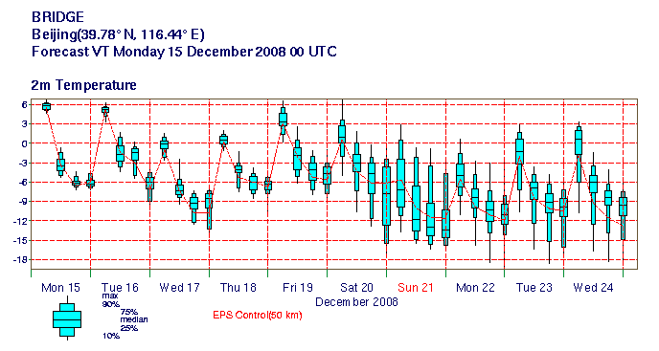
Example of product: a multi-model EPSgram

The following figure provides a comprehensive image of the full deployment currently set up at the end of the project. It shows the deployment at ECMWF, CMA and DWD. The deployment scenario is detailed in Deliverable D3.5

Full deployment

The objectives of Meteorological Application in BRIDGE, as defined in Annex 1 are as follows: “The implementation and deployment of GRID enabled services at CMA and ECMWF, allowing researchers worldwide to discover and retrieve data from the TIGGE databases, as well as the provision of simple analysis services, such as statistical computations, to be performed at the data location.”

Not only has these objectives have been clearly met on the technical level, but the BRIDGE project has strengthen the collaboration between the Chinese and European meteorological services.

Future Research Directions
The outcome of the BRIDGE will be further developed and used by ECMWF and CMA to provide distributed access to the TIGGE archive to the research community.
ECMWF will continue to promote the work done during the course of the project to the other TIGGE partners, in particular during the next user workshop that will be held next May in Monterey, USA, where all the data providers, archives centres and potential users will be present.

  - WP4: Pharmaceutical Application

Workpackage Summary
This work package focuses on the development of interoperable grid-based virtual screening applications for pharmaceutical R&D. The main objectives and expected outcomes of this work package are summarized below, and described in detail in the following sections.

- Grid-based Virtual Screening and Molecular Docking Application: Within Dockfow we will focus on a “proof of concept” scientific experiment for identifying novel potential lead candidate drugs against Bird flu / Dengue fever / Malaria. Our ability to find possible drugs by screening a virtual library with billions of compounds is hindered by the task’s intrinsic difficulty and often involves enormous computational demands. The task is to find small molecules that can modulate the actions of proteins or with interactions between them. With such large libraries, the main challenge is how to transform the available data into useful information and knowledge for drug discovery using methods of rapidly screening the available compound database. The application is compute and data intensive and requires the integration of various tools.

- An integrated Virtual Screening Platform: Different databases and tools have been developed for virtual screening and molecular docking. The ability to combine the different results of these tools in one platform will provide the researcher with unprecedented flexibility in their drug discovery tasks. Within this work package we aim to develop an integrated solution based on existing docking tools available to both the European and Chinese partners within a single platform. Furthermore, the development of an algorithmic approach towards interoperability of docking results is a real challenge and will be one of the main contributions of this task. This will be achieved through the continued development of CombiScore – including support for different protein-ligand-system representations, and their associated meta-data – to provide a unified score and visualization method to facilitate lead identification

- Workflow Execution Models for Virtual Screening: The essence of our approach is to enable dynamic integration of data sources and tools by end users based on a high-level workflow programming approach for describing virtual screening analyses. The execution of these workflows can then be delegated for execution to grid-enabled workflow execution engines that co-ordinate the execution on an underlying heterogeneous and distributed infrastructure. Within this work package we thus aim to both enrich the existing workflow systems for supporting the interactive analysis required for virtual screening analyses through the production of reusable, validated “canned” virtual screening workflows authored by domain experts that can then be published for execution by a wider audience. Another objective is to extend the existing workflow engines used in the project by developing interoperability methods between them that ensures transparency to the end user of the workflows.

Virtual Screening Applications and Molecular Docking
Virtual screening and molecular docking pose many challenges, not only because of the inherent knowledge discovery aspect of the task, but also because of its computationally intensive nature. Addressing this challenge requires effective integration of many research disciplines including information science, data warehousing, online analysis processing and data mining. Furthermore, since the computations required for the calculation of ligand--receptor interaction energy in all possible docking configurations cannot be completed in a reasonable amount of computational time, any effective approach must include the use of multi-object optimization methods executing on high performance computing resources.

Over the past decade numerous databases and computational tools have been developed to address this problem. Virtual screening requires the integration of such tools. Database access to PDB and one or several compound databases (ZINC, NCI) are required for retrieval of target and compound structures. Before they can be docked, these raw structures have to undergo pre-processing that includes the addition of hydrogens and charges and energy minimization of the compounds. The single individual tools for this step are available but have to be combined into a pre-processing engine. A range of docking tools can be used, each of which executes on high performance resources. A result database is used to store the docking results from the different tools, and results are then fed into a combined rescoring and analysis phase.

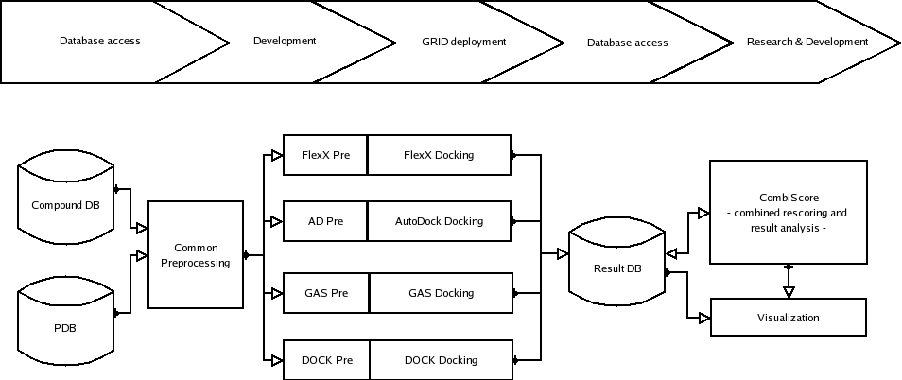
Main virtual screening workflow involving four different docking services

Grid based composition of screening tools
The goal of our work is to construct an integrated grid-based virtual screening environment. The figure above provides a high-level view of a generic virtual screening workflow: with generic elements (PDB; a compound repository) and elements which require some implementation / gridification work (e.g. the common pre-processing module). We will base our work on the use of InforSense KDE, a flexible workflow tool that is already successfully used in the pharmaceutical R&D as well as other scientific application.

In the scenario under consideration for this project, we anticipate the use of four different docking tools, each requiring specific input file formats and requiring specific pre-processing to be applied to the data before invoking the tool. This will allow compounds to be docked using the following docking services: FlexX (BioSolveIT), AutoDock (Scripps Research Institute), DOCK (UCSF) and Gas Dock docking software from the Chinese BRIDGE partner institute in Shanghai.

A result database has to be set up for storage of the docking scores and conformations (BioSolveIT). The main goal is a combined evaluation of the docking results by CombiScore which is superior to the single scores of the docking tools. CombiScore will integrate the different protein-ligand-system representations and provide a unified score and visualization to facilitate lead identification. An integration of FlexX and AutoDock is currently under development and has to be extended for assimilating other docking tools.

With respect to the enabling potential, the workflow depicted in Figure 1 has the potential to be taken up by industrial and academic users of docking services, as it will allow for comparison of docking results generated by different docking services. However, it is essential to highlight the main challenges in achieving such integration:

- Individual, tool-specific pre-processing will also require some dedicated development and integration into the workflow management environment used in the project (InforSense KDE). Some of these tools will be integrated as backend applications. However, interactive user interfaces will need to be integrated within the visual and portal-based front-ends.

- The result database for docking results will come from BioSolveIT GmbH; the module “CombiScore” is a development of the Department of Bioinformatics at Fraunhofer SCAI. Significant development work is anticipated with this tool, as the algorithmic approach towards interoperability of docking results is a real challenge.

- To achieve the speed required for screening a virtual library consisting of billions of candidate small molecules for compounds that can bind to known protein binding sites, part of our work also requires the investigation of grid-enablement of existing virtual screening methods. We adopt a multi-level searching strategy based on grid computing, i.e. database searching for candidate small molecules (grid-level job), molecular searching (node-level job) and conformation searching for each molecule (a task). The grid-level job consists of some node-level jobs, which will be sent to the nodes by grid centre. Every node-level job gives some candidate small molecules that must be screened in the compound database, in which small molecules are equal in number approximately. The node-level job consists of a set of tasks, and each task will finish the optimal conformation searching for a molecule. When a node of the grid receives a node-level job, the small molecules submitted of the job will be screened one by one. The results of the optimal conformation searching for each molecule will be sent back to grid centre.

Once the basic workflow is operating, a wide range of optimisations are possible. Two interesting examples might be:

- Mining of virtual experiment metadata – i.e. which combinations of algorithms and parameters produced the best results for particular input molecule classes. This could then be used to optimize the detailed workflow used for future inputs.

- Using the result database to remove redundancy in the process by suggesting molecule/parameter combinations that might increase the coverage of the data repository, or to present precomputed results for inputs that are sufficiently similar to a job that has already been run by that or other users.

Flexible Workflow Models for Virtual Screening
Part of work in this work package is dedicated to the development of flexible workflow environments for virtual screening applications. Our approach is to enable dynamic integration of data sources and tools by end users based on the use of a high-level workflow programming approach for describing virtual screening analyses to be conducted. The execution of these workflows can then be delegated for execution to grid-enabled workflow execution engines that co-ordinate the execution on an underlying heterogeneous and distributed infrastructure.

Although the workflow model for virtual screening can be described in a generic fashion, it can not be pre-defined as a fully automated process:

- Users need to interact with the system to test different parameter setting and approaches during the drug discovery process, collecting and comparing intermediate results to decide how the workflow could proceed.

- The pre-processing stages themselves within the workflows may require non-trivial, and interactive, pre-processing and analysis work by the user.

The workflow systems required for this work package need to support a flexible grid workflow model both at design time and runtime providing support for capturing and modelling user interaction within the whole process. This requires capturing such interactions including activity within the workflow, and as also capturing the decisions that affect the process execution path at run time.

Our work is based on using and extending the InforSense KDE workflow system for supporting virtual screening workflows. The definition of a flexible workflow model for virtual screening at design time requires enriching the definition of more complex logic structure and data flow structure that is based on event-condition-action rules. Through event composition, we can define much more complex process model than by current standard workflow modelling language. To enhance the run time flexibility, we should provide users with the ability to construct and change the process model of each workflow instance dynamically. Within DockFlow, and based on the requirements gathered from the end users, we will extend the InforSense KDE language and model to support these operations

Furthermore, the execution of long-running distributed workflows in an open and distributed environment is non-trivial. Different workflow execution engines exist, with each engine providing different benefits - ranging form the invocation co-ordination of distributed grid-services based on a user-defined plan, to scheduling engines which provide an efficient execution plan for a user workflow specified at a high level of abstraction. Resolving the interoperability issues between the different engines is an essential part of any real-life integration, and must be effectively addressed in this work package. InforSense, within the EU-funded SIMDAT project, has been investigating such mechanisms for interoperability between three other grid-based engines. The Chinese partners of the project are currently developing distributed designs for grid-based workflow engines that can be expanded by adding new enactment services and client request can be allocated to a proper enactment service according to a load-balancing strategy. Within Dockflow, we will investigate the interoperability issues between the InforSense KDE workflow execution engine and the distributed execution engines, and extend the interoperability framework to include the new technology developed by the Chinese partners.

Finally, a computing grid comprises heterogeneous resources, policies and applications with varied requirements. The effective use of the underlying grid-fabric requires exposing such mechanisms to the workflow user as well as to the workflow engines. A workflow user accessing such information can specify their computational needs and select the resources for executing individual workflow components, or complete workflows. The workflow engine and system must have to have access to protocols for advertising resource capabilities, enabling the user to query them, as well as to submit their tasks for execution. Within the SIMDAT and CNGrid, such capabilities are provided through different protocols and interfaces. Within DockFlow, we will thus develop uniform mechanisms for accessing the underlying GRID resources from the same workflow interface.

Achievements during the first project year
WP4 focuses on the development of a re-usable and interoperable grid-based virtual screening platform, DockFlow, for pharmaceutical R&D, with clear and well-defined case studies around Malaria and Bird Flu.

Within the first year of the project, WP4 has successfully met its objectives for the period, and the partners have successfully implemented all the required tasks to achieve these objectives. In particular the partners have developed the first prototype of DockFlow integrating four protein docking tools; with two tools operating in the Europe on European middleware and two tools operating in China on Chinese middleware. Initial testing and validation of the platform has already started based on Malaria data sets provided by the European partners and Bird Flu data sets provided by the Chinese partners.

The key tasks within the first year of the project are:

Task 1: Scientific Application: Virtual Screening and Molecular Docking:
- The goal of Task 1 is to formalize the scientific application scenario and to evaluate the scientific data and results. Within the first six months Task 1.1 focused on requirement gathering of the application, providing detailed analyses workflows and use scenarios, and a detailed evaluation plan. The requirements will be feed into the design of the case study, design of the integrated environment, and the extension of the workflow tools used. Task 1.2 focused on definition of data sets to be used within the scientific studies. Task 1.3 focused on experimental evaluation of the platform.

Task 2: Integrated Platform for Grid-based Composition of Virtual Screening Tools
- The goal of Task 2 is to develop a re-usable and extensible grid-based platform for virtual screening applications. The platform will primarily provide integrated access to the four docking tools identified above together with the associated reprocessing tools, input data sources and output result database. It will be extensible to add further docking tools, as well as for other chemiformatics and bioinformatics tools and data sources. Within the first six months of the project Task 2.1 focused on the integration of screening databases and docking tools within the platform and Task 2.2 focused on the algorithmic interoperability approach for docking applications. The remaining sub-tasks in Task 2 will be the focus of the coming period. These are mainly constructing a portal-based interface for the platform and the evaluation of the integrated platform.

Task 3: Interoperable EU-China Grid-based Workflow Infrastructure for Virtual Screening
The goal the task is to develop the underlying grid-based workflow system for coordinating the execution of the virtual screening tools and data sources used. The work will be based on extending the existing InforSense KDE workflow execution system (front-end and servers) and allowing its interoperability with the workflow systems used within the CNGrid workflow tools for China’s Drug Discovery Grid project. Task 3.1 focused on extending the workflow tools used in the project to support complex interactions defined in the platform. Task 3.2 focused on enabling interoperability between workflow tools used in the project. Task 3.3 focused on interoperability between the underlying heterogeneous grid fabrics Task 3.4 focused on Grid-enabling the available protein docking tools. Task 3.5 focused on the evaluation of the platform.

Technical outcome
- Within the first three months of the project we successfully collected the requirements from the application partners for grid-based docking tools. In particular, this included identification of the protein docking tools and data sources to be used within the project, their invocation mechanisms as well as a staged plan for accessing and integrating these tools as Grid services based on both GRIA and GOS. Within the first three months, the requirements gathering phase also identified the high-level workflow descriptions for using each of the tools from a user perspective and the key pre-processing and post-processing activities required. A staged implementation plan of the virtual screening platform has also been identified. These achievements have been documented in Deliverable D.4.1.

- Between PM4 and PM6, the partners started implementation of the staged plan for building the virtual screening platform by providing a high level design of the virtual screening platform based on a generic workflow system architecture and investigating its implementation based on the InforSense KDE system. The work also included identifying the properties of the individual protein docking tools used within the project (their input/output data requirements and their invocation mechanisms in standalone modes) to enable their integration within the workflow platform and also their deployment within GRIA and GOS systems. The work also included translating the high-level protein docking workflows into prototype InforSense KDE workflows and the integration of the required protein docking tools as components executing locally on the InforSense services rather than remote components to test and validate the interfaces. The work also included investigation of the features of the algorithmic interoperability framework (CombiScore). These achievements have been documented in Deliverable D.4.2.

- Between PM7 and PM12, the partners have collaborated on the implementation of the platform itself. This included deploying the Dock and GAsDock protein docking tools as GOS services and the FlexX and Autodock protein docking tools as GRIA services. The implementation of individual docking tools has also been conducted to ensure their execution on HPC clusters as parallel applications. Workflow components for accessing these different services from the InforSense workflow system have been implemented, and also the individual workflows that pre-process the input data sets. Based on the design of the platform the workflow tools are used to enable seamless interoperability between GRIA-based and GOS-based implementations of the underlying protein docking tools. The partners have also collaborated on the design of the results database to store the outputs of the different protein docking tools in a common format and on the design of the CombiScore tools used to uniformly score, compare and integrate the outputs. Initial experiments of using the tools were based on the available data sets (Malaria and Bird Flu) to validate the prototype. These developments and achievements have been documented in D4.3.

Prototype Implementation
Figure 14 presents the basic system architecture of our prototype system. It’s based on the Phase 1 release of WP1 to implement GRIA/GOS interoperability, so the InfoSense KDE interacts only with GRIA and knows nothing about CNGrid GOS.

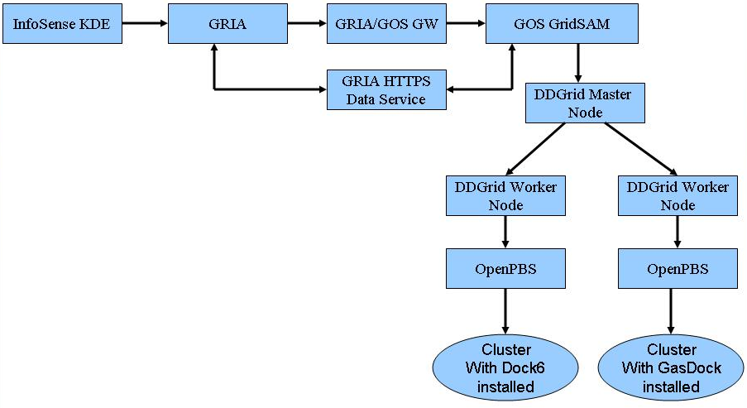
Basic System Architecture of the Pharma Prototype
The basic system architecture mainly consists of five components:
- InfoSense KDE:
- InfoSense KDE is a workflow engine and used to drive the drug discovery process;
- InfoSense KDE in charge of invoke different dock tools provided by different partners.
- GRIA,GRIA/GOS GW:
- A full installation of GRIAv5.2;
- GRIA/GOS GW from WP1 Phase 1’s release.
- GOS GridSAM:
- Extends GOS GridSAM’s plug-in mechanism and provides a web service job manager which is used to interact with DDGrid master node.
- DDGrid Master Node
- DDGrid master node takes care of parsing client request, and downloading/uploading data files;
- Schedules client request to proper DDGrid worker node.
- DDGrid worker node for OpenPBS
- OpenPBS is in charge of managing cluster resource and provide scheduling support;
- DDGrid worker node for OpenPBS receives job process request from the master node, submits job to OpenPBS, monitors job status and uploads result file to target locations;
- Two different dock tools (Dock6 and GAsDock) are deployed currently.

Experimental Environment Set up
The next figure presents the machines involved in this experimental environment of the prototype.
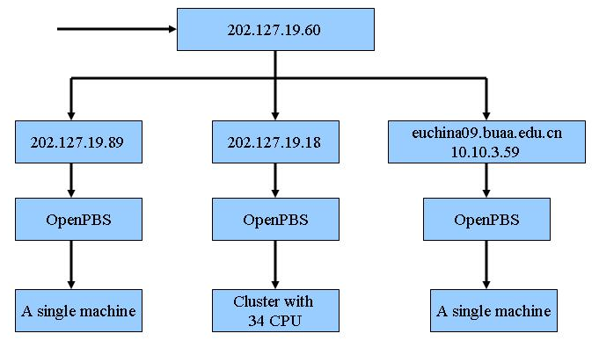
Experimental Environment Set up

The table details the machines used in Experimental Environment
IP Address | OS | Components installed | Location
202.127.19.60 | Linux AS 4 | GRIA, GRIA/GOS GW, GOS GridSAM,  DDGrid Master Node | SIMM, Shanghai , China
202.127.19.89 | Linux AS 4 | DDGrid Worker Node for OpenPBS with Dock6 and GAsDock installed | SIMM, Shanghai , China
202.127.19.18 | Linux AS 4 | DDGrid Worker Node for OpenPBS with Dock6 and GAsDock installed | SIMM, Shanghai , China
euchina09.buaa.edu.cn  10.10.3.59 | Linux Scientific 4.0.8 | DDGrid Worker Node for OpenPBS with Dock6 and GAsDock installed | Beihang University, Beijing, China

Collaboration
Within the first year of the project, the partners have collaborated internally to conduct the work plan. The collaboration effort has been enabled through a trip by the Chinese partners to the UK for the kick-off meeting of the project that was used to organize the WP efforts and assign tasks. A trip by the European partners to China also took place in October/November where most of the common development work was conducted. Through the period two meetings between the European partners have taken place in Sankt Augustin in Germany, also a number of meetings have taken place in Shanghai and Beijing between the Chinese partners. Chinese and European partners have collaborated throughout the period through regular exchange of emails and teleconferences.

Within this period, there has been no concerted effort to collaborate with other projects. However, the WP (through InforSense) was represented in the EU concentration meeting.

CNIC’s achievements during the first project year
CNIC has participated in the application studies and gathering requirements for porting current pharma tools to the Grid service platform GOS, and set up a testing and development environment of the GOS-based docking tools. CNIC has deployed DOCK and GasDOCK into the national Grid platform of China, the CNGrid. CNIC has participated in development of Drug Discovery Grid 2 led by SIMM from July to August. The partners of the projects are from CNIC, SIMM, BUAA, JNICT, HIT, and HKU.

CNIC has become one of the six computing nodes with Drug Discovery Grid 2 deployed. During the work package meeting in CNIC in October, implementation of interoperable Grid services between GOSv2.1 and GRIA 5.1 was discussed and a design for interoperability was given. DOCK and GasDOCK are encapsulated as GOS services, and user in Europe can access GOS services via GRIA. So the GOS services appear as remote GRIA services from the end-user perspective.

InforSense’s achievements during the first project year
InforSense Ltd is the leader of WP4 and has conducted all activities allocated to it. These have included work on Task 1: participation in the collection of the requirements from the end users and then turning them into the technical requirements and documenting them in D4.1 and technical work on Task 1 for the validation of the tools used in the scientific applications. The work also included leading the activities on Task 2 on the design of the overall platform architecture specifying interactions between its key components and the technical work on Task 2 for the implementation of the executable workflows and workflow components and nodes within InforSense KDE to pre-process the input data, to invoke the GRID services and to collect the results. It also included technical work on design and implementation of extensions for its workflow tools to enable interoperability between the underlying heterogeneous grid fabrics.

FhG SCAI-Bio’s achievements during the first project year
Within the first year of the project FhG/SCAI-Bio has focused on the application studies of the Task 1 and used the FlexX and Autodock tools to execute the required test and validation runs on the Malaria available to them and the Bird Flu data sets contributed by the Chinese partners. FhG/SCAI-Bio has also implemented the deployment of FlexX and Autodock tools as GRIA services and used the tools to execute the required test and validation runs on the Malaria and Bird Flu data sets. FhG/SCAI-Bio has also contributed to Task 2 by providing specifications for the invocation of the individual protein docking tools (FlexX, DOCK and AutoDock), providing initial specifications of the CombiScore tool and identifying higher-level algorithmic interoperability framework between the tools and implementing the deployment of FlexX and Autodock tools as GRIA services and also by designing the ResultDatabase and CombiScore tool as described in D4.3.

SIMM CAS’s achievements during the first project year
Within the first six months of the project SIMM CAS has contributed to Task 1 focusing on the application studies providing the required inputs for the requirements gathering phase relating to the usage of GAsDock and to Task 2 on the specification and initial implementation of GOS-based docking tools. Within the next six months SIMM has contributed to Task 1 and used the Dock and GAsDock tools to execute the required test and validation runs on the Bird Flu data sets available to them and the Malaria data sets contributed by the European partners. During this period, SIMM has contributed to Task 2 by implementing the deployment of Dock and GAsDock tools as GOS services and also ensuring their interoperability through the GRIA-GOS Bridge as described in D4.3. SIMM has also contributed to Task 3 through the implementation of High Performance versions of Dock and GAsDock on work station clusters.

NeoTrident’s achievements during the first project year
Within the first six months of the project NeoTrident has led the user-level requirements gathering phase (Task 1.1) focusing on documenting the high-level usage scenarios of the protein docking tools. Over the next phase, NeoTrident will contribute to validation of the implementation of the grid-enabled tools and their use in application studies. During the next six months NeoTrident has led collaborated to Task 1 and Task 2 focusing the validation of the design on the platform and especially on the workflow design for the application studies.

Achievements during the second project year
WP 4 focuses on the development of a re-usable and interoperable grid-based virtual screening platform for pharmaceutical R&D. Our aims within this WP were to develop new mechanisms for allowing interoperability between Grid-based docking tools at both the infrastructure and algorithmic levels, with a focus on a clear and well-defined case study.

WP 4 has successfully met all its objectives for the period January 2008 – February 2009 and has implemented the required tasks to achieve these objectives. In particular, these include the evaluation of the first Dock Flow prototype implemented in Year 1, which was reported in the D4.4 deliverable at PM 15 and the implementation and evaluation of the second DockFlow prototype during the second project year. The new RTD activities within the reporting period have included: a) the design and implementation of the results database (DDB) and CombiScore modules; b) setting up the experimental environment for the DockFlow prototype; c) implementation of extensions of the underlying workflow system infrastructure to support interactive execution over docking tools; d) evaluation of the scientific case studies, data sets and application workflows; and e) technical evaluation of the integrated DockFlow platform. These advances have been reported in D4.5, D4.6 and D4.7.

Tasks within the reporting period
Task 1: Scientific Application: Virtual Screening and Molecular Docking: The goal of Task 1 is to formalize the scientific application scenario and to evaluate the scientific data and results. Within the reporting period, the focus has been on Tasks 1.2 and 1.3. Task 1.2 has focused on the refinement and elaboration of the definition of benchmark data sets to be used within the scientific studies for CombiScore and their exchange between the partners. Task 1.3 has focused on the evaluation of the first year prototype will extend in the upcoming period for the evaluation of the CombiScore modules and the second DockFlow prototype, and Task 1.4 has focused on the overall scientific evaluation of the case studies using the integrated platform.

Task 2: Integrated Platform for Grid-based Composition of Virtual Screening Tools: The goal of Task 2 is to develop a re-usable and extensible grid-based platform for virtual screening applications. The platform will primarily provide integrated access to the four docking tools identified above together with the associated reprocessing tools, the input data sources and the output result database. It will be extensible to add further docking tools, as well as for other chemiformatics and bioinformatics tools and data sources. Within the past six months of the project the focus has been on Tasks 2.1 and 2.2. Task 2.1 focused on simplifying access to the screening databases and docking tools within the platform and within the past period has focused on the design of the integration mechanisms to the results database (DDB) and CombiScore modules, including evaluation of the different architecture options for dealing with fire wall restrictions across sites. Task 2.2 focused on developing the algorithmic interoperability approach and associated tools (Results database and CombiScore). The output has been the implementation of the first prototype of DDB and CombiScore and their evaluation on a small test data set. Tasks 2.3 has focused on both upgrading the workflow infrastructure for operation with the new GRIA and GOS implementations as well as the provision of the front-end tools and portal-based service for accessing the tools, submitting data and collecting results from portal-based user interfaces. Task 2.4 has focused on the use of the test data sets from all docking tools in the validation and evaluation of our novel algorithmic interoperability approach and the integrated system.

Task 3: Interoperable EU-China Grid-based Workflow Infrastructure for Virtual Screening: The goal the task is to develop the underlying grid-based workflow system for co-ordinating the execution of the virtual screening tools and data sources used. The work is based on extending the existing InforSense KDE workflow execution system (front-end and servers) and allowing its interoperability with the workflow systems used within the CNGrid workflow tools used in the China Drug Discovery Grid project. Task 3.1 – 3.4 have been the focus of the work conducted in period PM 7- PM12. The focus of the work conducted in the this reporting period has been on Tasks 3.1 the implementation of new mechanisms for workflow execution that enable the complex event-based mechanism and interaction with the underlying resource scheduling tools. Currently no new developments have been done in Task 3.3, beyond upgrade of the GRIA nodes. This task follows the architecture and development activities of WP 1 and will implement the new mechanisms defined there within the upcoming period. Within Task 3.4, the design of GAsDOCK worker nodes has started together with the evaluation of the different interaction forms with the workflow tools. Finally, Task 3.5 has focused on conducting a technical evaluation of the approach, and comparing the different approaches used for service integration and deployment as well as for integration of the results.

Technical outcome and progress towards objectives
Across all tasks, the Key technical outcomes of WP4 in the reporting period can be summarized as

- Infrastructure Interoperability: Assembly of the experimental environment and different services that are distributed geographically using KDE which is provided by InfoSense Ltd. In the past year, we have extended our experimental environment and provide support for GAsDock service at the China side and access to the Autodock and FlexX service at the European side. This has been evaluated and reported on in D4.4, D4.5 and D4.7.

- Algorithmic Interoperability: Design and implementation of CombiScore and Results Database and the associated data sets to be used within the case studies. The results database and CombiScore tools allow sharing of results across the four docking tools used in the project: Autodock, FlexX, Dock and GAsDock. This has been reported in D4.4, D4.5 and D4.7.

- Overall platform and workflow evaluation: Evaluation of the overall DockFlow platform, individual tools, workflows and data sets has been successfully conducted and reported in D4.4 and D4.6.

Experimental Environment Set up

Overall view of the experimental set-up
Overview
Our approach to implementing the DockFlow platform is based on using the GRIA distributed middleware. Each of the four docking tools used by DockFlow were wrapped and deployed as GRIA services. The FlexX and AutoDock were deployed directly as GRIA services at Fraunhofer SCAI in Germany while GAsDock and DOCK at SIMM were deployed first as Grid Operating System (GOS) services and then accessed via a GRIA-GOS adapter provided by WP-1. This adapter exposes a traditional GRIA interface and handles the conversion and preparation of files required for GOS data submission and job execution.

Docking Services
Currently, both Dock6 and GAsDock service are supported at the China side, with GAsDock providing novel implementations and both and both can be accessed remotely from the European side via the InforSense KDE workflows. Similarly access to the Autodock and FlexX services at the European side from the China side is also enabled via the InforSense workflow.
Integrated Workflows
Service orchestration within DockFlow has been implemented using the InforSense workflow tool. remote services are accessed using special components designed using the GRIA API. These components handle all interactions with the GRIA middleware including uploading data, executing remote jobs and downloading results. The workflow engine is also in charge of all intermediate data management and integration. The complete virtual screening workflow is shown in Figure 2 below.
The DockFlow workflow implemented as an InforSense workflow

Results Database and CombiScore
The design and implementation of the results database has been implemented based on the BioSolveIT Docking Database which is currently installed at the Fraunhofer site and which is being used to store and analyze the docking results from FlexX, AutoDock, DOCK and GasDOCK. The central element is an ORACLE database which contains the detailed results of all docking runs. The Seeker graphical front-end of the docking environment enables the whole environment to be controlled interactively. The third major element - a cluster of compute nodes that perform the actual docking calculations – is currently not be used in BRIDGE as the docking results were already produced outside this environment; they will be imported into the database via Seeker. The results database has been populated with test data sets from the different tools and is currently ready for update of the actual experimental runs from the malaria and bird flu case studies.
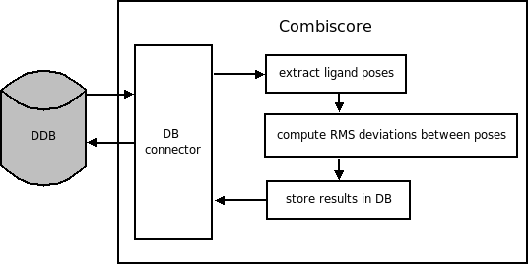
CombiScore Architecture

Combiscore has been developed within the BRIDGE project to work in close connection to the Docking Database, and its architecture is show in Figure 3. The data used as well as that produced are stored in the database. Moreover it makes use of the seeker functionalities including rescoring of poses and filter options. Thus far, Combiscore developed and tested using tests data set specifically designed for this purpose. Docking data from all docking tools used in BRIDGE have been produced for this test set which consists of two targets (avidin and trypsin) for which known binders with measured affinities are available. The CombiScore tool has also been validated using the data sets from malaria and bird flu case studies over the coming period.

Evaluation
The DockFlow prototype described was successfully applied in two case studies, malaria and avian flu. The biological description and analysis of the case studies is described in D4.6

Collaboration
Within the second year of the project, the partners have collaborated internally to conduct the work plan. The collaboration effort has been enabled through a number of teleconference calls as well as visits of Chinese partners to Europe for the review meeting which was used to host a number of satellite meetings.

InforSense’s achievements during the second project year
InforSense Ltd is leader of WP 4 and has conducted all its required activities allocated to it. In addition to WP management, these tasks have included work on Task 1: in terms of coordinating the overall evaluation of the individual docking tools used on the available data sets and leading the evaluation report. The work also included leading the activities on Task 2 the design and implementation of the workflow infrastructure to access the different docking tools, results database and CombiScore module. It has also included work on Task 3 on the extension of the underlying event-based mechanisms for the workflow tools, and upgrade of the GRIA Components used. InforSense has also coordinated the overall demo and infrastructure used in the first year review.

CNIC’s achievements during the second project year

Within the reporting period, CNIC CAS has contributed to Task 2 in terms of evaluating the current pharma tools to the Grid service platform GOS. A test and development environment of the GOS-based docking tools has been set up. CNIC CAS has also participated in setting up the infrastructure required for the evaluation case studies.

FhG/SCAI-Bio’s achievements during the second project year
Within the reporting period, FhG/SCAI-Bio has focused on the application studies of the WP 4 (Task 1) and on the implementation of DDB and CombiScore (Task 2) and in the Evaluation of the Framework (Tasks 3 and 4). In particular FhG/SCAI-Bio has led application studies and experiments using FlexX and AutoDock tools aiming at comparing their results, and also the definition of the test data sets for the DDB and CombiScore. For task 2, FhG/SCAI-Bio has successfully developed the first prototype of the DDB and CombiScore tools as described above. FhG/SCAI-Bio has also participated in the first year review demo and has maintained the necessary services for the evaluation purposes. For Tasks 3 and 4, a number of use cases and test data sets have been used to evaluate and validate both CombiScore and the overall framework.

SIMM CAS’s achievements during the second project year
Within the reporting period SIMM CAS has focused on the application studies of the WP 4 (Task 1) and on the implementation of GAsDOCK (Task 2) and associated Grid-tools (Tasks 3). In particular SIMM CAS has contributed application studies and experiments using DOCK and GAsDOCK tools aiming at comparing their results, and also the definition of the test data sets to use within the DDB and CombiScore. For task 3, SIMM CAS has successfully developed the GAsDOCK and deployed as service and has collaborated on the access to the workflow tool infrastructure.

NeoTrident’s achievements during the second project year
NeoTrident has led the overall evaluation of the prototype developed focusing the validation of the implementation of the individual docking tools as well as the grid-enabled tools and their use in application studies. NeoTrident has also contributed to the overall definition of the tests used for the individual tools.

Beihang University’s achievements during the second project year
Beihang University has collaborated closely with SIMM CAS to set-up the experimental evaluation environment and infrastructure interoperability (Task 2) and to provide service-based implementations of GAsDOCK (Task 2 and 3) as well as to organize the overall demonstration of the prototype and infrastructure on the China side for the review demo.

Overall achievements and outlook
WP 4 within the BRIDGE project has successfully achieved all its deliverables and has implemented and evaluated the DockFlow virtual screening platform in two case studies, malaria and avian flu.

DockFlow is based on inter-operable Grid middleware and integrates four protein docking services executing in different locations: AutoDock and FlexX in Europe deployed on GRIA middleware and DOCK and GAsDock in China deployed on GOS middleware. The key challenge addressed within DockFlow has been how to enable users to integrate the use of multiple protein docking tools executing using different Grid computing middleware at different locations within the same analysis process. Such integration is of great benefit since different docking tools are based on differing algorithms and scoring functions and provide complementary insights. Effectively achieving the integration requires overcoming both the infrastructure interoperability issues and the algorithmic interoperability issues associated with using the tools and systems remotely. Briefly, infrastructure interoperability concerns achieving interoperability between the different Grid computing platforms used by different tools, so that the invocation and integration of the different protein docking tools can be achieved irrespective of the Grid middleware technology being used. In contrast, algorithmic interoperability concerns being able to deal with the different protein-ligand-system representations and scoring functions used by the different tools.

The first DockFlow Prototype was delivered at PM12 and focused on the deployment of the docking tools as Grid services, collecting results from the docking tools, design of Combiscore and accessibility from a high level workflow. On the European side, AutoDock and FlexX were deployed as GRIA services. On the Chinese side, only the DOCK/GAsDOCK docking tools were deployed remotely as GOS Services. As with AutoDock, the pre-processing steps for both tools were handled locally at the workflow level for both docking tools. The second prototype extends the first one developed for PM12 and tries to address some of the issues encountered. The aim is to provide a complete DockFlow solution that includes the results analysis with Combiscore. This prototype focused on moving as much as possible to remote services to provide a solution which could be easily shared or transferred without installation of a number of third party tools.

Infrastructure interoperability within DockFlow has been achieved using a grid services model for accessing the individual tools and a workflow model for coordinating their execution. From an end user perspective, the Grid Service approach enables scientific users to use multiple protein docking tools seamlessly in their virtual screening experiments and to be able to execute them without worrying about the details of the underlying Grid technology used. We have also used a workflow service orchestration model for supporting the data pre-processing required before submitting tasks to the remote services and also the post-processing operations required for collecting and integrating results from multiple remote services.

Algorithmic interoperability within DockFlow has been achieved by enabling users to combine and compare the results generated by the different tools easily. This is enabled by using a results database (DDB) to store the different docking results in a common format and the Combiscore tool to provide a uniform scoring mechanism.

We have used the system to successfully integrate four different docking tools FlexX, AutoDock, DOCK and GAsDock deployed as remote Grid services at geographically distributed locations in Europe and China, and coordinate their execution from a common workflow. We have also demonstrated on a test set that our combinatorial approach, Combiscore, improves docking accuracy compared to the use of a single tool as shown in D4.6.

Future Research Directions
In DockFlow the Pharma partners have successfully integrated the four different docking tools executing as remote services at geographically distributed locations in Europe and China from a common workflow. The Pharma partners used multiple algorithms for solving the same problem in a branched workflow to address the problem of diversity of results produced by different docking tools. The storage of the outcomes of these tools in a common docking database supports a comparison of the results. Moreover, as shown in D4.6, the Pharma partners could demonstrate on a test set that our combinatorial approach Combiscore improves docking accuracy compared to the use of a single tool. Environments like the DDB support result analysis in such large scale collaborative screening experiments by providing a common platform with sorting, filtering and visualizing facilities but the current implementation of the DDB is not suited to be easily integrated as a Grid service in a generic way with other tools, and has been specifically integrated for the DockFlow prototype. This clearly marks a limitation of virtualization with the tools and techniques currently available. There is a long road to go for software tools routinely used in cheminformatics to enable them as services integrated in a Grid environment. Our next step in building a truly integrated problem-solving environment for virtual screening would aim at an integration of the docking database (DDB) as a true grid ressource. As on the technical site implementations of the core grid technology already exist, like in the Oracle 10g family of software products [20], we do not anticipate major problems at this point. Once we have the DDB integrated as a true grid service, the prototypic PharmaGrid will be turned into a truly productive environment that supports virtual screening with the ability to optimize docking strategies and to make full use of the adaptive features of the workflow.

The Pharma partners are fully aware of the fact that with DockFlow they sketch only how an adaptive PharmaGrid for virtual screening could look like. However, they will continue to work towards productive PharmaGrids and extend the workflow implemented in DockFlow by intelligent approaches to select focused virtual libraries and to qualify predicted in silico hits further by molecular dynamics (MD) simulation analysis.

  - WP5: Information Disseminations and Take-up of Results

Workpackage Summary
The objectives of this WP were summarized in the initial DoW:

• End-users
In each of the application activities the project includes major players in product and process development, pharma and aerospace companies. Each of these companies intends to use the results of the BRIDGE project for their product development. The implementations will be showcases, which will stimulate other companies using Grid technology. All the end-users will report to their application specific conferences and industrial interest groups on the progress and results of BRIDGE.

BRIDGE will provide a reference implementation for the World Meteorological Organisation (WMO): the WMO community will benefit from the results, which will impact the future WMO Information System. All the end-users will report to their application specific conferences and industrial interest groups on the progress and results of BRIDGE.

• Developers of Problem Solving Environments
Problem Solving Environments (PSE) providers organises regular conferences for their actual and potential users involving several hundred developers from various industrial sectors. BRIDGE results will be presented at these conferences and therefore reach many other industrial sectors. In aerospace and meteo, development is typically in-house. Much of the market is covered by project partners - in aerospace, AVICII and EADS; in meteo, ECMWF and its direct links to the WMO.

• Technology partners
Technology partners will make available the BRIDGE results to third parties under suitable licenses that assure reasonable and non–discriminatory access. Release under Open Source licenses will be considered. This license policy will guarantee availability under fair terms for (commercial) use after the project, and be amenable to academic and commercial exploitation according to EU rules. The SMEs will provide Grid enabled versions of their products. The technology partners will therefore leverage their many contacts to OEMs, ISVs and important customers and scientific partners to disseminate the approach and proven results of the BRIDGE project, demonstrating the benefits of Grid–based approaches for the management of engineering, scientific and engineering data and encouraging the uptake of the BRIDGE technology. In addition, dissemination by contributions to working and discussion groups, presentations at conferences and exhibitions and publications in conferences and journals will be actively pursued. The technology partners will play an active role in the standardization in bodies like the GGF and the W3C.

• Application partners
The partners in the meteorology activity are committed to use and promote standards such as GRIB for encoding and transmitting gridded data (WMO FM 92-VIII Ext. GRIB) and BUFR (WMO FM 94 BUFR) for any other binary data. Metadata catalogues will follow the ISO 19115:2003 standard, which defines the schema required for describing geographic information and services and provides information about the identification, the extent, the quality, the spatial and temporal schema, spatial reference, and distribution of digital geographic data. The main focus of Research Centre of EADS (CRC) is to feed the EADS business units with new research outputs opening the way to use grid technology for the benefits of aerospace design.

The close link between web services and emerging technologies for workflow in a distributed environment mean that the development of standards for interoperability of workflow languages is a hot research theme. BRIDGE research on distributed execution of heterogeneous workflows will influence standardisation bodies such as WfMC and have direct bearing on Business Process Modelling Language (BPML), which is a metalanguage for the modelling of business processes.

The success of this project will go beyond the partners and reach a large part of the meteorological community. To raise international awareness of the meteorological activity within the BRIDGE project, the partners intend to attend a number of meteorological events inside and outside Europe. WMO organises each year seminars and conferences and presentations will be given on BRIDGE activities. It is expected that other meteorological centres could use the outcome of this project to build virtual organisations.

ECMWF has connections with leading High Performance Computing Centre in Europe and worldwide and these connections might also be used to disseminate BRIDGE information. ECMWF will cooperate with its European partners in deploying the results of the meteorology activities as part of its operational services to disseminate its products to its Member States and Co-operating States.

Achievements during the first project year
In the first project year, an overall dissemination strategy has been defined and a dissemination activity roadmap drawn. The initial dissemination material included a project flyer, standard project presentation and work package introduction. Both an English and a Chinese project website have been designed.

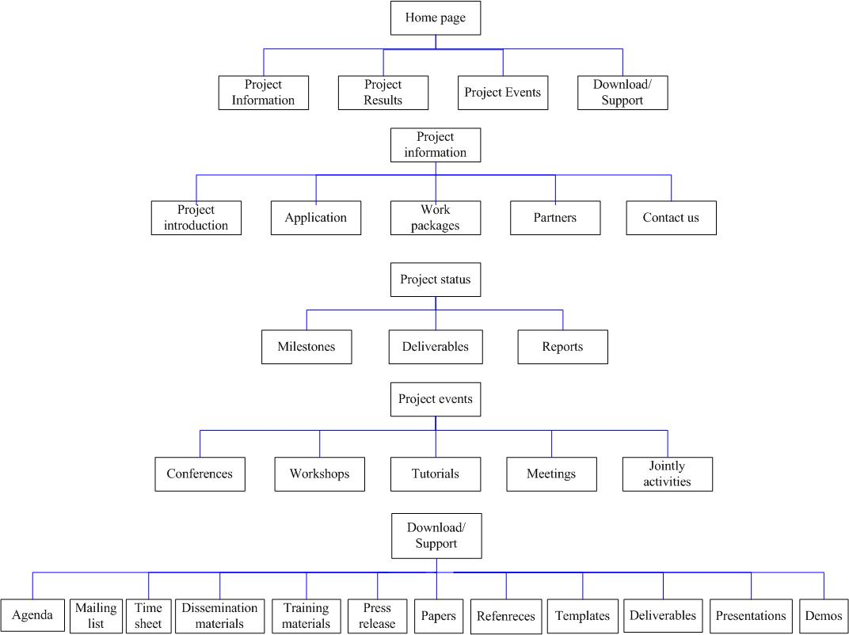
Structure of the BRIDGE website

For better internal communication, a BSCW server with a project calendar is used as internal resource repository. All Bridge-related materials can be found in corresponding folders of the BSCW server. An access control is used for security. Also a Bridge-Wiki is ready for internal communication to share information for all project members.
Two project workshops were held which periodically discussed the project results and future plan. Also Bridge members participated in several conferences and workshops in which Bridge project are introduced to other scientific communities and projects.

Another important progress is the relationship with press and government. Journalist from several Chinese newspapers participated in the 2nd project meeting and reported about BRIDGE.

Cooperation with other projects
The collaboration with other IST Grid-related projects is a major topic of Bridge. The global information dissemination of Bridge project results is mainly performed as part of this collaboration. Information and technical coordination among these projects is an additional topic.

DWD and ECMWF are partners of SIMDAT. ECMWF is also the partner of the EU funded GMES project (http://www.gmes.info/). IT Innovation is currently partner in the following EU Grid projects: SIMDAT, NextGRID, Akogrimo, BREIN, edutain@grid and Bridge. Beihang University is currently participating in another EU project – EUChinaGRID. An interoperability study between gLite and CNGrid GOS is being conducted by EUChinaGRID. The Bridge project can coordinate the effort in interoperability with EUChinaGRID. The new Chinese 863 program has started. “Grid infrastructure and grid applications” is the major topic of the new 863 key project on HPC and Grid. The BRIDGE project can cooperate with related Chinese Grid application projects in disseminating the knowledge and in extending the Grid infrastructure. For example, some Chinese applications run on the Bridge platform and the interoperability experiences we learned in Bridge help other Chinese projects in dealing with the heterogeneous platform problem. The similar activities are carried out on the EU side in relation to other EU projects.

An important content in cooperation activities is joint events like joint conferences and workshops. Common or coordinated events, exchange and reuse of dissemination material, exchange of contacts related to new or potentially interested communities will help to maximize the effectiveness of dissemination and in the meanwhile to optimize budget resources.

On October 31 2007, a joint meeting of three FP6 projects, Bridge, ECHOGRID and GridCOMP was held at CNIC with an attendance of over 70, which also attracted the officers from the Ministry of Science and Technology of China and French Embassy. Future plan on Grid technology has been discussed. Under the headline “Grid Joint Meeting held at Beijing” an article about the meeting was later published on Science Technology Daily of China. Science Technology Daily is an important national academic publication founded by the Chinese Academy of Sciences in conjunction with Chinese Academy of Engineering and National Science Foundation of China.

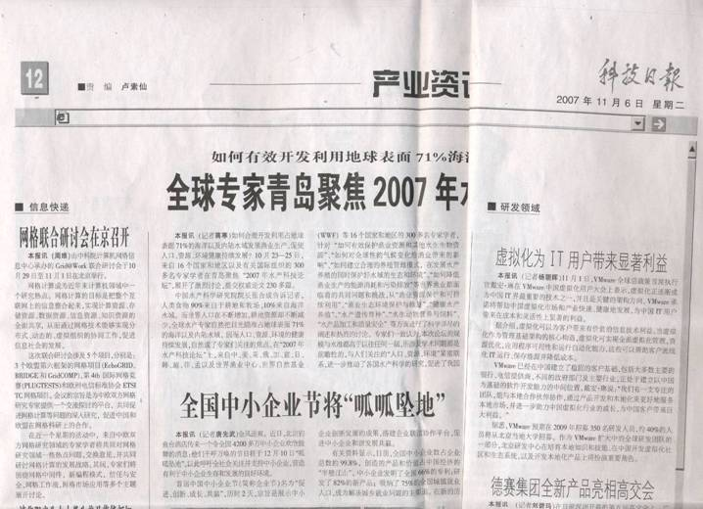
Article on the BRIDGE collaboration meeting in the “Science Technology Daily of China”

Bridge also worked on cooperating with ECSS (European Community for Software and Software services) to raise more public awareness. The ECSS website is a platform for networking and knowledge transfer between scientific and industrial communities in the field of ICT and for jointly pursuing the interests of the stakeholders. It is therefore an ideal place for us to present our BRIDGE to a wide audience. The ECSS Community is a permanent platform for information exchange, coordination and research clustering of the industries and organisations dealing with policies in S&S. It is an active forum where all stakeholders of the S&S scene are invited to contribute to the preparation of the ECSS Action Papers, and to keep alive ECSS would provide e-portal to showcase Bridge project and announce project activities on calendar.

BRIDGE was presented during the first project year at:
- 1st International Conference, 24-27 April 2007, Beijing, China The 1ST Joint EchoGRID & EUChinaGRID International Conference was held 24-27 April 2007 at the ICT, Chinese Academy of Science in Beijing, China, co-organised with the LIAMA and the CNIC. This conference presented complementarities between European and Chinese initiatives and disseminated the goals and foreseen activities of EchoGRID. EchoGRID and EUChinaGRID organised this conference to promote cross-fertilisation between Grid-related projects and initiatives in Europe and China by interacting with top Grid research and industrial communities, exchange experiences and best practices for Grid middleware and applications interoperability. Several Bridge partners participated in this conference, including Beihang University, CNIC, AVIC II.
- The NiHao Project Beijing Conference, "Future Internet/IPv6 and FP7", 19-20 November 2007, Beijing, China. Ni Hao is a project financed by the European Commission aimed at helping Chinese ICT enterprises and relevant research academies to realize the EU’s specialized IST plan, which includes the provision of information on the latest IST developments, the IST plan and project bidding. The main goal of the Ni Hao project is the establishment of a National IST Chinese Contact Point to encourage and facilitate the participation of the Chinese research and industry community and other parties interested in EU IST research projects and initiatives. The initiative will encourage more Chinese enterprises to take part in EU projects by promoting the 7th Framework Programme in particular. Ni Hao will promote cooperation between China and Europe in the fields of IST academic research, policy development, and science and technology cooperation between enterprises. Through bilateral policy-level communication cultural, commercial and practical differences can be eliminated, allowing for China and the EU to mutually achieve strategic consensus in the ICT field.
3rd IEEE International Conference on e-Science and Grid Computing, 10-13 December 2007, Bangalore, India. The e-Science 2007 conference is designed to bring together developers and users of e-Science applications and enabling IT technologies from leading international and interdisciplinary research communities. The conference serves as a forum to present the results of the latest research & product/tool developments, and highlight related activities from around the world. IT innovation team published a paper in this conference. CNIC delegate attended this conference and distribute the dissemination materials of the Bridge project.
- 26th ICAS Congress: The International Council of the Aeronautical Sciences(ICAS), 4-19 September 2008, Anchorage, Alaska. The 26th Congress of International Council of the Aeronautical Sciences (ICAS) including the 8th AIAA Aviation Technology, Integration, and Operations (ATIO) Conference brought together researchers, designers, analysts, manufacturers, integrators, and operators in a diverse program intended to foster the exchange of ideas and to spark dialogue on how to enhance aviation and the aviation system of today while preparing for the needs and issues of tomorrow. Bridge partner AVIC II will attend the conference.
- Cracow Grid Workshop 07 & EUChinaGRID Workshop, 15-18 October 2007, Poland. The Cracow Grid Workshop was organized for the seventh time to support the community of researchers, developers, practitioners as well as current and potential grid users who work in the fascinating field of grid technologies and their applications. CGW'07 was organized by Academic Computer Centre Cyfronet AGH, Institute of Nuclear Physics Polish Academy of Sciences (IFJ PAN), Institute of Computer Science AGH and Jagiellonian University Medical College in the framework of EU IST grid projects: EGEE, int.eu.grid, GREDIA, CoreGRID, K-WfGrid, BalticGrid, EUChinaGrid and ViroLab., It covered:
- current research advances in grid systems and grid applications,
- current research advances in computational science
- overview of research in the main European grid projects,
- overview of national grid projects,
- two special sessions: "ViroLab and its virtual laboratory", "EUChinaGrid"
- tutorial Chemomentum
Members from several Bridge partners participated in this conference, including Beihang University, CNIC.
- 17-19/03/2008 Summit on Applications and Grid Middleware for the PRAGMA, Swiss Grid and Euro Grid Associations
A summit on Applications and Grid Middleware for the PRAGMA, Swiss Grid and Euro Grid Associations will be held at University of Zurich in March 2008. The purpose of the meeting is to bring together key players in these large group efforts to see if there are points of synergy that will benefit each, and in the best case provides points of growth for each. Such efforts can offer the opportunity to more fully utilize the power of local, national, regional and international investments of the grid. To carry this through more productively, it is first necessary to know more about each other, and then probe ways to bridge the natural geography and distance boundaries. A CNIC delegate presented latest outcome of the Bridge project.

The Chinese partners also worked on the relationship with government side. A workshop on “Cooperation on Grid technology between China and EU” is being prepared by Beihang University and will be held at Beihang University in Jan 25, 2008. This workshop will also be a major event in China-EU Science & Technology Year, This workshop will gather all the experts and researchers participating in the national or China-EU international programmes on Grid technologies, conducting dialog and discussion with the officials from the Department of International Cooperation, Ministry of Science and Technology of China. It is also a good chance to disseminate the Bridge project results and benefits. The success of this workshop will certainly darw more attention and support from Chinese government to international cooperation on Grid.

Both EU and Chinese press will be contacted, as an effective way to give an overall introduction of Bridge and timely report on project progress to public. This will definitely extends public awareness of Bridge project and its impact in academic and industrial fields.
At the same time, as an important part of knowledge dissemination, a series of training activities will be held in both China and EU after prototypes are developed and deployed for all application scenarios. Training activities can start at the beginning of the second year in parallel with the final refinements of the workflows and applications. The targeted trainees are end-users and any organisations and communities which are interested in grid technologies and will be our potential users in the future. The training will be focused on the operation and management of the interoperability interface and toolkits. As in different fields, the training will be tailored to specific application domain. Each work packages will provides with experts to accomplish tutorials.

Exploitation Activities
While project dissemination activities will provide a general picture of the project, the promotion and exploitation of Bridge will provide detailed technical information to end-users and give them the skills to deploy and use the grid computing infrastructure allowing them to learn and practice using the Bridge grid computing infrastructure for dissemination and training. It requires more manpower and time to accomplish this goal.
Activities of Bridge results promotion and exploitation will be composed of following three aspects.
- Dissemination of project results,
- Exploitation of project results, and
- Training services for end-users.

Task 3: Communication Activities
Internal communication activities are the key to the success of Bridge. A good communication atmosphere would bind different work packages and different partners tightly. In general, internal communication involves every project member.
First of all, the Technical Management Board coordinates all issues, which affects more than just one single work package. The Board is composed of representatives from each work package. The Project Coordinator chairs the Technical Management Board. The Board will verify that there is efficient cooperation between the different activities. The Technical Management Board has met periodically. The agenda usually includes a review of previous actions, and reporting on research, development and integration issues from the work package coordinators.
For each individual project partner, internal work reports will be made every three months and reported to the corresponding work package leader. The overall quarterly management and technical reports of each work package is reported to the Technical Management Board to keep control on the resources, efforts and advances of the project.
For better internal communication, a BSCW server with a project calendar has already been in use as internal resource repository. All Bridge-related materials can be found in corresponding folders of the BSCW server. Access control is used for security. Also a Bridge-Wiki is ready for internal communication by sharing information for all project members. At this point of time there are mainly two pages of current events and regulations. More pages will be created as the project progresses.
We have established and are improving audio and video conference capabilities. Last not least, we have set up the bridge-grid mailing lists. We are working on improving the administration of these lists to make them more flexible.
Because of the geologically separated locations of the project partners, Bridge has to cope with challenges brought by its intercontinental dimension, so multiple effective communication methods are used. Project members can choose a proper way according to actual needs.
- Project BSCW server
A BSCW document server including a calendar has been in place since the very beginning of the project, which is used as a platform for exchanging opinions among partners and a document repository. The BSCW server is username/password protected for security. Members with proper right can upload, download and delete files on the server. Now the server consists of following folders:
- Calendar of Bridge Project
- Archives of old documents
- Contract and addendum
- Deliverables
- Description of Work
- Financial statements
- Meetings
- Miscellaneous
- Templates and working documents
- Work packages
- Bridge wiki
A bridge wiki was set up for working on shared documents and information that needs frequent cooperation on details. Unlike the public project website, its target audience is mainly project partners. It will facilitate the exchange of information among project partners, third parties and contributors. Up to now only part of the wiki has been put into use, but as the project proceeds, it will be definitely enriched and used more extensively as a very effective and efficient way to communicate among project partners.
- Emails
Email are used as a simple but very effective and fast communication between partners. Mail lists at both work package level and project level have been created, maintained and updated as project moves on. Now we are working on improving the administration of these lists to make them more flexible. Any project-related information will be sent to members on corresponding mail list besides other means like published on project website or Bridge wiki.
- Physical meetings
Physical meetings are very traditional means for communication purpose. Face-to-face meetings are very effective and efficient. Periodical meetings has been scheduled as the project proceeds, which consist of the kick-off meeting, project workshops and other related or joint conferences. Workshops and seminars for specific topics have been scheduled by individual work packages to enable face to face communication. Examples of the WP2 face to face meetings are listed as follows:
- 25/06/2007 the 1st meeting of WP2, Beijing, China
The 1st WP2 meeting was held in AVIC II, Beijing China, on June 25, 2007. The partners included: LMS, AVIC II STC, SARDC, BUAA, and JNCI. The main goal is to establish the workflow and make work responsibility clear.
- 02/07/2007 the 2nd meeting of WP2, Beijing, China
The 2nd Joint meeting was held in July 2 in Beijing, aiming at introducing LMS software and giving training on how to use OPTIMUS software for project partners. Mr. Jiang Jiyun from LMS Company introduced LMS software and gave an example usage of of OPTIMUS by establishing a workflow.
- 29/10/2007- 02/11/2007 the 3rd meeting of WP2, Beijing, China
This meeting reviewed the progress of WP2.
- 22/11/2007 the 4th meeting of WP2, Beijing, China
This meeting defines the final scenario of aviation application. Nick Tzannetakis hosted this meeting with 20 participants from Bridge members.
- Virtual meetings
Besides physical meetings, virtual meetings like video/audio conferences are also of great importance for time and expense reasons. VoIP facility has been used to reduce the communication cost. Skype is also a good choice. It has been used regularly for computer to computer call conference. The cost is none. The frequent TMB meetings have been held by call conference.
- Quarterly work report
Periodical work report is a very important way for internal communication. Project members report to their work package leader about their work status. Achievements obtained, problems occurred and next step planned are included in this report, so that work package leaders will have an overall view of the project status, and can better execute or adjust work plan. Meanwhile each partner is required to send their dissemination work report to WP5 every three months with a detailed record of all the dissemination work that have been carried out within their application fields. WP5 will summarise all the reports and give an overall dissemination work report to project office quarterly.

Achievements during the second project year
The work in WP5 has progressed as planned, all the tasks have been completed and all the corresponding deliverables have been produced. The partners also took part in several dissemination activities. During the second year the highlight dissemination events of the application activities were:
We had a project presence on the 23rd Open Grid Forum in Barcelona and other presentations from the technical work packages in Europe, China and in the USA.

  - 17 - 19 March 2008: Summit on Applications and Grid Middleware for the PRAGMA, Swiss Grid and Euro Grid Associations
  - June 2008: 23rd Open Grid Forum in Barcelona: Project presentation and presentations form the technical workpackages.
  - 14 - 19 September 2008: The 26th Congress of International Council of the Aeronautical Science (ICAS)
  - 28 October 2008: China-EU Cooperation Workshop
  - 19 – 20 February 2009: Aero Dissemination Meeting, Beijing, China
  - 24 February 2009: Pharma Dissemination Meeting, Beijing, China

Beihang University’s progress towards objectives
During the period of January 1st to June 30th, 2008, the following dissemination activities were carried out by Beihang University.
1st BRIDGE Newsletter
The 1st BRIDGE newsletter was issued January, 2008, introducing the first year results of WP1 to 4. The newsletter was handed to the Ministry of Science and Technology of China and related projects with BRIDGE flyer to spread the project information.

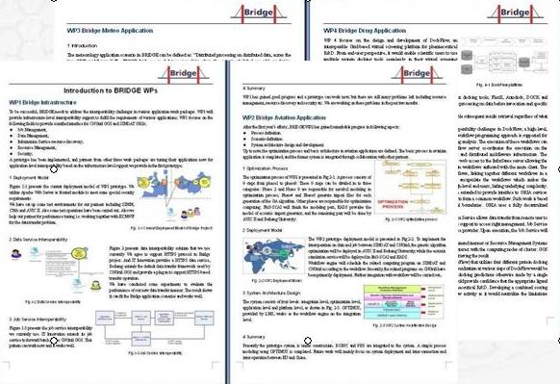
E-strategies Article about the BRIDGE project achievements
Prof Qian contributed a major part to this article “BRIDGE: Supporting East-West GRID Cooperation”, which was published in February 2008 in the issue number three of the eStrategies magazine, such as the report on the achievements of the first year of the BRIDGE project activities perspectives for future development and possible exploitation of results: BRIDGE infrastructure and application scenarios were described as well as their impact on future international cooperation in design and engineering.

Organization and participation of the “Cooperation on Grid technology between China and EU Workshop”
This workshop was held in Beihang University in Jan, 2008, as a major activity in China-EU Science & Technology Year, The workshop gathered over 60 Chinese experts and researchers participating in national or China-EU international programmes in Grid fields from over 20 organizations, and head officers from the Ministry of Science and Technology of China also. During the workshop, China-EU Grid Corporation, including BRIDGE project was reported to Chinese government agency and academic & industrial field. Future plan for EU-China cooperation on Grid technology was discussed.

Prof. Qian Depei, Yongjian Wang and Danfeng Zhu participated in the mid-term project review rehearsal and official review in Leuven March 13th-14th 2008. Prof. Qian presented the “Project summary: achievements and challenges”. Yongjian Wang gave impressive demos of WP1 and WP2 and jointly presented the work of WP1 with IT Innovation partner. Danfeng Zhu concluded the achievements of WP5 with Gilbert Kalb from Fraunhofer SCAI.

Participation to EchoGrid Workshop in Greece
Prof. Qian and other colleagues of Beihang University attended the 2nd EchoGrid Workshop in Greece, June 9th to 10th. We communicated with other research institute and industry enterprises on Grid technology and participated in the writing of roadmap of grid technology in future. BRIDGE project was also introduced to related projects and organizations.

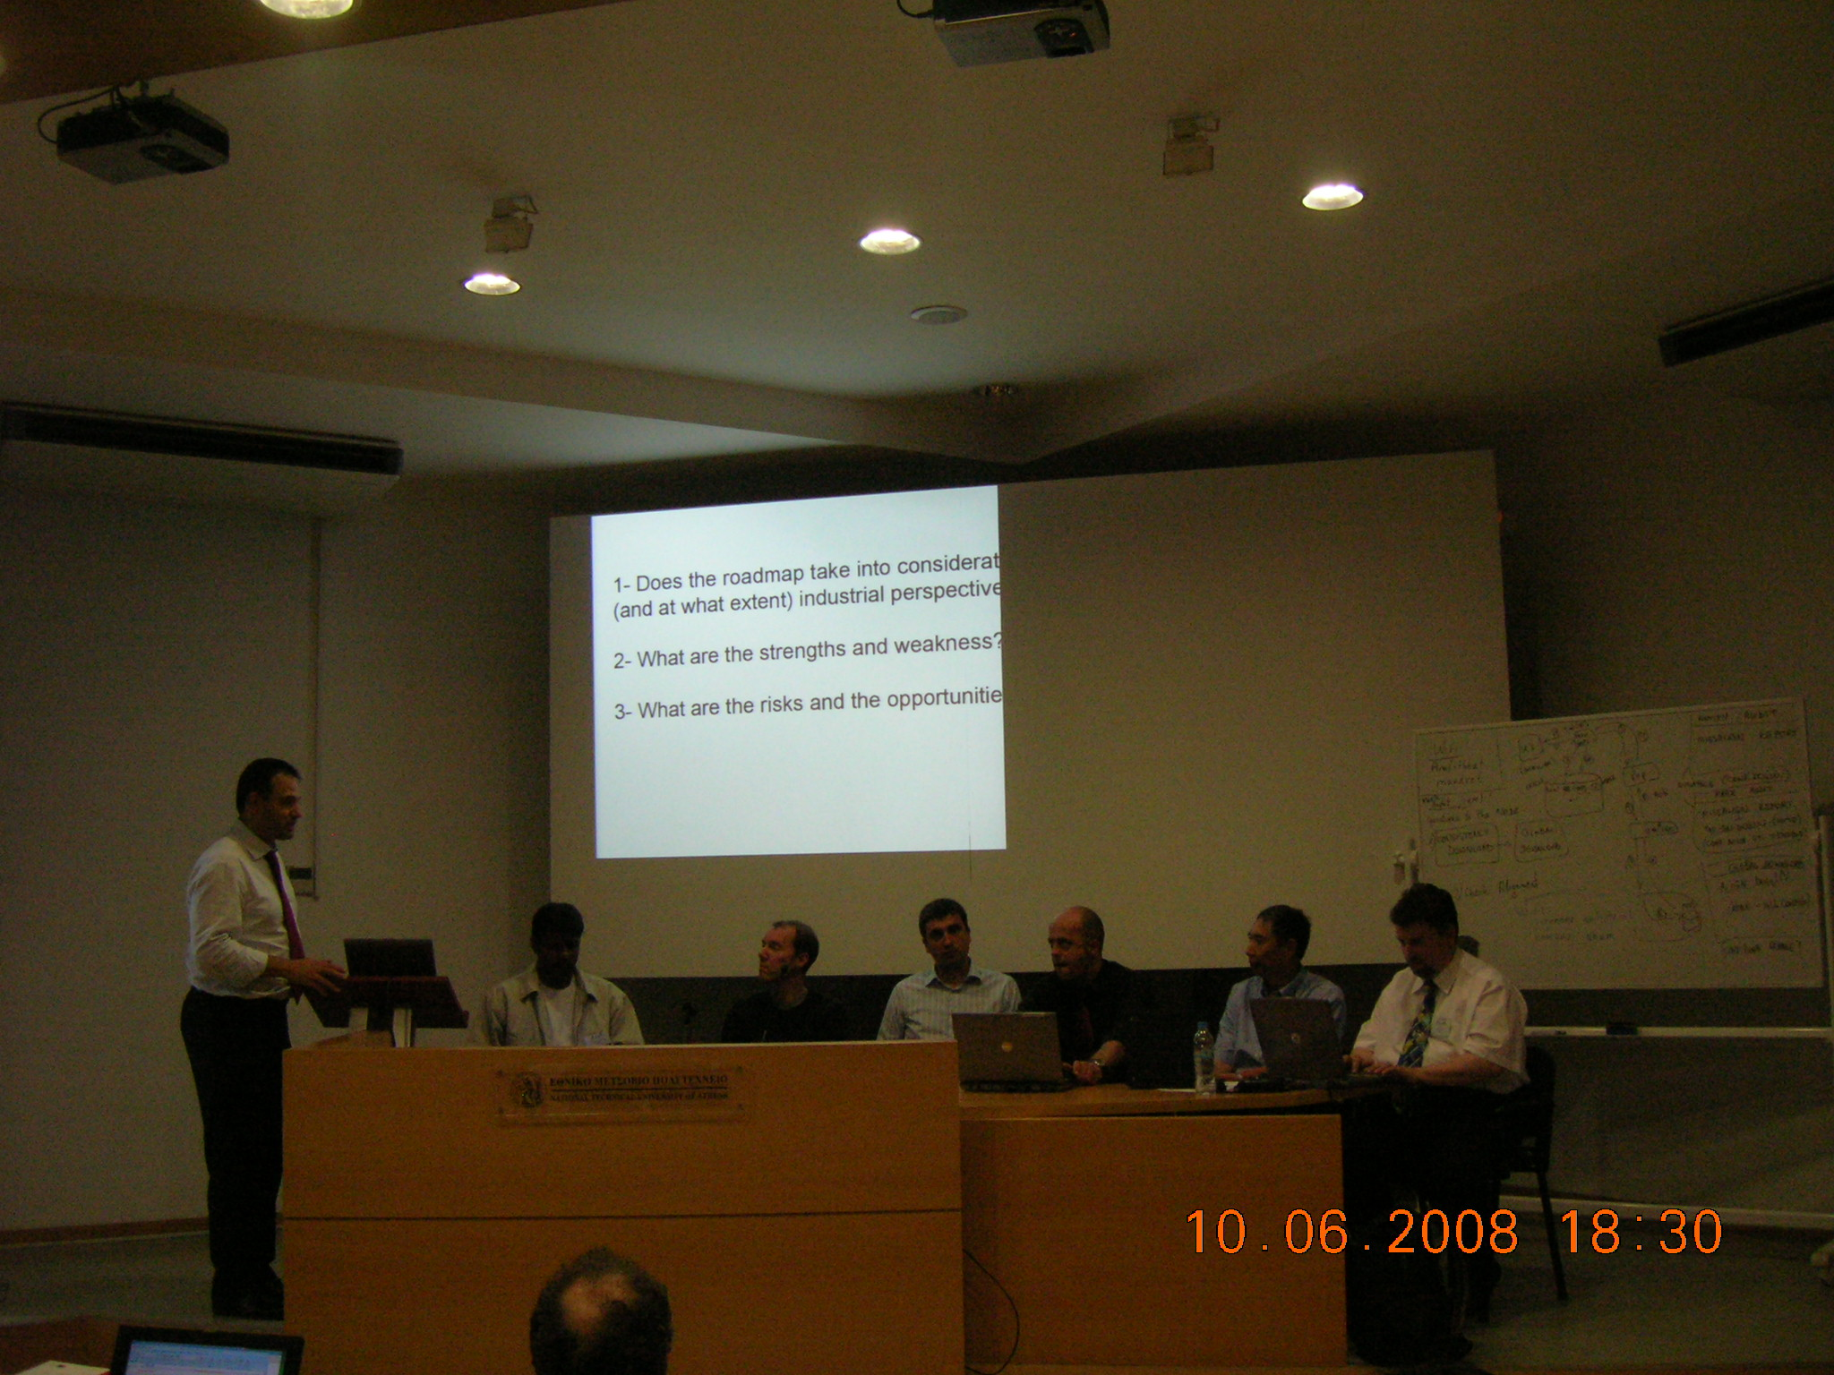

China-EU Cooperation Workshop
In October 2008 a China-EU Cooperation Workshop was also held in Beihang University. This workshop was launched by EchoGRID, Sponsored by Department of International Cooperation, MoST, China and Information Society Technologies, EU, and took place at Beihang University, 28 Ocotber 2008. BRIDGE, as one of the important cooperation project between China and EU was introduced during this workshop to about 100 participants including both Chinese and European government officials and industrial and academic attendees. Through this face-to-face communication we introduced our project activities and experience and looked for more and better cooperation opportunities in the coming future.

4th and 5th BRIDGE project meetings
The 4th and 5th BRIDGE project meetings were hosted by Beihang University in October 2008 and in February 2009. These meetings provided face-to-face communication among project partners to discuss the BRIDGE progress and status and plan future work.

ECMWF progress towards objectives

ECMWF is active in many intentional events related to its community. ECMWF took these opportunities to present the work done in BRIDGE to international audiences:
- A presentation on “TIGGE and the EU Funded BRIDGE project” was given at the Global Organization for Earth System Science Portal (GO-ESSP) 6th workshop in June 2007 in Paris. The presentation was entitled “TIGGE and the EU Funded BRIDGE project”.
- A presentation on “TIGGE and the EU Funded BRIDGE project” was given at the 11th Workshop on Meteorological Operational Systems in November 2007 at ECMWF.
- ECMWF provided a presentation on BRIDGE at the 24th Conference on International Interactive Information and Processing Systems (IIPS) for Meteorology, Oceanography, and Hydrology, 20–24 January 2008 in New Orleans, Louisiana.
- ECMWF published an article on BRIDGE in the ECMWF Newsletter released in November 2008.. Around 1,500 copies of the newsletter are printed and sent to National Meteorological Services, Universities and Research Institutes around the world.
- A presentation entitled “The EU funded BRIDGE project: creation of EPS products in a service oriented architecture” was presented at the workshop on the use of GIS/OGC standards in meteorology held at ECMWF between the 24th and 26th November 2008.

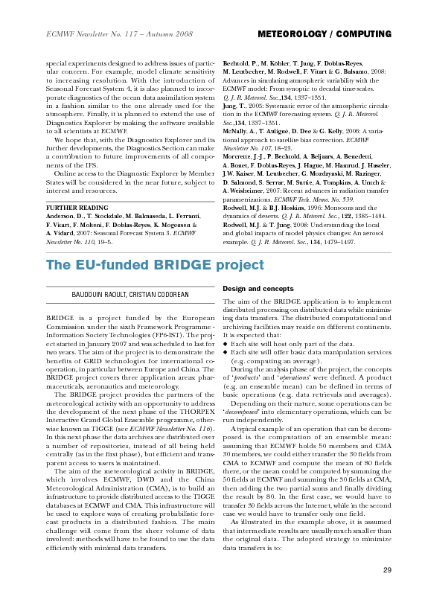 | 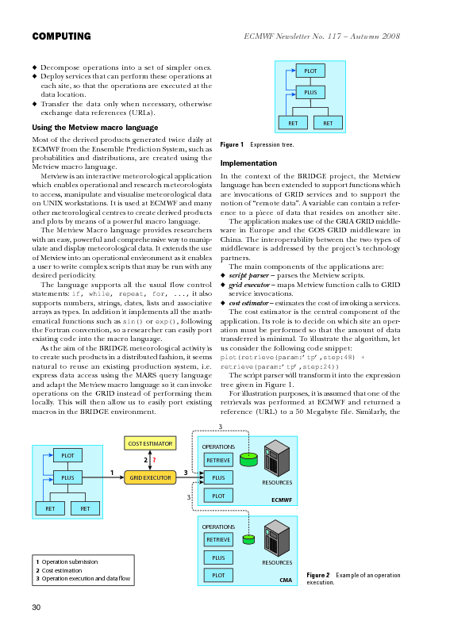
ECMWF Newsletter article on BRIDGE

Fraunhofer SCAI’s progress towards objectives
Fraunhofer SCAI and Fraunhofer ZV are contact point for all BRIDGE Deliverables. To ensure that all deliverables are legible the SIMDAT Management has provided templates specifying the structures of the various kinds of deliverables such as Application Activity deliverables or technology area deliverables and has introduced an internal reviewing process.

To disseminate BRIDGE results in a proactive way various new actions have been initiated and performed during the final phase of the project. In particular, triggered on the global project level, each Application Activity has held at least one key dissemination event targeted at industry or industrial usage per year.

The key research area of BRIDGE “Transcontinental Workflows for Simulation, Engineering and Design on heterogeneous platforms” has been promoted via Internet and a project flyer. Both include contact points and present the BRIDGE architecture as well as information on the different BRIDGE achievements.

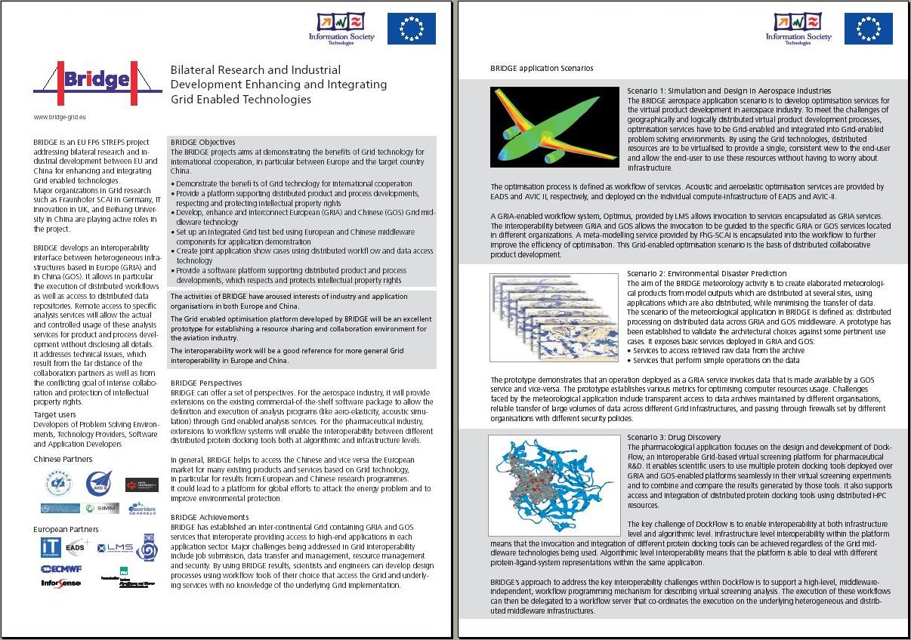
BRIDGE project flyer

Towards the end of the project the BRIDGE Management has issued a Pharma Success Story:

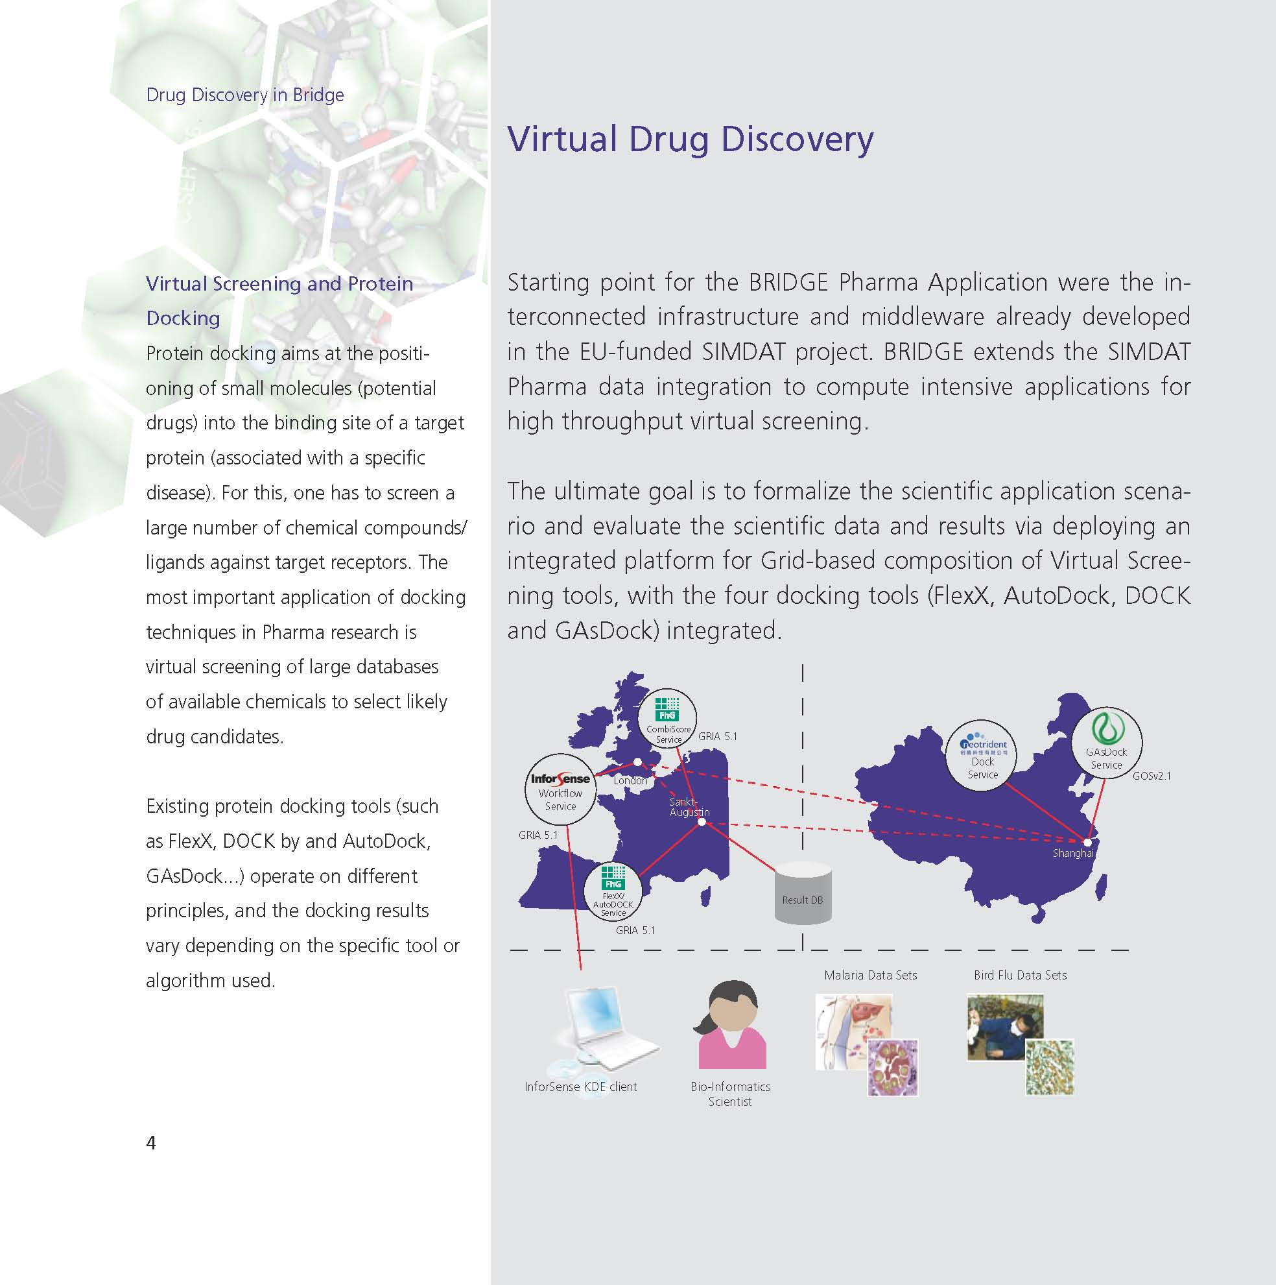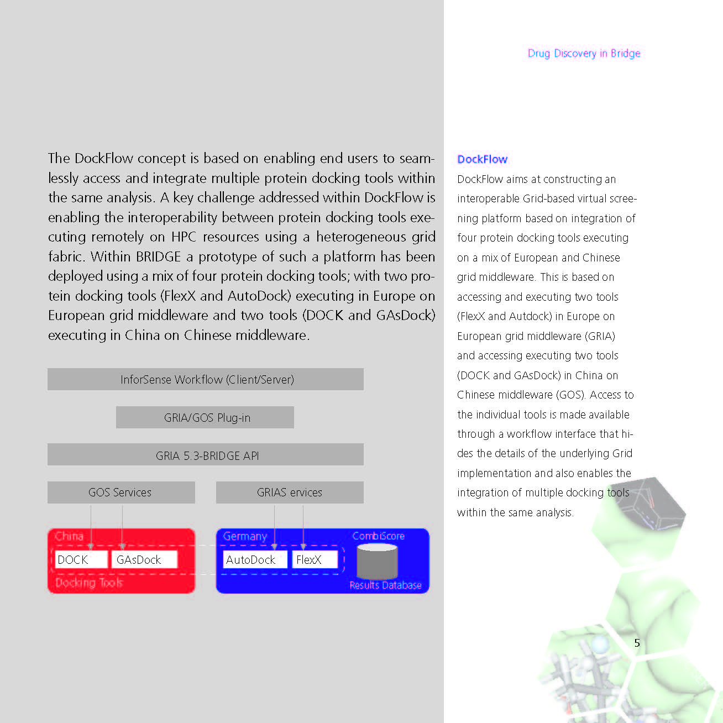

An Aero Success Story will be prepared for the final review.

Outlook

BRIDGE’s information dissemination activities will continue well beyond the end of the project.

Both Success Stories (Pharma and Aero) will be available well distributed by the BRIDGE partners after the end of the project as they focus on the final achievements.

The BRIDGE website will be maintained well beyond the end of the project with BRIDGE public deliverables being available for download.

Conclusion

BRIDGE is a Specific Targeted Research Project (STREP) focussing on demonstrating the benefits of GRID technology for international cooperation, in particular between Europe and the target country China.

The project has been a success, with many results already in commercial applications.

Compared to its objectives BRIDGE achieved what was originally planned and even more.

The BRIDGE strategic objectives and the related outcome are

- To demonstrate the benefits of GRID technology for international cooperation
BRIDGE has been highly successful. IT Innovation and BUAA have developed a Grid infrastructure. First the requirements were analyzed before specifications were implemented by GRIA and extensions to provide the performance required by the BRIDGE applications and interoperability with GOS. The differences between GRIA and GOS were handled through a series of phased developments, starting with a simple but limited gateway-based approach to interoperability, which was then replaced by a more generic client-side API capable of invoking different types of service. This was then augmented by an “Adaptive API”, which provides a common interface to workflow authors. Finally, IT Innovation and BUAA looked at some newer technology stacks and began the process of migration to one of them in order to take advantage of the newer standards support that these platforms offer.

- To develop, enhance and interconnect European and Chinese GRID middleware technology
GRIA and GOS do have significant similarities in core message level protocols and the services provided for data processing and storage but there are important differences in approaches to management of business relationships. BRIDGE achieved interoperability by federating services using a combination of adaptive client interfaces (disparate approaches) and services based on standardised interfaces (analogous approaches). Three main interoperability areas were considered:
- policy management: initiating trust relationships, managing security policies, and maintaining access rights Process state
- resource and capacity management: deciding how to provision service considering service providers resource constraints
- data processing and storage: executing computational jobs, requesting data transfer and Storage

BRIDGE brought together technologists, engineers and scientists from across the globe to examine issues of collaboration and interoperability. The project demonstrated that by balancing the use of standards with adaptability service-oriented infrastructures can support global collaboration and interoperability for inter-domain Grid applications. BRIDGE’s success is only a beginning for the Internet of Services. The reliance on service-oriented systems will dramatically increase as society and the enterprise endeavour to meet the social, political, environmental and economic challenges of the next decade. Collaboration and interoperability will be foundation for success and BRIDGE has made an important step in that direction.

- To set up integrated GRID test bed using European and Chinese middleware components for application demonstration
GRIA and GOS both supported a number of these standards before the BRIDGE project. IT Innovation and BUAA have together been able to deliver a powerful and consistent infrastructure which has allowed the BRIDGE application partners to collaborate effectively in running integrated application workflows that utilise Grid resources across Europe and China.

- To disseminate the results of the project to industrial and academic communities
BRIDGE results have been presented on a large number of conferences, both in China and Europe. Especially the Chinese partners have organized and hosted many workshops, where industrial partners from the relevant Chinese industrial sectors participated. In addition, special application sector specific events were organised targeting scientists and engineers from these application areas. Project flyers and press releases have promoted the results and findings of BRIDGE to a wider audience and were widely taken up (see the section on WP 5 Information dissemination).

- To provide a software platform supporting distributed product and process developments, which respects and protects intellectual property rights
BRIDGE has developed a service-oriented interoperability framework between European and Chinese middleware technologies that allows the execution of distributed workflows with transparent access to distributed data repositories and heterogeneous Grid resources. European sites provide services based on GRIA and Chinese sites to provide services based on CNGrid GOS (GOS). Interoperability focuses on supporting secure and managed distributed collaborations between Chinese and European industrial and academic communities, whilst satisfying the specific needs of the target application sectors.

- To set up joint application show cases using distributed workflow and data access technology
Demanding applications show cases have been defined in each of the 3 application sectors, which have been solved be the project partners implementing related prototypes:

Aerospace
The aerospace scenario has been for the BRIDGE project a though challenge to accomplish. Starting from the original objectives of the DOW, the complexity of the implementation of this scenario has been unveiled and its representativeness of industrial aerospace applications has been clearly demonstrated in the two prototypes (Phase I and Phase II).

In fact, the original aims of the Aerospace Applications work package to set-up and demonstrate in operation a distributed workflow for optimization that includes at least two simulation modules and a total of five GRID Services developed and set-up during the course of the project have been successfully achieved. The activities carried out to reach and, in some cases, exceed the objectives set in the description of work have been split in two different phases. In the first phase, demonstrated during the first review meeting, the aerospace scenario has achieved the implementation of analysis services based on Grid technologies as supplied by GRIA and CNGrid/GOS and has been described in the D2.2 document. The interoperability schemas developed in WP1 have been deployed in the Phase I prototype and described in the D2.3 document to achieve the needs of the overall optimization workflow. In the second phase, the prototype integrated five out of seven Analysis Services for optimization purposes and executed the genetic optimization procedure. The aerospace Phase II prototype used the results of the Phase I prototype to generate the meta-modeling services and the extended workflow definitions to accomplish GRID interoperability and deployment across the EU and China.

Moreover, an additional important achievement of the WP2 aerospace scenario has been the cooperation between different aerospace partners across the globe, allowing the fruitful exchange of information and technology to enable interoperability of analysis services and specific aspects of the aerospace analyses. In particular, the three dissemination and exploitation meetings held in China and the technology cooperation between the partners (e.g. LMS and EADS, SCAI and AVIC) have contributed to the successful achievement of the WP objectives and the realization of the aerospace prototype. This prototype effectively represents a complex aerospace scenario that can be addressed by taking advantage of the BRIDGE technologies.

Thus, the Aerospace applications workpackage has successfully achieved the completion of the optimization process and workflow, including five of the seven analysis services developed (as described in D2.3 and D2.4) and has aligned the development to the new GRID Interoperability schemas worked out in WP1. This constituted an effective communication, computational and testbed framework that has demonstrated to be effective in addressing complex aerospace simulation problems and to solve them efficiently over cross-continental GRID networks, especially between Europe and China.

Meteorology
During the course of the BRIDGE project, the partners of the Meteorological activity have deployed a hybrid GRID infrastructure based on GRIA in Europe and GOS in China.
The GRID offers access to model outputs as well as basic analysis services, such as the computation of averages, standard deviation and plotting facilities amongst many others. Using the Metview macro languages, a power full language used in the meteorological community to manipulate model outputs, users can chain these services to compute elaborated probabilistic products, such as clusters or EPSgrams, in a distributed fashion over the grid.

In order to achieve this, the Metview language has been enhanced to support GRID based services. Furthermore the Meteorological Archival and Retrieval System (MARS) has been interfaced with both GRIA and GOS to provide access to the multi-terabyte TIGGE archive.
Many services have been deployed at each site, offering a variety of analysis services ranging from simple arithmetic on meteorological fields to more complex statistical functions. ECMWF’s graphical package, MAGICS++, has also been made available on the GRID to allow the plotting of results. The outcome is a framework in which new sites and new services can easily be integrated. This has been validated by offering access to deterministic model outputs as well as data conversion services available from DWD.
A web portal has been developed, with the associated security and user management, to allow researchers to make use of the infrastructure that has been developed during this project. Two catalogues have been implemented: a data catalogue, hidden from the users, that describes what data is available from where, and a product catalogue, searchable and browsable by the users, which list of products that we want to make available to the end-user. Each product is described by a name, a short abstract, the Metview script that when executed on the GRID will create the product, and the arguments and their possible values. Users are given the possibility to parameterize these product definitions to suit their needs before submitting them to the GRID. Users are also able to upload new product definition to the catalogue, to share with their community.

The objectives of Meteorological Application in BRIDGE have been defined as: “The implementation and deployment of GRID enabled services at CMA and ECMWF, allowing researchers worldwide to discover and retrieve data from the TIGGE databases, as well as the provision of simple analysis services, such as statistical computations, to be performed at the data location.” Not only has these objectives have been clearly met on the technical level, but the BRIDGE project has strengthen the collaboration between the Chinese and European meteorological services.

The outcome of the BRIDGE will be further developed and used by ECMWF and CMA to provide distributed access to the TIGGE archive to the research community. The work done during the course will be further promoted to the international community, starting with the next TIGGE user workshop that will be held next May in Monterey, USA, where all the data providers, archives centres and potential users will be present.

Pharmaceutical
In DockFlow the Pharma partners have successfully integrated the four different docking tools executing as remote services at geographically distributed locations in Europe and China from a common workflow. The Pharma partners used multiple algorithms for solving the same problem in a branched workflow to address the problem of diversity of results produced by different docking tools. The storage of the outcomes of these tools in a common docking database supports a comparison of the results. Moreover, as shown in D4.6, the Pharma partners could demonstrate on a test set that our combinatorial approach Combiscore improves docking accuracy compared to the use of a single tool. Environments like the DDB support result analysis in such large scale collaborative screening experiments by providing a common platform with sorting, filtering and visualizing facilities but the current implementation of the DDB is not suited to be easily integrated as a Grid service in a generic way with other tools, and has been specifically integrated for the DockFlow prototype. This clearly marks a limitation of virtualization with the tools and techniques currently available. There is a long road to go for software tools routinely used in cheminformatics to enable them as services integrated in a Grid environment. Our next step in building a truly integrated problem-solving environment for virtual screening would aim at an integration of the docking database (DDB) as a true grid ressource. As on the technical site implementations of the core grid technology already exist, like in the Oracle 10g family of software products [20], we do not anticipate major problems at this point. Once we have the DDB integrated as a true grid service, the prototypic PharmaGrid will be turned into a truly productive environment that supports virtual screening with the ability to optimize docking strategies and to make full use of the adaptive features of the workflow.

The Pharma partners are fully aware of the fact that with DockFlow they sketch only how an adaptive PharmaGrid for virtual screening could look like. However, they will continue to work towards productive PharmaGrids and extend the workflow implemented in DockFlow by intelligent approaches to select focused virtual libraries and to qualify predicted in silico hits further by molecular dynamics (MD) simulation analysis.

Exploitation and Dissemination of Knowledge

While project dissemination activities will provide a general picture of the project, the promotion and exploitation of BRIDGE will provide detailed technical information to end-users and give them the skills to deploy and use the grid computing infrastructure allowing them to learn and practice using the Bridge grid computing infrastructure for dissemination and training. It requires more manpower and time to accomplish this goal.

Activities of Bridge results promotion and exploitation will be comprised of the following aspects.
- Dissemination of project results,
- Exploitation of project results, and
- training services for end-users.

A training course on LMS Optimus workflow tools was given in early July of 2007 in Beijing. This training attracted interest of Chinese aviation industry users.

  - WP1 Grid Infrastructure

Exploitation Activities from BUAA
BUAA undertook many efforts with several industrial and academic partners inside and outside the project to ensure the exploitation of the results obtained from the project.

Based on our work about interoperability between CNGrid GOS and SIMDAT GRIA, we helped the CNGrid GOS team from ICT (Institute of Computing Technology) of CAS (Chinese Academy of Science) to extend CNGrid GOS client toolkit and BES service and related security issues to make CNGrid GOS an interoperable middleware. These extensions were included in the new released version of CNGrid GOS. The new version GOS has been deployed and operated in ten-site CNGrid environment.

Using the technology outcome from the activities of WP2, we have implemented a prototype and set up an experimental environment. These helped our industry partners in AVIC to establish their distributed optimization system for aircraft design. We also popularize our research results to some other area, for instance, food safety. We have got a new Chinese project to do further research based on some results of BRIDGE project.

We also set up experimental environment to test the functionalities of our prototype on drug discovery. We use these result in project of high technology research and development programme (863 programme) to build a drug discovery grid based on China National Grid (CNGrid).

Exploitation Activities from IT Innovation

Exploitable Knowledge (description) | Exploitable product(s) or measure(s) | Sector(s) of application | Timetable for commercial use | Patents or other IPR protection | Owner & Other Partner(s) involved
How to virtualise heterogeneous Grid middleware through adaptive client | GRIA | All Internet based business sectors | 1 year | Copyright and LGPL | IT Innovation
How to apply emerging Web Service standards for dynamic industrial collaboration | GRIA | All Internet based business sectors | 1 year | Copyright and LGPL | IT Innovation

How to virtualise heterogeneous Grid middleware through adaptive client frameworks: Client adaptability is an essential capability for integration of services with different business processes and application interfaces. BRIDGE’s standards enhancements and adaptive API have been integrated with GRIA’s client package. The resultant prototypes and demonstration results have been published to NEXOF-RA for inclusion in their reference implementation so that other projects can use this as the foundation for their research. The software has been published open source (LGPL) on the GRIA website and is being deployed in other application sectors beyond BRIDGE. We expect these deployments to lead to further commercial opportunities.

How to apply emerging Web Service standards for dynamic industrial collaboration: many web service standards and specifications have stabilised throughout the lifetime of the BRIDGE project. The strengths and weaknesses of various alternatives have been analysed and evaluated for adoption in GRIA as a baseline for middleware interoperability. The conclusions are important for both developers and end-user of service-oriented infrastructures. This knowledge asset has the potential to contribute to further consultancy work.

  - WP2 Aerospace Application

Exploitation
LMS has actively worked in the exploitation of the results of the activities of the BRIDGE project. The promotion done and the positive feedback have motivated LMS to invest more resources in the completion of the objectives posed for the project. Moreover, the active campaign that LMS has carried out with its customers has been oriented to increase visibility and awareness of the BRIDGE technologies.

In particular, the overall feedback received so far for BRIDGE related technologies have lead to the creation of commercial prototypes and significant improvements in the OPTIMUS technologies as well as in the LMS Virtual.Lab Acoustics product. In particular, feedback from key customers has motivated key improvements in distributed executing of workflows and analyses, according and, sometimes, going beyond project objectives. Additionally, the integration of the Actipole acoustic solver, developed by EADS, in the LMS Virtual.Lab Acoustics product (including distributed computing features) has considerably contributed to increase the visibility of the results achieved in the BRIDGE project with LMS customers using acoustic products.

Moreover, LMS objective to increase customer awareness of GRID technologies and its advantages have raised considerable interest – nevertheless suggestions have been received to improve licensing models and efficient software license usage across GRID frameworks. This has lead LMS to further investigate business related aspects, trying to find appropriate licensing schemes in support of GRID technologies developed within BRIDGE, taking part into a new and more specific research project oriented to software licensing schemes named SmartLM.

Overall, the exploitation activities can be bundled in one of the following three categories:
- Commercial presentations to prospect customers
- Training Activities
- Collaboration amongst IST GRID Projects
In the future plans and as the GRID enabled OPTIMUS becomes a fully industrialized product, LMS will include the capability achieved with the BRIDGE project on its OPTIMUS commercial material, such as brochures, Product Information Sheets, Application notes. Visibility of the BRIDGE research activities carried out during project execution will be given on the LMS corporate website as soon as the R&D activities section will become active (planned by summer 2009).

Moreover, the activities and results of the aerospace application have been also distributed through the commercial channels of EADS and LMS. In particular, the results of the BRIDGE project have lead to the joint dissemination in China and worldwide of the Actipole acoustic solver developed by EADS and integrated into LMS Virtual.Lab Acoustics product through the LMS commercial channels as result of the BRIDGE collaboration.
Also, the dissemination of the BRIDGE results has happened through LMS representatives in China for the LMS OPTIMUS product, thanks to the improvements achieved through the cooperation activities between LMS and SCAI, AVIC and BUAA.

Exploitable Knowledge (description) | Exploitable product(s) or measure(s) | Sector(s) of application | Timetable for commercial use | Patents or other IPR protection | Owner & Other Partner(s) involved
Genetic Algorithm Optimization | GAO | China AVIC | 2009 | BEIHANG University | AVIC
Acoustic Algorithms for large scale simulations | Acoustic Software | Noise prediction | Ready | License | LMS & EADS
Multi-level workflow methods | Multi level workflow feature in LMS OPTIMUS | Simulation Process integration | Ready | License | LMS

Genetic Algorithm Optimisation
GAO has been used in Shenyang Aircraft Design And Research Institute successfully for aircraft design optimisation since August 2008.

Acoustic Algorithms for large scale simulations
The active and close cooperation between LMS and EADS in the execution of the activities for the aerospace scenario have led to the technology transfer of the acoustic algorithms for large scale simulations developed by EADS and now integrated into LMS software Virtual.Lab Acoustics. The dissemination of the benefits of these algorithms has been carried out separately by LMS and EADS, through the participation to conferences and exhibitions, while the exploitation aspect has been carried out jointly by LMS and EADS in order to address the market of aeroacoustic simulations with an efficient solver. In particular, the integration of this algorithm has been presented in the last dissemination and exploitation meeting in Beijing, China in February 2009.

Multi-level workflow methods
A new functionality has been developed in LMS OPTIMUS to allow a much increased flexibility in the process capturing phase to address the real break down system/subsystem scheme. By using the multi-level workflow, the user has the possibility to nest sub workflows into other workflows, thus generating a hierarchical structure of nested process flows. This feature has been used in the aerospace scenario in order to allow the execution of the GAO optimisation procedures for flap noise reduction.

In particular, the multi-level workflow feature can be used to import an existing OPTIMUS project via a tasklist, i.e. a batch execution of analysis methods defined on a workflow. In the main OPTIMUS workflow project, the user can import methods, inputs, outputs and constraints, defined in another OPTIMUS workflow project.

After inserting the imported OPTIMUS workflow in the main OPTIMUS graph, allthe inputs, outputs and the necessary connections are automatically created.

This feature is already available in the latest version of OPTIMUS on the market.

Dissemination of Knowledge

Overview table
Planned/  actual  dates | Type | Type of audience | Countries addressed | Size of audience | Partner responsible /involved
 | Press release(press/radio/TV) | General public
 | Media briefing | Higher education
 | Conference | Research
 | Exhibition | Industry ( sector x)
23 June 2008 | Introduce BRIDGE and partner and products | Industry (aerospace) | 8 | 42 | AVIC
19 February 2009 | Introduce BRIDGE and products | Industry (aerospace) | 9 | 22 | AVIC
7-12 December 2008 | International Conference IGIIW2008 | Industry & academia (IT HPC) | Many | 150+ | BUAA & LMS
June 2009 | ISC 09 Conference | Industry (IT HPC) | Germany |  | EADS/LMS
 | Publications
 | Project web-site
 | Posters
 | Flyers
 | Direct e-mailing

BRIDGE Exploitation meeting June 2008
23.June.2008 BRIDGE partners has hold meeting in Beijing to introduce BRIDGE project, partners LMS EADS FhG SCAI and their products Optimus, Acoustic, DesParO etc after WP2 working meeting , 14 organization in AVIC have jointed the meeting.28 audience have jointed this meeting, 6 Vice Chief Engineer and 8 head of department in deferent research institutes and companies are amount them Some research institutes and companies are very interested the results of BRIDGE and those products.
24.6.2008 BRIDGE partners has hold Sehnyang China to give Dissemination BRIDGE and introduce partners. Vice President Vice Chief Designer and 20 head of department have jointed this meeting. They give very active response.

BRIDGE Exploitation meeting February 2009
19.Febraury.2009 BRIDGE partners has hold meeting for WP2 desalination. 22 audiences are attainted the meeting. Some come from AVIC, some come from Commercial Aircraft Corporation of China and some come from other industry partners. They give very food response for BRIDGE project and WP2 results.
AVIC has pooches two DesParO software after this meeting and more companies are interested LMS Optimus software and Acoustic software.
Shenyang Aircraft Design and Research Institute has try to use the two software in aero-elastic analysis and optimization and got good results.

Participation to the International Grid Interoperability and Interoperation Workshop 2008 (IGIIW 2008), December 7-12, Indianapolis, Indiana, USA with a paper titled “Cross-Domain Middlewares Interoperability for Distributed Aircraft Design Optimization” written by Yongjian Wang (BUAA), Roberto d'lppolito (LMS), Mike Boniface (IT Innovation), Depei Qian (BUAA), Degang Cui (AVIC), Jiyun Jiang (LMS)

ISC09 conference paper
The International Supercomputing Conference (ISC) is Europe’s leading Conference and Exhibition on High Performance Computing, Networking and Storage. The aero workpackage has submitted the following paper: Cross-Domain Middleware Interoperability for Distributed Aircraft Design Optimization by Yongjian Wang, D'Ippolito Roberto, Mike Boniface, Depei Qian, Degang Cui, Jiyun Jiang, Alleon Guillaume

  - WP3 Meteorological Application

Exploitation
The GRID deployed by the meteorology activity within BRIDGE will be used operationally to provide free access to the TIGGE data and BRIDGE services to users from research and education oriented institutions throughout the world.

The software developed by the partners during the course of the project will be provided under an Open Source licence (Apache 2.0) and will be made publicly available from a web based source code management system hosted at ECMWF that will allow contributions from third parties.

The partners will demonstrate and promote the BRIDGE software and infrastructure to other TIGGE partners during TIGGE technical meetings and to the WMO community during expert team meetings as a key building block of WMO’s Global Interactive Forecasting System.

The synergy established between the Chinese and European partners of the meteorological activity during the BRIDGE project will continue at several levels: on an operational level, by running an operational GRID, on a technical level by developing further the functionalities and services, and on a scientific level by exploiting the results of the TIGGE database to improve forecasting of severe weather events.

Dissemination of Knowledge

Planned/  actual  dates | Type | Type of audience | Countries addressed | Size of audience | Partner responsible /involved
June 2007 | TIGGE and the EU Funded BRIDGE project  Presentation at the Global Organization for Earth System Science Portal (GO-ESSP) 6th workshop |  |  |  | ECMWF
November 2007 | TIGGE and the EU Funded BRIDGE project  Presentation at the 11th Workshop on Meteorological Operational Systems |  |  |  | ECMWF
20–24 January 2008 in New Orleans, Louisiana | Presentation at 24th Conference on International Interactive Information and Processing Systems (IIPS) for Meteorology, Oceanography, and Hydrology |  |  |  | ECMWF
November 2008 | Article in the ECMWF Newsletter |  |  |  | ECMWF
24th and 26th November 2008 | Presentations “The EU funded BRIDGE project: creation of EPS products in a service oriented architecture”  Workshop on the use of GIS/OGC standards in meteorology at ECMWF, Reading, UK | International |  | > 100 | ECMWF
May 2009, Monterey, California | BRIDGE presentations at the TIGGE user workshop |  |  |  | ECMWF

Description 1
This workshop was intended to promote the goals and objectives of GO-ESSP. Participants had to share their progress in developing software infrastructures that facilitate discovery, acquisition and analysis of climate data with, for this meeting, a special emphasis on model-generated data. They had to seek to identify and foster integrated efforts that lead to global interoperability of their independently developed systems.

Description 2
This workshop reviews the state of the art of meteorological operational systems and addresses future trends in the use of medium-range forecast products, data management and meteorological visualisations on workstations. It is expected that users of the ECMWF forecasts report on their approach to medium and extended range weather forecasting, including the use and application of ECMWF products.

Description 3
This conference, sponsored by the American Meteorological Society, was organised by the AMS Committee on IIPS as part of the 88th AMS Annual Meeting. The conference addressed quite a few subjects like Global Meteorological and Hydrological Service Updates, International Applications, Applications in Meteorology, Oceanography, Hydrology and Climatology, GIS Applications; Internet Applications and Cyberinfrastructure, Challenges in Data Access, Distribution, and Use.

Description 4
The ECMWF Newsletter is a publication released quarterly which contains articles about new developments and systems at ECMWF. Around 1,500 copies of the newsletter are printed and sent to National Meteorological Services, Universities and Research Institutes around the world. The newsletter is also available on the ECMWF public web site from where it can be downloaded.

Description 5
The aim of this workshop was to review the use of OGC standards in geo-sciences in Europe and worldwide, to promote collaboration between meteorological services in order to define a set of common standards that will enhance interoperability.

Description 6
The aim of the workshop will be to show researchers how to use the TIGGE archive, publicise and seek feedback on the plans for the development of a Global Interactive Forecasting System (GIFS) and present early scientific results from TIGGE.

  - WP4 Pharmaceutical Application

Exploitation
Whereas the direct final outcome of the pharma activity is an integrated DockFlow prototype, the individual software components and services developed within the project themselves provide more tangible exploitation opportunities. Furthermore, an auxiliary but strong output from the project lies in the molecular results arising from using the platform and individual tools.

An overview of the outputs and the exploitation strategy for each is summarized in the table below and then described in more detail in the individual partner sections. Overall, in the short term, the direct beneficiaries of the technology, services and results would be academic institutions and research projects, e.g. the WISDOM project in Europe and the Drug Discovery Grid consortium in China that provide wider consortia for disseminating the outputs and form larger test-beds for the technology. In the medium term, the project outputs enable the partners to forge new national and international research and service collaborations (e.g. the consortium has received string interest from researchers in Egypt where Bird Flu is a major concern). In the longer term, and after having proved the technology and approach, commercial exploitation opportunities targeting pharmaceutical and biotechnology companies also exist. These will be pursued by the individual partners as described in the relevant sections.

Software | Main characteristics and exploitation strategy | Exploitation date
CombiScore  [SCAI] | CombiScore is a new proprietary tool developed by SCAI integrating and combing the results of docking tools. SCAI will exploit CombiScore through a number of strategies to reach end user communities, including provision as standalone software package, as a remote service and as part of an integrated prototype through licensing to third parties. | 2010
Extended HPC workflow engine  [InforSense] | Within the project, InforSense is developing extensions to its workflow engine technology to support compute intensive and data intensive applications with specific application to protein docking including access to protein docking tools. InforSense will exploit these technology developments by integrating them within its main product based on commercial licensing to end users within the pharma and biotech sector. | 2010
Integrated DockFlow Platform  [InforSense, all WP partners] | The final DockFlow prototype embodies and integrates the different technology developments conducted by the individual partners including the end user tools, the workflow engine, CombiScore and grid-enabled specialized protein docking tools and services. As an integrated prototype, its successful exploitation successful strategy requires a collaborative agreement between the partners and also appropriate licensing agreements. | 2010
Services | Main characteristics and exploitation strategy
Grid-enabled protein docking services  [SCAI & SIMM] | There are four protein docking tools used within the project. Each of the tools is being deployed as a Grid service accessible from remote locations. AutoDock and Dock are third party tools. FlexX is provided by BioSolveIT a subcontractor in the project. GAsDOCK is developed by SIMM. Within the project these tools are mainly set-up as experimental facilities for development. In addition, SIMM already provides virtual drug screening services based on Grid computing using DOCK and GAsDOCK that are free academic institutes and colleges within the Drug Discovery Grid consortium. The partners will investigate how such services can be provided as public services to wider academic communities and also as commercial services to meet industry needs. The key bottleneck to such an exploitation strategy lies in the cost and administration effort associated with setting up and maintaining the HPC resource used and also for maintaining and supporting live services. | 2009
Integrated DockFlow Service  [All WP partners] | An integrated service based on the DockFlow prototype could potentially be set-up for remote access through a specialized portal interface or service interface. The successful deployment and exploitation strategy for setting up such a service requires a collaborative agreement between the partners and also appropriate licensing agreements. Such a service could act as a meta-service (at one of the academic partners) coordinating the execution of the remote docking services. As with individual services, the key bottleneck to such an exploitation strategy lies in the cost and administration effort associated with setting up and maintaining the HPC resource used and also for maintaining and supporting live services. | 2010
Other Exploitable Results | Main characteristics and exploitation strategy
Protein docking results Molecular outputs)  [SCAI, SIMM] | Protein docking results are immediate input for molecular dynamics studies, where protein ligand interactions are studied microscopically. These results form input for other research projects and will be exploited by the application partners in the WP. In the longer term, they may also be commercially exploitable. | 2010

Dissemination of Knowledge

Overview table
Planned/actual  dates | Type | Type of audience | Countries addressed | Size of audience | Partner responsible /involved
30 January 2009 | DockFlow – a PharmaGrid for Virtual Screening Integrating Four Different Docking Tools | Research |  |  | Fraunhofer SCAI  InforSense  SIMM
06 February 2009 | DockFlow: Interoperability of Protein Docking Tools across heterogeneous Grid Middleware | Research |  |  | InforSense  Fraunhofer SCAI  SIMM

Description 1
A research paper entitled DockFlow – a PharmaGrid for Virtual Screening Integrating Four Different Docking Tools, collaboratively written by Fraunhofer SCAI, InforSense and SIMM, was submitted to the HealthGrid conference on 30th of January 2009. The seventh annual HealthGrid conference will take place 28 June - 1 July 2009 in Berlin, Germany. The HealthGrid conference is the premier conference on the transformation of biomedical research, education and medical care through the application of Grid technologies. HealthGrid is dedicated to:
- Enhancing biomedical research and healthcare delivery
- Creating an open collaborative virtual community
- Communicating the collective knowledge of the HealthGrid community

If the paper is accepted by the conference committee, Fraunhofer SCAI will give a talk at the conference being able to disseminate the activities of the BRIDGE Pharma consortium to an interdisciplinary community of computer scientists, physicians, medical educators and students, epidemiologists, bioinformatics and medical informatics experts, military medicine specialists, security and policy makers, economists and futurists. Moreover, the paper will be published in the series "Studies in Health Technology and Informatics" published by IOS Press (www.iospress.nl) and referenced in PubMed. This makes the BRIDGE Pharma results available for a broader research community not present at the conference.

Description 2
One of the long term problems associated with docking methods were integration of results in databases and results obtained from standalone docking producing large false positives. Through BRIDGE project these two long standing issues were addressed by integration of docking results at one common place using ORACLE based FlexX Docking DataBase and further development of the novel scoring function, Combiscore.

The Combiscore scoring function will be further improved and made freely available to the academic research community. On the biological side, the in silico results obtained against the target proteins will be made freely available to the research community who are active in the area of malaria and avian flu. These results can serve as a starting point for pharmaceutical companies or research institutes working on malaria and avian flu for drug development.

Appendix

Annex 1: Overview Bridge deliverables PM1 – PM26

Deliverable  No | Deliverable name | WP no. | Lead participant | Estima-ted person-month | Nature | Dissemination  level | Delivery  date
D0.1 | Project Progress Report | 0 | FhG SCAI |  | R | PP | M6
D0.2 | Periodic Activity Report | 0 | FhG SCAI |  | R | PP | M12
D0.3 | Periodic Management Report | 0 | FhG SCAI |  | R | PP | M12
D0.4 | Project Progress Report | 0 | FhG SCAI |  | R | PP | M18
D0.5 | Periodic Activity Report | 0 | FhG SCAI |  | R | PP | M26
D0.6 | Periodic Management report | 0 | FhG SCAI |  | R | PP | M26
D0.7 | Final activity report | 0 | FhG SCAI |  | R | PP | M26
D0.8 | Final project report | 0 | FhG SCAI |  | R | PU | M26
D1.1 | Report on interoperability requirements and interoperation schemes | 1 | IT Innovation |  | R | CO | M3
D1.2 | Report on Grid infrastructure interoperability design | 1 | IT Innovation |  | R | CO | M6
D1.3 | Prototype implementation of interoperable Grid services and gateway supporting basic discovery, except meta-scheduling | 1 | IT Innovation |  | P | PU | M9
D1.4 | Stable implementation of interoperable Grid services and gateway | 1 | IT Innovation |  | P | PU | M15
D1.5 | Report on Best Practice Approaches for Grid infrastructure Interoperability | 1 | IT Innovation |  | R | PU | M26
D2.1 | Description of Scenario | 2 | LMS |  | R | PU | M3
D2.2 | Description of completed Services | 2 | LMS |  | R | PU | M9
D2.3 | Phase 1 Prototype – Software and Description | 2 | LMS |  | PR | PU | M12
D2.4 | Phase 2 Prototype – Software and Description | 2 | LMS |  | PR | PU | M26
D2.5 | Final Report | 2 | LMS |  | R | PU | M26
D3.1 | Meteorology Scenario Statement of requirements | 3 | ECMWF |  | R | PU | M3
D3.2 | Proposal Internal Architecture | 3 | ECMWF |  | R | PU | M6
D3.3 | Prototype | 3 | ECMWF |  | R | PU | M12
D3.4 | Statement ofrquirements from DWD | 3 | ECMWF |  | P | PU | M18
D3.5 | Final Implementation | 3 | ECMWF |  | P | PU | M24
D4.1 | DockFlow Requirements Report: | 4 | Inforsense |  | R | PU | M3
D4.2 | DockFlow Design Report | 4 | Inforsense |  | R | PU | M6
D4.3 | DockFlow First Prototype | 4 | Inforsense |  | R | PU | M12
D4.4 | DockFlow First Evaluation Report | 4 | Inforsense |  | R | PU | M15
D4.5 | DockFlow Second Prototype | 4 | Inforsense |  | R | PU | M24
D4.6 | DockFlow Scientific Evaluation Use Case | 4 | Inforsense |  | R | PU | M24
D4.7 | DockFlow Final Evaluation Report | 4 | Inforsense |  | R | PU | M24
D5.1 | Delivery of an Communications Activity Plan | 5 | Beihang University |  | R | PU | M03
D5.2 | Exploitation Strategy Plan | 5 | FhG SCAI |  | R | PP | M6
D5.3 | Delivery of a detailed Dissemination Action Plan including Strategy | 5 | Beihang University |  | R | PU | M6
D5.4 | Delivery of a adapted material | 5 | Beihang University |  | O | PU | M18
D5.5 | Final dissemination report and update of publications and presentations | 5 | Beihang University |  | RO | PU | M26

AutoDock and FlexX have been used already in grid-based virtual screening approaches (see http://wisdom.eu-egee.fr/ ) and FlexX comes with a license management system which has already been used on the EGEE middleware gLite.
http://berlin2009.healthgrid.org
Deliverable numbers in order of delivery dates: D1 – Dn
Please indicate the nature of the deliverable using one of the following codes: R = Report P = Prototype D = Demonstrator O = Other
Please indicate the dissemination level using one of the following codes: PU = Public PP = Restricted to other programme participants (including the Commission Services). RE = Restricted to a group specified by the consortium (including the Commission Services). CO = Confidential, only for members of the consortium (including the Commission Services).
Month in which the deliverables will be available. Month 0 marking the start of the project, and all delivery dates being relative to this start date.

