EUROPEAN COMISSION - SIXTH FRAMEWORK PROGRAMME

Final report

Period: 1.4.06 – 31.3.09
Contract Number: | 016424
Project Acronym: | NanoPlasma
Project Title: | Plasma etching for desired nano-feature shape and nano-texture: an advanced reactor and simulation software for feedback-loop plasma control

Document Identifier: | NanoPlasma_Final report
Status: | Final

Title of Document: | Final project report
Dissemination Level: | Public

Author(s): | M Cooke, partners
Reviewed by:
Approved by: | M Cooke

Created on:
Last update:

Table of Contents

1. Summary 3
2. Simulations 4
3. Plasma etch tool and process development 10
4. Nanoscale roughness control 12
5. Plasma control 14
6. Plan for using and disseminating the knowledge 16
Acknowledgement 16

1. Summary
The nanoPlasma project was a partnership between
Oxford Instruments Plasma Technology (UK) - OIPT
Technische Universitaet Ilmenau (Germany) -TUI
Dublin City University (Ireland) -DCU
IMEL/NCSR Demokritos (Greece) -Demokritos
S3 solutions GmbH "Software & System Solutions" (Germany) -S3
ISMA (Bulgaria) -ISMA
The project duration was 3 years, from April 2006, funded under FP6 with a total EC contribution of 1.58m Euros.
Through plasma and surface modelling software, plasma diagnostics and an improved plasma etch tool design, the project aimed to improve the reproducibility and control of some of the more difficult etching processes at the nanoscale.

Notable achievements of the project were:

- A validated software simulation of plasma etching, working from process control inputs (gas flows, plasma power…) directly to etch rate and etch profile of a gas-chopped silicon etch process. This is believed to be a world first to obtain an integrated code of this kind
- An advanced plasma etcher featuring a new plasma source, RF automatch, integrated spectroscopy and closed loop control features, shown to reduce substantially the variation of etch rate with exposed silicon area (the ‘loading effect’), and to be capable of very high aspect ratio silicon etching.
- A robust plasma resonance probe (the ‘hairpin probe’) which measures electron number density in reactive gas plasmas with unprecedented precision.
- Nanoscale roughness control in plasma etching: a theoretical and experimental demonstration of the cause of nanoscale roughness evolution during plasma etching, showing both how to reduce the roughness, or to use it as a method to create 50nm textured pillars.

2. Simulations
Control of plasma reactors in real time, as well as fast simulation of nanostructure profile evolution and surface nanotexturing with plasma processes demand the use of fast ‘global’ or ‘0-dimensional’ models, originating in this project at Demokritos. Such models use average plasma variables ignoring their spatial variation (these are the so-called well stirred tank reactors in chemical engineering). A zero dimensional (Global) plasma chemistry code has been developed for 3 gases, namely O2, SF6, C4F8 applicable for high Density plasma reactors. Surface models have also been developed for calculation of the etching rates of
- SiO2 etching in C4F8 / fluorocarbon plasmas
- Si in SF6 plasmas or Si in the gas chopping process using alternating SF6/C4F8 plasmas,
- Organic polymer (PMMA) etching AND silicon containing polymer etching (silsequioxane type). This model enables simulation of bilayer lithographic processes using silicon-containing resists (an application useful for microelectronics, microsystems and microfluidic channel fabrication).
TUI and S3 have created and validated (with data from partners) a usable feature-scale model for the evolution of an etched nano-scale feature, including surface models and gas phase inputs. S3 have combined codes from other partners, and created user interfaces. They have created a powerful database from the validation etching results which can form the core of a ‘process expert’ assistant. An overview of the code structure is given below.
The plasma etch simulation software has been validated by comparing experimental cross sections of etched silicon wafers with the predicted profile. Although plasma etching often seeks to produce perfectly anisotropic etching, with vertical walls defined by the mask pattern, we chose to validate the code in a regime where both anisotropic (ion-stimulated etching) and isotropic (neutral radical etching) was present, producing an undercut below the mask. Here the motion of active species inside the feature must be captured accurately to reproduce the actual etched shape, including adsorption and re-emission from surfaces.

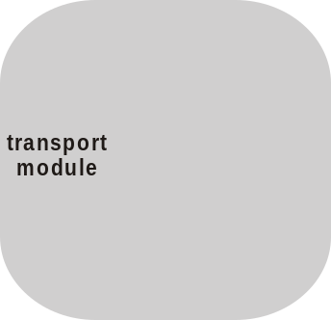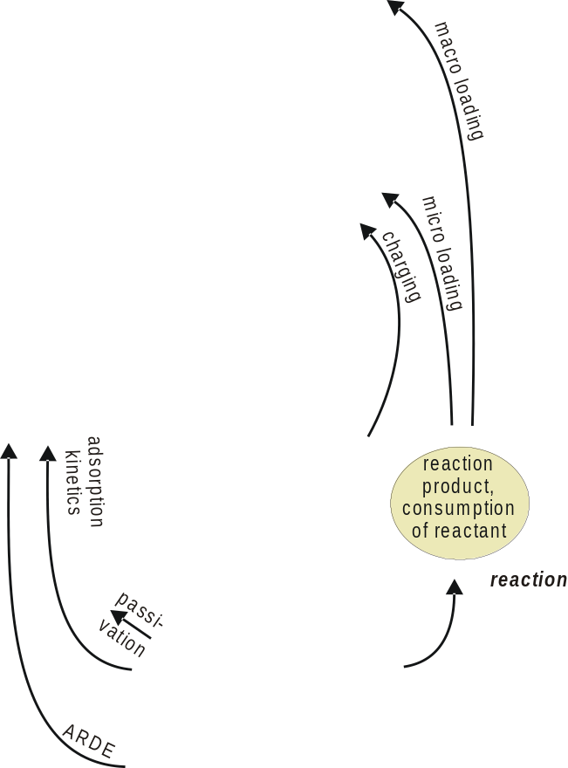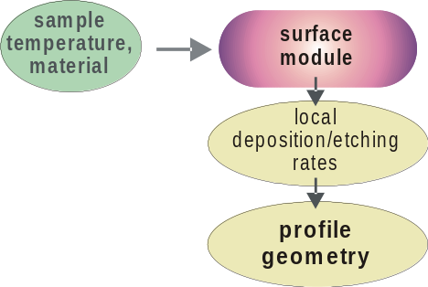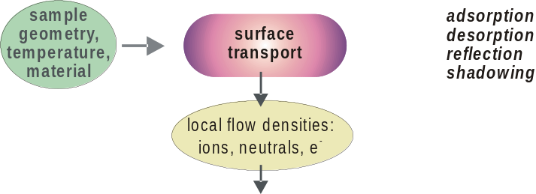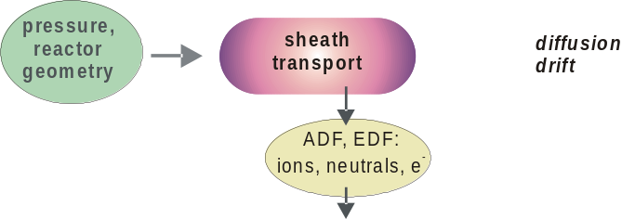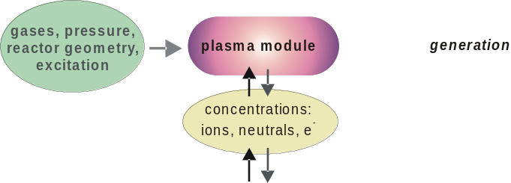

Figure 1 Overview of simulation model

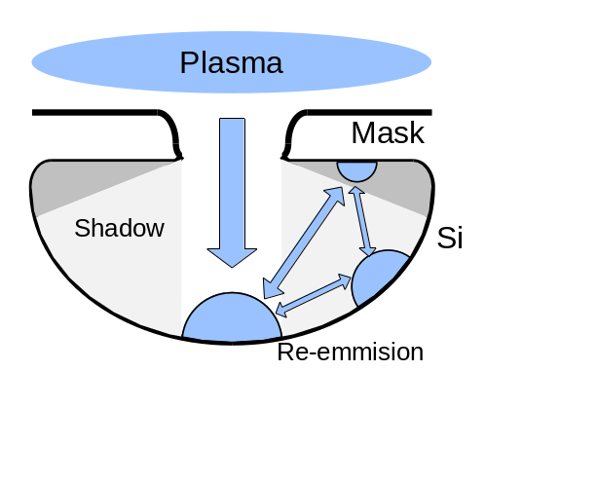
Figure 2 Transport of etching species underneath an undercut mask

Because the movement of neutral particles and diffuse reflection is similar to the distribution of light in a diffuse reflecting environment, the radiosity method, well known in computer graphics, was adapted. The most challenging task of the radiosity approach is the calculation of geometric relations between the finite elements, so called form factors. Even for simple arrangements of flat surface areas, there is no closed solution to calculate them directly. For the efficient calculation of both, visibility and form factors, a hemisphere projection approach, known as the Nusselt analogue, was utilized.
Although ions are much fewer in plasma than neutral particles, they gain energy on their way through the sheath and fall zone down to the sample. Etch and deposition processes are in general enhanced by the occurrence of energetic ions. Ion enhanced etching is appropriate to increase etch rate and for anisotropic etching.
When ions cross the sheath and fall zone, their velocity and energy distribution is altered and predicted by the sheath model. In contrast to neutrals, reflection on surfaces is specular and reflection probability depends on the incident angle on a surface. The radiosity method is not applicable for ions because of this. Instead of, a forward iteration approach was chosen to calculate in and outbound ion flux distribution.
Ions and electrons have different angular distributions on the lower sheath boundary near the sample surface. The angular distribution of ions is almost anisotropic, while at the same time the angular distribution of electrons is much more isotropic. That is why in the case of the etched trench with large aspect ratio, the ions travel almost parallel to the sidewalls, while a considerable amount of electrons have velocity compounds perpendicular to the sidewalls. Therefore, the probability of ions reaching the bottom of a trench is considerably higher than for electrons.
As a result, the upper part of the profile is charged up negatively, and correspondingly the bottom of the trench is charged up positively. Therefore the local electric field in the trench appears, that influences on the other charged particles, which come from plasma, causing the distortion of their trajectories, thereby deflecting the positively charged ions to the sidewalls. This causes etching in the lateral directions, what is very harmful for the anisotropy of the profile.

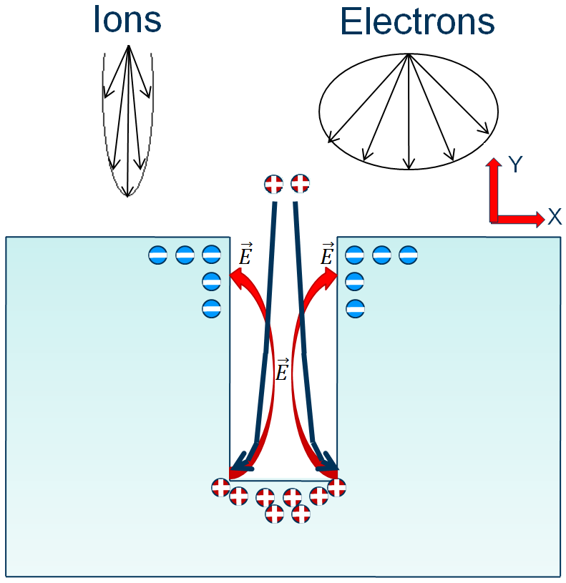
Figure 3 Influence of charges on particle transport within an etched feature

We made measurements from a range of feature sizes etched at different levels of ion impact energy, using scanning electron microscopy.

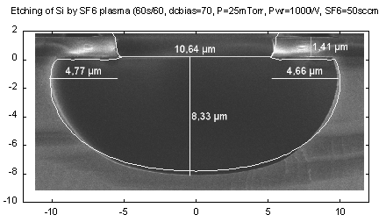
Figure 4 Simulated and experimental etching profiles

The results are summarized in this graph, comparing measured and simulated undercuts across different feature sizes and ion impact energies:

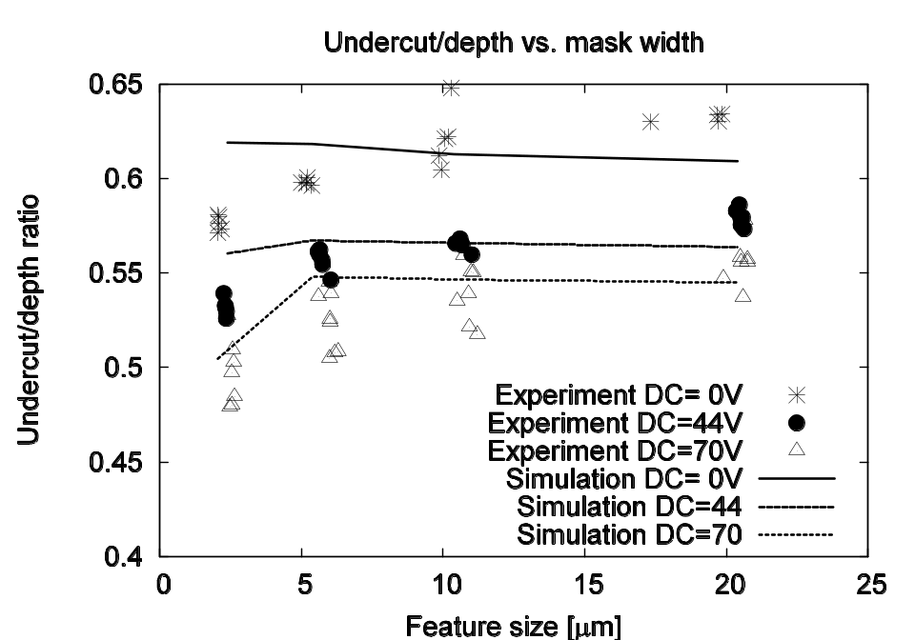
Figure 5 Summary of simulated and experimental plasma etched undercut in SF6 plasma
Even without using fitting parameters, there is good quantitative and trend agreement in most cases. The degree of undercut increases as the ion impact energy decreases as expected, because the ion-stimulated anisotropic etching component is reduced. The zero bias case at the lowest feature size shows some deviation, possibly because the ion impact energy is not actually zero in the zero bias case.

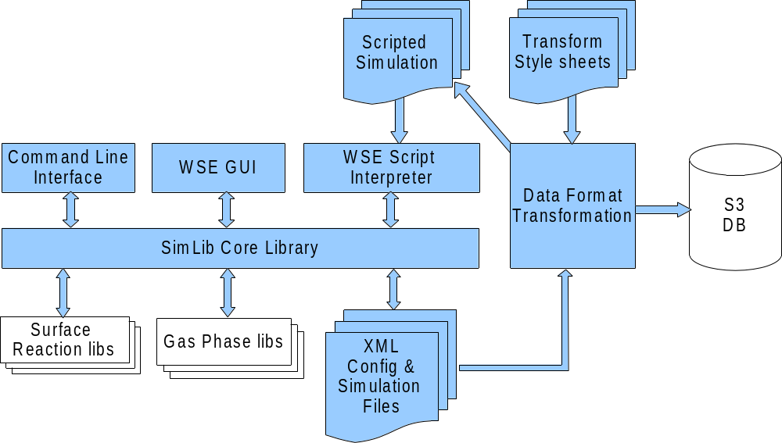

Figure 6 Simulation database structure

Using the software library in commercial or educational context, requires a modern, graphical, and interactive user interface. The WinSimEtch application bundled with the simulation library package, allows users to define, run, control, and evaluate simulations in a Windows based environment. All features of the core simulation library are accessible by dialogs and graphical visualizations of simulation progress and results.

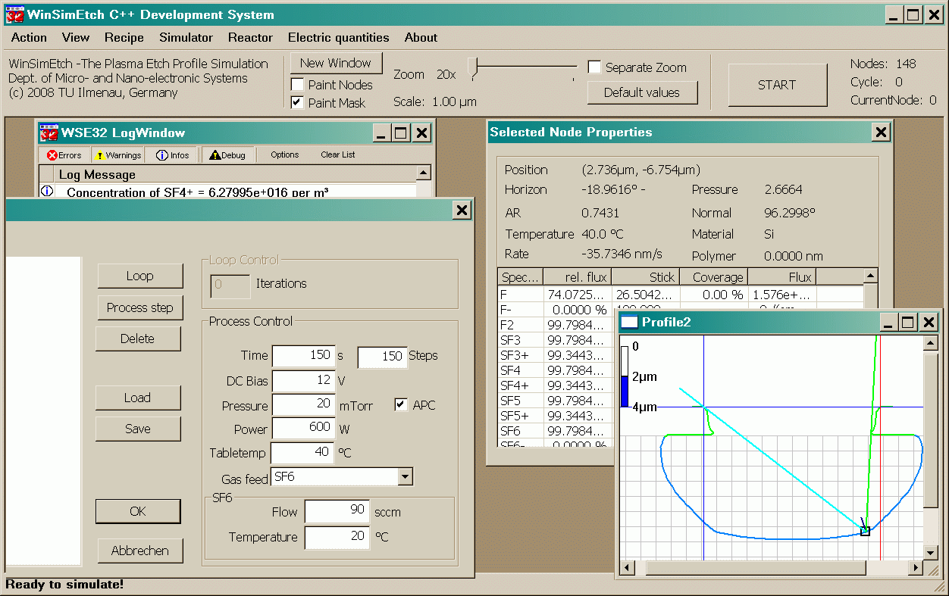

Figure 7 Simulation software screens
The drawback of interactive simulation tools is the necessary awareness of the user to do inputs and control successive simulations. To overcome this, for long simulation runs and simulations with frequently changing parameters, and for flexibility, a simulation programming language was developed. Based on the popular and widely used Tool Command Language, a script interpreter application is capable of executing program scripts defining the simulation structure and controlling the execution of simulations using the SimLib core library.
The script interpreter interface is preferably used for batch simulations or for parameter studies.

3. Plasma etch tool and process development

OIPT designed and qualified a new plasma source optimised for uniformity and the control of particle fluxes to the substrate. The conditions in this tool were measured using the diagnostic resources of ISMA and DCU, and were modelled using the software tools developed by Demokritos, TI and S3.

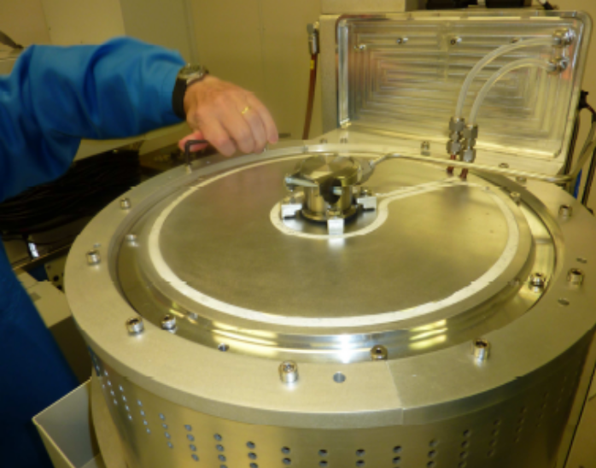

Figure 8 OIPT plasma source.

Shown below is an SEM image of the resulting high aspect ratio features etched in 2µm wide trenches. Also shown is a graph highlighting the effect of increased etch DC bias (in run2) on the achievable aspect ratio. The removal of polymer from the base of the high aspect ratio trenches was the key to high aspect ratio etching. In addition pulsed ICP and/or RIE power reduces charging of the wafer surface and improves directionality.

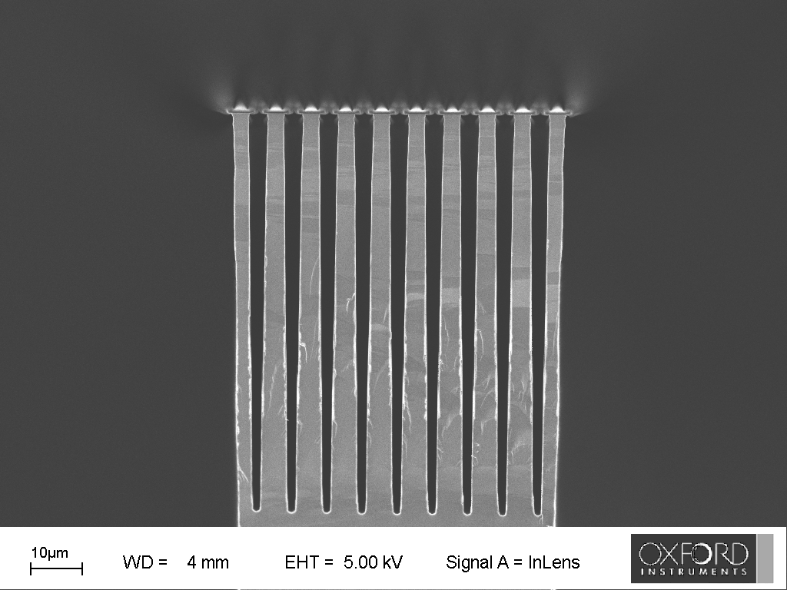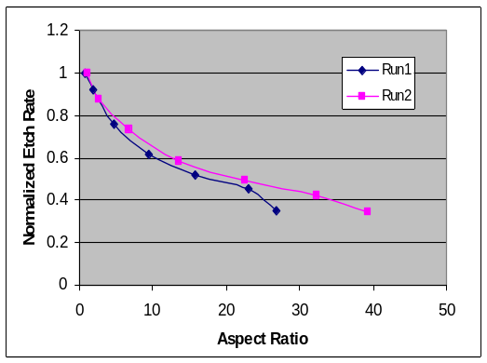

Figure 9 High aspect ratio etching and etch rate change with aspect ratio

The specifications achieved were:
Etch Gases: C₄F₈, SF₆
Plasma Clean Gases: O₂
Substrate sizes: up to 200mm diameter

Etch rate > 5 µm/min (in <1:1 aspect ratios, for total exposed Si area <20%)
Selectivity Si: PR > 75:1
Selectivity Si: SiO₂ > 150:1
Uniformity < ±5%
Reproducibility < ±3% (run to run)
Profile control 90° ± 1º
Aspect Ratio up to 40:1

Much higher etch rates were achievable on smaller areas with a less stringent profile control. The uniformity of etch rate is demonstrated in the graph below.

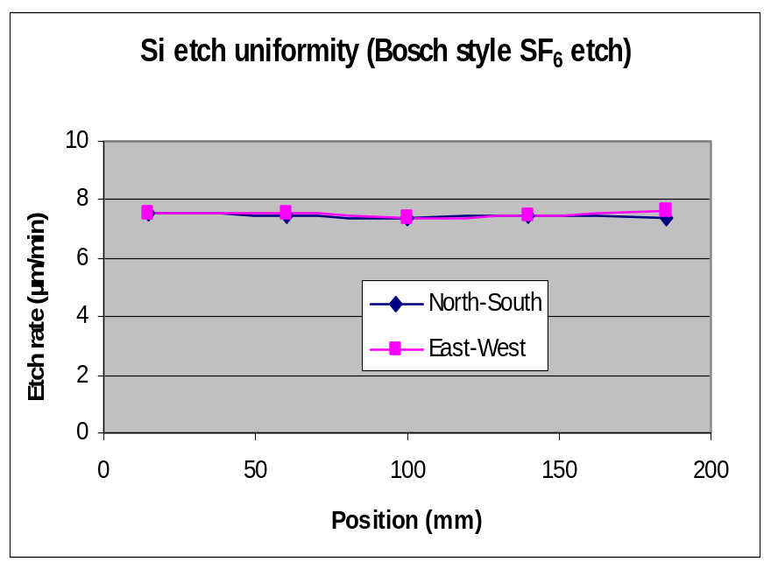

Figure 10 Uniformity of etch rate across a 200mm silicon wafer
By the end of the project, two tools equipped with the new plasma source had been shipped to a first customer.

4. Nanoscale roughness control
Demokritos has also focused on the nano-scale texture and roughness imparted on materials by plasma processing. This work includes studies of nanoroughness measurements, and studies of simulations and experiments to understand the causes of nanoroughness formation.
Simulation has shown that sputtering of the Alumina source and codeposition of sputtered flux during etching was the main cause of roughness formation. The model formulated used hard and soft inhibitors both of which could explain the experimental observations. See fig. Below. Key factors in the nanoroughness formation is the angular distribution of etch inhibitors versus that of ions and their sticking probability compared to that of reactive neutral species.

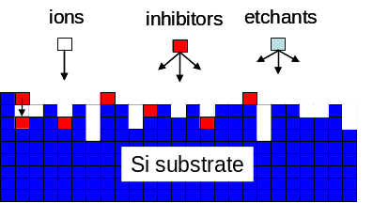 | 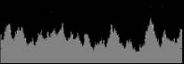 | 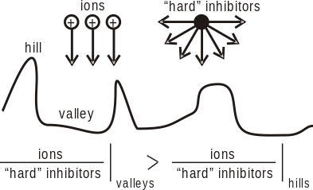
(a) 2-D cellular representation of the etched topography in MC simulator for surface etching. | (b) 2-D snapshots of a Si surface etched by SF₆ plasma resulted by the simulation. Compare with figures above. | (c) One possible mechanism of nanoroughness formation due to hard inhibitor deposition preferentially on the top of hills

Figure 11 Method for simulating roughness evolution in plasma etching

This has led to an improved understanding of the role of the plasma chamber wall in the development of surface roughness, and to a method for creating a moderately ordered array of <50nm dots on the surface. This was used as a mask at OIPT to transfer this polymer pattern into silicon by plasma etching.
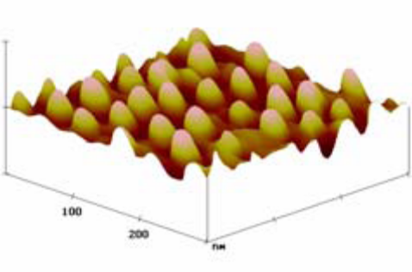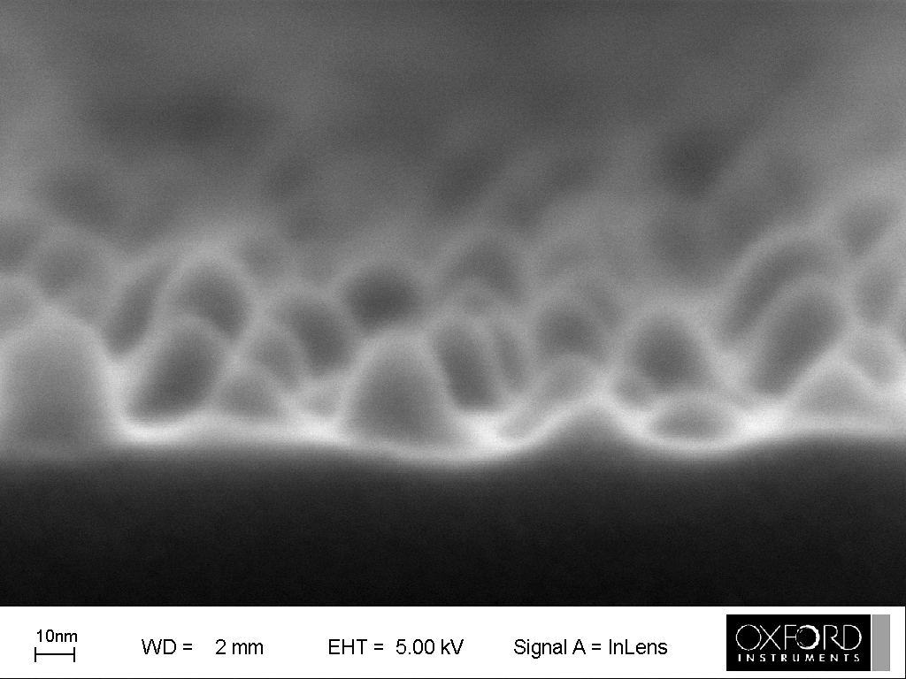

Figure 12 AFM and SEM images of <50nm dots created by plasma etching

Having identified the causes by simulation careful experiments were designed for the control of roughness. The reactor walls were covered with polymer, which reduced significantly roughness. Experiments were also performed in the OIPT prototype reactor having an electrostatic shield and minimal roughness was observed (see below). Thus, design of the wall interaction with the plasma is the key to nanoscale roughness control.

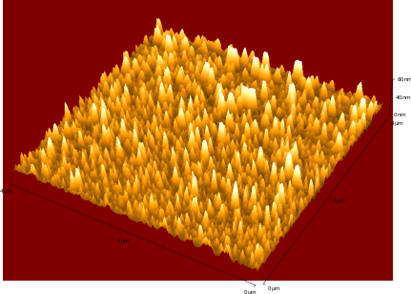 | 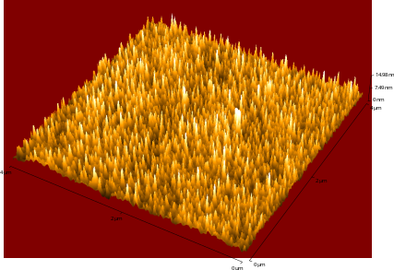
Roughness for inorganic (Poly(dimethyl-Siloxane)) polymer etching in SF6 plasmas. Photoresist Az5214 covers the ring and in the dome (all the cylinder of the Adixen Prototype reactor). RMS is now only 8nm for 2min etch instead of 100nm see above when no polymer covers the dome. | Roughness for inorganic (Poly(dimethyl-Siloxane)) polymer etching in SF6 plasmas in the OIPT plasma reactor. RMS for 2min etching is only 1.6nm demonstrating further reduction of the nanoscale roughness. Similar results were obtained for organic polymers and for Silicon.

5. Plasma control
There are two keys to a control system:
- An understanding of the mechanisms that link process control inputs (pressure, power, and gas flows, in the case of plasma etching) to the outputs (rate, and profile). This understanding was derived from the simulation and validation work.
- A measurement method that is more accurate more reproducible than the variable to be controlled. In the case of plasma etching, this was not available at the start of the project.

The plasma measurement and diagnostics work in the NanoPlasma project was led by researchers at the National Centre for Plasma Science and Technology, Dublin City University. Bulgarian SME ISMA were responsible for the creation of prototype probe hardware, designing, characterising and delivering a plasma resonance probe engineered to withstand more than 300C. This frequency-based technique offered far higher resolution and accuracy than conventional current-collection sensing methods. This ‘hairpin’ probe was used together with optical emission spectroscopy in a plasma etcher at DCU, revealing significant chamber memory effects, which could begin to be correlated with the etch processes themselves.

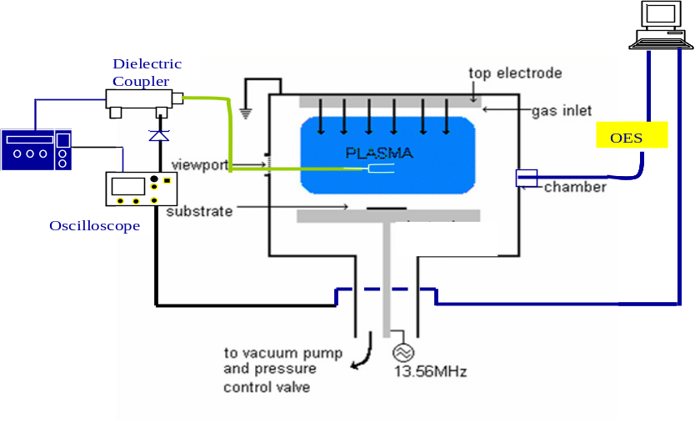
Figure 13 Schematic of experimental set up for plasma diagnostic tests

The hairpin probe was first tested in a relatively inert Argon/Oxygen (60/40) plasma, using an OIPT RIE 80+ plasma tool at DCU. The purpose of these trials was to investigate the performance of the hardware over an extended period of time, simulating an industrial process. To realize this simulation, a cycle of plasma on/plasma off for one minute each was employed and the performance of the probe and emission spectrometer evaluated. Data from both diagnostics were taken simultaneously.

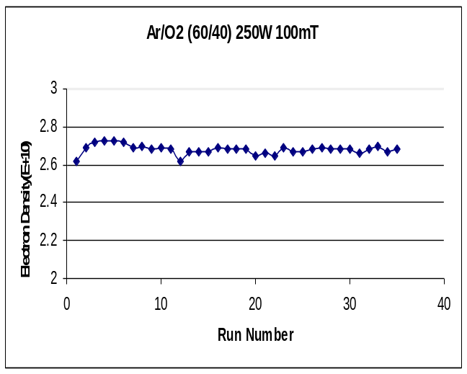
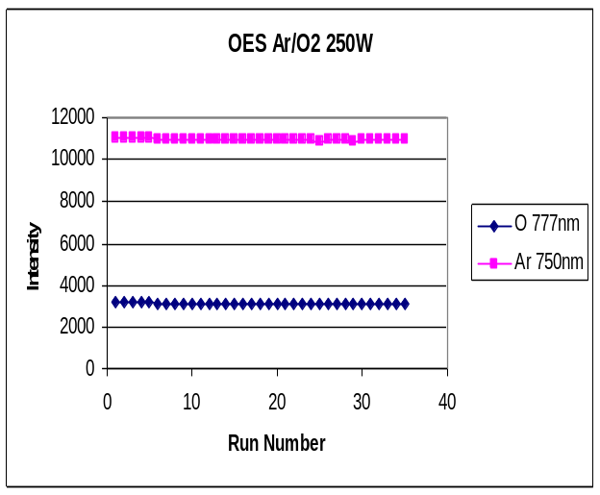
(a)
(b)

Figure 14(a) Electron density, as measure by hairpin probe in Ar/O₂ plasma over an extended period. (b) Emission intensities of Argon 750nm and Oxygen 777nm as measured by emission spectrometer over extended period in RIE 80+ chamber.
Figure 14 shows the reproducibility of the hardware over 37 runs. Both the probe and optical sensor show a high degree of stability and reproducibility of less than 2% for the given conditions. The initial tests of the closed loop control method used optical emission spectrometry input from a CCD spectrometer.
Closed loop control of Si etching via monitoring of peak heights of a band of Fluorine peaks and control of the SF₆ flow was shown to provide a stable Si etch rate independent of Si etch load, for moderate increases in Si load (up to approximately 2x).
Shown below are graphs showing the control of Si etch rate achieved via SF₆ flow adjustment, based on F peak height measurement, and the flow rates required at each Si load.
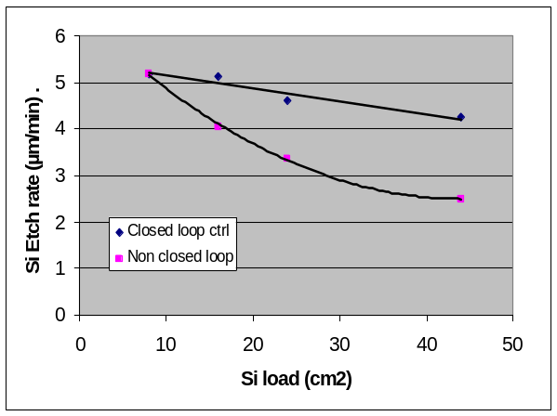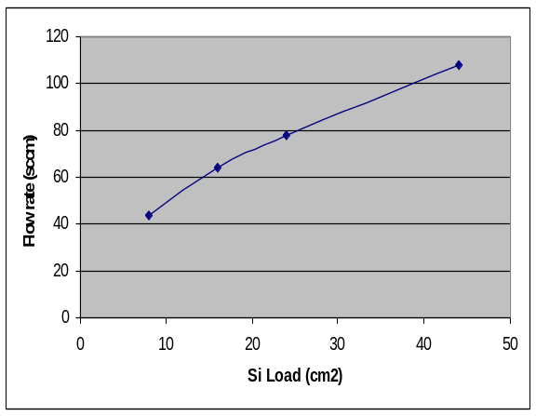
Figure 15 Etch rate compensated for silicon load using closed loop control

At higher Si loads the etch rate fell off but was still within much better control than that of the non-closed loop method.
This may be partly due to the initial delay in achieving the optimum gas flow, due to limitations of the incremental control method. It could also be due to the fact that the Si load was a single large block of blank Si at the centre of the carrier wafer. On masked wafers where the Si load is spread across the entire wafer surface at a lower local percentage exposed Si area the loading effect will be less severe.
Studies of closed loop control of polymer deposition rate using CF₂:F peak height ratio showed less success, since the effect of wall temperature dominated the process results. This suggests that there are other deposition species (e.g. C₂F₄, C₂F₃, and CF₃) present in the plasma that contribute to the deposition, but cannot be detected by OES.
The closed loop control feature is now being delivered to beta site customers for further testing and development.

6. Plan for using and disseminating the knowledge
The consortium of one industrial partner, two SME partners and three academic institutes have produced significant outputs, notably:
- A plasma etch tool incorporating a new plasma source and control system, shipped two beta versions to the Molecular Foundry at LBNL, USA (OIPT)
- A plasma etch simulator ready for beta shipment. It will be pursued first via a collaboration with LBNL, USA (S3)
- A new plasma diagnostic hardware ready for beta shipment. (ISMA)
- 15 academic journal articles (Demokritos, TUI, DCU)
- 50 academic conference publications (all partners)
- 4 patent applications (Demokritos, OIPT)

The academic output should be noted for its productivity, especially from Demokritos.

Acknowledgement
The partners, and especially the coordinator, thank the EC project officers responsible for monitoring and guiding this project for their support, and to Framework Programme 6 of the EC for its financial support for the work.
Antoaneta Folea (Contract preparation period)
Hans Pedersen ( Apr 06 - Mar 07)
Philipp Dreiss (Mar 07 – Nov 08)
Barry Robertson (Nov 08 – Apr 09)

