PROJECT FINAL REPORT

Grant Agreement number: MIRG-CT-2007-209871
Project acronym: URBANQUAKE
Project title: Istanbul Urban Earthquake Test Site
Funding Scheme: FP7-PEOPLE-2007-4-3-IRG
Period covered: from 01/09/2007 to 01/09/2011
Name of the scientific representative of the project's co-ordinator, Title and Organisation:
Atilla Ansal, Prof. Dr., Bogazici University
Tel: +90 216 332 5530
Fax: +90 216 462 1932
E-mail: ansal@boun.edu.tr
Project website address: -

Final publishable summary report

URBANQUAKE is designed to install and monitor seismic array networks in Istanbul where the probability of having a major earthquake in the next thirty years is very high. The real earthquake data that is collected using these arrays are highly valuable for the scientific community around the world since they constitute one of the most reliable source of information to develop, verify and modify the existing analysis and design procedures in earthquake engineering. In this final summary report, an executive summary of the work undertaken during the period of project is provided followed by a brief description of the project context and objectives. Main scientific achievements are described along with the dissemination activities that have been done so far to promote foregrounds of the project. Potential impact, plans for further development and exploitation of the Istanbul’s Urban Earthquake Test Site are also discussed.

Executive Summary

Estimation of site specific ground motion characteristics has been a crucial issue in the assessment of the vulnerability of the existing structures, for retrofit and rehabilitation alternatives as well as in the design of new structures. The scientific aspects contain significant degree of uncertainties and reliable solution of this problem requires development of realistically comprehensive analytical models that rely on large amount of field evidence. Seismic arrays, which are deployed in seismically active areas to record ground motion during earthquakes, are one of the ways to collect field evidence for response of soil layers. The information and data provided by these arrays is considered very crucial for verification, calibration and development of predictive tools that are used in earthquake engineering.

In the ‘Urban Earthquake Test Site’ project a strong motion network of vertical arrays has been installed within the city of Istanbul, Turkey complementing already existing horizontal Rapid Response network. The existing high seismic activity of the region increases the scientific importance of these arrays because large number of earthquake records could be obtained within relatively short period. In order to achieve this objective, up to 350,000€ research grant is secured through various national institutions and agencies, and all this support is used to deploy ‘vertical seismic arrays’ which will complement and improve Istanbul Rapid Response Network composed of 100 strong motion stations and form a fully functional Urban Earthquake Test Site. Vertical seismic arrays are composed of several accelerometers installed in boreholes at various depths in the soil profile. The real earthquake data that is collected at Urban Earthquake Test Site is evaluated through numerical and analytical methods by utilising the detailed assessment of site conditions that are compiled based on the extensive microzonation project that was conducted by Istanbul Metropolitan Municipality. The data that has already started to accumulate from the Urban Earthquake Test Site enables progress in development and calibration of site response analysis and site-specific damage scenario methodologies.

The major impact of the project today and in the future is its unique potential to generate invaluable data about site effects in earthquake engineering which is today regarded as one of the most-needed type of information to develop, modify and verify the current analysis and design procedures in the profession. The impact potential of project and the achievements attained in the first project period has also been acknowledged by CORDIS; the project has been selected for special promotion on Technology Marketplace and is announced as an exploitable technology on official website.

Istanbul Urban Earthquake Test Site has been presented in various international conferences and workshops as invited lectures and as articles in peer-reviewed publications. National and international funds that are obtained with the efforts of the researchers of this project are used to cover travel expenses of all dissemination activities. All these efforts for dissemination have brought an international recognition to Istanbul Strong Motion Network. An on-going collaborative FP7 Framework project titled ‘Seismic Engineering Research Infrastructures for European Synergies (SERIES)’ has already proposed to use data that has been accumulated at Istanbul Urban Earthquake Test Site to develop new techniques for experimental studies of seismic wave propagation. The Institution (i.e. KOERI) and the researchers of this project are a part of the consortium formed for SERIES. In the meantime, collaborations with USA and European based organizations such as Network for Earthquake Engineering Simulation (NEES) and the Euroseistest Site have been initiated to share and exploit foregrounds of the project.

Significant efforts have also been spent in order to continue to build the capacity of the test site. A comprehensive research project have been prepared which proposes to implement a large-scale research capacity development in geotechnical, geophysical and structural earthquake engineering area using resources offered by Turkish Central Planning Agency. The project proposal focused on acquiring state-of-the-art systems for laboratory and in-situ measurements of engineering properties of soil layers and soil-structure systems and extending the seismic urban network in Istanbul by additional arrays of both permanent and portable nature including an in-situ ‘liquefaction’ test site. The proposed development with a 1.5M€ budget will equip KOERI with the state-of-the-art research capacity in earthquake engineering that is compatible with those available in USA and Japan and will provide a unique platform for collaborative research throughout EU community. The researcher supported by URBANQUAKE has a leading role in preparation and execution of the proposed project which at this time has successfully passed the first evaluations and is in process of further review.

Strongly related to the achievements described above, academic performance of the researcher, which has accelerated during the period of this project, has enabled her to apply for a permanent position at KOERI. Her integration to the institution will contribute significantly to the research capacity and publication rate of the Institution and will pave the way for more research projects both at national and international scales.

Context and Objectives

The project had multiple objectives. The first objective was to deploy and ensure successful operation and monitoring of vertical seismic which would complement and improve Istanbul Rapid Response Network composed of 100 strong motion stations and form a fully functional Urban Earthquake Test Site. In order to achieve this objective, significant amount of financial support was needed, therefore one of the crucial tasks was to prepare and submit project proposals to various funding institutions and agencies and obtain the necessary research grant for instrumentation and field work.

The second objective involved analytical evaluation of real earthquake data collected at the Istanbul Urban Earthquake Test Site by utilizing the detailed assessment of site conditions at the strong motion array locations. Site conditions would be compiled based on the extensive microzonation project which was being conducted by Istanbul Metropolitan Municipality under the technical guidance of KOERI as well as on the site-specific investigations that would be conducted at the vertical seismic array sites by means of field and laboratory testings.
The third objective was to use the data that will accumulate at the Urban Earthquake Test Site to make progress in development and calibration of site response analysis and site-specific damage scenarios.

The fourth objective was to bring international recognition to Urban Earthquake Test Site and to disseminate scientific achievements related to the project through of international conferences and peer-reviewed articles; and by doing that to pave the way for collaborations with well-known research institutions to share and exploit the foregrounds of the project.

The fifth objective was to ensure integration of the researcher to the Institution by offering her a research environment where she could get a permanent position as a result of her academic performance.

All these objectives have been fulfilled during the course of the project. Moreover, significant efforts have been spent to obtain a much larger-scale financial support through national funding agencies for further building the capacity of the Istanbul Urban Earthquake Test Site and creating a center of excellence for earthquake engineering at the Institution.

Science and technology (S&T) results

In accordance with the objectives briefly described above, an Urban Earthquake Test Site has been formed by deploying vertical seismic arrays at selected locations in the western European Side of Istanbul which are complementing the Istanbul Rapid Response Network composed of 100 surface strong motions. Each vertical array is composed of four or three borehole accelerometers and one surface accelerometer. Financial support for all instrumentation and field work is granted by national organizations such as The Scientific and Technological Research Council of Turkey (TÜBİTAK) and Turkish Central Planning Agency. At this time, all instrumented sites are in operation. Locations of instrumented sites are shown in Figure 1.

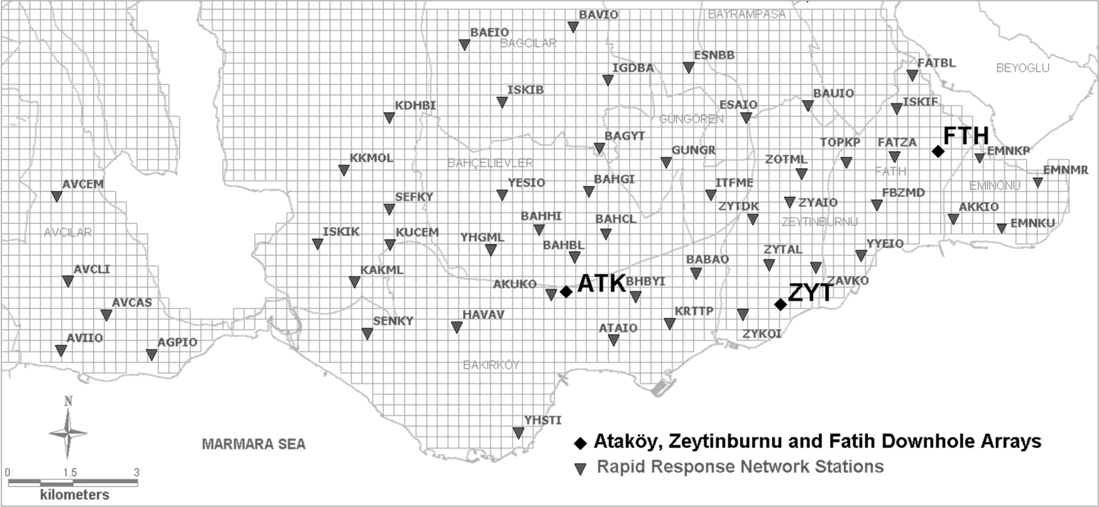

Figure 1. Istanbul Strong Motion Network (250mx250m grids for Istanbul Microzonation Project are shown in the background)
Soil conditions at the instrumented sites are evaluated based on the geophysical and geotechnical data compiled from an extensive microzonation project for south western part of Istanbul which was conducted by the Metropolitan Municipality. The faculty members of KOERI was providing technical support to the project where approximately 2900 boreholes were drilled within an area of about 182 km² to investigate local soil conditions. Soil conditions are further investigated at the vertical seismic array sites by means of site-specific field and laboratory testings. The sites are briefly described below.

Ataköy Array

This array has been deployed in late 2006 before the start date of URBANQUAKE grant. It has been the example for other arrays that are installed within the context of this project. Brief information about the array is provided here since it constitutes a part of Istanbul Urban Earthquake Test Site and its effective monitoring is one of the objectives of the project.

Ataköy vertical array (ATK) is located close to the Atatürk International Airport and represents a stiff-soil/rock site. Geologically, the site can be characterized with a Miocene age unit known as Güngören formation underlain by Eocene age Ceylan Formation. Güngören formation is mostly associated with hard clay and sand layers but also includes limestone. Ceylan formation consists of sandstone and claystone and represents bedrock layer with an approximate depth of 100-150m at this part of the city. Geotechnical site investigations carried out at the array location revealed that the soil profile is composed of alternating hard sandy clay and dense to very dense clayey sand layers down to 110m while sandstone is encountered below this depth. Between the depths of 5m-34m there is a layer of highly weathered limestone with clay interlayers. These clay interlayers as well as the overlying sandy clay layer are classified as CL (PI=16-26, FC=52-56%). Below the depth of 35m, clay layers are more plastic (PI= 51-56) and have higher fines content. Dense sand layers down to the depth of sandstone layer are classified as SM and compromised of 16-34% fines with nonplastic nature. Average shear wave velocity profile inferred from PS Logging tests and soil layering obtained from geotechnical investigations are given in Figure 3a. According to the profile presented in Figure 3a, the equivalent shear wave velocity for the top 30m of the soil profile (V_{S30}) at the site is approximately 278m/s.

ATK is composed of four triaxial accelerometers that are installed at depths of 25, 50, 70 and 140m and one triaxial accelerometer on the ground surface. Sensors at depths of 25m, 50m and 70m are Kinemetrics SBEPI, while the deepest sensor is Kinemetrics FBA ES-DH (with in-built compass). All four of the borehole sensors are connected to a 12-ch Kinemetrics K2 Digital Recorder. A second digital recorder, a 4-ch Kinemetrics K2 with internal three-component accelerometer, records the motion on the ground surface. Common triggering and GPS timing between the borehole sensors and the sensor at the ground surface allows for synchronized recording. Threshold-triggered data collected at a rate of 200 samples per second is periodically retrieved via ADSL connection. Among the borehole sensors only the deepest borehole sensor has a built-in compass for accurate orientation. The orientations of other three borehole sensors are determined through analysis of recorded acceleration-time histories (Kurtuluş et al. 2008).

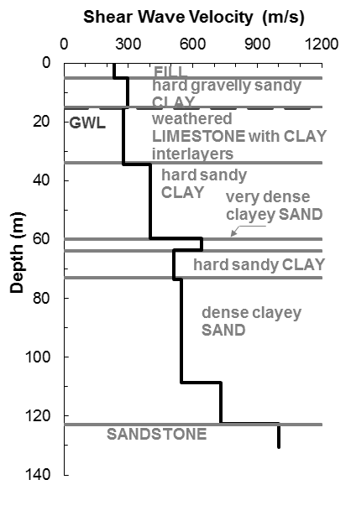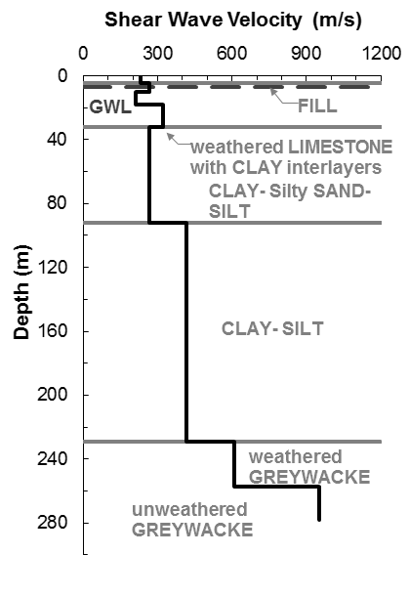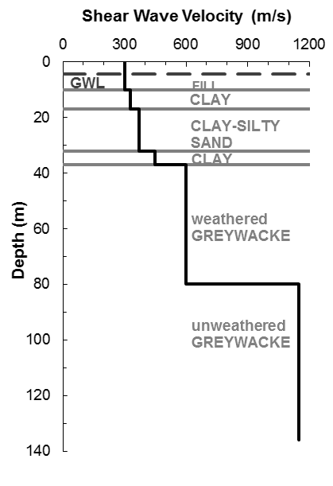
- (b) (c)
Figure 3. Shear wave velocity profiles inferred from PS-Logging tests at a) ATK, b)ZYT, and c)FTH vertical array sites

Zeytinburnu Array

Zeytinburnu vertical array (ZYT) is located close to the shoreline at south west of the city and represents a relatively soft-soil/rock site. According to recently conducted seismic damage scenario studies, Zeytinburnu district represents one of the most vulnerable areas in the city (Ansal et al. 2010). Geologically, the site can be characterized by Miocene age units known as Bakırköy and Güngören formations. Bakırköy formation overlies Güngören formation and is associated with a 5 to 10m thick limestone layer containing thin layers of clay. Underlying these is the Paleozoic age Trakya formation composed of sandstone and shale (greywacke) which represents the bedrock layer. Trakya formation is encountered at a depth of about 200-250m at this part of the city.

Geotechnical site investigations carried out at Zeytinburnu vertical array location revealed that the soil profile is composed of alternating clay and silt layers down to 230m while greywacke is encountered below this depth. Between the depths of 5m-32m there is a layer of weathered limestone with clay interlayers. Clay layers alternate between CL (PI= 13-22) and CH (PI=37-67) while silt layers are classified as MH (PI=22-49). Fines content of CL, CH and ML materials are typically very high (FC=72-100). Thin layers of silty sand (SM) are encountered occasionally between the alternating clay and silt layers. Average shear wave velocity profile inferred from PS Logging tests and soil layering obtained from geotechnical investigations are given in Figure 2b. According to the profile presented in Figure 2b, V_{S30} at the site is equal to 263m/s.

ZYT is composed of three triaxial accelerometers that are installed at depths of 30, 57, and 288m and one triaxial accelerometer on the ground surface, as shown in Figure 4, but with more up-to-date instrumentation. All boreholes are instrumented with Kinemetrics FBA ES-DH (with in-built compass) while an external three-component accelerometer (Kinemetrics EpiSensor) is installed on the ground surface. All sensors are oriented to exact North. Sensors are connected to a 12-ch Kinemetrics Rock Digital Recorder which allows for threshold-triggered data collected at 200 samples per second to be automatically sent to an ftp website of KOERI via ADSL connection.

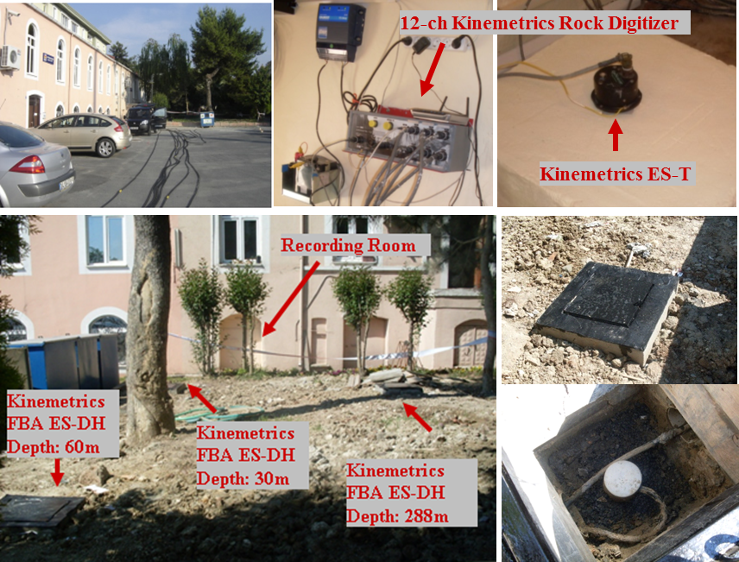

Figure 4. ZYT vertical array site

Fatih Array

Fatih vertical array (FTH) is located on a hill adjacent to a seismically monitored historical mosque within the old city and represents a stiff-soil/rock site. Historically the site has always been an important location for religious structures (dating as early as 550 BC) most of which had been significantly damaged during the past major earthquakes. Ground accelerations as high as 0.2g have been recorded at this site during the M_{w}= 7.4, 1999 Kocaeli Earthquake which was located about 100km away from Istanbul. Geologically, the site has similar features as ZYT site which can be characterized by the Miocene age units known as Bakırköy and Güngören formations underlain by the Paleozoic age Trakya formation representing the bedrock layer. Trakya formation is encountered at a depth of approximately 60-80m at this part of the city.

Geotechnical site investigations carried out at this location revealed that the soil profile is composed of alternating clay, silty sand layers up to 40m while greywacke is encountered below this depth. It was observed that the top 40m of greywacke is considerably weathered and the intact material is located at a depth of about 80m. Clay layers are mostly classified as CH (PI=32-59), occasionally as CL (PI=14-24) at shallower depths (<20m). Fines content of these materials are variable (FC= 63-93%). Silty sand (SM) layers with FC=14-43% are encountered between the clay layers at the depths of 17 to 32m. Average shear wave velocity profile inferred from PS Logging tests and soil layering obtained from geotechnical investigations are given in Figure 3c. According to the profile presented in Figure 3c, V_{S30} at this site is equal to 335m/s. FTH is composed of four triaxial accelerometers that are installed at depths of 23m, 60m, 136m and on the ground surface (Figure 5). Instrumentation and field set-up at this site is identical to that at ZYT array. Given the fact that Fatih Mosque is also instrumented and monitored by KOERI, the site is expected to provide valuable data not only for free-field soil response but also for soil-structure interaction related studies.

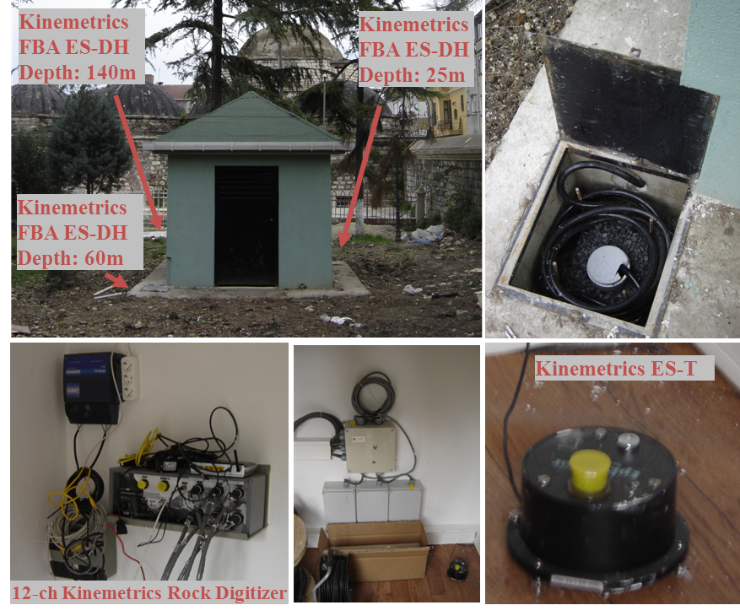
Figure 5. FTH vertical array site

Istanbul Rapid Response Network

Istanbul Rapid Response Network (IRRN), operated by KOERI, is composed of 100 strong motion stations distributed within the city of Istanbul. The network consists of strong-motion instruments (Güralp CMG-5T) located at grade level in small- to medium-sized buildings. Full-recorded waveforms at each station can be retrieved using GSM and GPRS modems subsequent to an earthquake (Erdik et al. 2003). Out of 100 rapid response network strong motion stations, 55 stations are located in the European side of Istanbul (Figure 1). ATK, ZYT and FTH vertical arrays operates in synchronization with Rapid Response Network and provides reference bedrock motion for the ground motions recorded by this network.

As mentioned before a comprehensive site investigation study involving 2900 geotechnical borings was conducted for this area (OYO 2007). The data included mostly Standard Penetration Test (SPT), seismic reflection, seismic refraction measurements and some Cone Penetration Test (CPT) and PS-Logging measurements as well as a number of laboratory test results from disturbed soil samples. The information compiled is used to obtain a representative soil profile at each IRRN station. Profiles for some of the stations are illustrated in Figure 6. Measurements performed at borings conducted in the near vicinity (<200m) of the stations are taken into account in determining these profiles. Depths of engineering bedrock are typically estimated based on the 3D engineering bedrock model that was prepared during the Istanbul Microzonation Project (OYO 2007). Variations of V_{S30} and depth to bedrock formation at IRRN stations are shown in Figure 7. As can be observed from Figure 7, all station sites have comparable V_{S30} values while depths of bedrocks are quiet variable.
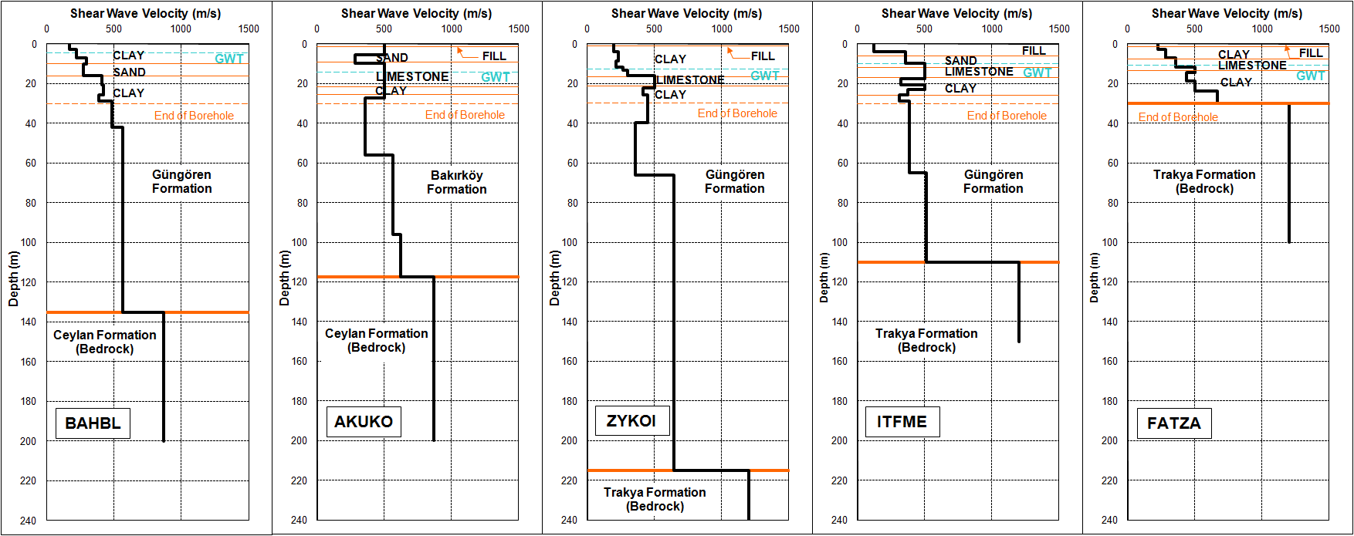

Figure 6. Representative shear wave velocity profiles for some of the IRRN station sites (from geophysical tests conducted for Istanbul Microzonation Project).
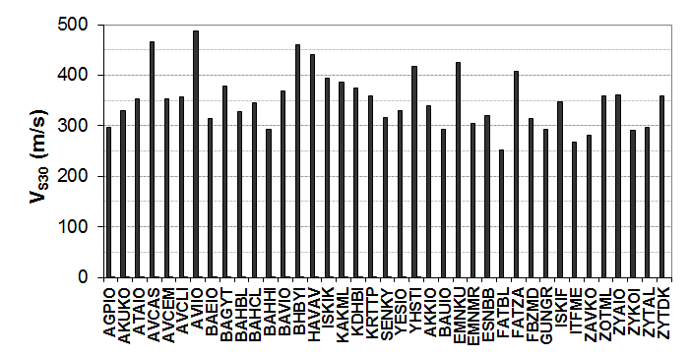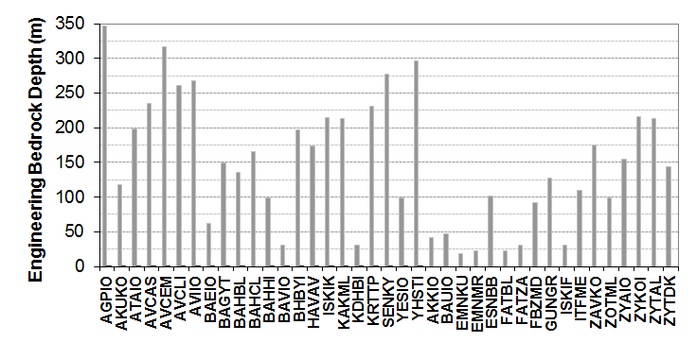

Figure 7. Variation of a) V_{S30}, and b) depth of engineering bedrock at IRRN station sites.

Ground Motions Recorded

The arrays are relatively new, they have been in operation for the last few years, therefore only a number of small magnitude earthquakes have been recorded so far. A list of most significant events (M>4.0, R<200km) recorded at these stations is given in Table 1. Maximum ground accelerations recorded at the sites so far does not exceed 0.01 g. However, given the high seismic activity of the region, the arrays are bound to generate important scientific data.

Table 1. List of M_{L}>4 events recorded by vertical arrays in Istanbul

Date/Local Time | Lat. ° | Long. ° | Depth (km) | M_{L} | Station | Distance (km) | PGA_{surface}(g)
12/03/2008/18:53:39 | 40.620 | 29.004 | 11.2 | 4.8 | ATK | 43.4 | 0.008
05/10/2008/09:04:05 | 40.650 | 29.017 | 8.5 | 4.1 | ATK | 41.6 | 0.002
24/01/2009 15:58:38 | 40.803 | 27.785 | 11.2 | 4.2 | ATK | 91.7 | 0.001
27/04/2009 19:03:06 | 40.759 | 27.543 | 18.2 | 4.1 | ATK | 115.5 | 0.003
01/08/2009 16:42:38 | 40.366 | 28.274 | 9.1 | 4.1 | ATK | 85.3 | 0.001
08/08/2009 13:52:38 | 40.328 | 27.411 | 15.6 | 4.4 | ATK | 141.8 | 0.001
03/10/2010 20:49:02 | 40.846 | 28.110 | 11.2 | 4.4 | ATK, ZYT | 64.2, 68.8, 73.2 | 0.008, 0.008
19/05/2011 23:15:23 | 39.152 | 29.088 | 7.6 | 5.9 | ATK, ZYT, FTH | 205.5, 204.8, 208.2 | 0.005, 0.006, 0.011

Detailed assessment of site conditions at the strong motion array locations allowed for comprehensive numerical and analytical evaluation of the real earthquake data that has accumulated at the Istanbul Urban Earthquake Test Site so far, enabling a number of research studies. As can be seen from Table 1, the data recorded up to now represent low amplitude motions which allows for linear analysis of soil response only. More records of varying levels of intensity, source and path characteristics that will become available in future will provide opportunities to improve site response models.

One of the first utilization of data generated by the arrays has been to investigate the predicted and modelled site response given the detailed information about in-situ soil conditions (Kurtulus 2011). Among the earthquakes listed in Table 1, 12.03.2008 Çınarcık, 03.10.2010 Marmara and 19.05.2011 Kütahya events have also been recorded by IRRN stations. The epicenters of these three events are shown in Figure 8. Response spectra of downhole records from the three events are shown in Figure 9. The effect of distance can be readily seen by comparing response at Kütahya event with that observed during the two other events. Even if similar spectral accelerations are recorded and all at linear range, frequency response can be quiet different depending on the distance and source effects.
Average of surface/bedrock spectral ratio at each array site is shown in Figure 10. As can be observed from Figures 9 and 10, amplification potential of FTH seems to be the greater than the others even though ZYT is a softer and deeper site. Observed spectral ratios show that the average amplification from bedrock to the surface of the soil reaches a factor of 4, 7 and 12 at periods of 0.9 s, 1.5 s and 0.5s at ATK, ZYT and FTH sites, respectively.

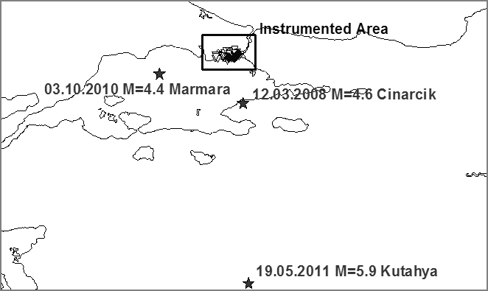
Figure 8. Epicenters of 12/03/2008 M=4.8 Çınarcık, 03/10/2010 M=4.4 Marmara and 19/05/11 M=5.9 Kütahya events

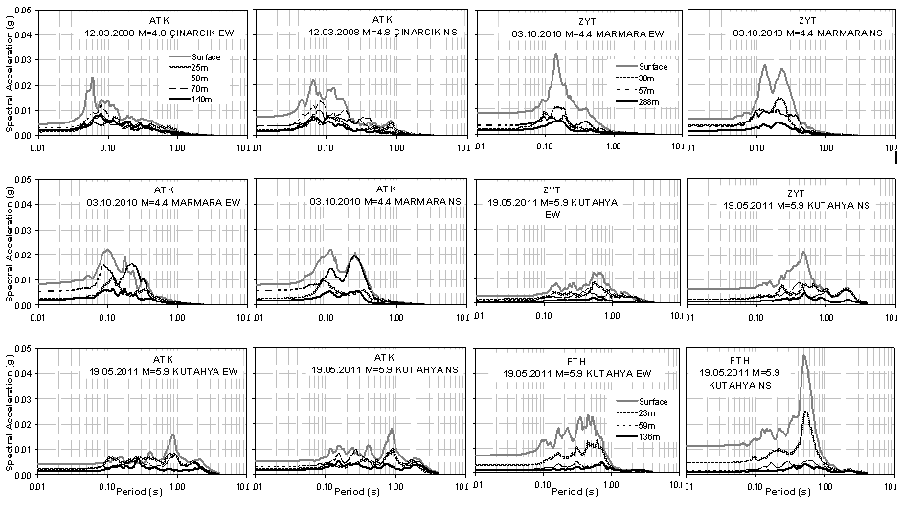
Figure 9. Acceleration spectra of downhole records during the 12/03/2008 M=4.8 Çınarcık, 03/10/2010 M=4.4 Marmara and 19/05/11 M=5.9 Kütahya events

At ATK and FTH sites, the values of predominant periods observed from amplification spectra seem to be in agreement with theoretical 1D fundamental periods of 1.1 and 0.6, respectively, that are calculated from the measured wave velocity profiles using the well-known V_{S}=4H/T₀ relationship. However, calculated fundamental period suggests a longer period (2.7 s) for ZYT than that observed from the records obtained at this site. On the other hand, the observed higher amplification potential of FTH site is related to the similarity of the fundamental period of the site to that of the recorded event (~0.6s).

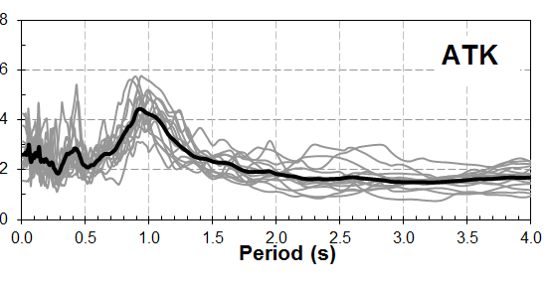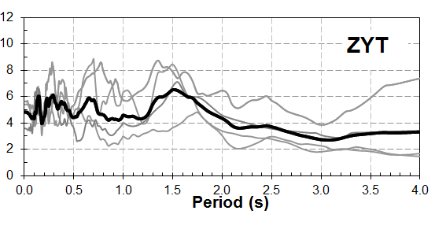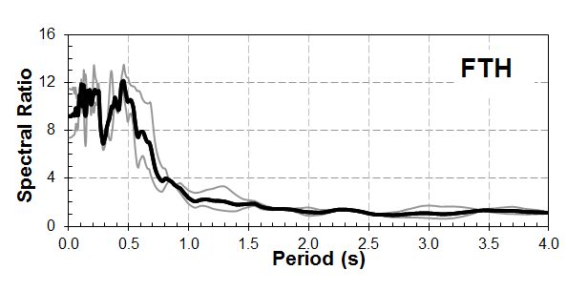
Figure 10. Average site amplification (surface/bedrock) at ATK, ZYT, and FTH sites calculated from events 4.0<M< 4.7 and 40 km<R<200 km (listed in Table 1)

Recorded response at the IRRN stations during the same events are shown in Figure 11, NEHRP (2001) soil classes of station sites are also indicated. A significant variation is observed for all three events with average cov (coefficient of variation) in the range of 0.6 to 0.8. The observed high scatter of the ground motions recorded during each event suggests that a significant part of the observed variation can be related to site effects. The variations of ground motion parameters with respect to NEHRP (2001) site classes show some indication of site effects (i.e. stations sites identified as Site C tend to have lower spectral response) but also demonstrate that V_{S30} alone is not a sufficient indicator for amplification potential, as observed from the significant scatter in the spectral response of stations located on Site D soils. As shown in Figure 7, almost all strong motion stations have comparable V_{S30} values.

Recorded and Modelled Site Response

An attempt is made to estimate site-specific ground motion parameters at IRRN stations by performing 1D response analysis using Shake91 (Idriss and Sun 1992) with the assumption that time histories recorded by the deepest accelerometers at ATK, ZTY and FTH vertical arrays can represent bedrock motions for these sites. Site response modelling is carried out for 10 of the IRRN stations that recorded all three events. In the analysis, the bedrock acceleration time histories recorded at ATK, ZYT and FTH are used as input motions. A comparison of the recorded and modelled PGA and PSA values are shown in Figure 11. In general, there is a certain agreement between the recorded and the calculated parameters (mean squared error < 0.2). However, as seen in the figure, calculated ground motion parameters are different from each other depending on the input acceleration time history. ZYT seems to be providing the best-fitting bedrock motion. One reason could be the associated bedrock geology; another possible reason is the selection of ground motion parameter used in the comparisons. It may be necessary to investigate other ground motion characteristics to evaluate the most representative bedrock reference.

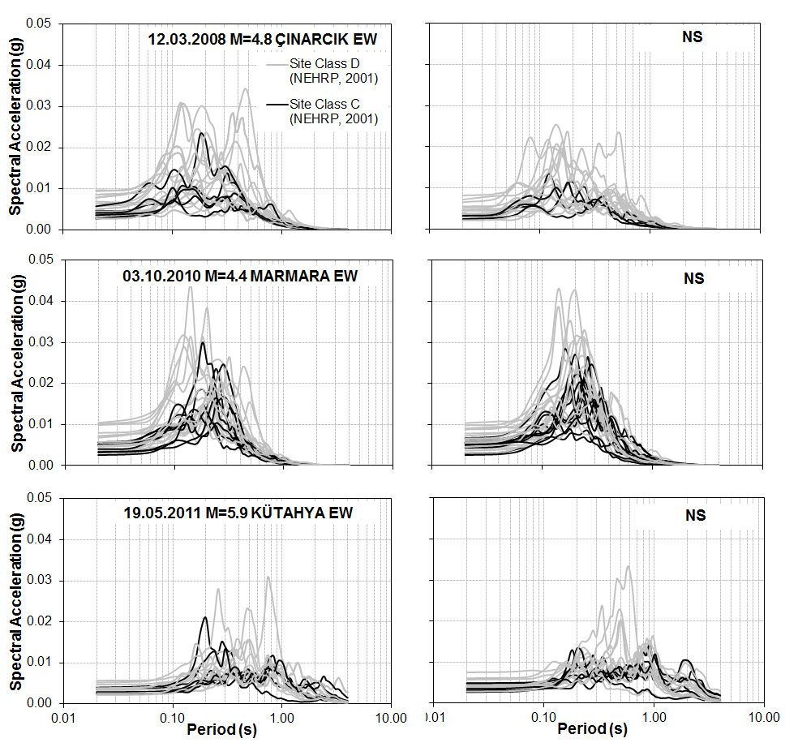
Figure 11. Acceleration spectra recorded by IRRN stations in relation to NEHRP Site Class

Figure 12. Comparison of the recorded and modelled ground motion parameters at the 10 IRRN stations (logarithmic mean of the two horizontal components are considered)

One other study involves developing a new methodology to characterize dynamic properties of soil layers by most-used geotechnical earthquake engineering parameters such as shear wave velocity and material damping. The data that has been collected at Istanbul Urban Earthquake Tests Site so far is utilized to verify the proposed technique (Kurtuluş et al. 2011).

The technique is usually based on cross correlation of waves recorded at different receivers. Elgamal et al. (1995) applied cross-correlation to the Lotung array records and have been able to obtain soil response characteristics. Snieder and Safak (2006) used seismic interferometry by deconvolving waves instead of cross-correlating them and extracted the building response. Mehta et al. (2007) have applied the technique proposed by Snieder and Safak (2006) to Treasure Island array records to extract 1-D velocity profile of soil layers. Here, a similar approach is used by first applying deconvolution to waves recorded at different depths to separate the response of soil layers from the incoherent waveforms excited by an earthquake. In contrast to customary, waveforms are deconvolved using the surface recording (instead of motion recorded at the bedrock level) in order to obtain a simple downgoing wave as proposed by Snieder and Safak (2006). Once response of layers are isolated from interacting up and downgoing waves, wave travel times between the receivers are calculated to obtain wave propagation velocities.

The two standard approach to calculate wave travel times between two recording points is to use the time differences between characteristics peaks or to determine the time lag where the cross-correlation of the waveforms has a maximum. However, these methods are acceptable for non-dispersive, non-attenuating media, where the waveforms do not change their shape as they travel. In fact, waves do change their shapes due to attenuation while travelling through soil layers. In other words, the phase shifts between the two records at different depths are caused by the combined effect of wave travel times plus the phase distortions due to damping. It is possible to eliminate the phase shifts introduced by damping on the calculated wave travel times by using the envelope functions of the waveforms. The travel times obtained from the envelope functions will be smaller; the difference representing the phase shift due to damping. The damping values corresponding to these phase shifts can be calculated and will constitute the intrinsic part of attenuation for the soil medium (Safak, 1995).

Acceleration-time histories recorded at ZYT site during the 19.05.2011 Kütahya event are used to demonstrate the applicability of this approach. Figure 13a shows the NS component of the raw records. The time- windowed accelerations showing the arrival of S waves are shown in Figure 13b. Deconvolution is applied to the signals shown in Figure 13b.

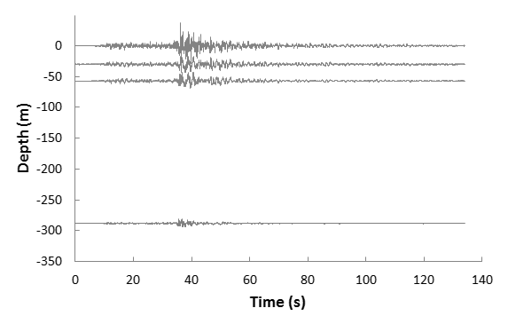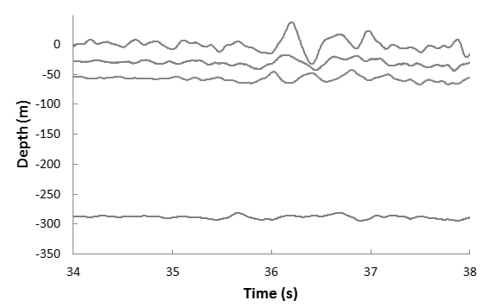
(a) (b)
Figure 13. NS component of 19.05.2011 Kütahya event recorded at ZYT site a) raw acceleration-time histories, and b) time-window showing S-wave arrival
In order to avoid instability, regularized deconvolution is performed using,

(1)

where the asterix denotes complex conjugate and is white-noise parameter added at the denominator to prevent instability (Snieder and Safak, 2006). Figure 14a shows the waveforms after deconvolving the waves at each depth with the waves at the surface using the S-wave window shown in Figure 13b, while Figure 14b shows deconvolved waves after band-pass filtering around a narrow frequency band (1Hz-3Hz) centered at the predominant frequency (∼2Hz) and increasing the sample rate of the waveforms to 1000sps in order to have sufficient accuracy for calculation of wave travel times. As seen from Figure 14, after deconvolution with the surface record, the acceleration records at depth become a simple downgoing wave.

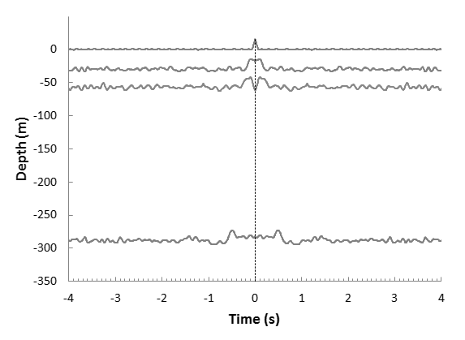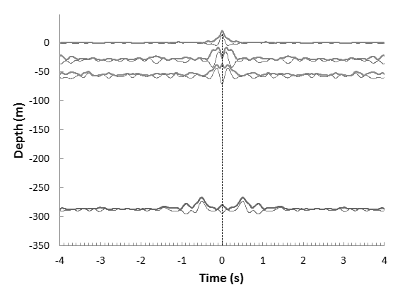
(a) (b)
Figure 14. Waveforms obtained by deconvolving the waves in the S-wave window a) deconvolution without filtering, and b) deconvolution after narrow band-pass filtering and envelope of the filtered and deconvolved waveforms

Next, the envelopes of the filtered and deconvolved waves are determined using the analytical signal defined as

(2)

where represents Hilbert transform and is the unit complex number. The envelope is obtained from the amplitude of the analytical signal (i.e. ). In Figure 14b, envelopes of the deconvolved waves are also shown. Cross-correlation is then used to calculate travel times for the deconvolved waves and their envelopes. As expected, the travel times calculated from the envelopes are smaller than those calculated from the signal itself. It can be shown that the envelope functions are not affected by the dispersive properties of the medium (Bendat and Piersol, 1985). This property of envelope functions allows for determination of phase shifts which can be related to intrinsic attenuation through

(3)

where and are the travel times calculated from the filtered and deconvolved signal and its envelope, respectively and Q is the quality factor that represents intrinsic attenuation. The approximation given in (4) comes from the use of the complex wave velocity to in order to incorporate damping to wave propagation. By using the relationships and where denotes the thickness of layer, one can obtain

(4)

Equation (4) can be approximated by Eq.(3) since Q>>1 (Safak, 1995). Calculated average shear wave propagation velocities, Q factors and corresponding damping ratios for the soil layers between the accelerometers at ZYT site are presented in Table 2. Average V_{S} values inferred from PS-Logging tests are also given. An important advantage of the technique described above is that it provides a way to separate intrinsic attenuation and radiation damping.
Table 2. Dynamic properties of soil layers extracted from vertical array records

Sensor Depth (m) | Thickness (m) | V_{S} measured (m/s) | V_{S} from deconvolved waveforms (m/s) | V_{S} from envelope of deconvolved waveforms (m/s) | Q | Damping Ratio (%)
0 | 30 | 268 | 287 | 295 | 18 | 2.71
30 | 27 | 272 | 298 | 302 | 38 | 1.32
57 | 231 | 478 | 610 | 612 | 153 | 0.33
288 | - | - | - | - | - | -

Another progress that was made during the course of the project has been the development of a microzonation methodology that incorporates site-specific response analysis to perform damage scenarios for urban areas (Ansal et al., 2009, and 2008). An application conducted for one of the most vulnerable districts in Istanbul has demonstrated the importance of site effects on seismic damage (Ansal et al. 2010).

The proposed methodology is composed of two main phases. The first phase involves generation of microzonation maps with respect to earthquake ground shaking parameters due to the selected regional earthquake hazard scenario. In the second phase, vulnerability of buildings and pipelines are estimated based on the calculated earthquake ground shaking parameters. Results are displayed in damage distribution maps for buildings and pipeline systems that are produced in GIS environment.
The first step is to adopt a grid system that divides the investigated urban area into cells (typically 250m×250m) according to the availability of geological, geophysical and geotechnical data. Variations of earthquake shaking parameters for bedrock outcrop within the area are separately determined for a specified level of exceedance probability or using deterministic simulations. Site characterization is performed based on available borings and other relevant information by defining one representative soil profile for each cell with shear wave velocities extending down to the engineering bedrock (shear wave velocity, Vs ≥ 750m/s).

Site specific earthquake characteristics on the ground surface for each representative soil profile are calculated using one dimensional site response analyses, Shake91. Hazard compatible acceleration time histories (in terms of expected fault type, fault distance, and earthquake magnitude) are selected and site response analyses are performed for a selected number of acceleration time histories. It was demonstrated by Ansal and Tonuk (2007) that if limited number of input acceleration time histories (e.g. 3 records as specified in some earthquake codes) are used, even with scaling to the same peak ground acceleration (PGA) amplitudes for site response analysis, the results in terms of PGA, peak ground velocity (PGV) and elastic acceleration response spectrum (SA) can be significantly different for different sets of input motion records. This would introduce an important uncertainty when estimating the damage distribution. Therefore to partially overcome this issue, one possible option is to use as many acceleration time histories as possible (e.g. 25 to 30) from the hazard compatible bin (in terms of fault type, earthquake magnitude and epicenter distance) as input motions for site response analyses. The selected time histories can be real earthquake acceleration records, or alternatively can be calculated using simulation models (Ansal et al., 2009). In the case of using real acceleration time histories, PGA scaling is adopted as suggested by Ansal et al. (2006a).

Site response analyses using Shake91 provide the variations of PGA and SA on the ground surface. Variation of PGV is determined through integration of acceleration time histories on the ground surface. Average of all spectral acceleration values between 0.1 and 1.0s periods of the elastic acceleration response spectrum (SAavg (0.1-1s)) is calculated as one parameter representing earthquake shaking intensity on the ground surface. Site-specific peak spectral accelerations corresponding to 0.2s (SA_{Borcherdt}) are also calculated through empirical relationship proposed by Borcherdt (1994) using equivalent (average) shear wave velocities for the top 30m of soil profiles (V_{s30}). Superposition of empirically calculated values (i.e. SA_{Borcherdt}) with those calculated using Shake91 (e.g. SAavg (0.1-1s)) provides a general assessment of the variation of site effects and is used as a parameter for microzonation with respect to ground shaking intensity (Ansal et al., 2004a).

In order to assess seismic vulnerability for buildings, two parameters; site-specific short period (corresponding to 0.2s) and long period (corresponding to 1s) spectral accelerations are calculated. Site-specific acceleration response spectrum is used to determine spectral accelerations for the short period (Ss) and for the long period (S1). An approach is adopted to determine the best fit NEHRP (2003) envelope to the calculated average acceleration response spectra (Ansal et al., 2006b). All the requirements of the NEHRP design spectra are applied in obtaining the short (Ss) and long (S1) period spectral accelerations. The two independent variables in the developed optimization algorithm are Ss and S1. The NEHRP design spectrum is preferred because of its flexibility in defining spectral accelerations (Erdik and Fahjan, 2005).

At this stage, microzonation maps for the investigated urban area may be prepared with respect to V_{s30}, NEHRP site classification, PGA, PGV, SA_{avg (0.1-1s)}, SA_{Borcherdt}, Ss and Sl. A map representing the ground-shaking intensity is prepared where the estimated relative shaking intensity levels are based on the superposition of two parameters: SAavg (0.1-1s) and SA_{Borcherdt}. The approach adopted in the assessment of the calculated microzonation maps using SAavg (0.1-1s) and SA_{Borcherdt}, involves the division of the area into three zones as A, B, and C (Ansal et al., 2004b). Since the site characterizations, as well as all the analysis performed, require various approximations and assumptions, it is preferred not to present the numerical values for the microzonation parameters. The variations of the parameters are considered separately and their frequency distributions are calculated to determine the boundaries between the three zones. The zone C shows the most unsuitable 33 percentile (e.g. high spectral accelerations), zone B the medium 34 percentile and zone A shows the most favorable 33 percentile (e.g. low spectral accelerations). The final microzonation map is a relative map defined in terms of three zones independent of the absolute values of the ground shaking intensity.

In the second phase of the procedure, vulnerability analyses for building and pipeline inventories are evaluated. Site-specific spectral accelerations Ss and Sl are used to assess the vulnerability of the building stock. The analytical estimation of structural damage is formulated based on Hazus (2003), where the vulnerability relationships (also called fragility curves) are developed in terms of spectral displacements, which in turn are calculated from the estimated mean inelastic drift capacities of buildings for various damage states. The mean drift demand of a typical building is estimated through NSP’s (Nonlinear Static Procedures), which are based on performance-based seismic evaluation (ATC 40, 1996; FEMA 273, 1997; FEMA 356, 2000). NSP’s are based on the capacity (pushover) curve of the given building and the estimation of the inelastic spectral displacement demand consistent with the capacity curve. Vulnerability of pipeline inventory with respect to wave propagation is evaluated using site-specific PGV values as input parameters. Empirical correlations which relate damage rate to PGV are employed to predict damage in pipelines in terms of damage rate and number of pipe damages at each cell in the grid system. Results from vulnerability analyses are used to prepare damage distribution maps for the buildings and pipelines.

The methodology is developed into a software package (KoeriLossV2, 2007) to provide a practical tool for assessing the seismic vulnerability of an urban area. A pilot study is carried out using KoeriLossV2 to perform a damage scenario for Zeytinburnu district in Istanbul, Turkey, where building and gas pipeline inventories are available to some detail. The area of investigation is approximately 20km² occupied mostly with low- to mid-rise residential buildings. The available inventory indicated that natural gas pipeline system in the district consists of steel pipes with diameters changing between 102mm and 762mm.

A grid system with cells of 250m×250m is defined for the study area. Probabilistic seismic hazard analysis is carried out to evaluate PGAs and spectral accelerations at T=0.2s and T=1s for each cell on the engineering bedrock outcrop (Erdik et al. 2005). A regional time dependent Poisson model for the return period of 475 years that corresponds approximately to 10% probability of exceedance in 50 years is considered in the analysis (Erdik et al. 2004). 24 real acceleration time histories compatible with the earthquake hazard in terms of probable magnitude (M=6.5-7.5), epicenter distance (R= 20-40km) and fault mechanism (strike slip) recorded on stiff site conditions with average shear wave velocities (V_{s30}) larger than 420 m/s are selected as the probable input acceleration time histories from the PEER strong motion data bank (Ansal and Tönük, 2007). Selected acceleration time histories are scaled with respect to PGAs estimated from the seismic hazard analysis for each cell before being used as outcrop motions in site response analyses.

The local site conditions are characterized based on an extensive site investigation study conducted in the area with at least one soil boring conducted at each cell location along with in-hole PS-Logging, surface seismic wave measurements and laboratory index tests (OYO, 2007). All available information on geological and geotechnical conditions is evaluated to determine one representative soil profile with shear wave velocities extending down to engineering bedrock (V_{s} ≥ 750m/s) for each cell. Typical soil profiles obtained for Zeytinburnu are illustrated in Figure 15. The variation V_{S30} in Zeytinburnu as determined from the detailed soil profiles is shown in Figure 16. Empirical shear modulus and material damping ratio curves that are used to define dynamic properties of soil types are given in Table 3.

Figure 15. Typical soil profiles and variation of shear wave velocity with depth in Zeytinburnu

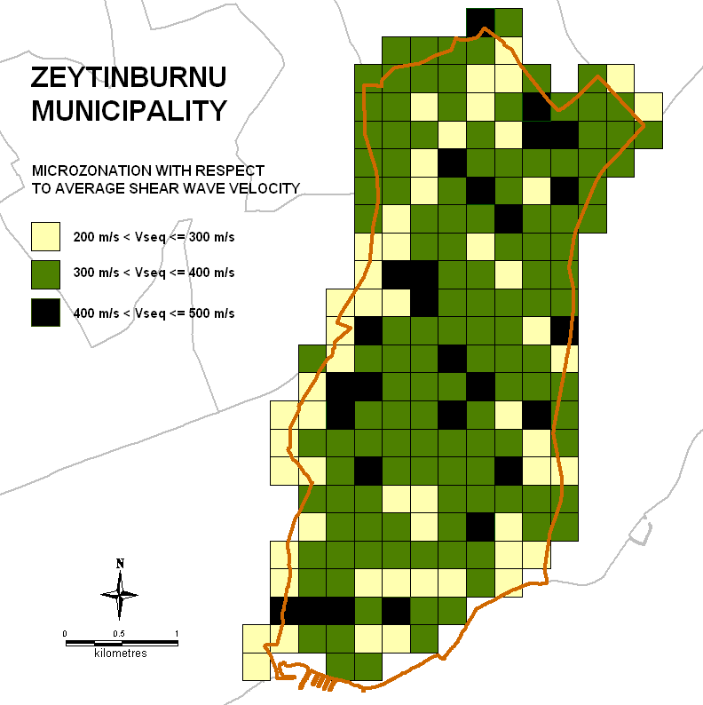
Figure 16. Variation of average (equivalent) shear wave velocity for the top 30m of soil profiles (V_{s30})
Table 3. G/G_{max} and damping ratio - shear strain relationships used to define nonlinear soil properties
Material Type | Soil Type | Reference
1 | Fat clay (CH) PI=60% | Vucetic & Dobry (1991)
2 | Fat clay (CH) PI=45% | Vucetic & Dobry (1991)
3 | Lean Clay (CL) PI=30% | Vucetic & Dobry (1991)
4 | Lean Clay (CL) PI=15% | Vucetic & Dobry (1991)
5 | Silt (ML-MH) PI=10% | Darendeli (2001)
6 | Sand with fines (SM-SC) | Darendeli (2001)
7 | Clean Sand (SW-SP) | Seed et al. (1986)
8 | Gravel (GM-GC) | Seed et al. (1986)
9 | Gravel (GW-GM) | Menq (2003)
10 | Soft Rock (0-6m) | EPRI (1993)
11 | Soft Rock (6-16m) | EPRI (1993)
12 | Rock (16-37m) | EPRI (1993)
13 | Rock (153-305m) | EPRI (1993)

Site response analyses are performed for 24 acceleration time histories for the representative soil profiles in each cell using Shake91. The averages of 24 values of PGA, PGV and acceleration response spectra from 24 Shake91 runs for each cell are determined to define the variation of ground shaking parameters due to the probabilistic seismic hazard scenario. The short and long period spectral accelerations (Ss and Sl) are obtained through optimization for the best-fit NEHRP envelope spectrum as shown in Figure 17.

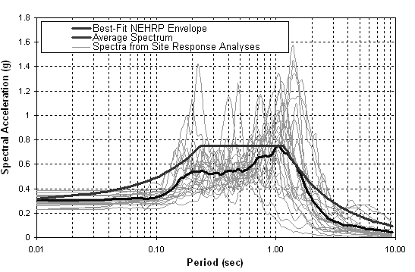
Figure 17. Typical best-fit NEHRP envelope spectra fitted to average elastic acceleration response spectra, in comparison with the all acceleration response spectra calculated by site response analysis

Resulting microzonation maps showing variations of site-specific PGA, PGV and Ss values in Zeytinburnu are shown in Figures 18, 19, and 20, respectively, along with the distribution histograms. The variations of PGV and Ss can also be calculated empirically based on V_{s30}. Ss and Sl can be obtained by using the procedure proposed by Borcherdt (1994) as suggested in NEHRP. PGV can be determined using Hazus formulation that relates Sl to PGV. Figures 21 and 22 show variation of PGV and Ss, respectively, as obtained through NEHRP based empirical procedures.

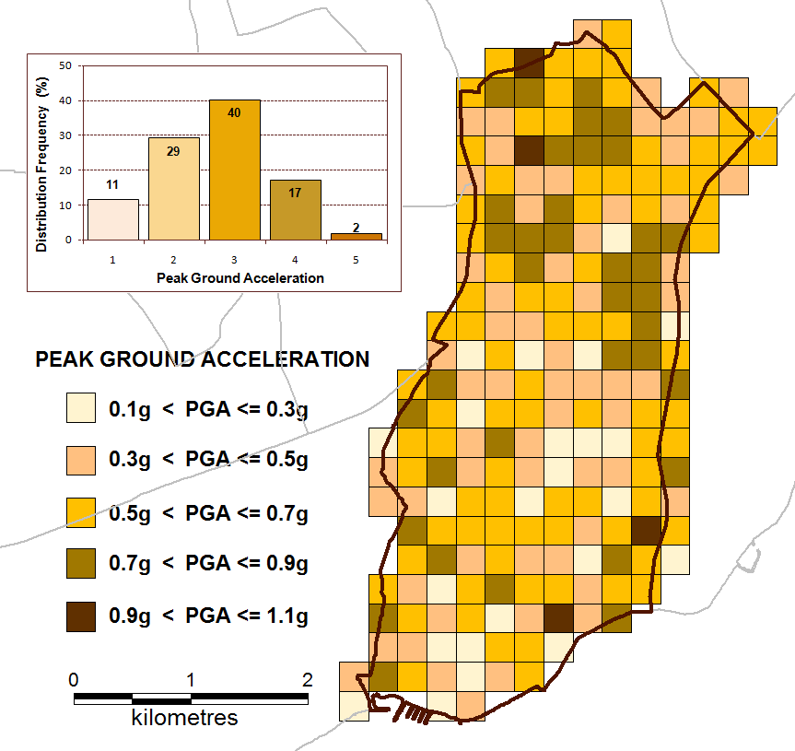
Figure 18. Variation of peak ground acceleration (PGA) from site response analyses
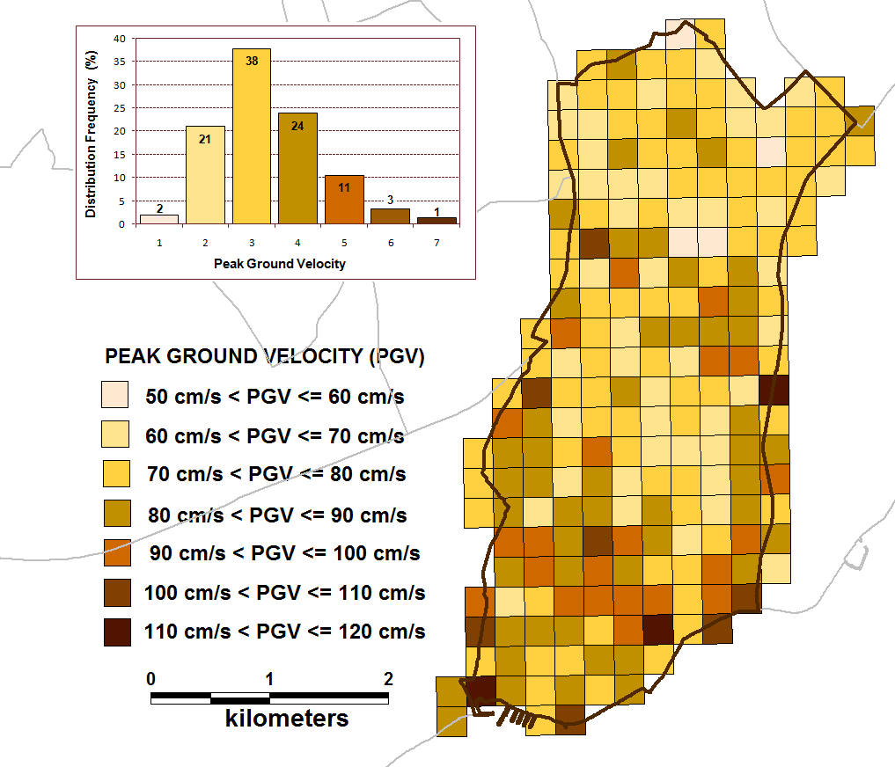
Figure 19. Variation of peak ground velocity (PGV) from site response analyses
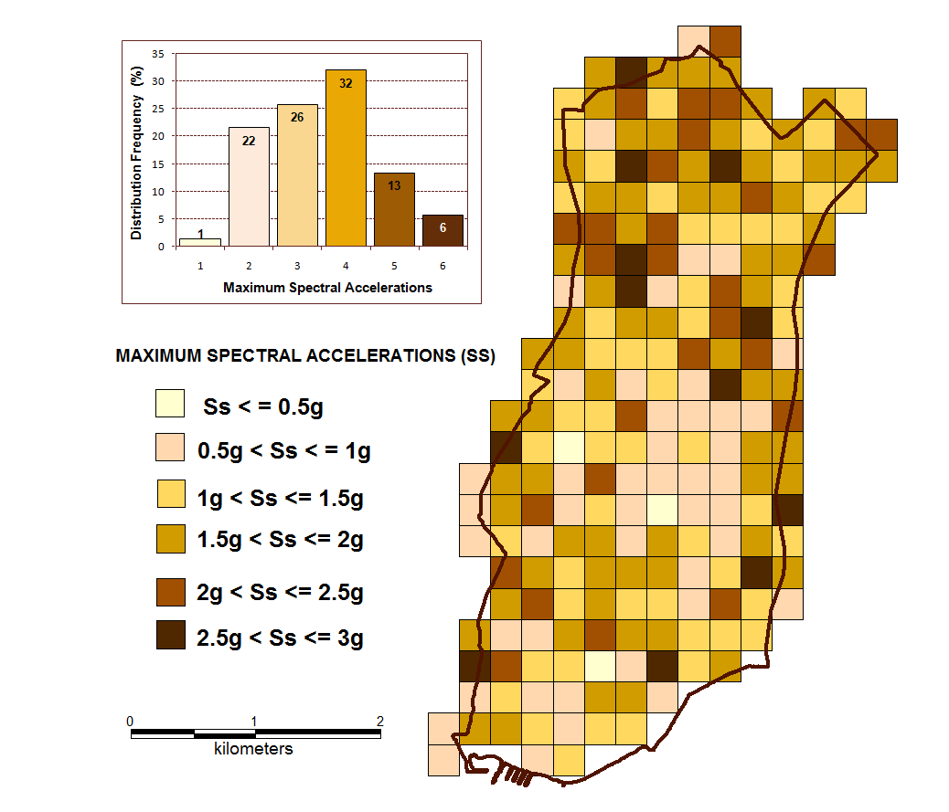
Figure 20. Variation of short period (T= 0.2s) spectral accelerations (Ss) from site response analyses.
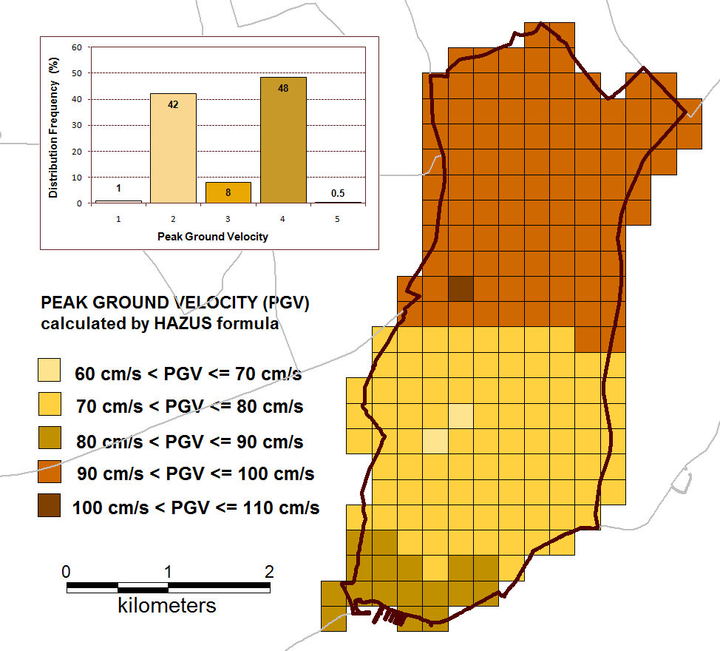
Figure 21. Variation of peak ground velocity (PGV) by the Hazus formula using long period (T= 1s) spectral accelerations (Sl) estimated by NEHRP site amplification factors
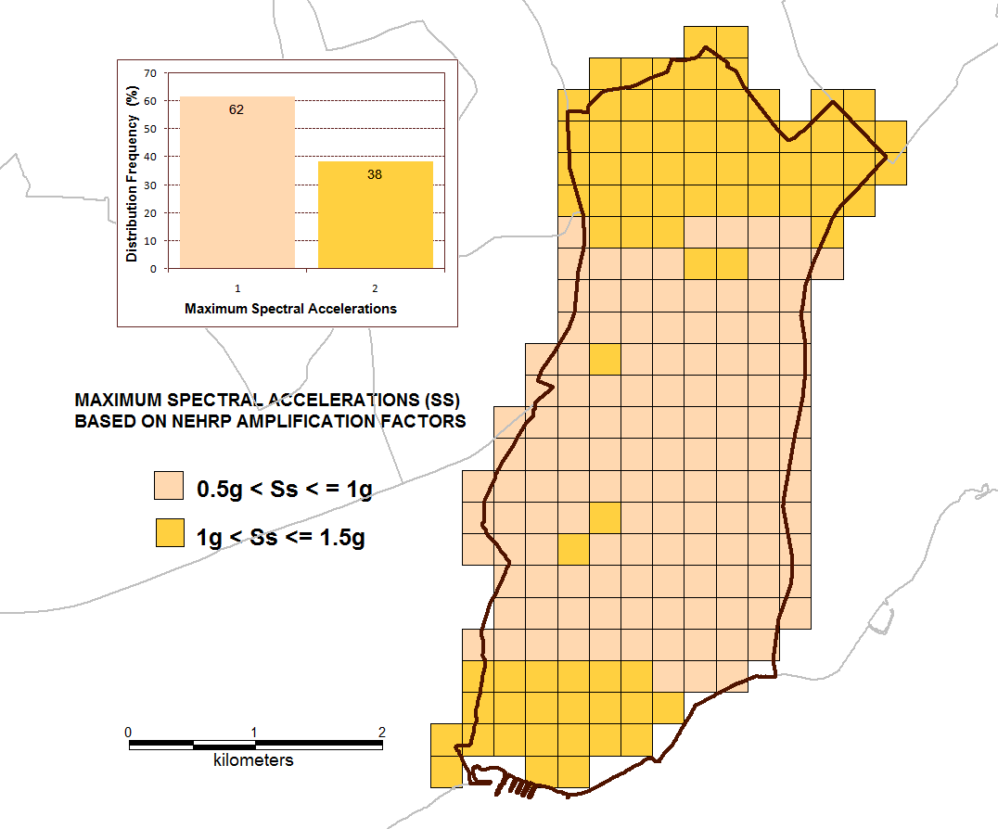
Figure 22. Variation of short period (T= 0.2s) spectral accelerations (Ss) estimated by NEHRP site amplification factors
Comparisons of variations presented in Figures 19 and 20 with those given in Figures 21 and 22 show that the use of equivalent shear wave velocity to estimate the effects of site conditions may yield very different Ss and PGV amplitudes that may not always be on the safe side. The observed differences between Figure 19 and Figure 21 as well as between Figure 20 and Figure 22 indicate the importance of methodology employed in estimating the effects of site conditions.

A detailed building inventory from street surveys for approximately 16000 buildings is considered in the evaluation of seismic vulnerability of Zeytinburnu (Aydınoglu and Polat, 2004). Building inventory is divided into groups based on the construction type, number of stories and construction year of buildings (Erdik et al., 2002, 2003). All buildings are classified according to a ‘Bijk’ matrix where “i” shows the construction type as: (1) Reinforced concrete frame building, (2) Masonry building, (3) Reinforced concrete shear wall buildings, (4) Precast building. The number of stories (“j” dimension of the matrix) is defined as: (1) Low rise (1-4 stories, including basement), (2) Mid rise (5-8 stories, including basement), (3) High-rise (8 or more stories, including basement). The construction date (“k” dimension of the matrix) is defined as: (1) Construction year: Pre-1980 and (2) Construction year: Post-1980. The building inventory classified according to ‘Bijk’ matrix in the town of Zeytinburnu is shown partly in Figure 23. The available inventory in Zeytinburnu indicates that almost all of the buildings are mid-rise reinforced concrete frame buildings.

Region-specific vulnerability relationships (Aydınoglu and Polat, 2004) that relate spectral displacements to building damage for each building type are used to estimate damage in Zeytinburnu. Figure 24 illustrates the displacement-based fragility curves for low-rise, mid-rise and high-rise reinforced concrete frame buildings constructed before and after 1980.

Figure 23. Distribution of building types in Zeytinburnu

Figure 24. Vulnerability relationships for reinforced concrete frame buildings
The distribution of number of buildings at each damage state for all building types in the area are computed and displayed in maps showing number of buildings at each cell for a given type of building and damage state. A summary of all results from damage evaluation is presented in Table 4. Numbers of buildings at each damage state estimated using NEHRP amplification factors are also given in Table 4 to provide direct comparisons.

Table 4. Damage distribution for different building types in Zeytinburnu
Building Type | Total Number of Buildings | Damage Level (Number of Buildings)
Building Type | Total Number of Buildings | None |  | Slight |  | Moderate |  | Extensive |  | Collapsed
Building Type | Total Number of Buildings | SR | NH | SR | NH | SR | NH | SR | NH | SR | NH
RC Low rise | 3394 | 449 | 534 | 563 | 854 | 1054 | 1265 | 729 | 538 | 599 | 203
RC Mid rise | 10306 | 526 | 452 | 2236 | 3063 | 3707 | 3865 | 2384 | 1789 | 2083 | 1137
RC High rise (132) | 144 | 4 | 7 | 31 | 49 | 34 | 37 | 39 | 31 | 35 | 21
Masonry Low rise (212) | 1821 | 238 | 262 | 359 | 476 | 444 | 514 | 357 | 334 | 423 | 235
Masonry Mid rise (222) | 22 | 2 | 1 | 5 | 6 | 6 | 8 | 4 | 4 | 5 | 3
ALL | 15687 | 1219 | 1256 | 3194 | 4448 | 5245 | 5689 | 3513 | 2696 | 3145 | 1599
SR: using site response analysis NH: using NEHRP amplification factors

Distribution of total number of collapsed buildings in Zeytinburnu obtained using site-specific ground shaking parameters is shown in Figure 25. The variation of number of collapsed buildings estimated based on NEHRP amplification factors is given in Figure 26. A comparison of Figures 25 and 26 clearly indicates that there are variations in the distribution of damage within the investigated region which cannot be detected when the site conditions and their effects are evaluated using NEHRP site classification and related amplification coefficients.

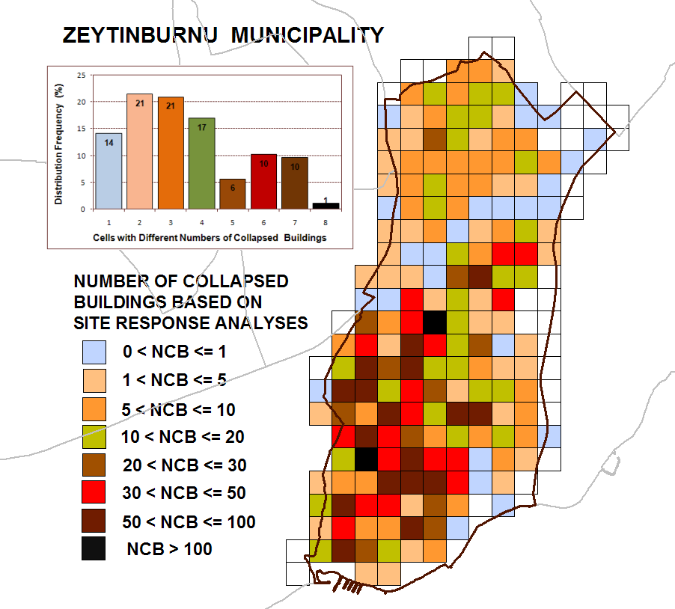
Figure 25. Distribution of collapsed buildings in Zeytinburnu estimated using results of site response analyses
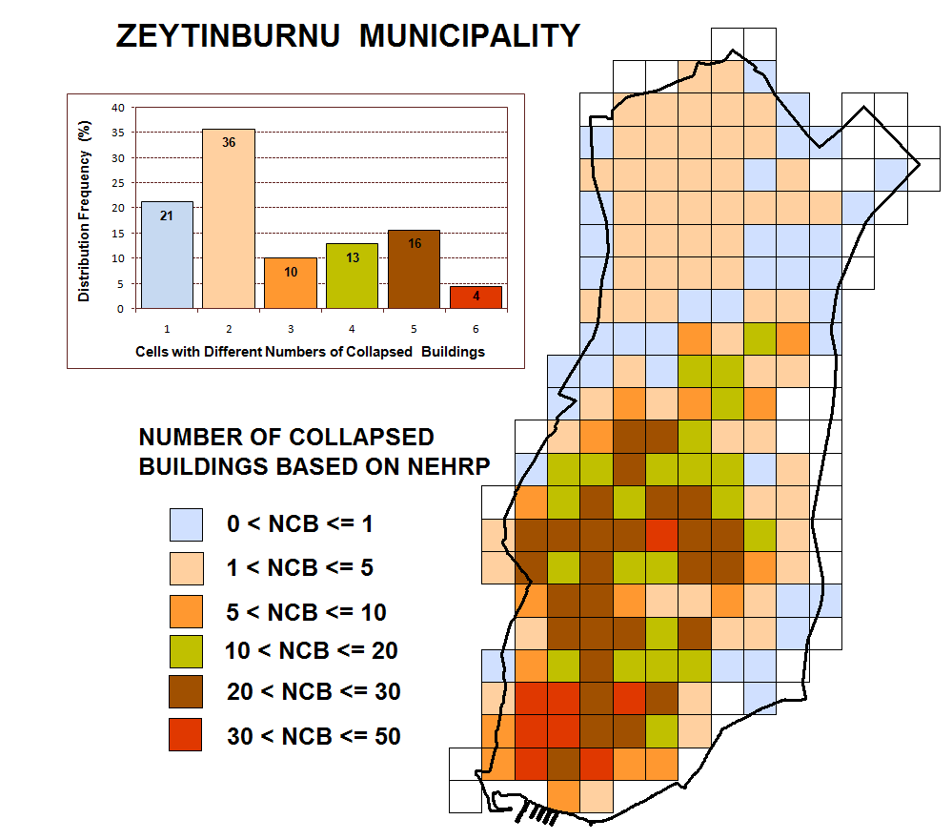
Figure 26. Distribution of collapsed buildings in Zeytinburnu estimated using NEHRP factors
In order to demonstrate the extent of expected damage in Zeytinburnu, a representative damage ratio is calculated for each cell by:

(5)
where are total number of buildings (includes all building types) at none, slight, moderate, extensive and collapsed damage states, respectively, within that particular cell. The variation of DR in Zeytinburnu is shown in Figure 27.

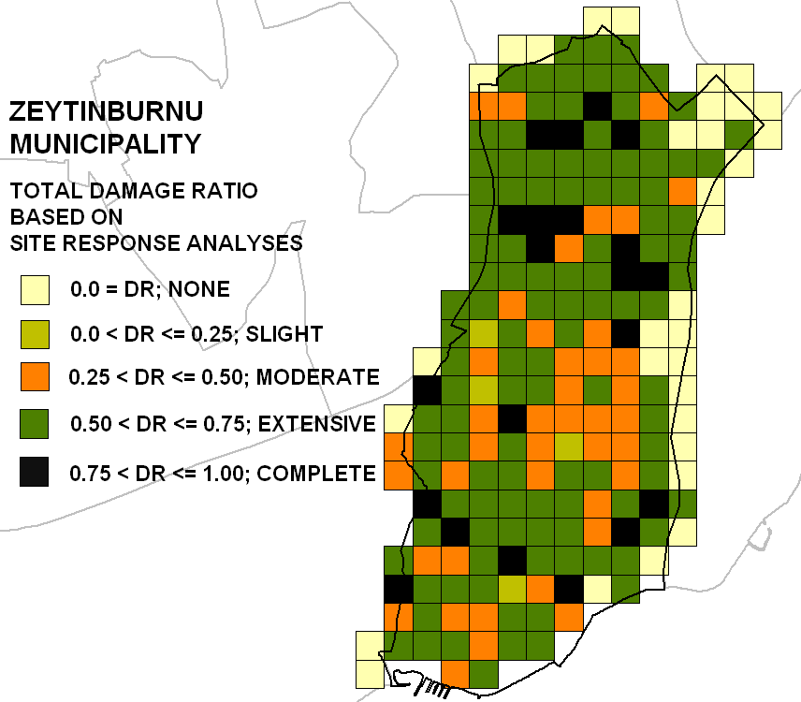
Figure 27. Variation of total damage ratio representing the extent of damage for all building types in Zeytinburnu

The natural gas pipeline inventory of Zeytinburnu area is compiled based on information provided by İGDAŞ (Istanbul Gas Distribution Industry and Trade Co. Inc.). The inventory is consisted of length, diameter and material properties of the main steel pipeline system. Empirical correlations listed in Table 5 that relates PGV to pipeline damage is used to estimate repair rate and number of repairs in the pipeline system due to wave propagation. Numbers of expected repairs at each cell are calculated as the product of repair rate and total pipeline length. Damage distribution maps showing the variation of repair rate is presented in Figure 28.

Table 5. Empirical pipeline vulnerability relations available in KoeriLossV2
Empirical Relation | Factors | Reference
RR(repair/km) = 0.0001*K*PGV^{2.25} | PGV (cm/sec)  K: 1 if brittle material, K: 0.3 if ductile material. | O’Rourke and Ayala (1993)
RR(repair/1000 ft) = 0.00032*K*PGV^{1.93} | PGV (in/sec)  K: coefficient depending on material type | Eidinger and Avila (1999)
RR(repair/1000 ft) = 0.00187*K*PGV | PGV (in/sec)  K: coefficient depending on material type | ALA (2001)
RR(repair/km) =  K*513*PGS^{0.89} | PGV (cm/sec)  PGS =ground strain  K: 1 if brittle material, K: 0.3 if ductile material | O’Rourke and Deyoe (2004)

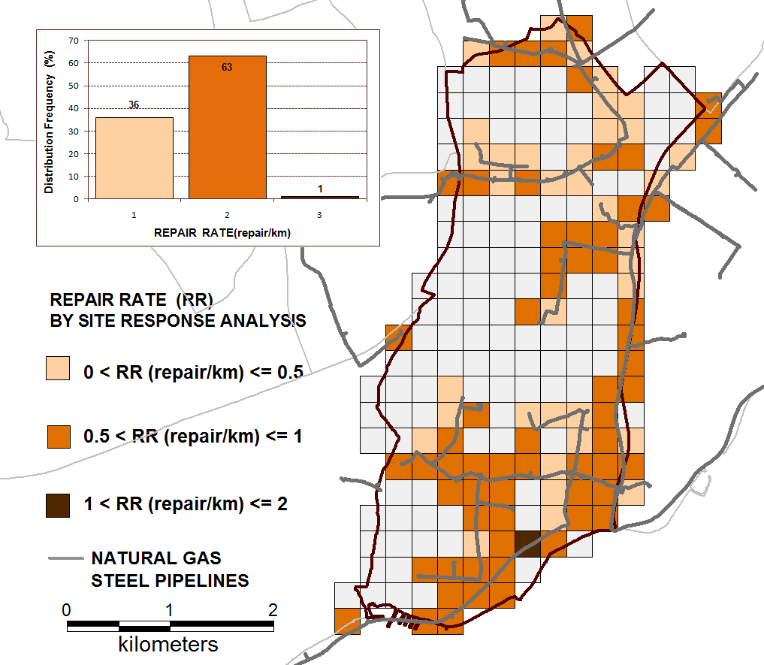
Figure 28. Distribution of predicted repair rate in natural gas pipeline system in Zeytinburnu

Application of the methodology to Zeytinburnu demonstrates that there are significant variations in the ground motion parameters within the investigated region which cannot be detected when the site conditions and their effects are evaluated using NEHRP site classification and related amplification coefficients. Therefore it appears essential to incorporate site-specific response analysis in order to have more accurate information on ground shaking characteristics for microzonation and for the estimation of seismic damage in buildings and lifeline systems.

References:

ALA (American Lifelines Alliance) (2001) Seismic Fragility Formulations for Water Systems, Part 1-Guideline, http://www.americanlifelinesalliance.org.
Ansal, A. & Tönük, G. (2007) Source and Site Effects for Microzonation. Theme Lecture, 4th International Conference on Earthquake Geotechnical Engineering, Earthquake Geotechnical Engineering, Editor: K.Pitilakis, Chapter 4, pp.73-92. Springer.
Ansal, A. Akinci, G. Cultrera, M. Erdik, V. Pessina G. Tonuk, G. Ameri (2009) “Loss Estimation In Istanbul Based on Deterministic Earthquake Scenarios of the Marmara Sea Region (Turkey)”, Soil Dynamics and Earthquake Engineering, 29(4):699-709
Ansal, A., A. Kurtuluş, and G. Tönük (2010) “Seismic Microzonation and Earthquake Damage Scenarios for Urban Areas”, Soil Dyn. Earthquake Eng., Vol. 30, pp. 1319–1328.
Ansal, A., Durukal, E. and Tönük, G. (2006a) “Selection and scaling of real acceleration time histories for site response analyses”, Proceedings of ISSMGE ETC12 Athens Workshop, Athens Greece.
Ansal, A., Erdik, M., Studer, J., Springman, S., Laue, J., Buchheister, J., Giardini, D., Faeh, D. and Koksal, D. (2004b) Seismic Microzonation For Earthquake Risk Mitigation In Turkey. Proceedings of the 13th World Conference of Earthquake Engineering, Vancouver, CD paper No.1428.
Ansal, A., Laue, J., Buchheister, J., Erdik, M., Springman, S M., Studer, J. and Koksal D. (2004a) Site Characterization and Site Amplification for a Seismic Microzonation Study in Turkey. Proceedings of 11th International Conference on Soil Dynamics and Earthquake Engineering and 3rd Earthquake Geotechnical Engineering, San Francisco, USA
Ansal, A., Tönük, G., Demircioglu, M., Bayraklı, Y., Sesetyan, K. and Erdik, M. (2006b) “Ground motion parameters for vulnerability assessment,” Proceedings of the First European Conference on Earthquake Engineering and Seismology, Geneva, Switzerland, Paper Number: 1790.
ATC & SSC – (1996), “ATC-40 Seismic Evaluation and Retrofit of Concrete Buildings”. Report SSC 96-01, California, EUA.
Aydınoglu, N. and Polat, Z. (2004) First level evaluation and assessment of building earthquake performance, Report for the Istanbul Master Plan Zeytinburnu Pilot Project, Metropolitan Municipality of Istanbul, Planning and Construction Directorate (in Turkish).
Bendat, J.S. and A.G. Piersol (1985) “Random Data: Analysis and Measurement Procedures”. John Wiley& Sons, New York.
Beresnev, I. A., E.H. Field, P.A. Johnson, and den KE-A. Abeele (1998) “Magnitude of Nonlinear Sediment Response in Los Angeles Basin during the 1994 Northridge, California, Earthquake”, Bull. Seism. Soc. Am., Vol. 88, pp. 1079-1084.
Borcherdt, R.D. (1994) “Estimates of site dependent response spectra for design (methodology and justification)” Earthquake Spectra 10(4), 617-654.
Darendelli, M. B. (2001) “A new family of normalized modulus reduction and material damping curves”, PhD. thesis, Civil Engineering Dept., University of Texas at Austin.
Eidinger J, Avila E (1999) Guidelines for the Seismic Upgrade of Water Transmission Facilities. Monograph No. 15, TCLEE/ASCE.
Elgamal, A. W., M. Zeghal, H.T. Tang, and J.C. Stepp, (1995) “Lotung Downhole Array, I: Evaluation of Site Dynamic Properties”, Jour. Geotech. Engrg., ASCE, Vol. 121, No. 4, pp. 350–362.
EPRI (1993) Guidelines for Determining Design Basis Ground Motions, Palo Alto, CA, Electric Power Research Institute, Vol. 1, EPRI TR-102293.
Erdik, M. and Fahjan, Y. (2005) “System analysis and risk” in Assessing and Managing Earthquake Risk Geo-scientific and Engineering Knowledge for Earthquake Risk Mitigation: Developments, Tools, Techniques, Part 3, Book Series: Geotechnical, Geological, and Earthquake Engineering, V2, eds. Oliveira CS, Roca A, Goula X.
Erdik, M., Demircioglu, M., Sesetyan, K. and Durukal, E. (2005) “Assessment of earthquake hazard for Bakırköy, Gemlik, Bandırma, Tekirdağ and Körfez”, WB MEER Project -A3 Component, Microzonation and Hazard Vulnerability Studies For Disaster Mitigation in Pilot Municipalities, Bogazici University, Kandilli Observatory and Earthquake Engineering Research Institute.
Erdik, M., Demircioglu, M., Sesetyan, K., Durukal, E. and Siyahi, B. (2004) “Earthquake hazard in Marmara region”, Soil Dynamics and Earthquake Engineering 24, 605-631.
Erdik, M., N.Aydinoglu, Y.Fahjan, K.Sesetyan, M.Demircioglu, B.Siyahi, E.Durukal, C.Ozbey, Y.Biro, H.Akman and O.Yuzugullu (2003) “Earthquake Risk Assessment for Istanbul Metropolitan Area”, Earthquake Engineering& Engineering Vibration, 2(1):1-25
Erdik, M., Y. Fahjan, O. Özel, H. Alcik, A. Mert, and M. Gül (2003) “Istanbul Earthquake Rapid Response and the Early Warning System”, Bull. Earthquake Eng., Vol. 1, pp. 157-163.
Erdik, M., Aydınoglu, N., Barka A., Yüzügüllü, Ö., Siyahi, B., Durukal E., Fahjan, Y. Akman, H., Birgören, G. Biro, Y. Demircioglu, M., Özbey, C.and Sesetyan K. (2002) BU-ARC, Earthquake Risk Assessment for Istanbul Metropolitan Area, Project Report, Bogazici University Publication.
FEMA 356 (2000). “Prestandard and Commentary for the Seismic Rehabilitation of Buildings“ , Federal Emergency Management Agency, Washington, D.C. USA.
FEMA273 (1997). NEHRP Commentary on the Guidelines for the Seismic Rehabilitation of Buildings. Federal Emergency Management Agency, SW Washington, D.C. USA.
Fukushima Y., K. Irikura, T. Uateke, and H. Matsumoto (2000) “Characteristics of Observed Peak Amplitude for Strong Ground Motion from the 1995 Kobe Earthquake”, Bull. Seism. Soc. Am., Vol. 90, pp. 545-565.
HAZUS (2003) Earthquake Loss Estimation Methodology, Technical Manual, Federal Emergency Management Agency and National Institute of Buildings Sciences, Washington, D.C., USA.
Idriss, I. M., and JI. Sun (1992) “Shake91”, A computer program for conducting equivalent linear seismic response analysis of horizontally layered soil deposits, modified based on the original SHAKE program by Schnabel, Lysmer and Seed, 1972.
KoeriLossV2 (2007) Earthquake Disaster Scenario Prediction and Loss Modelling for Urban Areas, Spence, R. ed. EU FP6 Project on Risk Mitigation for Earthquakes and Landslides Report.
Kurtuluş, A., E. Şafak, A. Strollo, S. Parolai, and A. Ansal (2008) “Sensor Azimuth Determination at a Seismic Vertical Array in Istanbul, Turkey”, European Seismological Commission ESC 2008, 31st General Assembly, Crete, Greece.
Mehta, K., R. Snieder, and V. Graizer (2007) “Downhole Receiver Function: a Case Study”, Bull. Seism. Soc. Am., Vol. 97, No. 5, pp. 1396-1403.
Menq, F. Y., K. H. Stokoe, E. Kavazanjian (2003) “Linear dynamic properties of sandy and gravelly soils from largescale resonant tests,” International Symposium IS Lyon 03, Deformation Characteristics of Geomaterials, (Lyon, France) 22-24 September 2003.
NEHRP (2003) Recommended Provisions For New Buildings and other Structures, FEMA-450, prepared by the Building Seismic Safety Council for the Federal Emergency Management Agency, Washington, DC.
O’Rourke, M. and Ayala, G. (1993) “Pipeline damage due to wave propagation”, Journal of Geotechnical Engineering 119 (9), 1490–1498.
O’Rourke, M. and Deyoe, E. (2004) “Seismic damage to segmented buried pipe”, Earthquake Spectra 20, 1167–1183.
Şafak, E. (1995) “Discrete-time Analysis of Seismic Site Amplification”, Jour. Engrg. Mechanics, ASCE, Vol.121, No.7, pp.801-809.
Snieder, R., and E. Şafak (2006) “Extracting the Building Response using Seismic Interferometry; Theory and Application to the Millikan Library in Pasadena, California”, Bull. Seism. Soc. Am., Vol. 96, No. 2, pp. 586-598.
Trifunac, M. D, and M. I. Todorovska (1998) “Nonlinear Soil Response as a Natural Passive Isolation Mechanism- the 1994 Northridge, California, Earthquake”, Soil. Dyn. Earthquake Eng. (17): 41-51.
OYO Inc., Japan (2007) Production of Microzonation Report and Maps on European Side (South), Final Report to Istanbul Metropolitan Municipality.
Seed, H. B., Wong, R. T., Idriss, I. M., and Tokimatsu, K. (1986) “Moduli and damping factors for dynamic analysis of cohesionless soils”, Journal of Geotechnical Engineering 112(11), 1016–1032.
Vucetic, M. andDobry, R. (1991) “Effect of soil plasticity on cyclic response”, Journal of Geotechnical Engineering, ASCE 117(1), 89-107.

Potential Impact

During the 20th century earthquakes claimed over 130,000 lives in the countries of today’s EU alone (and over 400,000 in the wider European-Mediterranean area), as well as vast but uncalculated damage to property and economic activity. Over the last 20 years improved understanding and the experience of earthquake loss has driven the progressive development of new and better codes and regulations for building in earthquake areas; and buildings and facilities constructed according to current codes are less likely to be heavily damaged by expected earthquakes. But throughout the European area, most of the built environment was created before these codes were formulated and enforced, and without the benefit of present understanding of the effects of earthquakes. Many of these buildings and facilities (which include schools, hospitals, and highway structures used continuously by the public) are unsafe by current standards and are liable to be seriously damaged or to collapse during probable earthquakes.

The major impact of the project today and in future is its unique potential to generate invaluable earthquake data which is today regarded as one of the most-needed type of information to develop, modify and verify the current analysis and design procedures in earthquake engineering. Scientific studies that would be supported by the information collected at the Istanbul Urban Earthquake Test Site will enable more accurate identification of the earthquake ground motion characteristics thus leading to more realistic estimation of the vulnerability of the building stock. Accurate assessment of structural vulnerabilities in earthquake prone cities could provide effectiveness in dealing with urban retrofit and rehabilitation projects and in mitigating the earthquake damages and causalities. In the case of retrofit and rehabilitation projects, the findings could lead to more efficient and economical solutions.

In terms of state-of-the-art research in the field of local site effects, the Istanbul Urban Earthquake Test Site is unique in Europe with respect to instrumentation and accumulated data. The existing high seismic activity in the region creates a unique opportunity for scientific observations. These findings and the analyses of these data by the European engineers and scientists could lead to significant progress in the field of earthquake engineering, site response and vulnerability evaluations in the long run. The scientific achievements will enhance significantly the competitiveness of EU in the field of Earthquake Engineering since very few similar test sites at similar scales with similar active seismicity exist in the world.

The impact potential of project and the achievements attained in the first project period has already been acknowledged by EU Community Research and Development Information Service (CORDIS); the project has been selected for special promotion on Technology Marketplace and is announced as an exploitable technology on official website.

Dissemination Activities

During the course of project, special attention has been given to the dissemination of project results and the exploitation of foregrounds developed within the project. Istanbul Urban Earthquake Test Site has been presented in various national and international conferences and workshops as invited lectures and as articles in peer-reviewed publications. A list of these publications and dissemination activities can be found in Tables A1 and A2.

As a result of these efforts for dissemination Istanbul Urban Earthquake Test Site has gained the attention of the research community throughout the world. Collabrative FP7 projects as well as collaborations with other tests sites in USA and Europe such as NEES and the Euroseistest Site have been initiated to share and exploit foregrounds of the project.

Use and dissemination of foreground

Significant efforts have been spent so far to present Istanbul Urban Earthquake Test Site in various international conferences and workshops as invited lectures and as articles in peer-reviewed publications which have brought international recognition to Istanbul Strong Motion Network. Collaborations have been formed with various USA and European based organizations and consortiums as described above. In the coming years these efforts will be continued; as more data is accumulated within Istanbul Urban Earthquake Test Site and as the foreseen capacity developments are achieved, the opportunities for collaborative projects on international scale and for attracting world-class researchers to the Institution will be inevitable. A unique set of earthquake data that is generated at the Urban Earthquake Test Site will be available to the community. It is strongly believed that the end result of all the scientific activities initiated with the grant rewarded by EU for URBANQUAKE will lead to significant progress in the field of earthquake engineering.

Section A (public)

This section includes two templates

- Template A1: List of all scientific (peer reviewed) publications relating to the foreground of the project.

- Template A2: List of all dissemination activities (publications, conferences, workshops, web sites/applications, press releases, flyers, articles published in the popular press, videos, media briefings, presentations, exhibitions, thesis, interviews, films, TV clips, posters).

These tables are cumulative, which means that they should always show all publications and activities from the beginning until after the end of the project. Updates are possible at any time.

template A1: list of scientific (peer reviewed) publications, starting with the most important ones
NO. | Title | Main author | Title of the periodical or the series | Number, date or frequency | Publisher | Place of publication | Year of publication | Relevant pages | Permanent identifiers  (if available) | Is/Will open access provided to this publication?
1 | Istanbul Geotechnical Downhole Arrays | Kurtuluş, A. | Bulletin of Earthquake Engineering | Voume 9, No 5, April 2011 | Springer | Netherlands | 2011 | pp. 1443-1461 |  | no
2 | Seismic Microzonation and Earthquake Damage Scenarios for Urban Areas | Ansal, A. | Soil Dynamics Earthquake Engineering | Volume 30, No 11, November 2010 | Elsevier | UK | 2010 | pp. 1319-1328 |  | no
3 | Determination of shallow S-wave attenuation by down-hole waveform deconvolution: a case study in Istanbul (Turkey) | Parolai, S. | Geophysical Journal International | Volume 181, No 2, May 2010 | Wiley-Blackwell | Netherlands | 2010 | pp. 1147-1158 |  | no

template A2: list of dissemination activities
NO. | Type of activities | Main leader | Title | Date | Place | Type of audience | Size of audience | Countries addressed
1 | Invited Lecture,  Conference | USA | 4th IASPEI / IAEE International Symposium: Effects of Surface Geology on Seismic Motion | 23–26 August 2011 | Santa Barbara, CA, USA | Scientific Community | 300 | USA, France, UK, Germany, Italy, Finland, Japan, China, Australia, Brazil etc. (all world countries)
2 | Lecture,  Conference | Australia | General Assembly of the International Union of Geodesy and Geophysics (IUGG 2011) on Earth on the Edge: Science for a Sustainable Planet | 28 June - 7 July 2011 | Melbourne Australia | Scientific Community, Industry | 1000 | all world countries
3 | Invited Lecture,  Conference | Turkey | 7th National Conference on Earthquake Engineering | 30 May-3 June 2011 | Istanbul, Turkey | Scientific Community,  Industry | 400 | Turkey
4 | Symposium | Iceland | International Symposium On Strong-Motion Earthquake Effects | 29 April 2011 | Reykjavik, Iceland | Scientific Community | 100 | Iceland, Germany, UK, USA, Sweden
5 | Invited Lecture,  Conference | Chile | 5th International Conference on Earthquake Geotechnical Engineering | January 2011 | Santiago, Chile | Scientific Community | 350 | all world countries
6 | Workshop | Turkey | U.S.-Iran-Turkey Seismic Workshop, | December 14-16, 2010, | Istanbul, Turkey | Scientific Community | 100 | Turkey, USA, Iran
7 | Invited Lecture,  Conference | France | 32. General Assembly of the European Seismological Commission | 5-10 Sep. 2010 | Montpellier, France | Scientific Community | 500 | all world countries
8 | Invited Lecture,  Conference | Macedonia | 14. European Conference on Earthquake Engineering | 29-Aug 3-Sep. 2010 | Ohrid, Macedonia | Scientific Community, Industry | 700 | all world countries
9 | Invited Lecture,  Conference | Canada | 9th US National/10th Canadian Conference on Earthquake Engineering | July 2010 | Toronto, Canada | Scientific Community | 700 | all world countries
10 | Invited Lecture,  Conference | USA | Fifth International Conference on Recent Advances in Geotechnical Earthquake Engineering and Soil Dynamics | May 24-29, 2010, | San Diego, CA -USA | Scientific Community | 600 | all world countries
11 | Invited Lecture,  Conference | Japan | 7th International Conference on Urban Earthquake Engineering (7CUEE) & 5th International Conference on Earthquake Engineering (5ICEE) | March 3-5, 2010 | Tokyo, Japan | Scientific Community | 500 | all world countries
12 | Invited Lecture,  Conference | Japan | Kyoto Seminar 2010 Geotechnics/Earthquake Geotechnics towards Global Sustainability | 12-14 January 2010 | Kyoto,  Japan | Scientific Community | 200 | all world countries
13 | Invited Lecture,  Conference | Bosnia & Herzegovina | International Conference on Earthquake Engineering; The Banja Luka Earthquake 40 Years of Engineering Experience | 26-28 October 2009 | Banja Luka, Bosnia Herzegovina | Scientific Community, Industry, Civil Society | 200 | all world countries
14 | Invited Lecture,  Conference | Bulgaria | Balkan Seminar on Earthquake Engineering | 9-10 October 2009 | Sofia,  Bulgaria | Scientific Community, Industry, Civil Society | 500 | all world countries
15 | Invited Lecture,  Conference | Egypt | TC4 Satellite Conference on Earthquake Geotechnical Engineering | 2-3 October 2009 | Alexandria,  Egypt | Scientific Community | 100 | all world countries
16 | Invited Lecture,  Conference | Turkey | International Conference on Earthquake and Tsunami | 22-24 June 2009 | Istanbul, Turkey | Scientific Community, Industry, | 300 | all world countries
17 | Lecture,  Conference | Japan | International Conference on Performance-Based Design in Earthquake Geotechnical Engineering, from case history to practice | 15-18 June 2009 | Tsukuba, Japan | Scientific Community, Industry | 300 | all world countries
18 | Lecture,  Conference | South Africa | General Assembly of International Association of Seismology and Physics of the Earth’s Interior | 12-17 January 2009 | Cape town, South Africa | Scientific Community, Industry | 500 | all world countries
19 | Invited Lecture,  Conference | Greece | 3rd Greek Conference on Earthquake Engineering | 5-7 Nov. 2008 | Athens Greece | Scientific Community, Industry | 400 | Greece, Turkey, UK
Section B (Confidential or public: confidential information to be marked clearly)
Part B1

There are no applications for patents, trademarks, registered designs, etc. for this project.

Part B2

Type of Exploitable Foreground | Description  of exploitable foreground | Confidential  Click on YES/NO | Foreseen embargo date  dd/mm/yyyy | Exploitable product(s) or measure(s) | Sector(s) of application | Timetable, commercial or any other use | Patents or other IPR exploitation (licences) | Owner & Other Beneficiary(s) involved
General advancement of knowledge | Urban Earthquake Test Site | NO | - | - | M72 - Scientific research and development | - | - | KOERI (owner)

The purpose, potential impact, plans for exploitation of foreground and further research related to the Urban Earthquake Test Site that is formed within the context of this project are already discussed in the report.

Report on societal implications

 | A General Information (completed automatically when Grant Agreement number is entered.
 | Grant Agreement Number:
 |  |  |  |  |  |  |  |  |  |  |  |  |  |  |  |  | MIRG-CT-2007-209871
 | Title of Project:
 |  |  |  |  |  |  |  |  |  |  |  |  | Istanbul Urban Earthquake Test Site
 | Name and Title of Coordinator:
 |  |  |  |  |  |  |  |  |  |  |  |  | Atilla Ansal, Prof. Dr., Bogazici University
 |  |  | B Ethics
 |  | 1. Did your project undergo an Ethics Review (and/or Screening)?  - If Yes: have you described the progress of compliance with the relevant Ethics Review/Screening Requirements in the frame of the periodic/final project reports?  Special Reminder: the progress of compliance with the Ethics Review/Screening Requirements should be described in the Period/Final Project Reports under the Section 3.2.2 'Work Progress and Achievements' |  |  |  |  |  |  |  |  |  |  |  |  |  |  |  |  |  |  |  |  |  |  |  |  |  |  |  |  |  |  |  |  |  |  |  | NO
 |  | 2. Please indicate whether your project involved any of the following issues
 |  | Research on Humans
 |  | - Did the project involve children? |  |  |  |  |  |  |  |  |  |  |  |  |  |  |  |  |  |  |  |  |  |  |  |  |  |  |  |  |  |  |  |  |  |  |  | no
 |  | - Did the project involve patients? |  |  |  |  |  |  |  |  |  |  |  |  |  |  |  |  |  |  |  |  |  |  |  |  |  |  |  |  |  |  |  |  |  |  |  | no
 |  | - Did the project involve persons not able to give consent? |  |  |  |  |  |  |  |  |  |  |  |  |  |  |  |  |  |  |  |  |  |  |  |  |  |  |  |  |  |  |  |  |  |  |  | no
 |  | - Did the project involve adult healthy volunteers? |  |  |  |  |  |  |  |  |  |  |  |  |  |  |  |  |  |  |  |  |  |  |  |  |  |  |  |  |  |  |  |  |  |  |  | no
 |  | - Did the project involve Human genetic material? |  |  |  |  |  |  |  |  |  |  |  |  |  |  |  |  |  |  |  |  |  |  |  |  |  |  |  |  |  |  |  |  |  |  |  | no
 |  | - Did the project involve Human biological samples? |  |  |  |  |  |  |  |  |  |  |  |  |  |  |  |  |  |  |  |  |  |  |  |  |  |  |  |  |  |  |  |  |  |  |  | no
 |  | - Did the project involve Human data collection? |  |  |  |  |  |  |  |  |  |  |  |  |  |  |  |  |  |  |  |  |  |  |  |  |  |  |  |  |  |  |  |  |  |  |  | no
 |  | Research on Human embryo/foetus
 |  | - Did the project involve Human Embryos? |  |  |  |  |  |  |  |  |  |  |  |  |  |  |  |  |  |  |  |  |  |  |  |  |  |  |  |  |  |  |  |  |  |  |  | no
 |  | - Did the project involve Human Foetal Tissue / Cells? |  |  |  |  |  |  |  |  |  |  |  |  |  |  |  |  |  |  |  |  |  |  |  |  |  |  |  |  |  |  |  |  |  |  |  | no
 |  | - Did the project involve Human Embryonic Stem Cells (hESCs)? |  |  |  |  |  |  |  |  |  |  |  |  |  |  |  |  |  |  |  |  |  |  |  |  |  |  |  |  |  |  |  |  |  |  |  | no
 |  | - Did the project on human Embryonic Stem Cells involve cells in culture? |  |  |  |  |  |  |  |  |  |  |  |  |  |  |  |  |  |  |  |  |  |  |  |  |  |  |  |  |  |  |  |  |  |  |  | no
 |  | - Did the project on human Embryonic Stem Cells involve the derivation of cells from Embryos? |  |  |  |  |  |  |  |  |  |  |  |  |  |  |  |  |  |  |  |  |  |  |  |  |  |  |  |  |  |  |  |  |  |  |  | no
 |  | Privacy
 |  | - Did the project involve processing of genetic information or personal data (eg. health, sexual lifestyle, ethnicity, political opinion, religious or philosophical conviction)? |  |  |  |  |  |  |  |  |  |  |  |  |  |  |  |  |  |  |  |  |  |  |  |  |  |  |  |  |  |  |  |  |  |  |  | no
 |  | - Did the project involve tracking the location or observation of people? |  |  |  |  |  |  |  |  |  |  |  |  |  |  |  |  |  |  |  |  |  |  |  |  |  |  |  |  |  |  |  |  |  |  |  | no
 |  | Research on Animals
 |  | - Did the project involve research on animals? |  |  |  |  |  |  |  |  |  |  |  |  |  |  |  |  |  |  |  |  |  |  |  |  |  |  |  |  |  |  |  |  |  |  |  | no
 |  | - Were those animals transgenic small laboratory animals? |  |  |  |  |  |  |  |  |  |  |  |  |  |  |  |  |  |  |  |  |  |  |  |  |  |  |  |  |  |  |  |  |  |  |  | no
 |  | - Were those animals transgenic farm animals? |  |  |  |  |  |  |  |  |  |  |  |  |  |  |  |  |  |  |  |  |  |  |  |  |  |  |  |  |  |  |  |  |  |  |  | no
 |  | - Were those animals cloned farm animals? |  |  |  |  |  |  |  |  |  |  |  |  |  |  |  |  |  |  |  |  |  |  |  |  |  |  |  |  |  |  |  |  |  |  |  | no
 |  | - Were those animals non-human primates? |  |  |  |  |  |  |  |  |  |  |  |  |  |  |  |  |  |  |  |  |  |  |  |  |  |  |  |  |  |  |  |  |  |  |  | no
 |  | Research Involving Developing Countries
 |  | - Did the project involve the use of local resources (genetic, animal, plant etc)? |  |  |  |  |  |  |  |  |  |  |  |  |  |  |  |  |  |  |  |  |  |  |  |  |  |  |  |  |  |  |  |  |  |  |  | no
 |  | - Was the project of benefit to local community (capacity building, access to healthcare, education etc)? |  |  |  |  |  |  |  |  |  |  |  |  |  |  |  |  |  |  |  |  |  |  |  |  |  |  |  |  |  |  |  |  |  |  |  | no
 |  | Dual Use
 |  | - Research having direct military use |  |  |  |  |  |  |  |  |  |  |  |  |  |  |  |  |  |  |  |  |  |  |  |  |  |  |  |  |  |  |  |  |  |  |  | no
 |  | - Research having the potential for terrorist abuse |  |  |  |  |  |  |  |  |  |  |  |  |  |  |  |  |  |  |  |  |  |  |  |  |  |  |  |  |  |  |  |  |  |  |  | no
C Workforce Statistics
3. Workforce statistics for the project: Please indicate in the table below the number of people who worked on the project (on a headcount basis).
Type of Position |  |  |  |  |  |  |  |  |  |  |  |  |  |  |  |  |  |  | Number of Women |  |  |  |  |  |  |  |  |  | Number of Men
Scientific Coordinator |  |  |  |  |  |  |  |  |  |  |  |  |  |  |  |  |  |  | 0 |  |  |  |  |  |  |  |  |  | 1
Work package leaders |  |  |  |  |  |  |  |  |  |  |  |  |  |  |  |  |  |  | 0 |  |  |  |  |  |  |  |  |  | 0
Experienced researchers (i.e. PhD holders) |  |  |  |  |  |  |  |  |  |  |  |  |  |  |  |  |  |  | 1 |  |  |  |  |  |  |  |  |  | 0
PhD Students |  |  |  |  |  |  |  |  |  |  |  |  |  |  |  |  |  |  | 1 |  |  |  |  |  |  |  |  |  | 1
Other |  |  |  |  |  |  |  |  |  |  |  |  |  |  |  |  |  |  | 0 |  |  |  |  |  |  |  |  |  | 1
4. How many additional researchers (in companies and universities) were recruited specifically for this project?
Of which, indicate the number of men: |  |  |  |  |  |  |  |  |  |  |  |  |  |  |  |  |  |  |  |  |  |  |  |  |  |  |  |  |  |  |  |  |  |  |  | 0
D Gender Aspects
5. Did you carry out specific Gender Equality Actions under the project? |  |  |  |  |  |  |  |  |  |  |  |  |  |  |  |  |  |  |  |  |  |  |  |  |  |  |  |  |  |  |  |  | X |  |  |  | Yes  No
6. Which of the following actions did you carry out and how effective were they?
 |  |  |  |  |  |  |  | Not at all  effective |  |  |  |  |  |  |  |  |  |  |  |  |  |  |  |  |  |  |  |  |  | Very  effective
 |  |  |  |  |  |  |  | Design and implement an equal opportunity policy
 |  |  |  |  |  |  |  | Set targets to achieve a gender balance in the workforce
 |  |  |  |  |  |  |  | Organise conferences and workshops on gender
 |  |  |  |  |  |  |  | Actions to improve work-life balance
 |  |  |  |  |  |  |  | Other:
7. Was there a gender dimension associated with the research content – i.e. wherever people were the focus of the research as, for example, consumers, users, patients or in trials, was the issue of gender considered and addressed?
 |  |  |  |  |  |  |  | Yes- please specify
 |  |  |  |  |  |  | X | No
E Synergies with Science Education
8. Did your project involve working with students and/or school pupils (e.g. open days, participation in science festivals and events, prizes/competitions or joint projects)?
 |  |  |  |  |  |  |  | Yes- please specify
 |  |  |  |  |  |  | X | No
9. Did the project generate any science education material (e.g. kits, websites, explanatory booklets, DVDs)?
 |  |  |  |  |  |  |  | Yes- please specify
 |  |  |  |  |  |  | X | No
F Interdisciplinarity
10. Which disciplines (see list below) are involved in your project?
 |  |  |  |  |  |  | X | Main discipline: 2.1 Civil engineering
 |  |  |  |  |  |  |  | Associated discipline²¹: |  |  |  |  |  |  |  |  |  |  |  | Associated discipline²¹:
G Engaging with Civil society and policy makers
11a Did your project engage with societal actors beyond the research community? (if 'No', go to Question 14) |  |  |  |  |  |  |  |  |  |  |  |  |  |  |  |  |  |  |  |  |  |  |  |  |  |  |  |  |  |  |  |  | X |  |  |  | Yes  No
11b If yes, did you engage with citizens (citizens' panels / juries) or organised civil society (NGOs, patients' groups etc.)?
 |  |  |  |  |  |  |  | No
 |  |  |  |  |  |  |  | Yes- in determining what research should be performed
 |  |  |  |  |  |  |  | Yes - in implementing the research
 |  |  |  |  |  |  |  | Yes, in communicating /disseminating / using the results of the project
11c In doing so, did your project involve actors whose role is mainly to organise the dialogue with citizens and organised civil society (e.g. professional mediator; communication company, science museums)? |  |  |  |  |  |  |  |  |  |  |  |  |  |  |  |  |  |  |  |  |  |  |  |  |  |  |  |  |  |  |  |  |  |  |  |  | Yes  No
12. Did you engage with government / public bodies or policy makers (including international organisations)
 |  |  |  |  |  |  |  | No
 |  |  |  |  |  |  |  | Yes- in framing the research agenda
 |  |  |  |  |  |  |  | Yes - in implementing the research agenda
 |  |  |  |  |  |  |  | Yes, in communicating /disseminating / using the results of the project
13a Will the project generate outputs (expertise or scientific advice) which could be used by policy makers?
 |  |  |  |  |  |  |  | Yes – as a primary objective (please indicate areas below- multiple answers possible)
 |  |  |  |  |  |  |  | Yes – as a secondary objective (please indicate areas below - multiple answer possible)
 |  |  |  |  |  |  |  | No
13b If Yes, in which fields?
Agriculture  Audiovisual and Media  Budget  Competition  Consumers  Culture  Customs  Development Economic and Monetary Affairs  Education, Training, Youth  Employment and Social Affairs |  |  |  |  |  |  |  |  |  |  | Energy  Enlargement  Enterprise  Environment  External Relations  External Trade  Fisheries and Maritime Affairs  Food Safety  Foreign and Security Policy  Fraud  Humanitarian aid |  |  |  |  |  |  |  |  |  |  |  | Human rights  Information Society  Institutional affairs  Internal Market  Justice, freedom and security  Public Health  Regional Policy  Research and Innovation  Space  Taxation  Transport
13c If Yes, at which level?
 |  |  |  |  |  |  |  | Local / regional levels
 |  |  |  |  |  |  |  | National level
 |  |  |  |  |  |  |  | European level
 |  |  |  |  |  |  |  | International level
H Use and dissemination
14. How many Articles were published/accepted for publication in peer-reviewed journals? |  |  |  |  |  |  |  |  |  |  |  |  |  |  |  |  |  |  |  |  |  |  |  |  |  |  | 4
To how many of these is open access provided?
How many of these are published in open access journals? |  |  |  |  |  |  |  |  |  |  |  |  |  |  |  |  |  |  |  |  |  |  |  |  |  |  | None
How many of these are published in open repositories? |  |  |  |  |  |  |  |  |  |  |  |  |  |  |  |  |  |  |  |  |  |  |  |  |  |  | None
To how many of these is open access not provided? |  |  |  |  |  |  |  |  |  |  |  |  |  |  |  |  |  |  |  |  |  |  |  |  |  |  | All
Please check all applicable reasons for not providing open access:
x publisher's licensing agreement would not permit publishing in a repository  no suitable repository available  no suitable open access journal available  no funds available to publish in an open access journal  lack of time and resources  lack of information on open access  other: …………… |  |  |  |  |  |  |  |  |  |  |  |  |  |  |  |  |  |  |  |  |  |  |  |  |  |  | None
15. How many new patent applications (‘priority filings’) have been made? ("Technologically unique": multiple applications for the same invention in different jurisdictions should be counted as just one application of grant). |  |  |  |  |  |  |  |  |  |  |  |  |  |  |  |  |  |  |  |  |  |  |  |  |  |  |  |  |  |  | None
16. Indicate how many of the following Intellectual Property Rights were applied for (give number in each box). |  |  |  |  |  |  |  |  |  |  |  |  |  |  |  |  |  |  |  |  |  | Trademark |  |  |  |  |  |  |  |  | None
 |  |  |  |  |  |  |  |  |  |  |  |  |  |  |  |  |  |  |  |  |  | Registered design |  |  |  |  |  |  |  |  | None
 |  |  |  |  |  |  |  |  |  |  |  |  |  |  |  |  |  |  |  |  |  | Other |  |  |  |  |  |  |  |  | None
17. How many spin-off companies were created / are planned as a direct result of the project? |  |  |  |  |  |  |  |  |  |  |  |  |  |  |  |  |  |  |  |  |  |  |  |  |  |  |  |  |  |  | None
Indicate the approximate number of additional jobs in these companies: |  |  |  |  |  |  |  |  |  |  |  |  |  |  |  |  |  |  |  |  |  |  |  |  |  |  |  |  |  |  | -
18. Please indicate whether your project has a potential impact on employment, in comparison with the situation before your project:
 |  |  |  |  |  | Increase in employment, or |  |  |  |  |  |  |  |  |  |  |  | In small & medium-sized enterprises
 |  |  |  |  |  | Safeguard employment, or |  |  |  |  |  |  |  |  |  |  |  | In large companies
 |  |  |  |  |  | Decrease in employment, |  |  |  |  |  |  |  |  | X |  |  | None of the above / not relevant to the project
 |  |  |  |  |  | Difficult to estimate / not possible to quantify
19. For your project partnership please estimate the employment effect resulting directly from your participation in Full Time Equivalent (FTE = one person working fulltime for a year) jobs:  Difficult to estimate / not possible to quantify |  |  |  |  |  |  |  |  |  |  |  |  |  |  |  |  |  |  |  |  |  |  |  |  |  |  |  |  |  |  |  | Indicate figure:  X
I Media and Communication to the general public
20. As part of the project, were any of the beneficiaries professionals in communication or media relations?
 |  |  |  |  |  |  |  | Yes |  |  |  | X |  | No
21. As part of the project, have any beneficiaries received professional media / communication training / advice to improve communication with the general public?
 |  |  |  |  |  |  |  | Yes |  |  |  | X |  | No
22 Which of the following have been used to communicate information about your project to the general public, or have resulted from your project?
 |  |  |  |  |  | Press Release |  |  |  |  |  |  |  |  | X |  |  | Coverage in specialist press
 |  |  |  |  |  | Media briefing |  |  |  |  |  |  |  |  |  |  |  | Coverage in general (non-specialist) press
 |  |  |  |  |  | TV coverage / report |  |  |  |  |  |  |  |  |  |  |  | Coverage in national press
 |  |  |  |  |  | Radio coverage / report |  |  |  |  |  |  |  |  |  |  |  | Coverage in international press
 |  |  |  |  |  | Brochures /posters / flyers |  |  |  |  |  |  |  |  |  |  |  | Website for the general public / internet
 |  |  |  |  |  | DVD /Film /Multimedia |  |  |  |  |  |  |  |  | X |  |  | Event targeting general public (festival, conference, exhibition, science café)
23 In which languages are the information products for the general public produced?
 |  |  |  | X |  | Language of the coordinator |  |  |  |  |  |  |  |  | X |  |  | English
 |  |  |  |  |  | Other language(s)

Question F-10: Classification of Scientific Disciplines according to the Frascati Manual 2002 (Proposed Standard Practice for Surveys on Research and Experimental Development, OECD 2002):

Fields of science and technology

1. Natural Sciences
1.1 Mathematics and computer sciences (mathematics and other allied fields: computer sciences and other allied subjects (software development only; hardware development should be classified in the engineering fields))
1.2 Physical sciences (astronomy and space sciences, physics and other allied subjects)
1.3 Chemical sciences (chemistry, other allied subjects)
1.4 Earth and related environmental sciences (geology, geophysics, mineralogy, physical geography and other geosciences, meteorology and other atmospheric sciences including climatic research, oceanography, vulcanology, palaeoecology, other allied sciences)
1.5 Biological sciences (biology, botany, bacteriology, microbiology, zoology, entomology, genetics, biochemistry, biophysics, other allied sciences, excluding clinical and veterinary sciences)

2 Engineering and technology
2.1 Civil engineering (architecture engineering, building science and engineering, construction engineering, municipal and structural engineering and other allied subjects)
2.2 Electrical engineering, electronics (electrical engineering, electronics, communication engineering and systems, computer engineering (hardware only) and other allied subjects)
2.3. Other engineering sciences (such as chemical, aeronautical and space, mechanical, metallurgical and materials engineering, and their specialised subdivisions; forest products; applied sciences such as geodesy, industrial chemistry, etc.; the science and technology of food production; specialised technologies of interdisciplinary fields, e.g. systems analysis, metallurgy, mining, textile technology and other applied subjects)

3. Medical Sciences
3.1 Basic medicine (anatomy, cytology, physiology, genetics, pharmacy, pharmacology, toxicology, immunology and immunohaematology, clinical chemistry, clinical microbiology, pathology)
3.2 Clinical medicine (anaesthesiology, paediatrics, obstetrics and gynaecology, internal medicine, surgery, dentistry, neurology, psychiatry, radiology, therapeutics, otorhinolaryngology, ophthalmology)
3.3 Health sciences (public health services, social medicine, hygiene, nursing, epidemiology)

4. Agricultural sciences
4.1 Agriculture, forestry, fisheries and allied sciences (agronomy, animal husbandry, fisheries, forestry, horticulture, other allied subjects)
4.2 Veterinary medicine

5. Social sciences
5.1 Psychology
5.2 Economics
5.3 Educational sciences (education and training and other allied subjects)
5.4 Other social sciences (anthropology (social and cultural) and ethnology, demography, geography (human, economic and social), town and country planning, management, law, linguistics, political sciences, sociology, organisation and methods, miscellaneous social sciences and interdisciplinary , methodological and historical S1T activities relating to subjects in this group. Physical anthropology, physical geography and psychophysiology should normally be classified with the natural sciences).

6. Humanities
6.1 History (history, prehistory and history, together with auxiliary historical disciplines such as archaeology, numismatics, palaeography, genealogy, etc.)
6.2 Languages and literature (ancient and modern)
6.3 Other humanities (philosophy (including the history of science and technology) arts, history of art, art criticism, painting, sculpture, musicology, dramatic art excluding artistic "research" of any kind, religion, theology, other fields and subjects pertaining to the humanities, methodological, historical and other S1T activities relating to the subjects in this group)

Usually the contact person of the coordinator as specified in Art. 8.1. of the Grant Agreement.
The home page of the website should contain the generic European flag and the FP7 logo which are available in electronic format at the Europa website (logo of the European flag: http://europa.eu/abc/symbols/emblem/index_en.htm logo of the 7th FP: http://ec.europa.eu/research/fp7/index_en.cfm?pg=logos). The area of activity of the project should also be mentioned.
Insert number from list below (Frascati Manual).
Open Access is defined as free of charge access for anyone via Internet.
For instance: classification for security project.

