Publishable summary

The funding of the Marie Curie Re-integration grant has been used very successfully to jumpstart an active research program in global seismic tomography. It has enabled us to finance a prototype of an underwater robot named “Mermaid” that is able to record acoustic waves in the oceans at a depth of up to 2000 m while it floats freely with the deep ocean circulation at a speed of about 1-3 km/day (Figure 1), to develop electronics, algorithms, satellite communication and software needed to let the Mermaids operate independently, to continue a collaboration with mathematicians in the US and Belgium to define a new parameterization of the Earth in terms of wavelets (Figure 2), and to finance participation of students and postdocs to international workshops and conferences directly related to these research activities.

This Marie Curie grant has been important in allowing the PI to submit proposals to the university of Nice for a BQR grant to finance the development of a Mermaid data acquisiton card, and to obtain a large ERC-Advanced grant from the European community that has allowed us to go beyond the original, rather modest, goals of this Marie Curie project.

Towards the end of the four years of the Marie Curie grant the design of the Mermaid was finalized and we were able to order a flottilla of seventeen Mermaids using the ERC funding. A first large-scale tomography experiment with these instruments is planned for the Indian Ocean near the Reunion hotspot in September 2012, and we are negotiating with INOCAR, the oceanographic institute of Equador to use their vessel for a deployment in the Pacific Ocean near the Galapagos hotspot.

We can do this because the tests with three Mermaid prototypes were very succesful, apart from the loss of one prototype with an experimental hull of carbon fiber instead of aluminum. In particular, we have been able to record earthquakes at large distances and the ability to recognize even moderate earthquakes (down to magnitude 5.5) in the presence of ocean noise has exceeded our most optimistic expectations (Figure 3). We shall soon be able to open up the oceans – 2/3 of the earth's surface - for global seismic tomography, a fact that has nog gone unnoticed in the scientific press (e.g. Nature News, 7 Oct 2011 and NBC News, 18 Oct 2011). The drift of the Mermaids allows them to cover a large surface area over time, and to yield new information even for aftershocks coming from the same location.

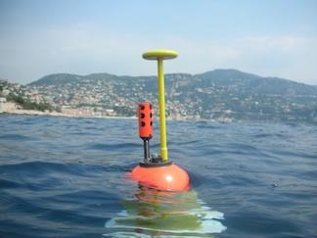

Figure 1. A prototype of the Mermaid robot that is designed to record the
arrival of earthquake waves while freely floating at a depth of 1-2 km in the oceans, photographed just before starting a test dive in the Bay of Villefranche. The red housing contains a hydrophone to observe pressure fluctuations due to earthquake waves entering the water column. The yellow antenna is used to communicate with the Iridium satellite system once the Mermaid surfaces to report an observed earthquake signal, as well as to obtain an accurate position using GPS.

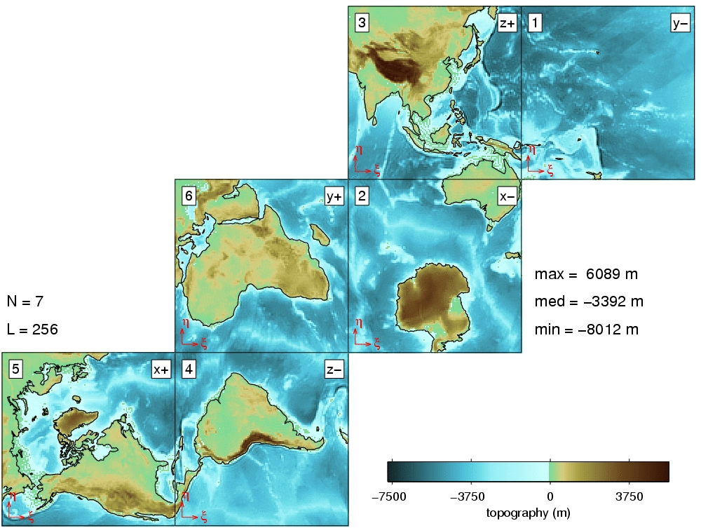

Figure 2. To apply wavelet transforms on a spherical Earth, it is convenient to divide the Earth's mantle into six "cubes". This figure shows the optimal configuration of such cubes, as defined during a workshop held in May 2009 in Villefranche. The wavelets allow for a “multiscale” interpretation of seismic information such as provided by the Mermaids, and to resolve more detail in regions of a dense instrument coverage. See Simons et al., Geophys. J. Int., doi : 10.1111/j.1365-246X.2011.05190.x, 2011.

Figure 3. Acoustic pressure variations as recorded by two MERMAID prototypes
during one of the tests done in the Ligurian Sea. The arrival time of the two pulses identifies them unambiguously as seismic P-waves from an earthquake that occurred on June 24, 2011, near Fox Island, Aleutians, at a distance of 9450 km from the Mermaid. The P waves have travelled through the lower mantle, turning just above the Earth's core to return to the surface. The excellent signal-to-noise ratio of these seismograms allows seismologists to pinpoint small delays or speed-ups of this wave in the deep Earth caused by variations in temperature or composition. Though this was a particularly strong earthquake of magnitude 7.4, such as happens only a few times per year, earthquakes with magnitudes as low as 5.5 have also been recorded. See also Hello et al., EOS, 92, 337-338, 2011; Sukhovich et al., Geophys. Res. Lett., 38, L18605, 2011.

