PROJECT FINAL REPORT

Grant Agreement number: 246037
Project acronym: FIRE-RESIST
Project title: Developing Novel Fire-Resistant High Performance Composites
Funding Scheme: Seventh Framework Programme - NMP
Period covered: from 01 Feb 2011 to 31 Jan 2015
Name of the scientific representative of the project's co-ordinator,
Title and Organisation: George Kotsikos & Conor O’Neill Newcastle University (UNEW)
Tel:
Fax:
E-mail:
Project website address: www.fire-resist.eu
  - Final publishable summary report

This section must be of suitable quality to enable direct publication by the Commission and should preferably not exceed 40 pages. This report should address a wide audience, including the general public.

The publishable summary has to include 5 distinct parts described below:

Executive summary (not exceeding 1 page).
The overall aim of the project is to develop novel, cost-effective, high-performance, lightweight polymer matrix composite materials with a step-change improvement in fire behaviour. FIRE-RESIST will achieve this by carefully targeted research in five key areas:
- Multi-micro-layered structural materials that are designed to delaminate extensively when exposed to heat, thereby generating a multiplicity of internal interfaces that provide a fire barrier of exceptionally low thermal conductivity.
- Hybrid thermoset composites that are polymeric at normal temperature, but which decompose under fire to provide highly protective ceramic char phases.
- High char polymer matrix composites derived from naturally occurring furan and cork.
- The commingling of particle-doped polymer fibres and conventional fibre reinforcements as a highly efficient means of dispersing fire retarding particles within a polymer composite.
- Advanced multi-scale simulation of polymer matrix composites in fire through the use of a fire degradation material model in conjunction with coupled computational fluid dynamics and structural finite element analysis as a tool for research, development and design.

The viability of the material solutions developed in Fire-Resist was proven through the development of application case prototypes for the aeronautic, rail and maritime industries. This work was supported by a suite of tests against the relevant industry standards and supported by CFD, FDS and FEA modelling. LCA and LCC was performed to demonstrate the long-term viability of introducing the developed materials to the marketplace against the operational criteria for each industry application. The project delivered three full-scale demonstrators as proof-of-application and these were showcased at JEC 2015 in Paris.

Summary description of project context and objectives

The greater use of polymer matrix composite materials would be highly desirable. Their low weight, along with their inherent resistance to corrosion and fatigue, enables more fuel efficient and sustainable transport structures. However, for many applications, the biggest factor currently preventing the more widespread use of light high-performance polymer matrix composites is their poor fire performance. This is due to the organic matrices, which first soften on heating, causing a loss of mechanical properties and then, at higher temperatures, decompose. Decomposition results in the production of smoke and toxic or flammable decomposition products. These products are not only hazardous in terms of lack of visibility and toxicity; they can also burn, releasing heat, which can lead to flame spread and exacerbate the fire. Furthermore, loaded composite structures often collapse in a fire within a period of minutes, depending on the magnitude of the load and heat flux.
The overall aim of the project is to develop novel, cost-effective, high-performance, lightweight polymer matrix composite materials with a step-change improvement in fire behaviour. FIRE-RESIST will achieve this by carefully targeted research in five key areas:
- Multi-micro-layered structural materials that are designed to delaminate extensively when exposed to heat, thereby generating a multiplicity of internal interfaces that provide a fire barrier of exceptionally low thermal conductivity.
- Hybrid thermoset composites that are polymeric at normal temperature, but which decompose under fire to provide highly protective ceramic char phases.
- High char polymer matrix composites derived from naturally occurring furan and cork.
- The commingling of particle-doped polymer fibres and conventional fibre reinforcements as a highly efficient means of dispersing fire retarding particles within a polymer composite.
- Advanced multi-scale simulation of polymer matrix composites in fire through the use of a fire degradation material model in conjunction with coupled computational fluid dynamics and structural finite element analysis as a tool for research, development and design.

Main S&T results/foregrounds (not exceeding 25 pages)

WP1
Multi-micro-layered laminates have been developed as an effective fire barrier that significantly prolongs the heat transfer into an underlying substrate and hence decelerates its temperature increase which delays mechanical softening as well as onset of thermal degradation processes. The concept behind this is the transformation of the polymeric constituent of multi-micro-layered laminates (MMLL) into a gaseous product because of pyrolysis when exposed to fire. Due to layered structure these volatile gases are trapped within the laminates causing extensive delamination which consequently forms an effective insulation shield.
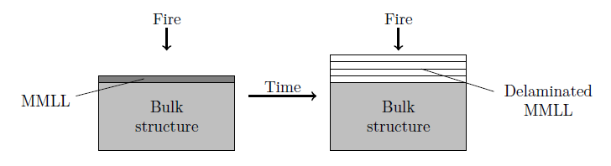
Figure 1: Schematic principle of the fire protection effect exerted by multi-micro-layered laminates

During the initial phase the focus was laid on the development of these novel material types. Suitable materials, i.e. metal foils and polymeric resin, and several manufacturing techniques have been tried out and eventually optimised. Various MMLL architectures have been developed in order to investigate the influence of basic characteristics such as foil thickness and layer number onto the fire behaviour of these MMLL when used as a surface fire protection material.
The main work involved the experimental characterisation of the newly-developed materials. Besides microstructural analysis and extensive investigation of the polymer resin used in the laminates, the thermal transport properties of the MMLL were determined in a simple thermal step-change experiment over a wide temperature range. Measurements from room temperature up to 250°C of the MMLL thermal conductivity revealed a continuous reduction with increasing temperatures which is associated with the resin softening and onset of thermal degradation. The thermal conductivity of a decomposed and expanded laminate was found to be reduced to 9% of its room temperature value which proves essential for the formation of the laminate’s fire protection effect.
Standard cone calorimeter tests were carried out to evaluate the fire performance of specimens featuring MMLL as a surface protection measure in comparison to unprotected substrates. The great improvements achieved are exemplarily shown in Figure 2 below for two different types of substrate materials. In general, laminated substrates exhibit much increased ignition times which are caused by the much slower heating up rate leading to a delay in the onset of substrate decomposition. For the GLARE substrate Peak HRR and THR are not greatly influenced which is in contrast to the MAHRE value. In this case the MAHRE is reduced by 50% which is due to the fact that burning consumption of the sample occurs over much longer time period which reduces the risk of fire spread in real case scenarios. For the test of entirely combustible materials CFRP substrates have been used and an even greater improvement in the fire reaction properties of samples featuring MMLL was observed. Besides the huge delay in ignition, HRR, Peak HRR and THR are significantly reduced. Unprotected samples experience a complete consumption of their polymeric constituents whereas MMLL featuring specimens have higher residual mass. This is associated with the overall lower temperatures reached within the substrate due to the insulation effect of the MMLL which leads to suppressed decomposition.
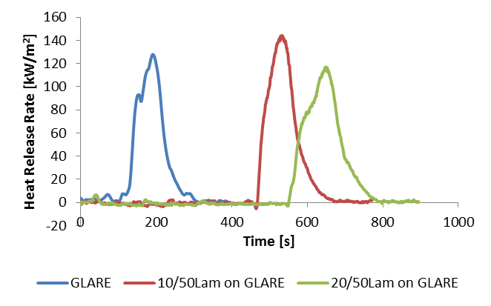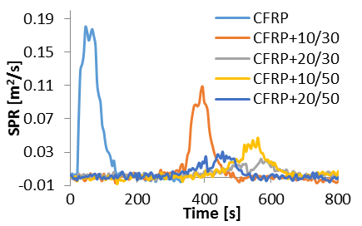
Figure 2: Comparison of cone calorimeter results between unprotected samples and specimens featuring MMLL surface protection

Fire-structural test have been carried to evaluate the laminates influence on samples simultaneously exposed to heat as well as mechanical load. It is shown that failure times in tests carried out under tensile and compressive conditions are greatly improved because of the introduction of MMLL. The MMLL insulation effect causes a much slower temperature increase of the substrate in comparison to an unprotected specimen which means it prolongs the time period until the onset of mechanical strength loss occurs, consequently leading to extended failure times and longer safe escape times in real fire scenarios. Figure 3 shows time-to-failure curves for a metal and a combustible substrate, respectively. Similar to the cone calorimeter results, in case of combustible substrates (CFRP) a suppression of the extensive on-going sample degradation at prolonged heating times can be achieved due to the application of the laminates onto the sample surfaces which changed the decomposition characteristics and consequently the failure behaviour in favour of extended failure.
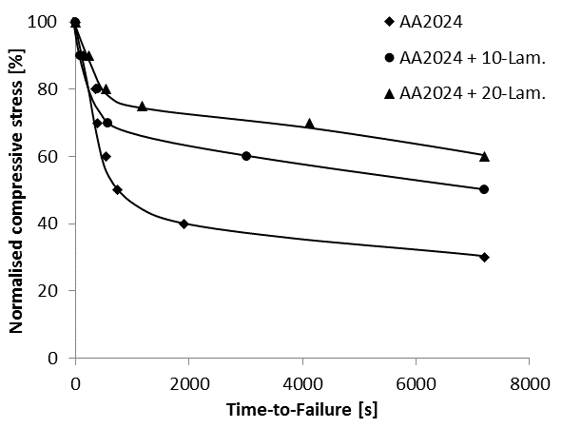
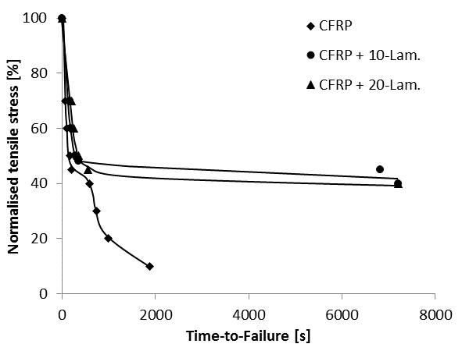
Figure 3: Time-to-failure curves for aluminium and carbon-epoxy substrate under fire-structural conditions, with and without MMLL.

To increase the applicability of the newly-developed MMLL, modified laminates have been developed which can be employed in applications posing the risk of severe fire conditions. Non-melting metal foils have been introduced as a laminate top layer in order to withstand temperatures well above 1000°C. Fire exposure tests verified the superior behaviour of the modified laminates in comparison to the basic MMLL design. Titanium and stainless steel top layers form a resistive barrier towards the impinging flame. In comparison, basic MMLL experience destructive behaviour due to successive melting of individual foils as well as ablation which increases the higher the heat flux is. Hence, modified MMLL pose an additional advantage over the already improved fire behaviour of structures that feature basic MMLL. The temperature rise of the substrate is inhibited even further due to the withstanding of the non-melting top layer. Figure 4 pictures the temperature reduction achieved at a certain time during the fire exposure test in comparison to an unprotected sample.
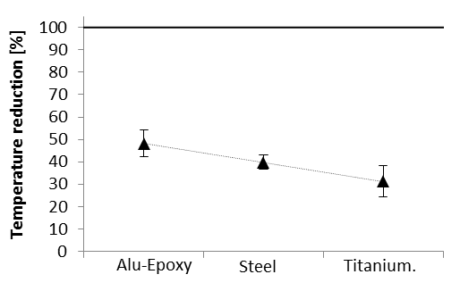
Figure 4: Temperature reduction at the substrate’s rear face measured for specimens feature a basic MMLL (alu-epoxy) or modified MMLL (titanium, stainless steel)

An explicit finite difference method was successfully developed in order to simulate the temperature development within specimens comprised of multi-micro-layered laminates bonded to a substrate that is exposed to one-sided heat flux.

WP2

The aim of WP2 was to develop improved fire reaction behaviour in high-performance fibre reinforced polymer composites through modification of the high temperature decomposition mechanism of the matrix phase. The fire performance of composites can be significantly improved by increasing the proportion of the matrix resin that transforms to solid char rather than volatiles. Char formation is beneficial because it results in lower heat release and if enough is formed, there can be sufficient char phase to hold together the fibres and provide a basic level of high temperature structural integrity. The aim was to promote char formation by using “hybrid thermosets”. These are resins which, at high temperatures, transform to ceramic or partially ceramic phases. The target is to achieve char yields of 60% or higher. A further advantage of promoting char formation ahead of volatile production is a reduction in the level of toxic emissions.

This work package aimed to examine several hybrid thermoset systems. Resins which have inherently good char-forming properties were included, such as polysiloxanes, cyanate esters and polybenzoxazines, furan resins and modified epoxies. Furthermore, the addition of ceramic char-promoting particles to the resins will be investigated. These different polymers will be combined with carbon or glass fibre reinforcements to produce high performance lightweight composite materials.

Before laminate fabrication, it was necessary to characterise the chemo-rheology of the cure processes in the materials systems identified. This was carried out using experimental techniques including differential scanning calorimetry (DSC) and rheometry. These measurements characterised the reactions that take place both during cure and at higher temperatures in order to determine viscosity changes and phase changes such as gelation and vitrification processes as a function of resin composition and cure schedule. Thermo-gravimetric analysis (TGA) measurements also gave an early indication of high temperature decomposition and the transformation to ceramic phases. The results obtained in this WP provided the information needed for laminate fabrication.
Matlab program UICOMFIRE_50_1_2, developed at the Centre of Composite Materials Engineering (CCME), University of Newcastle, allows predictions of thermal response of composite laminates in fire.
Program COMFIRE was initially developed in 1994 for predictions of thermal resistance of thick GFRP laminates when exposed (with one of its two faces) to hydrocarbon fire only, based on the one-dimensional (1D) model) using finite difference (FD) numerical analysis approach. Now the new version of the program developed in WP2 can be used to predict thermal responses of composite laminates exposed to a few different heating sources. Resin systems and fibre reinforcements involved can be of different type. A database of thermal properties for the most common resins and fibres systems is embedded; the user can also input customised thermal properties.
Feasibility studies of producing hybrid thermoset composites at the quality and volumes required by the transport sector end-users were completed. Options for both prepregging and liquid composite moulding (resin infusion, resin transfer moulding) were studied. Pilot trials on industrial equipment were performed to verify the recommendations.
WP2 SCALE UP STUDIES
The work covered here was a collaborative activity as undertaken between Cytec and project partners to identify potential fabrication routes and issues surrounding scale-up of the current structural composite technologies. The research in this Task focused on taking the laboratory scale developments from Cytec Industrial Materials UK and extending them to volume production, focussing on prepreg development. It was anticipated that the structural component in the multifunctional fire-resistant composites would be based on Cytec’s commercially available chemicals, tooling, resin systems and fibres.
For the structural composites reported here, plain weave carbon fibre fabric with an areal density of 245 g m⁻² and density 1.76 g cm⁻³ could be used among others. A glass fibre fabric or a polyester mat could be used as separators. Furan resins have been transformed into composites by means of infusion processing at larger scale facilities at Cytec UK and APC Company in Sweden and within WP3 as industrial scale up, but being actually conceived as a link between the prototypes developed in WP3 and the final pieces that will be developed within WP6.

WP3

1.-Objective
To develop light high-performance fire-resisting composite materials based on high char polymer matrix resins synthesized from natural sources.
2.-Tasks
Task 3.1- High Char Polymer Matrix (HCPM) formulations: (VA-RTM, infusion, pre-pregging and cork agglomeration)
Task 3.2- Pre-scaling of manufacturing processes.
Task 3.3- Characterization of natural composites samples.
Task 3.4- Industrial scale-up of HCPM composites from natural sources.

3.-Formulations, processing and characterization at pre-scaling level.

3.1.- Raw materials designed and developed during the project

Furan resins (TFC): Furolite 050915-C (for VA-RTM and infusion)
Furolite 050915-A (for cork agglomeration)
Furolite 120514 (for pre-pregging)

Acid catalysts (TFC): S and S+ (not P/N modified catalysts)
FR1 and FR2 (P/N modified catalysts)

3.2.-Commercial raw products used during the project

Flame retardants: FR CROS 484 (APP: ammonium polyphosphate)
(char precursors) BUDIT 3167 (MPP: melamine polyphosphate)

Other flame retardants: DMPP (dimethyl-propane phosphonate)
MICRAL 932 (ATH: aluminium trihydroxide)

Glass fibre: Biaxial fabric 800 g/m2 and 1700 g/m²
Chopped strand mat (csm) 300, 450 and 1800 g/m².
Roving 600 gm².
Other natural fillers: Liquid lignin and cork powder

3.3.-Prescaling: Processing methods and characterization tests
Plenty of formulations were designed and processed by means of 5 different processing methods: i) VA-RTM, ii) infusion, iii) prepregging, iv) cork agglomeration and v) vacuum curing process (see Figure 5).
Samples were characterized in order to obtain mechanical, reaction to fire and fire resistance properties.

Figure 5: Detail of three of the five selected manufacturing processes: VA-RTM (left), infusion (middle) and pre-pregging (right).

4. Results and conclusions.

The main results and conclusions obtained are:
4.1.- Formulations developed
- Furan resins developed during the project can be used for the production of high performance composites, pre-pregs and for cork agglomeration.
- Furolite resins show good fire behavior themselves.
- P/N modified catalysts increase cross-linking times excessively (2-3 hours).
- APP and MPP powder additives improve char formation.
- APP and MPP powder additives improve fire behavior but they lead to processing problems due to their particle size (filter effect in vacuum infusion and RTM).
- DMPP increases cross-linking times excessively.
- Cork powder increases excessively the viscosity of the resinous system and does not improve fire behavior.
- Lignin liquid does not improve reaction to fire properties.

4.2.- Prescaling: processes and characterization
VA-RTM and INFUSION
- The optimal formulations, based on furan resin Furolite 050915-C, are easily processed by means of VA-RTM or infusion.
- The formulations show a suitable viscosity to impregnate 800 g/m2 glass fibre fabrics.
- The optimal formulations processed by VA-RTM/infusion fulfill all the requirements for the railway sector (EN 45545-2:2013) demanded by interior wall coverings and external cab housing (very strict requirements).Nevertheless it does not fulfill one of the requirements demanded by the IMO 2010 FTPC Code for the naval sector.
- To fulfill this naval requirement it has been necessary to include 3 p.p.h of ATH MICRAL 932.
- The mechanical properties are also suitable for these applications.

PRE-PREGGING
- Furan resin (Furolite 120514) is suitable for pre-preg manufacturing.
- The furan composites manufactured show excellent mechanical and reaction to fire properties (similar to the phenolic ones).

CORK AGGLOMERATION
- Furan resin Furolite Furolite 050915-A does not show enough flexibility to manufacture thin flexible cork sheets (3-5 mm).
- Cork agglomeration with flame retarded (APP: FR CROS 484) furan resins is possible for thick panels (10 mm).
- Mechanical and reaction to fire results show that their use in railway applications can be possible.
- Some manufacturing problems: not suitable spreading of the mixture on the double belt press.

MICROWAVE CURING
- Microwave curing tool, compared to conventional curing methods, improves mechanical properties in the same order that found in the bibliography (more than 10% better).
- Fire properties are lightly better.
- Lower curing times have been obtained

COATING APPLICATION
- Furan superficial aspect can be improved using decorative coatings (epoxy, polyurethane, etc).
- Fire behaviour properties can be improved by means of intumescent coatings.

4.3.- Industrial scale-up
- Furan resins and their curing agents are very corrosive due to the content of water (resin) and the acidity of the curing agent. Moulds and tools need to be built in a non-corrosive material.
- Furan resin shows short pot-life, therefore cycle times need to be really short.
- Suitable curing and post curing cycles are necessary to achieve good properties (mechanical and reaction to fire).
- Although some curing problems appeared during vacuum infusion, this processing method should not be rejected. The problems seem to be a sizing matter of the fibres rather than a material issue.
- During the furan resin handling and its curing process, the product emits gases and smell. Even though the majority is water, it is recommended to use the same precautions as in other thermosetting resins (polyester, epoxy, phenolic).
- Protective precautions must be also taken into account during machining of material because the particles emitted are usually very sharp. Proper protective clothing and ventilation are recommended.
- The best and cheapest way to manufacture products such as sandwich panels, would be the use of a glass fibre reinforced furan pre-preg pressed into a heated tool. The investment is really high (approx. 600.000-900.000€) but, on a large scale production, the investment will be paid off in a fairly short time. The quality of the products would be much higher compared to hand lay-up process.

Figure 6: Infusion process at APC (left), samples manufactured (middle) and delamination problems during the mechanical characterization (right)

The following table summarized the problems appeared during the scale-up and the solutions propose for the demonstrators manufacturing.

MANUFACTURING PROCESS | PROBLEM AT THE SCALE-UP STEP | SOLUTION PROPOSED FOR THE DEMONSTRATORS
APC: glass fibre reinforced furan composite | The use of biaxial glass fibre leads to delamination problems at industrial level. | Use of chopped strand mat and roving.  Not expected important changes in the reaction to fire properties due to the change of the fibre type (non combustible material).
AMORIN: cork agglomeration | Cork panels agglomerated with furan resins break because of internal pressure when pressing. | Use of standard not flame retarded cork panels in the final demonstrators.

5.-WP3 Summary. Inputs to WP6: proposed demonstrator lay out
As a final result of the WP3, a sandwich panel lay out was proposed for the final demonstrators (WP6) regarding railway and naval sectors. The lay-out is collected in Figure 7.
Depending on the final application the number and the thicknesses of internal cork cores and intermediate layers can vary (Figure 8).
These demonstrators and their properties will be described in the corresponding work package report (WP6).

Figure 7: Lay out of the sandwich panel proposed to WP6

Figure 8: Demonstrators manufactured for rail (left) and maritime (right) sectors.

WP4

The concept behind the work in WP4 ‒ “Particle-doped polymer fibres for fire-retarded commingled composites” was to develop fire-optimised polymer matrix formulations based on polymers which in a next step were spun into continuous fibres and eventually commingled with conventional glass or/and carbon fibres to produce composite preforms for consolidation (Figure 9). During consolidation the very short polymer flow lengths, which are characteristic of commingled fibre composite systems along with the use of sub-micron-scale particulate fillers, would provide an extremely even and efficient distribution of the fire-retarding additive throughout the composite part.
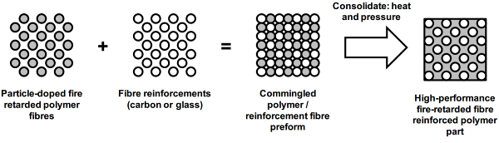
Figure 9. Schematic of the use of commingled fibres to provide a high performance fire-retarded polymer composite laminate.

The main emphasis during the initial part of the WP was to identify and develop suitable nanocomposite formulations for the production of polymeric fibers. The work included literature reviews as well as preparation and characterization of neat polymer nanocomposites based on three on three different types of material systems: Cloisite-doped PA6 (thermoplastic); Boehmite-doped PES (thermoplastic) and a particle-doped epoxy (thermosetting).
In the work, PA6 was mixed with an organo-modified montmorillonite and PES was doped with boehmite. After a proper evaluation of the combustion behaviour combined with their capability to be spun, the best formulations were sent to SICOMP for subsequent spinning and commingling activities. In the following figure, standard cone calorimeter results in terms of HRR are reported for both the used matrices. Clear improvements in the combustion characteristics with the addition of nanoparticles are observed for PA6 nanocomposites. The same level of improvement was not observed for PES-nanocomposites. This is mainly explained by the already inherently excellent fire resistance of neat PES that is illustrated by the difference on the scales on the y-axis in Figure 10. Moreover Proplast has also applied a specific characterization technique for the combustion behaviour which couples a cone calorimeter test with the measurements of the top and bottom surface temperatures.
Figure 10: Results from cone calorimeter testing of neat and nan-particle doped PA6 and PES

Optimization work on epoxy (TGDDM) and curative fibre provided by Cytec was also performed. The work included preparation of materials with different contents of thermoplastic (PEI) and various stoechiometric ratios. A process involving the use of solvent was implemented as problems of dissolution of the fibre in the epoxy prepolymer were experienced. A polyhedral Oligomeric Silsesquioxane with three silanol functions (POSSOH) was added to the networks, either alone or in combination with aluminium triacetylacetonate.
The PEI presence due to the curative fibre addition led to phase separation and possibly phase inversion, depending on the PEI content. In the network with a PEI content of 10wt%, containing the POSSOH without the aluminium salt, the presence of POSS domains was evidenced in the PEI-rich phase (Figure 11). On the contrary, with the aluminium salt the POSSOH did not phase-separated and could be located in the epoxy matrix, where it was likely to be molecularly dispersed.

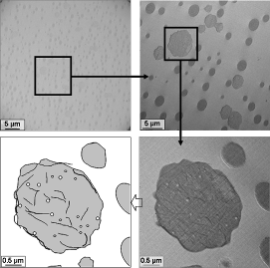
Figure 11: TEM images of the TCF-POSSOH network containing 10 wt% of PEI (a/e=0.26) at various magnifications. Dark nodules are made of PEI-rich phase and dark filaments within these nodules could be attributed to POSSOH

A great reduction of pHRR (86%) and a beneficial effect on other parameters (reduction of THR and TSR, increase of residual weight) was obtained when adding the POSSOH in combination with the aluminium salt, in the networks containing 10wt% of PEI (Figure 12). This beneficial effect was associated with a clear intumescent effect. Finally, the addition of both the POSSOH and the aluminium salt allowed to obtain materials with high Tg’s, even for off-stoichiometry networks, probably due to the enhancement of epoxy homopolymerization.
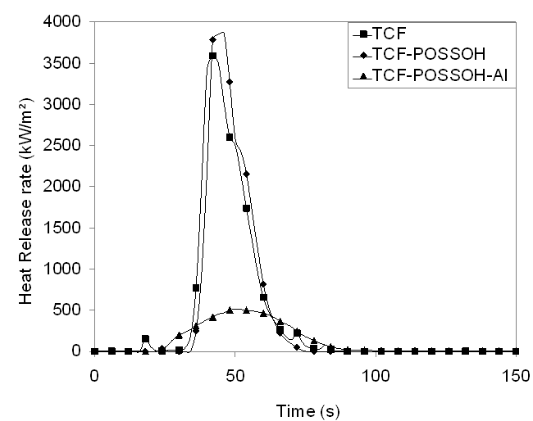
Figure 12: HRR curves of TCF networks containing 10 wt% of PEI

Preparation of polymeric fibres was conducted in the next stages of development. Initially, single-component monofilament fibre spinning trials were carried out to investigate the potential of spinning nanoparticle-doped theromoplastic fibres. Multifilament fibres, see Figure 13 with the different resins were prepared once the processing parameters were determined.
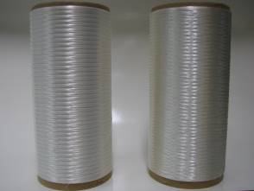
Figure 13: Neat PA6 (left) and PA6+2% wt. Cloisite fibres (right)[2].

The melt-spun fibres were later on used to prepare glass and carbon fibre composites that underwent through characterisation (microstructural, mechanical, thermal and fire behaviour).
The very innovative concept of thermosetting curative epoxy fibre (CF) was originally designed for the production of thermosetting composite materials using the commingling process. The idea was to wind together the curative fibres and the reinforcement fibres (carbon or glass fibres) to produce a preform, then inject the epoxy prepolymer in the preform and finally cure. The networks were based on the TGDDM epoxy prepolymer, while the crosslinking agent was introduced in the systems by using the curative fibre EF10007 (CF), produced and provided by Cytec. For fibre processing reasons a rather high content of thermoplastic additive was required in the CF. This high content caused problems in the subsequent cure since an inevitable phase separation occurred i.e. the thermoplastic and thermosetting phases are separated. A detailed study in which three different thermoplastic PEI contents were considered confirmed that the lowest possible PEI-content (from fibre spinning perspective) inevitably yields in an undesired phase inversion of the final composite.
With regards to the PA6-based commingled composites, within the framework of FIRE-RESIST, good quality laminates were routinely manufactured (fibre spinning-commingling-consolidation), tested and thoroughly characterised (quality control and combustion by-products). Although this nanoparticle-doped commingled composite system exhibited good properties and indications of enhanced fire reaction and flammability properties in some tests, it could not be completely confirmed that nano-particles had a significant positive influence on the fibre composite fire-behaviour. Tests of production of toxic gases and small particles during the combustion of neat and nano-doped PA6-based commingled composites were conducted at 35 kW/m² and 70 kW/m². No significant differences were observed between the two materials. The inherently high fire retardancy of the PES could not be apparently improved by the 0.6%wt of Boehmite nanoparticles.

WP5

Multi-field simulation framework for composite structures in fire
The objective of FIRE-RESIST WP5 was to develop and validate a novel multi-field simulation framework that could be used for virtual fire testing, i.e. for the response of polymer matrix composite materials and structures to fire. A description of the main results in each of the five tasks of WP5 is given below.

Task 5.1 – Simulation chain development

The approach that was drafted in the project’s description of work, and later detailed in milestone MS6, is based on coupling existing open-source and commercial simulation software. These include:

- Fire Dynamics Simulator (FDS), which is a widely used Computational Fluid Dynamics (CFD) tool for the simulation of fire phenomena. It is developed as an open-source project led by the National Institute of Standards and Technology (NIST). VTT Technical Research Centre of Finland is responsible for the development of the thermal radiation and condensed-phase heat transfer and pyrolysis modules of FDS.
- ABAQUS and ANSYS, which are both general purpose Finite Element Analysis (FEA) software. They offer tools for modelling structures under simultaneous thermal and mechanical loads. ABAQUS and ANSYS are commercial products of Dassault Systèmes and Ansys Inc. respectively.

In the simulation framework, FDS is used to model the fire environment and the heat exposure to relevant structures, while ABAQUS is used for their thermal and mechanical response. Thermal exposure to surfaces is extracted from the fire dynamics simulation and used as a time-dependent boundary condition in the subsequent thermal-mechanical analysis. The sequential coupling scheme is illustrated in Figure 14.

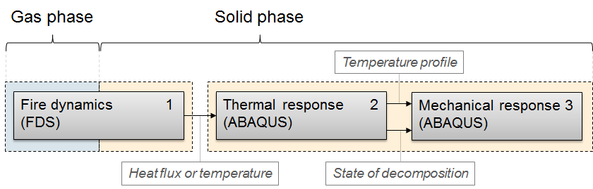
Figure 14. The multi-field simulation framework developed in WP5.

Task 5.2 – Implementation of CFD-FEA interoperability

To establish the coupling chain, an interoperability tool called FDS2FEM was developed and shared with the project partners in Deliverable D5.1. FDS2FEM provides sequential and one-directional transfer of thermal boundary conditions from FDS to ABAQUS (Figure 15). It was implemented as a command-line application for Linux and Windows operating systems, and in a later phase of the project, extensions for ANSYS support were realized in co-operation with DNV-GL. A number of verification cases were created to ensure the correct implementation of numerical algorithms within the interoperability tool.

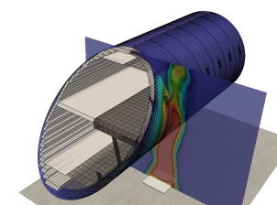 | 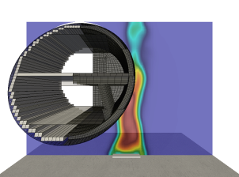
(a) | (b)
Figure 15: Two different views on an example case of FDS-ABAQUS mapping, displaying a section of an airplane hull with a burning kerosene pool next to it. Colour map on the outer surface of the hull displays its adiabatic surface temperature. The semi-transparent plane with a colour map indicates gas-phase temperatures. Both colour legends are omitted.

Task 5.3 – Implementation of the material models in the CFD code

Much of the work in WP5 concentrated in improving the capabilities of FDS and ABAQUS to model the thermal decomposition process in polymer matrix composites, and in creating feasible models for the new materials that were under development in other work packages of FIRE-RESIST.

The work related to FDS was focused on pyrolysis modelling. This included adding new capabilities to the physics sub-models, their verification and validation, and developing practical methods for the estimation of pyrolysis model parameters from small-scale laboratory experiments. A notable improvement to the FDS solid phase model was the capability to handle swelling and shrinking materials. Also, significant contributions were made to parameter estimation methods for creating pyrolysis models based on Thermogravimetric Analysis (TGA), cone calorimetry and the use of direct and evolutionary algorithms (Figure 16. FDS pyrolysis model for the furan+glass fibre laminate of WP3: (a) results of actual and simulated TGA experiment, (b) heat release rate of actual and simulated cone calorimeter experiment.Figure 16).

The implementation and verification of the FDS material models and guidance for parameter estimation was reported in Deliverable D5.2.

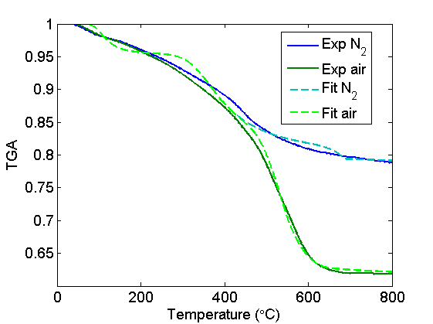 | 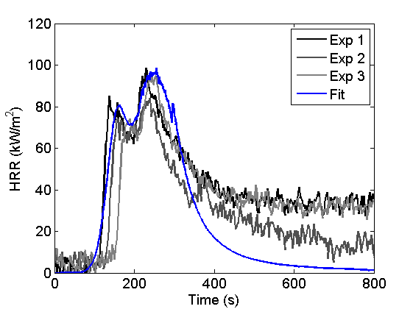
(a) | (b)
Figure 16. FDS pyrolysis model for the furan+glass fibre laminate of WP3: (a) results of actual and simulated TGA experiment, (b) heat release rate of actual and simulated cone calorimeter experiment.

Task 5.3 – Discretization and implementation of the material models in the FEA software
The work related to ABAQUS employed both standard and user-customizable features of the software. The models developed included i) a heat transfer analysis for the temperature distribution inside the composite, the state of pyrolysis of the polymer matrix and the oxidation of fibre reinforcements; ii) a new user defined subroutine for the internal heat generation that occurs during pyrolysis; and iii) implementing a thermal-mechanical model with a transversely isotropic material representation, and temperature and residual resin content dependent elastic constants. The thermal models (i and ii) received parameters from the same experiments as the FDS pyrolysis models. Parameters for the mechanical model (iii) were obtained from Dynamic Mechanical Thermal Analysis (DMTA). An example of temperature dependent mechanical behaviour present in the models is shown in Figure 17.

(a) | (b)
Figure 17. ABAQUS thermal-mechanical modelling of the furan+glass fibre laminate: (a) DMTA test result for the neat matrix, storage modulus and (3°C/min, 1 Hz), and (b) simulated longitudinal modulus for the NCF UD layer with wavy fibres (modulus calculated using rule-of-mixtures is also included).

The implementation and verification of the FEA material models was reported in Deliverable D5.3.
Relevant benchmark materials and FIRE-RESIST composites were characterized using TGA, cone calorimetry and DMTA to model their thermal and mechanical behaviour both at ambient conditions and during their thermal decomposition process. These material models were later employed for validation purposes of WP5 Task 5.5, as well as in the modelling of the maritime demonstrator experiment of WP6.

Task 5.5 – Validation of the simulation concept
The performance of the simulation framework was tested in a series of validation experiments. Two intermediate-scale experimental methods, the so-called mini-furnace test (SP Fire 119) and a custom experiment in slightly larger scale, were employed in the work (Figure 18). In both experiments, a planar composite specimen was exposed to simultaneous thermal and mechanical loading. The mini-furnace tests represented traditional fire-testing, whereas the custom experiment included the additional degree of freedom of fire spread. Repeated experiments were conducted on two FIRE-RESIST materials, including the carbon fibre reinforced multi-layer laminate of WP1 and the glass fibre reinforced furan laminate of WP3. Additional experiments were conducted on lightweight concrete and PMMA to gain further insight into the proper modelling of the custom set-up.

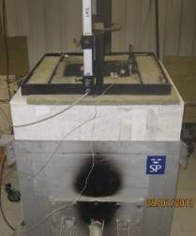 | 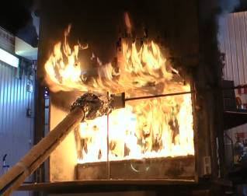
(a) | (b)
Figure 18. Experimental methods employed in the validation work: (a) mini-furnace with specimen holder and specimen on top, (b) custom intermediate-scale experiment on the carbon fibre reinforced multi-layer laminate of WP1.

The validation experiments were modelled using the CFD-FEA simulation framework. Uncertainties associated with the fire simulations, and the capabilities to predict structural behaviour were studied by comparing the model predictions against the experiments (Figure 19-Figure 21). The results indicate that, with properly configured material models, the simulation framework can be used to successfully predict the thermal and mechanical response of polymer matrix composites, until the structural deformations become considerable. The presence of a major structural deformation in the FEA analysis indicates, that the system has moved out of the applicability range of the simulation framework. In addition to providing data for model validation, the above mentioned experiments served in assessing product performance.

The validation effort on the complete simulation concept was reported in Deliverable D5.4.

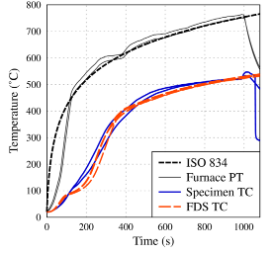 | 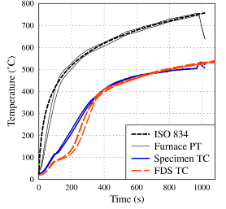
(a) | (b)
Figure 19. Mini-furnace experiment on the furan+glass fibre laminate: FDS simulation vs. experiments (a) and (b). The temperatures (orange and blue lines) are measured from the unexposed side of the composite specimen.

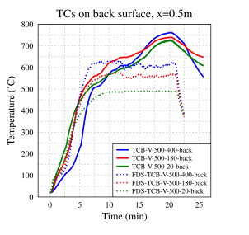 | 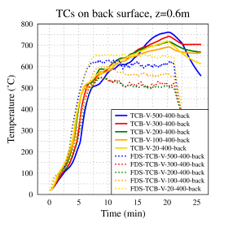
(a) | (b)
Figure 20. Custom intermediate-scale experiment on the furan+glass fibre laminate: FDS simulation vs. experiment. The solid lines represent experimental results and the dashed line the corresponding FDS predictions. The temperatures are measured from the back side of the vertical specimen at different locations.
Figure 21. Custom intermediate-scale experiment on the furan+glass fibre laminate: FEA model vs. experiments. Deflection of the vertical laminate as a function of time.

WP6

The aim of Fire-Resist Work Package 6 – ‘Application and Evaluation of Fire-resisting technologies’ is to apply the most promising material developments from WP1-4 to relevant case study components (aeronautic, rail and maritime). Following the specification and design of the case study components in Tasks 6.1 and 6.2 respectively, the manufacturing of these was performed successfully in Task 6.3 – “Manufacturing of Transport Industry Case Study Components”. In addition, the evaluation is performed in Task 6.4 on coupon specimens and case study components manufactured in Task 6.3, and based on selected requirements from the specification as prepared in Task 6.1.
Manufacturing
For the aerospace industry one reference stiffened fuselage panel was manufactured and one with a technology from WP1 by AGI (Figure 22). For the rail industry interior components were manufactured by AP&M and Newrail with technologies from WP3 (Figure 23), materials supplied by Amorim and Transfuran, though specimens for testing were produced separately, to evaluate the properties according to the EN45545 requirements. For the maritime industry two large bulkhead panels were produced by APC with technologies from WP3 with materials also from Amorim and Transfuran (Figure 24).

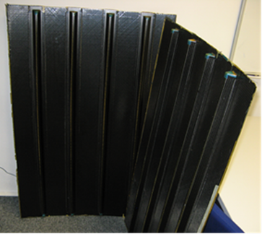
Figure 22: Fuselage panels, reference and with MLL technology from WP1

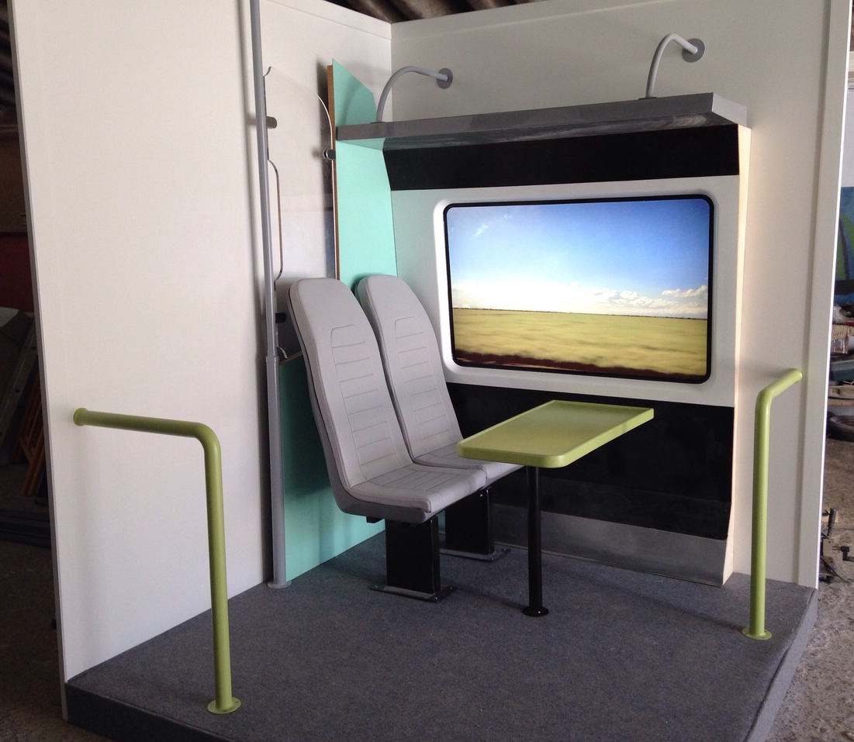
Figure 23: Rail vehicle interior manufactured with Fire-Resist technologies

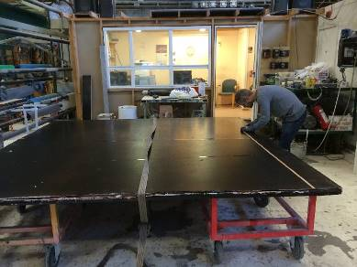
Figure 24: Maritime bulkhead panel made with Fire-Resist technologies

Because the components are all prototypes made of new materials, it was found that the applied manufacturing technologies could still be optimised in terms of processing cost, weight, cycle time and product quality, such as fibre volume content. For more information concerning the manufacturing of the components, the reader is referred to the report belonging to Deliverable D6.2.
Evaluation
Below is a summary on the evaluation of the case study components as performed in Task 6.4. For more detail the reader is referred to Deliverable D6.3 – Evaluation reports on the testing of the transport industry case study components.
Aerospace case study component
For the aerospace industry, a fuselage panel was selected as case study component. The reference technology is based on liquid composite moulding (LCM) of dry carbon fibre preforms impregnated with an aerospace grade epoxy resin suitable for vacuum assisted processing. The selected Fire-Resist technology is based on the same materials and manufacturing process, but with thermoplastic interlayers that act as a fire barrier. This is called a multi-layered laminate (MLL) with thermoplastics and was developed in WP 1 of Fire-Resist.
This section describes the evaluation of the aeronautic industry case study component in the project Fire-Resist, which is based on selected requirements from the specification as prepared in Task 6.1. Tests are performed on coupon specimens in WP1 and on case study components manufactured in Task 6.3a. In Task 6.3 two panels were manufactured, one with a reference material based on infusion of carbon fibres with an epoxy resin, one with additional thermoplastic interlayers to improve the fire, smoke and toxicity properties, the so-called multi-layer laminate (MLL).
Several main parameters were evaluated against the specification from Task 6.1. The main conclusion is that the processing as well as mechanical and physical properties of the resin were not affected much, since the same aerospace-grade impregnation resin was used. The only additional processing step for the MLL panel is the cutting, perforating and positioning of the thermoplastic layers. One major processing issue can be thickness control, due to the competing effects of additional layers, dissolution of the PEI interlayer and the vacuum assisted processing providing little pressure to compensate. The properties that could be influenced by the thermoplastic interlayer, such as glass transition temperature were already checked in WP1 and were shown to fulfil the requirements. In addition, the physical composite properties of the MLL are close to the reference properties and mostly within the targeted range, see Table 1. With the addition of the thermoplastic interlayers, especially the interlaminar shear and fracture toughness properties seemed to improve dramatically. The effects of media contamination or conditioning were not found to differ significantly for the MLL compared to the reference material.
Table 1: Composite material properties evaluation
Property | Target Value | Test Standard | Measured Values |  | Remarks
 |  |  | Reference panel | MLL panel
Degree of cure  [%] | >96 % | AITM 3.0008 | 96% | 93% | For MLL ‘fully cured’ TP interlayer was not subtracted.
Cured ply thickness [mm] | 0.125 | Taken from micrographs | 0.26 (average) | 0.26 (average) | Values deviate from target due to different reinforcement
Fiber volume content [Vol %] | 58 | EN 2564 | 58.9 | 57.4 | Lower FVG of MLL panel due to additional interlayer polymer
Porosity [Vol %] | <2 | EN 2564 | 0 | 0 | None seen in micrographs
Volatile content [Wt %] | <1 | EN 2558 | N/A | N/A | Not measurable
Achievable thickness monolithic laminate [mm] | >6 |  | N/A | N/A | Maximum thickness achieved was 4 mm at stringer foot area
Cured resin density [kg/m³] | < 1.3 | ISO 1183 - A | Epoxy: 1.14 | TP: 1.27 | Literature values [1,3]
Moisture uptake [wt%] | < 1 | EN 3615, EN 2378 | Epoxy: 0.8 | TP: 1.25 | Literature values [1,3], see also Section 4.6.1
Glass transition temperature [°C] | >198 | AITM 1.0003 | Epoxy: 197 | TP: 204 | DSC Tg Onset, 5K/min

FST Results
Horizontal and vertical burn tests (UL-94) on reference (REF) coupons as well as multi-layered-laminate (MLL) coupons with thermoplastic interlayers of 50 and 125 micrometre thickness were performed at AGI and the results are displayed in Table 2.
Table 2: UL-94 test results on reference and MLL coupons
UL-94 | 60s vertical |  | 12s vertical |  | 15s horizontal
 | t_{a} [s] | l_{b} [mm] | t_{a} [s] | l_{b} [mm] | V_{f} [mm/min]
Target | ≤15 | ≤152 | ≤15 | ≤203 | ≤64
REF | 22.4 ± 0.9 | 109 ± 7 | 0 | 0 | 0
MLL 50 μm | 17.5 ± 0.9 | 103 ± 4 | 0 | 0 | 0
MLL 125 μm | 1.4 ± 0.3 | 95 ± 7 | 0 | 0 | 0

For the 60s vertical test, the after flame length t_{a} does not meet the target value for the reference and MLL coupons with 50 micrometre interlayers whereas the MLL material with 125 thick thermoplastic interlayers does meet the target.
The fire, smoke & toxicity requirements according to the Fire Testing Handbook, DOT/FAA/AR-00/12, Chapters 5 and 6, were performed on reference (REF) and interlayered (MLL) coupon and the results are presented in Table 3 and Table 4.
Table 3: OSU Heat Release Rate Test acc. to AITM 2.0006
OSU | HRR_{max} (5 min) [kW/m²] | t_{HRRmax} [s] | HR (2 min) [kW/m²] | Thickness [mm]
Target | ≤65 | - | ≤65 | -
REF | 122 ± 8 | 84 ± 7 | 125 ± 3 | 2.1
MLL | 89 ± 5 | 93 ± 30 | 95 ± 4 | 2.2

Table 4: Results of Specific Optical Density of Smoke D_{smax} acc. to AITM 2.0007 and toxic component determination on combustion products acc. to AITM 3.0005, both in flaming mode.
NBS, Tox | D_{smax} [-] | HCN [ppm] | CO [ppm] | NO_{X} [ppm] | SO₂ [ppm] | HF [ppm] | HCl [ppm]
Target | ≤ 200 | ≤ 150 | ≤ 1000 | ≤ 100 | ≤ 100 | ≤ 100 | ≤ 150
REF | 167 ± 2 | 30 ± 1 | 231 ± 33 | 75 ± 2 | 1 ± 1 | 0 | 0
MLL | 156 ± 15 | 18 ± 3 | 175 ± 1 | 38 ± 3 | 1 ± 0 | 0 | 0

From the above results, it can be seen that the smoke and toxicity requirements are fulfilled for both reference and MLL materials, though the MLL material performs significantly better. The heat release (OSU test) is still too high for the target requirement.
The Reference and MLL panels manufactured in Task 6.3a were tested by SP according to ISO 2685:1998, following FAR25.853 Part VII of Appendix F, see Figure 25.
Figure 25: Test specimen during fire resistance test

Heat release rate, smoke density, and mass loss were also monitored during the burn test according to ISO 24473:2008. The results are presented in Table 5

Table 5: Results from fire resistance tests according to ISO 2685, from [4].
Specimen | Test time [min] | Result acc. To ISO 2685 | Mass loss [g] and [%] | Surface temperature after 15 min test time [°C]
REF 1 | 15 | No burn through (“Fireproof”) | 147 (7%) | 425
MLL 1 | 15 | No burn through (“Fireproof”) | 157 (7%) | 389
REF 2 | 60 | No burn through (“Fireproof”) | 193 (9%) | 418
MLL 2 | 60 | No burn through (“Fireproof”) | 202 (9%) | 458

According to the ISO2685 tests, all panels fulfil the fireproof requirements, and no significant difference between the reference and MLL panels can be deduced from the results. In addition, in general it can be stated that the MLL laminates perform better due to the lower peak heat release rate and smoke production.
Taking into account the composite properties as well as the supply chain requirements, the way forward seems to be the application of interlayers that replace existing layers, such that the composite properties as well as the manufacturing process are not much affected. Preferably, the interlayer material should be cheaper than the base material layers it replaces, to be cost-effective.

Rail case study component
The traditional material in the rail industry for the selected components is made of glass fibre reinforced phenolics (GRPh). The main properties of the developed fire resistant material used in the manufacturing of the rail demonstrator have been evaluated during and in the final stage of material development in WP3 work. They showed to have the same range of performance as the traditional material and as these are going to be used for interior panels there are no significant mechanical demands on the parts.
Once the components were manufactured samples of the appropriate size were sent to SP Technical Research Institute of Sweden for fire testing and results have been released on a separate report by SP (EN 45545-2 test results Test results from Smoke/toxicity, Cone calorimeter and Spread of flame tests; Rail case study WP6). HSE regulations did not make it possible to acquire a proper fire resistant coating for the demonstration product. The new material was then tested without flame retardant coating to assess the material fire performance of the base material developed in Fire-Resist.
Table 6 shows the comparison between the traditional GRPh panel, which receives class HL3, and the Dado waist rail, which receives class HL2. The Dado waist rail had a too high VOF4 result to receive the higher class (HL3).

Table 6: Material requirement sets (R1) for interior vertical surface products (IN1A) from Table 5 of EN 45545-2 and the results of the two tested products.
Test method reference | Parameter and unit | Max or Min | Hazard level classification |  |  | GRPh panel (reference product) | Dado waist rail (case study component)
Test method reference | Parameter and unit | Max or Min | HL1 | HL2 | HL3 | GRPh panel (reference product) | Dado waist rail (case study component)
ISO 5658-2 | CFE kWm⁻² | Min | 20 | 20 | 20 | 34 | 32
ISO 5660-1: 50 kWm⁻² | MARHE kWm⁻² | Max | - | 90 | 60 | 50 | 55
EN ISO 5659-2: 50 kWm⁻² | Ds(4) dimensionless | Max | 600 | 300 | 150 | 92 | 104
EN ISO 5659-2: 50 kWm⁻² | VOF4 min | Max | 1200 | 600 | 300 | 184 | 355
EN ISO 5659-2: 50 kWm⁻² | CITG dimensionless | Max | 1.2 | 0.9 | 0.75 | 0.14 | 0.21

At a prototype level the developed material is compliant with EN45545-2 HL2. This means that the product can be used on all mainline rolling stock designed to EN45545 in the UK. Samples would have to be painted with the rail manufacturer preferred paint system and retested for full approval for use, but the results achieved without coating give confidence that the product will pass those tests as well and it may even be classified as HL3. Indicative weight savings show that there would be a potential market for the material in rail depending on material cost. Manufacturing processes of the GRPh and the Fire-Resist material are similar to each other so there should not be differences in cost in manufacturing, while there may be on the raw material price on its own.

Maritime case study component
Fire-resisting technologies developed during the Fire-Resist project are used for design and manufacture of a maritime case study demonstrator. The usage of combustible materials in shipping industries is limited and broader application only possible if safety equivalence to traditional SOLAS compliant design can be demonstrated. In order to evaluate the case study of novel composite material for application in maritime industry, an assessment methodology is developed. The methodology is based on FTP Code and SOLAS requirements as well as Alternative Design process and mainly addresses the first phase of this approval process for the identification of violation of basic requirements (so-called show-stoppers). Based on the results of this first step the decision on carrying out a detailed design for a ship can be made. The developed assessment methodology comprises basic requirements with respect to smoke and toxicity, hazard identification for an exemplary integration in a ship and a comparative thermo-mechanical analysis. The comparative thermo-mechanical analysis is supported by a fire resisting division test in accordance with part 11 of the FTP Code (Figure 26). The test showed that the load bearing capacity under 7 kN/m vertical load was maintained for 77 minutes (60 minutes requirement). In addition, the insulation after 60 minutes showed;
- An average temperature rise on unexposed surface 5 °C (< 140 °C requirement)
- And an individual temperature rise on unexposed surface 6 °C (< 180 °C requirement)
Hence, the integrity was maintained until the load bearing capacity was lost after 77 minutes.
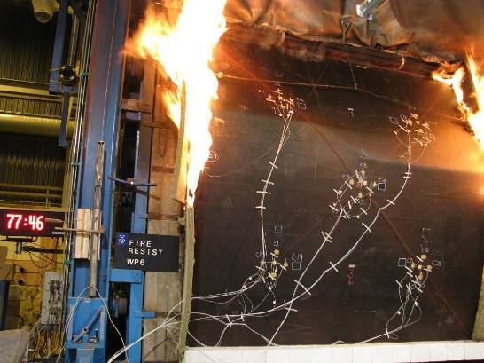
Figure 26: Test according to FTP Code Pt. 11 at SP.

Smoke and toxicity is tested for the different materials used for the maritime case study as well as for a sample representative for the bulkhead. The results are shown in Table 7and Table 8. The test carried out by SP showed that the test criteria of part 2 of FTP Code are satisfied.

Table 7: Smoke and toxicity results
With coating | Limit | 25 kW/m² with pilot flame | 25 kW/m² without pilot flame | 50 kW/m² with pilot flame
Dm | 200 | 81 | 97 | 134
CO conc. | 1 450 ppm | 260 | 132 | 692
HF conc. | 600 ppm | <5 | <5 | <5
HCl conc. | 600 ppm | 16 | 15 | 15
HBr conc. | 600 ppm | <10 | <10 | <10
HCN conc. | 140 ppm | 39 | 27 | 123
NO_{X} conc. | 350 ppm | 43 | <20 | 26
SO₂ conc. | 120 ppm | <10 | <10 | <10

Table 8: Reaction to Fire for selected maritime materials
With coating  Test no | 1 | 2 | 3 | Average | Surface flammability criteria
Heat for ignition, MJ/m² | -* | -* | -* | -* | ⎯
Average heat for sustained burning, Q_{sb}, MJ/m² | -** | -** | -** | -** | ≥ 1.5
Critical flux at extinguishment, CFE, kW/m² | 48.4 | 48.4 | 48.4 | 48.4 | ≥ 20.0
Total heat release, Q_{t}, MJ | < 0.1 | < 0.1 | < 0.1 | < 0.1 | ≤ 0.7
Peak heat release rate, Q_{p}, kW | < 0.1 | < 0.1 | < 0.1 | < 0.1 | ≤ 4.0
* Not calculated (extent of burn < 150 mm).
** Not calculated (extent of burn < 175 mm).

A Hazard Identification (HAZID) is performed using FMEA method for a systematic collection and ranking of hazards. For the current stage of investigation no ranking of hazards is performed. The HAZID process considers an outside cabin wall (a typical structural element of a ship superstructure) in front of a primary escape route, installed on RoPax vessel. The cabin wall should comply with A-60 class requirements according to SOLAS II-2/3.2. Therefore, the design is investigated against the highest requirement, i.e. A-60 class.
The outcome of the HAZID is in conclusion that the composite bulkhead fulfils most of the requirements. External high radiation fires in the proximity of the ship could result in an endangerment of persons, cargo, environment or the whole vessel as this scenario exceeds the standard FTP requirements. The external high radiation scenarios should be further assessed and quantified by comparative analysis in Alternative Design process based on a specific design. Additionally, the flame spread properties of the outside surface as well as the increase of fire load due to the combustibility of the composite wall are to be assessed further.
As the HAZID has not considered multiple failure scenarios, further assessments and calculations should be conducted to determine the behaviour of composite structure in those cases (e.g. fire & suppression non-functional & damaged intumescent coating).
The last step of the analysis on the maritime case study is a comparative thermo-mechanical analysis in combination with the fire test carried out by SP. For these investigations a bulkhead design in accordance with FTP Code specification is used (standard bulkhead without any openings like pipe penetration or cable transits, see Figure 27). The thermo-mechanical analysis is carried out in accordance with the calculation process developed in WP 5 and the tools developed therein. The fire test in accordance with FTP Code is simulated in FDS and thermal loads transferred to the finite element models for both designs, i.e. steel bulkhead and composite bulkhead. Temperature field is calculated for the whole test duration considering non-linear material properties. Subsequently thermal strains are calculated. For the steel bulkhead stress calculations are performed for various displacement boundary conditions because thermal expansion of steel is relatively high compared to composite materials and therefore already small temperature increase led to significant stresses (typically yield strength can be reached by an temperature increase of about 200°C in a component with zero displacement boundary conditions).

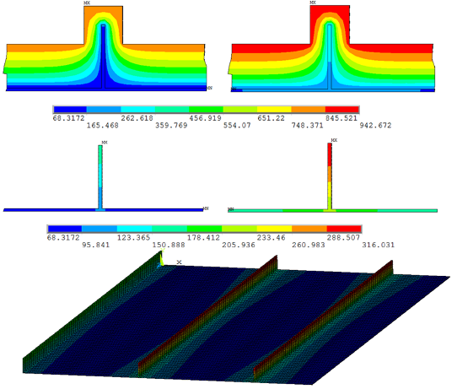
Figure 27: Results from thermo-mechanical model for reference material (steel).

As expected the reference design (insulated stiffened steel bulkhead) complies with the fire requirements (temperature and structural integrity). Depending on the displacement boundary condition remaining strength is determined for buckling failure between 18 N/mm² and 25 N/mm² resulting in only 25-30% of the initial load bearing capacity at room temperature. An evaluation whether this threshold is sufficient to guarantee structural integrity depends on the integration in the ship. The results for the novel design, see for example Figure 28, demonstrate the excellent thermal properties of composite materials which mean that compliance with temperature requirements of FTP Code can be easily achieved.

Figure 28: Thermal model for Fire-Resist material used in bulkhead.

Outlook Maritime
Regarding the residual load-bearing capacity of novel design, the performed thermo-mechanical simulation shows that after 60 minutes the bulkhead mostly lost its load-bearing capacity and no strength reserves exist. As long as loads a low enough the functional requirement of ‘keeping the fire in place of origin’ can be fulfilled, however this has to be carefully investigated in the next stage of the approval process.
This conclusion is also supported by the results of the fire test in which the bulkhead withstand the thermal and mechanical loads in accordance with FTP Code part 11 (HSC) for about 76 minutes until it collapsed. Therefore, the requirements of this part of FTP Code are satisfied but for more general application in shipping industries additional investigation for solution integrated in a real ship are regarded to be necessary.
The results of the investigation in context of phase 1 of Alternative Design process in order to determine so called showstoppers in early design phase show that no real showstoppers exist. However, as shown by the summary above some need for further detailed investigation in context of detailed design (integration in a real ship) exist.

Conclusion
Summarising, it can be stated that the aim of WP6 is achieved, case study components have been successfully manufactured using technologies from WP1-4. Moreover, the evaluation has shown that no show stoppers exist in terms of fire-resistance for future application of these technologies in the aimed products. That is, most of the fire, smoke & toxicity requirements in all industries are met with the Fire-Resist technologies.

WP7

Task 7.1: “Managing the risk of innovation”
Through the application of the MCDM tool within FIRE-RESIST project it was possible to analyse the development of the composite systems with respect to the target properties defined by the end-users. The ranking within the tools was end-user dependent, and the outcome from the analysis provided an overview and synthesis of the most promising results achieved within the project. In general it was possible to conclude that the composites systems studied either meet successfully the required targets (e.g. maritime & rail sectors) or are better than the reference materials (aeronautic sector) in terms of fire – resistant properties and costs. The compliance with other type of criteria should be carefully analysed when exploited further the results. The detailed analysis is available in the deliverable 7.2.

Task 7.2: Life cycle costing
General life cycle cost models for each transport sector are developed, which consider all relevant life cycle cash flow of the application case. Particular emphasis was put on the integration of the weight saving to fuel savings relation in order to evaluate the economic impact of the lighter FIRE-RESIST material. As a result, the general life cycle cost models enable the project partner to calculate the life cycle cost performance of their applications according to their individual schemes and anticipated market development beyond the FIRE-RESIT project.
Detailed results are documented in deliverable 7.2.

Task 7.3: Environmental life cycle assessment
During the final period of the project three comparative LCA have been performed to evaluate the environmental profiles of aeronautic/ maritime/rail industry components manufactured with Fire-Resist technology vs conventional technologies (benchmarks):

Maritime case study: one A-60 class bulkhead 2420 mm × 2480 mm (6m2), with a service life of 30 yr. made of made of Fire-Resist WP3 material (furanic-cork sandwich, triple core) vs one stiffened steel bulkhead (same dimensions) layered with mineral wool insulation. The concept foresees to replace 402 m² of steel bulkheads on a Ro-Pax ferry. That means 5t reduction in ship weight and amounts to 51t fuel savings in the 30 yr. operation of ferry. The marginal LCIA results (single score ReCiPe method) of the lifecycle of one 6 m2 bulkhead made of Fire-Resist triple-core composite material versus the conventional steel bulkhead prove that, in spite of the benefits gained in the service life of the bulkhead in the ship operation as a consequence of its reduced areal mass, the net values after considering impacts in production and EOL stages lead to higher overall impacts.
Aeronautic case study: the functional unit considered for the study has been one side wall panel with 4 omega-shaped PMI stiffeners, of dimensions 1200 mm x 800 mm and a radius of curvature 2000 mm, for achieving the technical requirements established in section 2.2 of Deliverable D6.1 over 40 years. CFRP+TP side wall panels (VAP produced) made of Carbon Fibre Reinforced epoxy resin (4 skin layers) and including a ThermoPlastic multi-layer-laminate (MLL) developed under WP1 has been compared with CFR epoxy panels (prepreg production). For modelling the use phase it has been assumed the replacement of 400 m2 sidewall panels in an Airbus A320, meaning 47.84 kg kerosene saved per 1 kg reduced in aircraft weight per year of operation. The novel fuselage panel performs better in all the life cycle phases analysed.
Railway case study: the basis for comparison in the LCA study has been one Draught Screen, of 0.007 m3 volume, for achieving the technical requirements established in section 3.6 of Deliverable D6.1 over 35 years. A new panel made of FireResist WP3 material (GFR furanic-cork sandwich panel, single core) is compared to a draught screen made of glass reinforced phenolic resin (GF=35wt%, Chopped Strand Mat), painted with PU. The concept foresees to replace 0.2016 m3 of draught screen per vehicle on a 4-car Electrostar. It would result in 192.17 kg saved per vehicle and in a total train interior weight reduction of 768.68 kg and will mean 101.804 kWh savings for traction energy in the 35 years service life of a railway unit. Therefore associated environmental impacts in the use phase of the screen mounted in the railway vehicle are reduced when replacing draught screens in conventional material with that developed in FireResist. On the other hand, the comparison between raw materials in one draught screen of 0.007 m3 manufactured in the novel WP3 composite material (single core sandwich) and raw materials in the GFR phenolic draught screen, shows that the production of the draught screen in FireResist material causes half the environmental impact of production of the benchmark.

The potential impact (including the socio-economic impact and the wider societal implications of the project so far) and the main dissemination activities and exploitation of results (not exceeding 10 pages).

WP1

30. Apr. 2013 - RAILTEX
Where: Earls Court, London UK
When: 30. April 2013 09:00 - 02. May 2013 17:00

FIRE-RESIST promoted at UK rail industry exhibition, London.
More information: http://www.railtex.co.uk05. Jun. 2013 - RIA Technology & Innovation Conference (1 document)
05. June 2013 - Rail Industry Association (RIA) Conference
Where: Leicester, UK
When: 05. June 2013 09:00 - 06. June 2013 17:00
FIRE-RESIST promotional material distributed at this UK conference.
More information http://www.riagb.org.uk

26. Nov. 2013 – Fire performance of metal-polymer laminates
Where: National Composites Centre, Bristol,UK
Sandra Christke was the winner of the SAMPE UK Student competition where she presented her research work.

7.-11. Mar. 2014 – Fire performance of metal-composite laminates as a novel fire protection material
Where: JEC 2014, Paris
Sandra Christke attended the SAMPE Europe Student Seminar and the European SEICO Conference presenting her research work

Oral conference presentations:
S. Christke, G. Kotiskos, G. Gibson “Fire performance of metal composite laminates“, ICSAAM5 – 16th International conference on structural analysis of advanced materials, Kos, Greece, 23-26 September 2013
Conference poster:
S. Christke, G. Kotiskos, G. Gibson “Fire performance of metal composite laminates”, SAMPE SEICO 2014, Paris, France,

WP2

05. Sep. 2012 - 6th European Silicon Days Conference (1 document)
Where: Lyon, France
When: 05. September 2012 09:00 - 05. September 2012 17:00
Poster presentation by Suzanne Laik, INSA-Lyon
More information: http://www.mmsconferencing.com/eod12/organosilicon.php?bt=contact
Presentations on the project were delivered at two conferences: “Fire Protection of Rolling Stock 2011” (24th – 25th March 2011, Brussels, BE), and the “Sixth International Conference on Composites in Fire” (9th – 10th June 2011, Newcastle upon Tyne, UK).

WP3
The main socio-economic impact can be summarized in:
- The most valuable objective of the development of fire resistant parts to be used in the transportation sector (railway, naval, etc), is to save human lives in case of fire. The materials developed show low flammability and combustibility, no dripping, and they emits low amount of dark smoke and toxic gases.
- The plastic matrix used during the project (furan resins) comes from agricultural waste.
- The use of plastic materials in the transportation sector, instead of metallic ones, leads to weight reduction and, in consequence, a CO₂ emission decrease when operating.

GAIKER and the consortium partners have taken part in some events related to this WP3:
- May 2012. Organized by GAIKER.
ON THE LINE OF FIRE: EXPERIENCES ON MATERIALS FIRE BEHAVIOR
Presentation: “Polymeric systems from natural sources: furan resins”. Iván Sánchez.
- November 2012. Organized by CEP (Spanish Plastic Center).
XXI INTERNATIONAL COMPOSITE MATERIALS CONFERENCE.
Presentation: “Furan composites fire behavior: a clear opportunity to burst into the rail sector”. Jesús Ballestero.
- February 2014. Organized by GAIKER.
NEXT TRAIN STATION: EN 45545. FIRE BEHAVIOR IN THE RAIL SECTOR.
Presentation: “Fire behavior of the furan composites: opportunities in the rail sector”. Iván Sánchez

Two papers have been published related to furan resins cross-linking using microwave tools:
- Lopez De Vergara, U.; Sarrionandia, M.; Gondra, K.; Aurrekoetxea, J. “Polymerization and curing kinetics of furan resins under conventional and microwave heating.” THERMOCHIMICA ACTA. (2014)
- Unai López de Vergaraab, Mariasun Sarrionandiab, Koldo Gondraa, Jon Aurrekoetxea “Impact behaviour of basalt fibre reinforced furan composites cured under microwave and thermal conditions” Composites Part B Engineering, 2014

WP4

PhD thesis:
Suzanne Laik, “Investigation of Polyhedral Oligomeric Silsesquioxanes for improved fire retardancy of hybrid epoxy-based polymer systems”, defended on the 12th December, 2014 at INSA-Lyon.
Journal papers:
M. Monti, S.A. Tsampas, S.P. Fernberg, P. Blomqvist, G. Camino. Combustion Behaviour Of Nanoclay-doped PA6 Commingled Glass Fiber Reinforced Composites, manuscript to be submitted to Polymer Degradation and Stability
S. Laik, J. Galy, J.-F. Gérard, M. Monti, G. Camino "Influence of triSilanolPhenyl POSS on the fire behaviour and morphology of hybrid organic/inorganic epoxy networks“ In: "Flame Retardancy and Protection of Materials: Recent Advances and Current Perspectives", Springer. Accepted manuscript.
M. Monti, G. Camino. “Thermal and combustion behavior of polyethersulfone-boehmite nanocomposites”, Polymer Degradation and Stability, (2013)
Y. Aitomäki, B. Hagström, R. Långström, P. Fernberg, “Novel reactive bicomponent fibres: material in composite manufacturing”, Journal of Nanostructured Polymers and Nanocomposites, (2012)
Oral conference presentations:
S. Laik, J. Galy, J.-F. Gérard, M. Monti, G. Camino “Fire-retardant epoxy matrices designed for composite materials processed by infusion“, ECCM16 – 16th European conference on composite materials, Seville, Spain, 22-26 June 2014
M. Monti, S. Tsampas, P. Fernberg, P. Blomqvist, G. Camino, Montmorillonite-doped commingled composites for improved fire performance, ECCM16 – 16th European conference on composite materials, Seville, Spain, 22-26 June 2014
R.Gutkin, H. Olsen, P. Blomqvist, Modelling the structural response of fibre-reinforced composites subjected to fire, ECCM16 – 16th European conference on composite materials, Seville, Spain, 22-26 June 2014
S.A. Tsampas, S.P. Fernberg, G. Camino, M. Monti, P. Blomqvist, Preparation and characterization of nanoparticle-doped commingled composites for improved fire performance. ICCM19, Montreal, Canada, July 28 – August 2, 2013
S. Laik, J. Galy, J.-F. Gérard, M. Monti, G. Camino . "Influence of triSilanolPhenyl POSS on the fire behaviour and morphology of hybrid organic/inorganic epoxy networks“. Fire Retardancy and Protection of Materials (FRPM), 2013, Lille, France.
S.P. Fernberg, S.A. Tsampas, M. Monti, G. Camino, Comingled fibre reinforced composites with enhanced fire performance. Fire Retardancy and Protection of Materials (FRPM), 2013, Lille, France.
S. Laik, J. Galy, J.-F. Gérard, M. Monti, G. Camino “Investigation of POSS nanoclusters for fire retardancy of hybrid thermoset polymers“, European Centre for Nanostructured Polymers (ECNP) International Conference, 2012,Prague, Czech Republic.
P Fernberg, Y Aitomäki, B Hagström, Development of methods to use polymeric matrix fibres to manufacture fibre reinforced composites, 7th International Conference on Nanostructured Polymers and Nanocomposites, April 24 - 27, 2012, Prague, Czech Republic
Conference poster:
S. Laik, J. Galy, J.-F. Gérard, M. Monti, G. Camino “Investigation of POSS nanoclusters for fire retardancy of hybrid thermoset polymers”,6th European Silicon Days, 2012, Lyon, France.
M. Monti, G. Camino. “Thermal and combustion behavior of polyethersulfone-boehmite nanocomposites”. Poster presented at 3rd International Conference on Multifunctional, Hybrid and Nanomaterials - Sorrento (NA), Italy 3-7 March 2013

WP5

In the FIRE-RESIST project proposal Annex I “Description of Work”, the following was envisaged:
“The modelling techniques that will be developed in FIRE-RESIST WP5, combined with the use of affordable small-scale test protocols that focus on fundamental material property information, will provide a means of developing and evaluating novel fire safe solutions on a considerably more cost-effective basis.”
Indeed, the development and validation effort of WP5 has decisively improved our capability to model the global fire response of polymer matrix composite materials and structures, thus opening new possibilities for materials research, development and design.
The modelling technique can, for example, be used to supplement existing experimental approaches to product fire performance assessment, and thus contribute to the introduction of next generation fire-safe materials into the transport sectors. Taking into account the high cost of large-scale “product qualification” fire testing, there is potential for savings in the development costs of fire-safe composite products. Furthermore, the modelling technique can be applied in the safety evaluation, and even design, of passenger environments via the advanced simulation of onboard fires in aircraft, trains, ships, etc. In the field of fire safety research, there is the logical progression to use the new modelling capabilities in conjunction with evacuation modelling software to study post-fire passenger safety.
From the beginning of the FIRE-RESIST, attention was paid to continuity and transparency by integrating the model development within the open source fire research community. Improvements to the FDS source code, as well as their verification and validation, were committed to the public FDS repository in Google Code. Furthermore, contributions to the pyrolysis parameter estimation techniques were published in scientific journal and conference articles, and are thus available for the research community.
For the beneficiaries involved in the model development work, i.e. Swerea SICOMP Ab and VTT Technical Research Centre of Finland, FIRE-RESIST has opened new business possibilities in consultancy work related to the design, modelling and simulation of polymer matrix composites.

Main dissemination activities
The work carried out in WP5 has thus far been presented in two scientific journal articles, four articles in conference proceedings, one article in a non-refereed journal, in several conference and seminar presentations, and as part of a doctoral dissertation. A summary of the dissemination activities is given below. At the end of the project, two scientific journal articles are under preparation, and one or two conference articles planned.

Doctoral dissertations
[1] A. Matala, Methods and applications of pyrolysis modelling for polymeric materials, VTT Science 44, 2013
Articles in international peer-reviewed journals
[2] A. Matala, C. Lautenberger, S. Hostikka, Generalized direct method for pyrolysis kinetic parameter estimation and comparison to existing methods, Journal of Fire Sciences 30(4), 339–356 (2012)
[3] A. Matala, S. Hostikka, Modelling polymeric material using microscale combustion calorimetry and other small scale data, Fire and Materials (submitted June 2013)
Articles in conference proceedings
[4] A. Paajanen, T. Korhonen, M. Sippola, S. Hostikka, M. Malendowski and R. Gutkin, FDS2FEM — a tool for coupling fire and structural analyses, in Proceedings of the IABSE Workshop Helsinki 2013: Safety, Failures and Robustness of Large Structures, Helsinki, 2013
[5] R. Gutkin, H. Olsen, P. Blomqvist, Modelling the structural response of fibre-reinforced composites subjected to fire, in Proceedings of the 16th European Conference on Composite Materials, Seville, 2014
[6] A. Matala, S. Hostikka, Pyrolysis modeling of polymer composites for fire simulations, in Proceedings of the 16th European Conference on Composite Materials, Seville, 2014
[7] A. Paajanen, S. Hostikka, A. Matala, R. Gutkin, CFD-FEA simulation framework for composite structures in fire, in Proceedings of the 16th European Conference on Composite Materials, Seville, 2014
Articles in non-refereed journals
[8] A. Paajanen, T. Korhonen, M. Sippola, S. Hostikka, Rakenteiden käyttäytyminen tulipalossa CFD-FEM mallinnuksella, Pelastustieto 64, 94–97 (2013)
Conference and workshop presentations
Work carried out in FIRE-RESIST WP5 has been presented in the following conferences and workshops.
- 3rd FM Global Open Source CFD Fire Modelling Workshop, Norwood MA, 2011
- 7th US National Technical Meeting of the Combustion Institute, Atlanta, 2011
- ABSE Workshop Helsinki 2013: Safety, Failures and Robustness of Large Structures, Helsinki, 2013
- 20th International Conference on Computer Methods in Mechanics 2013, Poznan, 2013
- 16th European Conference on Composite Materials, Seville, 2014

WP6

- JEC2015: Europe’s (World’s) largest composites show Showcasing components at the Transfuran and Airbus booths.
- AGI: Oral presentation planned at FRPM15 in Berlin: Investigations into Fire, Smoke & Toxicity Behaviour of Composite Aircraft Structures, June 2015
- SICOMP, VTT, DNV GL: Abstract for presentation submitted to LIMAS 2015: Numerical Simulation for Thermo-Mechanical Analysis within Alternative Design
- SP: SP official report on maritime testing available to the public

WP7

The results of the lifecycle cost calculation indicate the economic potential of the application of the novel FIRE-RESIST in each transportation sector. Especially the results of the aeronautic application case with calculated life cycle cost savings of more than € 242,000 thanks to the lower investment costs based on cheaper assembly method and weight savings throughout the operational phase are very promising towards a potential commercial exploitation.

Life cycle cost calculations for the maritime application case demonstrate remarkable life cycle cost savings potential in the operational phase based on energy savings. However the assembly process needs further development before the associated costs can be investigated and compared to the benchmark. Therefore, the developed general life cycle cost model will support the project partners in the assessment of the profitability in the next steps of the development.

The lifecycle cost calculation of the railway case indicates also significant life cycle cost savings potential based on the weight savings realised by applying FIRE-RESIST materials. Especially in the assessment of whole trains consisting of up to 5 vehicles, significant life cycle cost savings may lead to a competitive advantage for the project partner Bombardier.

Project public website

The project website is available at www.fire-resist.eu. It will remain active for a minimum of 5 years after the end of the project and will remain active thereafter based on visitor levels and external interest.
The website is divided into the following sub-menus:

- Home (website frontpage)
- Project
  - Overview (aim of the project)
  - Work Programme (project schedule)
  - Results (selected public results)
- Partners (Contact details of all project partners)
- Downloads (public dissemination, flyers - below)
- Articles (technical information on latest project developments)
- News (from, or relevant to the Fire-Resist project)
- Events (for, or relevant to the Fire-Resist project)
- Postcard flyers were designed to promote the project at conferences, expos and events (see picture below. 100 postcards were produced with gloss finish for each of the Fire-Resist partners.

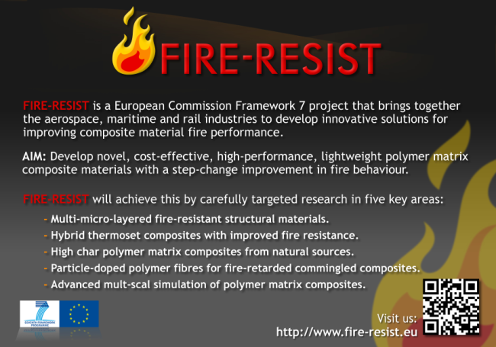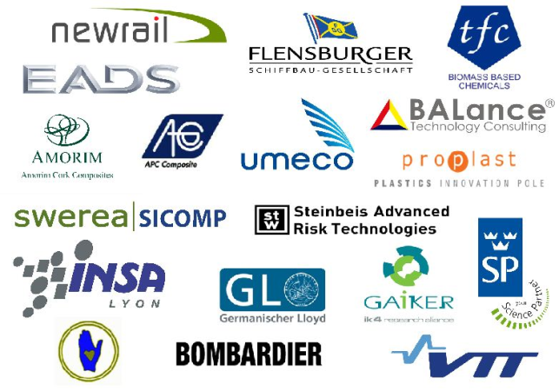
Postcard Front Postcard Back

Usually the contact person of the coordinator as specified in Art. 8.1. of the Grant Agreement.
Buckling is characteristic failure for plate fields in bulkheads.

