**CELLS**

**(Controlled Environment Laboratory for Life Science)**

### Principal Investigator: Dr. Danny Walsh, Limerick Institute of Technology, Limerick, Ireland (Daniel.Walsh@lit.ie)

### CELLS Group Leader: Ms. Michelle McKeon- Bennett, Limerick Institute of Technology, Limerick, Ireland Michelle (Michelle.Bennet@lit.ie)

### Recipient: Prof. Gary Stutte, Space Life Science Laboratory, Kennedy Space Center, Florida, USA (Gary.W.Stutte@nasa.gov)

The primary strategic objective of CELLS (Controlled Environment Laboratory for Life Sciences) was to support the relocation and development of a research programme by Dr. Gary Stutte to enhance the state-of-the art Life Science research capability in Ireland and establish a European Centre of excellence for Controlled Environment Research at Limerick Institute of Technology (Ireland). Dr. Stutte is an expert in hydroponic based controlled environments and space agriculture / horticulture based in the Space Life Science Laboratory at Kennedy Space Centre, Florida, U.S.A.

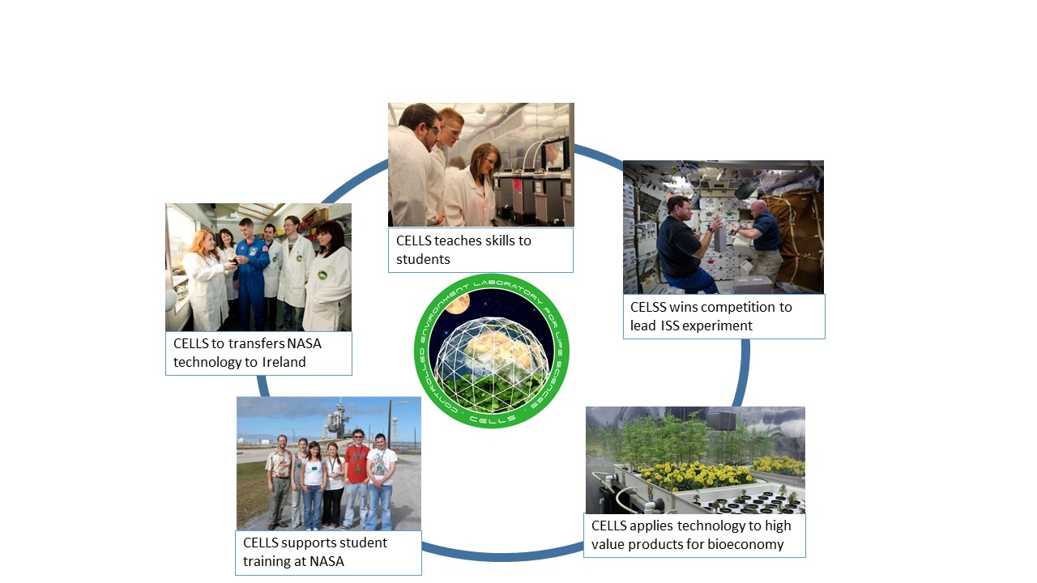Primary objectives were to 1. Transfer hydroponic and controlled environment technology to Ireland, 2. Develop facilities for production and analysis and bioactive productions from a range of plant types, 3. Acquire capabilities for the non-destructive assessment of plant quality, and 4. Transfer that knowledge to undergraduate, graduate and post-doctoral students.

CELLS developed an active program student training, public outreach, academic collaboration and enterprise development. CELLS has enhanced the research capabilities of the Limerick Institute of Technology, provided new training opportunities for undergraduate and post-graduate students, and enabled research support for Irish Small and Medium-sized Enterprises through innovation grants and partnerships.

These capabilities that resulted in LIT and CELLS laboratory being selected in international competition to develop an experiment for International Space Station though academic industrial partnerships that are advancing commercialization of space.

CELLS has had an active program of promoting research at all levels, including school presentation, public displays, and scientific presentations in Ireland, Europe, North America and Asia. CELLS research has been widely discriminated through its website ([www.cells.ie](http://www.cells.ie)), press, radio and television. The CELLS project was featured as REA ‘Success Story’ and Prof. Stutte featured in EU Conference on Research Careers and Mobility (May, 2013). CELLS research has been featured national press, and featured on RTE Science Squad, a prime time broadcast featuring leading research activities across Ireland.

**CELLS laboratory now has a unique controlled environment facility capable of supporting terrestrial and space research and is recognized as a Centre of Excellence in Controlled Environment Research**

# Research Outcomes

A primary objective of CELLS as the transfer of knowledge in controlled environment horticulture developed from space exploration at Kennedy Space Centre, Florida in order to support research to enhance the development of functional foods. CELLS allowed the transfer of technology to Limerick Institute and Technology and applied it to many different systems. Some highlights include:

## LED lights to increase yield and nutritional value of lettuce.

The use of small growth chambers designed for space flight was used to show a definitive requirement for blue light in the production bioflavonoids in lettuce, and demonstrate that yields and bioactive components would be increased using non-genetic, energy efficient controlled environment techniques. This research has wide application to greenhouse production of lettuce, and basic knowledge of photoregulation of pigments can be applied to many other food crops.

## Hydroponics for production of Sphagnum species

Sphagnum species are characteristic of peat bogs, and are critical for the long-term health of the planet. Sphagnum is a rich source of bioactive compounds with application to health and and cosmetic industries. CELLS technology increased the growth rate of sphagnum species 6 fold over rates observed in the bog. These finding are being applied to CELLS research to characterize bioactives in the species, and develop products for commercial development.

## Production of high value products

The application of hydroponic production, electric light sources, and CO2 enrichment was used to increase the concentration of high value bioactive compounds, including anthocyanin’s in lettuce, phytoestrogens from red clover and lutein from marigold species. Results included a threefold increase in flower production of *Tagetes* species grown under elevated CO2, and quantification of effect of light intensity on the concentration and composition of phytoestrogens in red clover.

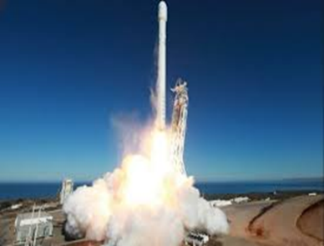Space: The next big step

The capacities of the facility increased resulting in LIT being selected in international competition to lead an experiment to be performed on the International Space Station. The SyNRGE3 experiment will be launched to ISS on SpaceX 4 mission to the International Space station. The experiment investigates the role of microgravity on development of beneficial plant/microbe interactions which have potential application for both space and terrestrial applications

**These successes, enabled by the CELLS Marie Curie Fellowship have increased the recognition in CELLS across Europe and enabled the Limerick Institute of Technology to increase its ability to serve the students, industry and public of Ireland and beyond.**

[**www.lit.ie**](http://www.lit.ie)**;** [**www.cells.ie**](http://www.cells.ie)**;** [**www.lit.ie/synrge3**](http://www.lit.ie/synrge3)