Grant Agreement number: 273711

Project acronym: QUANTUMDOTS

Project title: Experimental generation of distant quantum dot spin entanglement

Funding Scheme: FP7-MC-IIF

Project start date: 01/07/2011

Project end date: 30/06/2013

Name, title and organisation of the scientist in charge of the project's coordinator(1): Prof. Atac Imamoglu Eidgenössische Technische Hochschule Zürich

Tel: +41 44 633 45 70

Fax: +41 44 633 13 59

E-mail: imamoglu@phys.ethz.ch

Entanglement deepens our understanding of fundamental physics. A well-known example is the study of non-local interpretations of quantum mechanics by testing the violation of Bell’s inequality. In the practical side, an interface between a stationary qubit (spin) and a flying qubit (photon) is a basic element to build a distributed quantum network. Moreover, such a network can be used for building a quantum computer, that offers significant speedups in solving certain technologically relevant classes of problems. A realization of distributed quantum computation will use few-qubit quantum processor nodes (spins) connected by photons. A particularly interesting platform is a spin based semiconductor system in which photonic circuits that interconnect the nodes can be fabricated on the same semiconductor chip. Despite the appeal of semiconductor based systems the realization of spin-photon entanglement in these systems had been very challenging mainly due to fast transitions and strong decoherence of the quantum dot spins.

In this project, we have realized two main results. One of them is the spin-photon entanglement, and the other one is the teleportation from a flying photon to a single quantum dot, as an application of the generated spin-photon entanglement towards building a quantum network.

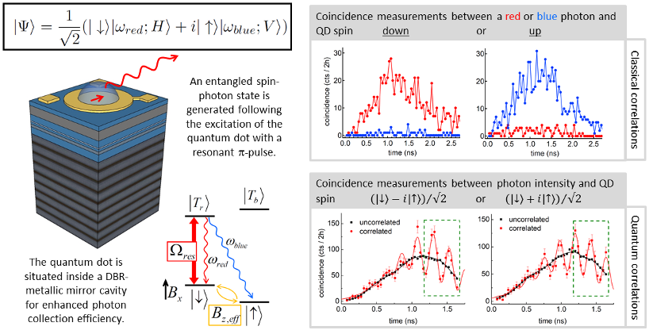

Figure 1. Our recent results demonstrate quantum entanglement between a semiconductor InGaAs quantum dot spin and the color of a propagating optical photon; this observation was made possible by favorable selection rules for QDs in Voigt geometry (in-plane magnetic field), our record high photon collection efficiency from charge controlled QDs under resonant excitation, and the ability to perform time resolved resonance fluorescent measurements. The demonstration of entanglement relies on the use of fast single-photon detection which allows us to project the photon into a superposition of its two frequency components. Our results extend the previous demonstrations of single-spin photon entanglement in trapped ions, neutral atoms and nitrogen vacancy centers to the domain of artificial atoms in semiconductor nano-structures.

In the first result of the project [1], the difficulty of measurement was overcome and the first semiconductor spin-photon entanglement was reported. Our experiment focuses on a single electron spin trapped in an InGaAs self-assembled quantum dot. The ground states of the quantum dot are identified by the orientation of the electron spin. The basic principle behind the deterministic generation of a spin–photon entangled state is straightforward: following the excitation of the quantum dot into an excited (trion) state, radiative recombination will project the system into an entangled state where the color and polarization of the emitted photon are entangled with the spin of the electron in the ground state. Our measurement process entails suppression of the laser background using cross polarized excitation and collection, thus erasing the polarization information of the quantum dot photons. We therefore focus on the entanglement between the spin qubit and the color (frequency) of the photonic qubit. To demonstrate entanglement we measure both classical and quantum correlations between the electron spin and the color of the emitted photon. We calculate an overall entanglement fidelity with a lower bound of 0.67±0.05, which is above 0.5 and thus constitutes a proof for entanglement in our system.

In the second result of our project [2], we have realized a basic element in a quantum network. A quantum interface between a propagating photon used to transmit quantum information, and a long-lived qubit used for storage is of central interest in quantum information science. A method for implementing such an interface between dissimilar qubits is quantum teleportation. Here, we experimentally demonstrate transfer of quantum information carried by a photon to a semiconductor spin using quantum teleportation. In our experiment, a single photon in a superposition state is generated using resonant excitation of a neutral dot. To teleport this photonic qubit, we generate an entangled spin-photon state in a second dot located 5 meters away and interfere the photons from the two dots in a Hong-Ou-Mandel set-up. Thanks to an unprecedented degree of photon-indistinguishability, a coincidence detection at the output of the interferometer heralds successful teleportation, which we verify by measuring the resulting spin state after prolonging its coherence time by optical spin-echo.

We expect quantum teleportation from a propagating photonic qubit to a stationary solid-state spin qubit to play a central role in quantum networks where nodes incorporating a small number of spin-qubits are interconnected using photons. While the finite efficiency of quantum state transfer is in general an important limitation, the heralding of successful transfer renders the implemented protocol relevant for schemes such as linear optics quantum computation which rely on post-selection on measurement results and where quantum memory for the photons is crucial. Since our photonic qubit is generated by a neutral QD exciton, our experiment can also be considered as the realization of teleportation from the exciton qubit of one QD to the spin qubit of another QD. A natural extension of the quantum teleportation protocol is to entangle the spin states of two distant QDs that have never directly interacted with each other. To entangle two spins one would replace the photonic qubit with a photon that is entangled with another QD spin: a coincidence detection at the output of the HOM interferometer, in this case, heralds successful generation of entanglement between the two distant spins.

In summary, in this project, we have made the first step towards the quantum network involving a quantum dot solid-spin qubit. The study of this subject will largely trigger the efforts in the material science and nan-fabrication techniques. With longer coherence time and mature on-chip fabrication and manipulation technique, the next-generation quantum computer is very promising with solid-spin qubits.

Reference:

Gao, W. B., Fallahi, P., Togan, E., Miguel-Sanchez, J., & Imamoglu, A. (2012). Observation of entanglement between a quantum dot spin and a single photon. *Nature*, *491*, 426-430.

Gao, W. B., Fallahi, P., Togan, E., Delteil, A., Chin, Y. S., Miguel-Sanchez, J., & Imamoglu, A. (2013). Quantum Teleportation from a Propagating Photon to a Solid-State Spin Qubit. Nature Communications4, 2744.