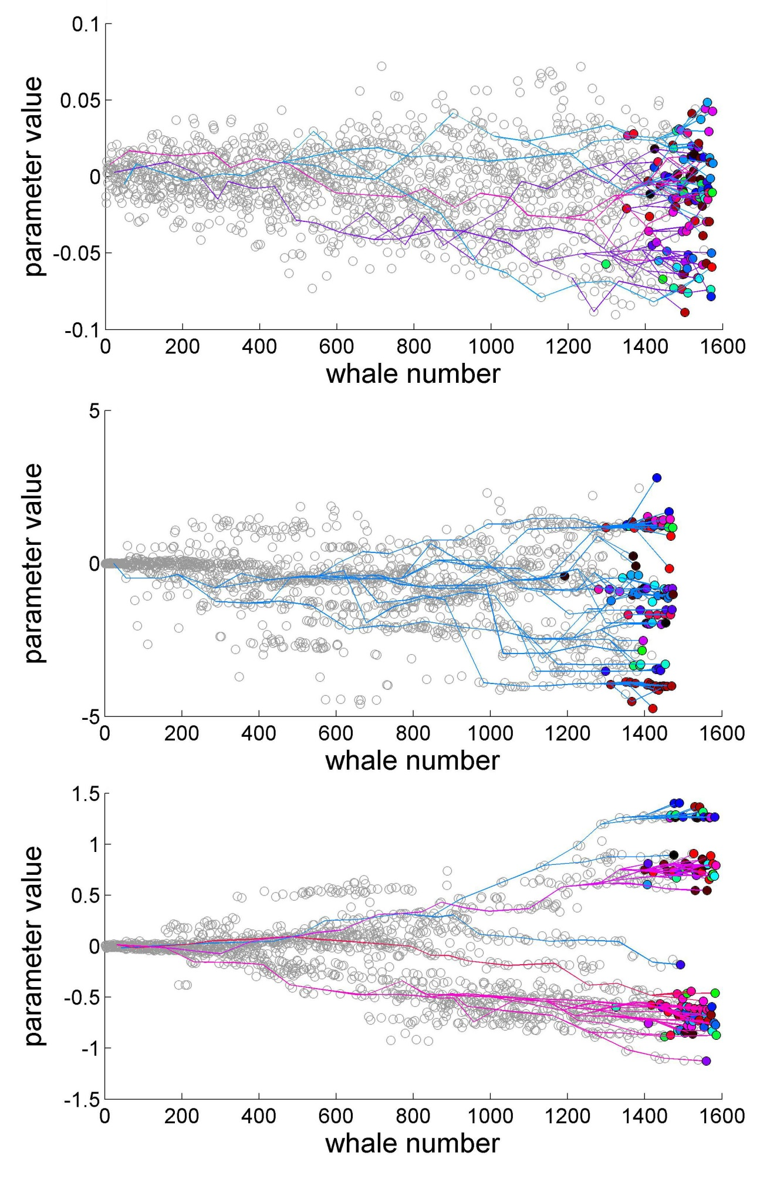

Results of modeling. Top: gradual distribution of call parameter when calls change only through random error. Middle and bottom: clusters similar to those observed in the wild when calls change through innovation (middle) and divergence from kin with error proportional to group variance (bottom).

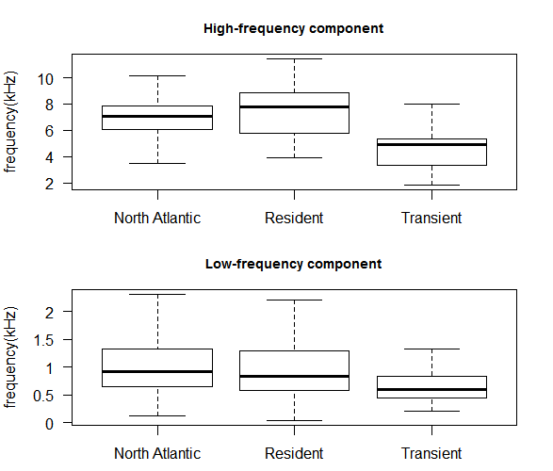

Median fundamental frequency of low- and high-frequency components of killer whale calls from eastern North Atlantic, North Pacific resident and transient populations.

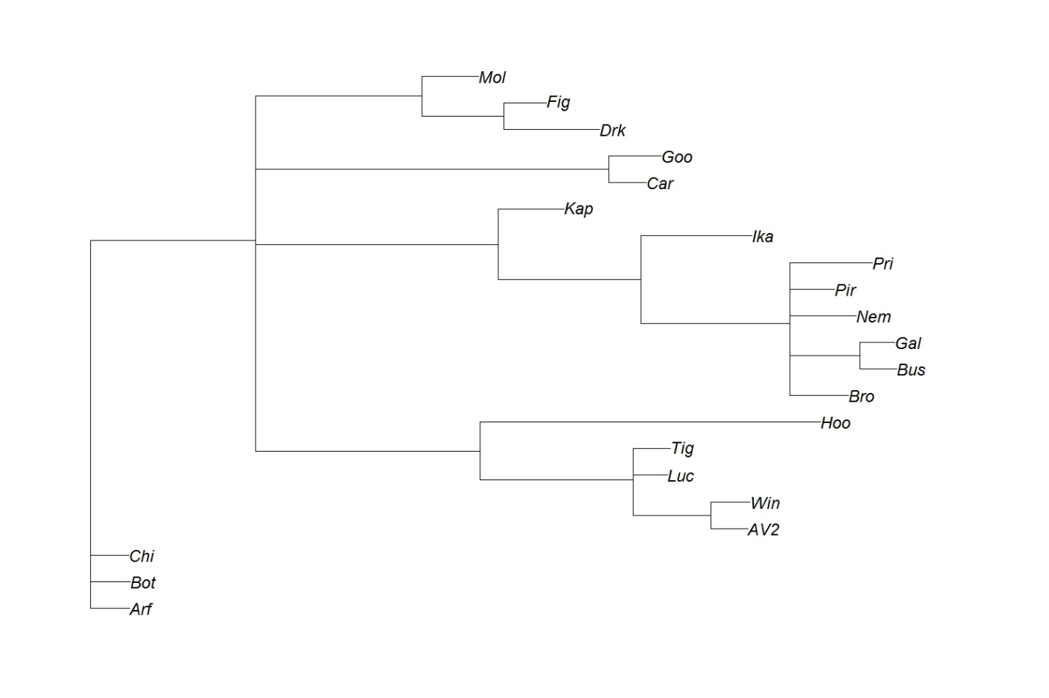

Bayesian phylogenetic tree of Kamchatkan killer whale groups. Note that the distance from the root to the branch tip is correlated to the number of group splitting events.