


CHIZAP

Child Health, Zinc and Pneumonia
in India and Nepal

Contract number: FP6-003740

Project acronym: CHIZAP

Community- and health facility-based intervention with zinc as adjuvant therapy for pneumonia to enhance child health and nutrition

Clinical trials in Nepal and India

INCO: International Scientific Cooperation Projects

Final Report

Period covered: from January 1, 2008 to August 31, 2008

Date of preparation: November 14, 2008

Start Date: January 1, 2005
Duration: 44 months
COORDINATOR

Name: Dr. Strand Tor A, Email: tor.strand@cih.uib.no,
Tel: + 47 55588560, Fax: + 47 55588561

Name: Bhandari Nita Email: community.research@cih.uib.no

Tel: + 91 11 26014136, Fax: + 91 11 26016449

University of Bergen
Faculty of Medicine
Centre for International Health
Overlege Danielsens Hus, 5th floor
Årstadveien 21
N-5009 Bergen
Norway

CONTRACTORS

Tribhuvan University Name: Adhikari Ramesh K
Institute of Medicine E-mail: ramesh@healthnet.org.np
Department of Child Health Tel: +977 14 412 292
Maharajgung, Kathmandu, Nepal Fax: +977 14 411 886

Statens Serum Institut Name: Branth Palle V
Department of Epidemilogy Research E-mail: pvb@ssi.dk
Artillerivej 5 Tel: +45 32 68 31 64
2300 Copenhagen, Denmark Fax: +45 32 68 31 65

All India Institute of Medical Sciences Name: Bhan Maharaj K
ICMR Advanced Centre for Diarrheal E-mail: community.research@cih.uib.no
Disease Research Tel: +91 11 265 88 822
Department of Pediatrics Fax: +91 11 265 88 663
Ansari Nagar, New Delhi-110029, India

Society for Applied Studies Name: Mahalanabis Dilip
108 Manicktala Main Road E-mail: dmahalanabis@vsnl.com
Kolkata 700054 Tel: +91 33 2337 8850
India Fax: +91 33 2337 6290

Name: Bhandari Nita
Email: community.research@cih.uib.no
Tel: + 91 11 26014136
Fax: + 91 11 26016449

Institut de Recherche pour le Deloppement Name: Simondon Kirsten B
Epidemiologie et Prevention E-mail: kirsten.simondon@mpl.ird.fr
911 Avenue Agropolis BP 64501 Tel: +33 4 67 41 63 32
34394 Montpellier Cedex 5 Fax: +33 4 67 41 63 30
France

CONTENTS
CONTRACTORS 2
CONTENTS 4
Executive Summary: 5
Work performed: 6
WP1: Community based clinical trial in 2681 Nepalese children 6
WP2: Thymus measurements of the enrolled children in WP1. 6
WP3: Virus laboratory 7
WP4: Clinical trial 2 at Kanti Children’s Hospital, Nepal 7
WP5: Clinical trial in children with bacterial infection at AIIMS 7
WP7: Project management 8
Results achieved so far 8
Expected end results 11
Section 1 – Project objectives and major achievements 13
Overview of general project objectives 13
Specific research objectives 13
Secondary objectives 15
The projects current relation to the state-of-the-art 15
Most important problems and actions/corrections taken 16
Section 2 – Work Package progress of the period 20
2.1 Work Package 1 20
2.2 Work Package 2 28
2.3 Work Package 3 31
2.4 Work Package 4 34
2.5 Work Package 5 37
2.6 Work Package 6 42
2.7 Work Package 7 43
Section 3 – Consortium management 44
3.1 Summary of project status 44
3.2 Management and follow-up activities 45
3.3 Consortium management tasks and their achievement 47
3.5 Project time table and status 54
Section 4 – Other issues 55
4.1 Ethical issues 55
Annex – Plan for using and disseminating the knowledge 56
Section 1 – Exploitable knowledge and its Use 56
Section 2 – Dissemination of knowledge 57
Section 3 – Publishable results 57

Executive Summary:

Pneumonia is one of the most important causes of childhood deaths worldwide. Routine zinc administration to children in developing countries reduces the incidence of pneumonia and diarrhea. Zinc has to be ingested every day and breast milk is a poor source of zinc. It is accordingly difficult to increase the zinc intake in young infants who are supposed to be exclusively breastfed. Therapeutic oral zinc administration during an ongoing infection might be a feasible alternative to counteract the consequences of poor zinc status. The benefits of therapeutic oral zinc given to children with diarrhea are well documented but the therapeutic effect of zinc when given during pneumonia or other severe bacterial illnesses has yet to be demonstrated. Furthermore, short courses of zinc have been shown to reduce childhood morbidity for up to six months and may become an alternative to long-term zinc supplementation. In this project we have assessed the efficacy of oral zinc given during pneumonia in hospitalized and in non-hospitalized children 2 to 35 months of age and during severe bacterial illness in children less than 4 months of age on the severity of the enrollment episode and on subsequent morbidity and nutritional status for six months.

This project consisted of three clinical trials

- In a community based clinical trial in 2683 Nepalese children we have assessed the efficacy of giving 10 or 20 mg elemental zinc during pneumonia. We will also measure the effect of this short-term zinc administration for 6 months after zinc has been given. The main outcome during the 6-month follow-up is number episodes of common infections. Furthermore, the thymus sizes have been measured and we have collected nasopharyngeal aspirates of the enrolled children and detected viral pathogens in a laboratory established by this project in Nepal.
ClinicalTrials.gov Identifier: NCT00148733

- In a hospital based clinical trial in 610 Nepalese children, 2-35 months of age we have assessed the effect daily 10 or 20 mg elemental zinc during severe pneumonia. We will compare the time until recovery between children that receive zinc and children that are given placebo. The children were followed until discharge. We also collected nasopharyngeal aspirates of the enrolled children and detected viral pathogens in the laboratory mentioned above.
ClinicalTrials.gov Identifier: NCT00252304

- In a hospital based clinical trial in 700 Indian children, < 16 weeks of age we are assessing the effect of giving 10 mg elemental zinc during severe bacterial illness. We will compare the time until recovery between children that receives zinc and children that are given placebo. The children are followed until 3 weeks after discharge from the hospital.
ClinicalTrials.gov Identifier: NCT00347386

Work performed:

WP1: Community based clinical trial in 2681 Nepalese children
The zinc and placebo tablets were provided by Nutriset (France), and were the same as used in WP 3 and WP4. They were identical in color, taste and appearance, and were packed in identical looking blister strips. The randomization list and numbered zip bags were prepared offsite by staff not involved in the study. The method of administration of the drug was standardized. We assessed the morbidity of the participants over two periods; during the 14 days of zinc or placebo supplementation and from end of supplementation until six month after enrollment. We screened 8,823 cases of pneumonia and enrolled 2681 (an average 64 children per month). The field workers undertook 10,500 home visits to assess morbidity and 37,424 to dispense zinc or placebo. Data collection of this clinical trial was finished on December 31, 2007. Double data entry was done concurrently. A workshop to undertake the initial analysis and to prepare for breaking of the randomization code was held in New Delhi, India in February 2008. Scientists from Partners 1 – 5 participated in this meeting. This workshop also included lectures on the statistical methods that will be used for analysis of the data (Survival analysis and analysis of count data). A draft manuscript has been prepared.

WP2: Thymus measurements of the enrolled children in WP1.
Thymus size was measured at 3 and 6 months after enrollment in 2,180 and 2,192 children, respectively. The fieldwork of this component was finalized in 2007. Double data entry was done concurrently. We have started the initial data cleaning and management. One Master student from Nepal (Dr. Meeru Gurung) was admitted to the University of Bergen and will use the data from this component for her degree. Her studies commenced in August 2008 and expected date of examination is June 2010. Her thesis work will be supervised with scientists from Partner 1 and 6.

WP3: Virus laboratory
The laboratory facility in Nepal was established to assess the viral etiology in the children enrolled in the trials undertaken in Nepal. We have assessed the viral etiology of the children included in WP1 (Clinical trial 1 in Bhaktapur) and WP 4 (Clinical trial 2 at Kanti Children’s Hospital in Kathmandu, Nepal). We have analyzed approximately 2,850 samples using the a RT-PCR set up (Hexaplex Plus). Three persons (two assistants and one Senior lab technician) have been working in this component. The senior lab technician has been admitted for a master program at the University of Northern Norway where he will continue to work on human viruses. One manuscript has been submitted from this WP.

WP4: Clinical trial 2 at Kanti Children’s Hospital, Nepal
We undertook a pilot study in January and February 2006 where 31 children were enrolled. After this period, 2198 children with severe pneumonia attending Kanti Children Hospital were screened out of which 610 children were randomized to receive zinc or placebo. Eight hourly monitoring of enrolled children were done for clinical examination, assessment of respiratory rate as well as oxygen saturation. Training of Medical Officers as well as health assistants was done at regular intervals. This study erolled its last child on June 15, 2008. Follow-up continued till July 1, 2008. Double data entry has been done concurrently.

In addition, we assessed the oxygen saturation of 400 healthy children aged 2 to 35 months (the age group that was included in the trial of WP4). This was to establish the normal range of oxygen saturation in this population.

WP5: Clinical trial in children with bacterial infection at AIIMS
The study sites at Deen Dayal Upadhyaya Hospital (DDU), All India Institute of Medical Sciences (AIIMS), and Kalawati Saran Children Hospital (KSCH) with AIIMS being the coordinating centre were established.

The initial months were spent on the preparation of the three sites, recruitment and training of research staff, pre-testing of case recording forms and preparation of data files. The intervention was provided by the World Health Organization (WHO) in June 2005. The zinc and placebo tablets were the same as used in WP1 and WP4, and were identical in color, taste and appearance and were packed in identical looking blister strips. The randomization list and numbered zip bags were prepared offsite by staff not involved in the study. The method of administration of the drug was standardized.

Enrollment of subjects (July 2005-August 2008): Enrollment of patients commenced in July 2005 at DDU and KSCH and in August 2005 at AIIMS. The enrollment of infants has been at an average of 19 per month. We screened 13684 infants and 686 were enrolled. The small number enrolled among the many infants screened is because of the strict inclusion criteria used in the study. Double data entry has been done concurrently. A safety analysis on the effect of zinc on mortality was undertaken in August 2008.

WP6. Zinc and copper assays

The zinc and copper concentration from WP5 have been analyzed at AIIMS. Approximately 800 plasma zinc samples from WP 1 have been analyzed at the University of Colorado Health Sciences Center in Denver, CO, USA.

WP7: Project management
Project management has been proceeding smoothly and good communication has been maintained between the partners. Project management meetings have been held approximately three times per year. Phone meetings involving the partners in India, Nepal, Denmark, and Norway were held every month when the fieldwork was undertaken.

Results achieved so far

WP1: Community based clinical trial in 2700 Nepalese children:
- The efficacy of oral zinc on community acquired pneumonia on duration of the illness and risk of treatment failure. The initial analyses have been undertaken and Palle Valentiner-Branth from Partner 3 (SSI) has produced a draft of the first publication describing the main effects. This paper has not yet been submitted for publication.
- The efficacy of oral zinc given during community acquired pneumonia on duration morbidity for six months (the downstream effect of giving zinc). We have undertaken the initial analyses of this oucome. The first draft of the paper will be produced by a Ph.D student from Partner 2 (IoM), Ram K Chandyo. He is supervised by scientists from partner 1 and partner 3.
- We have measured plasma C-reactive protein and plasma hemoglobin concentration in all children that were enrolled.

WP2: Thymus measurements of the enrolled children in WP1
Thymus size was measured at 3 and 6 months after enrollment in 2,180 and 2,192 children, respectively. The fieldwork of this component was finalized in 2007. Double data entry has been done concurrently.
- One student from Nepal (Meeru Gurung) has been admitted to the University of Bergen (Partner 1) and will write her thesis based on the data from this component. Currently she is doing data cleaning. She will be supervised by scientists from Partner 1 and partner 6

WP3: Virus laboratory

The viral etiology has been assessed in 2200 of the enrolled children in WP1 and in 641 children enrolled in WP4 (including 31 children that were enrolled in the pilot study).
- Ph.D. Student Maria Mathisen has submitted one publication based on the virus results from the children enrolled in WP1. These results were also presented orally at the 13th International Congress on Infectious Diseases 19th - 22nd June 2008, Kuala Lumpur, Malaysia.
- One manuscript based on recoverability of the viruses based on different sampling strategies has been prepared (March 2006).
- The virus results from the children enrolled in WP 4 have been presented in a local meeting in Nepal (March 2008).
- Partner 3 has undertaken one analysis on the geographic distribution of respiratory viruses. This was possible from the GIS coordinates collected from the participants of WP1 and the virus results (WP3) from the same trial.

WP4: Clinical trial 2 at Kanti Children’s Hospital, Nepal

The fieldwork was completed in June 2008 and the data from this trial is still being analyzed. The viral etiology from this trial has been described (see WP 3)

WP5: Clinical trial in children with bacterial infection at AIIMS
In August 2008, the Data Safety Monitoring Board (DSMB) called for a safety analysis, which was done by a neutral body. The results were shared with the DSMB and the other sponsor, Department of Biotechnology (DBT), Govt. of India. The results were as follows; among the total 680 infants enrolled, 349 infants were randomized to the group receiving the standard treatment for sepsis, and 339 infants to the group who received the same standard treatment for sepsis plus zinc (10 mg per day). In the group without zinc, 17 infants died (risk of death = 5.0%), while in the group with zinc only 10 infants died (risk of death = 3.0%). In conclusion, there was a 40% reduction in risk of dying (or deaths) in the group that got zinc supplementation. This reduction was not statistically significant but the data suggest that there are potential benefits in adding zinc supplementation to the management of infants with severe sepsis. This analysis was undertaken because the public raised suspicions regarding increased mortality in the study.

We have decided to continue to enroll children beyond the allocated time frame of the project. It was therefore decided to extend the study as long as possible to gain enough power to look at mortality as an outcome. This is possible with funds from Meltzer Foundation (Norway) and from DBT. We have not made a final decision on the revised sample size. This depends on additional funds as well as on other issues.

WP6. Zinc and copper assays

Part of the samples from WP 5 has been analyzed as planned at AIIMS (with partner 4). Another 800 samples have been analyzed at the University of Colorado Health Sciences Center, Denver, CO, USA using inductively coupled plasma mass spectrometry (ICP-MS). The reason for choosing this method (that is not yet available at AIIMS, Partner 4) is that it requires relatively low sample volume and accordingly a higher proportion of the plasma specimen could be analyzed.

WP7: Project management

Not applicable

Expected end results
The main outcomes of the projects are:
- The efficacy of zinc as adjuvant therapy to children with
  - Pneumonia (treated in a community)
  - Severe clinical pneumonia (hospitalized children)
  - Severe bacterial illness (hospitalized children)
- Whether inflammation or viral etiology can modify the effect of zinc given during pneumonia.
- Whether a short course of zinc given during an episode of pneumonia reduces the incidence of other infections for six months after zinc administration.

Intentions for use and impact
The results will be published in international peer-reviewed journal and communicated directly to local and regional health authorities. If zinc is found to be efficacious when given during pneumonia or other severe bacterial illnesses this can change the treatment strategies for these infections in children of developing countries.

Publishable results of the plan for using and disseminating the knowledge
Planned scientific papers (working titles and status)
WP | Name | Status
WP1 | The efficacy of oral zinc given as adjuvant therapy to young children with pneumonia treated in the community | Draft
 | The efficacy of oral zinc given as adjuvant therapy on subsequent morbidity for 6 months | Analysis
 | The efficacy of oral zinc given as adjuvant therapy on growth | Planned
 | The efficacy of oral zinc given as adjuvant therapy to young children treated in the community in various sub-groups based on viral etiology. | Planned
WP2 | The efficacy of oral zinc given as adjuvant therapy on the size of thymus | Planned
 | Predictors for thymus size in the community | Planned
WP3 | RNA viruses are an important cause of community-acquired pneumonia in Nepalese children living in a semi-urban district in the Kathmandu valley | Submitted
 | Duration of pneumonia and other clinical features in children with different viral etiology | Draft
 | Duration of storage of Nasopharyngeal aspirates and consequences for sensitivity of the Hexaplex assay. | Draft
 | Viral etiology in children with severe pneumonia in Nepal | Planned/Analyzed
WP4 | Efficacy of 2 RDA of zinc as adjuvant therapy in severe childhood pneumonia | Planned
 | Duration of severe pneumonia and other clinical features in children with different viral etiology | Planned
WP5 | Efficacy of 2 RDA of zinc as adjuvant therapy in young children with severe bacterial illness | Planned
WP6 | Plasma zinc concentrations after 2, 6, and 10 weeks after end of zinc administration. | Planned

Contract number: FP6-003740

Project acronym: CHIZAP

Community- and health facility-based intervention with zinc as adjuvant therapy for pneumonia to enhance child health and nutrition

Section 1 – Project objectives and major achievements

Overview of general project objectives

Principal objective of the proposed project. In double masked randomized placebo controlled clinical trials, measure whether and to what extent zinc given as adjuvant therapy to standard antibiotic treatment for pneumonia or severe bacterial illness reduces the risk of treatment failure, the duration of the illness and whether this short-term micronutrient intervention enhances nutritional and health status for six months thereafter.

Specific research objectives
1) Measure if and to what extent daily administration of 2 recommended daily allowances (RDA) of elemental zinc given orally during pneumonia in children 2-35 months of age treated in community settings:
a. reduces the risk of treatment failure of the enrollment episode,
b. reduces the number of non-injury hospitalizations during the enrollment episode,
c. reduces the number of non-injury visits to a physician or hospitalization for six months after completed zinc administration,
d. enhances linear and ponderal growth for six months after completed zinc
administration,
e. enhances the “immuno-nutritional” status measured by thymic size for up to six
months after zinc administration, and
f. causes adverse events.

2) Measure if and to what extent daily administration of 2 RDA elemental zinc during severe pneumonia in children 2-35 months of age treated in a reference hospital:
a. reduces episode duration and number of days hospitalized, and
b. causes adverse events.

3) Measure if and to what extent daily administration of 2 RDA elemental zinc during severe bacterial illness in children 7 days to 4 months of age treated in a reference hospital:
a. reduces the episode duration and number of days hospitalized, and
b. reduces the risk of treatment failures.

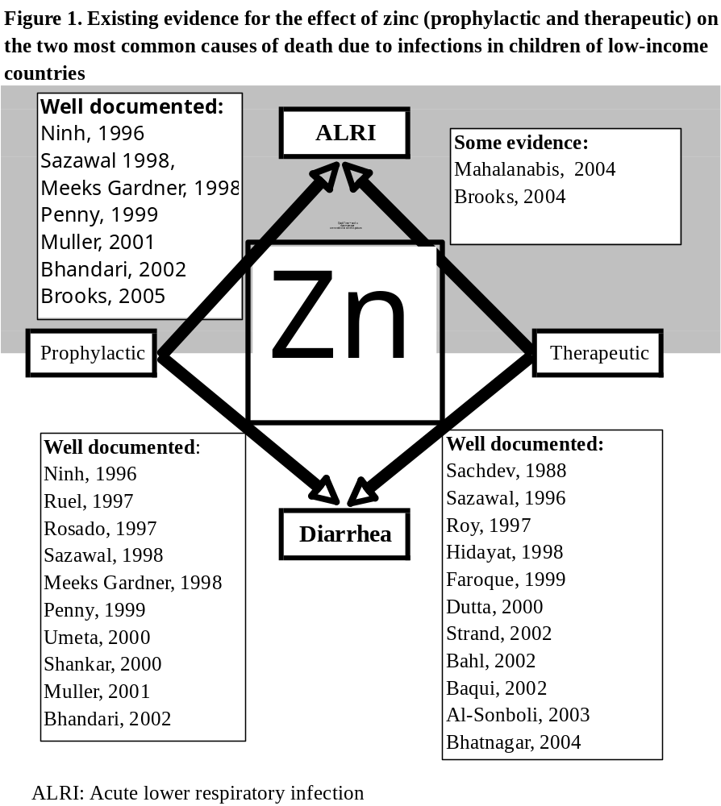

Secondary objectives
1) Whether the following are modifiers for the above-mentioned effect of zinc given during pneumonia.
a. severe inflammation, reflected in : high fever and/or elevated plasma C-reactive protein (CRP) concentration
b. categories of thymic sizes
c. breast feeding status and age categories
d. categories of nutritional status
e. viral etiology

2) Breastfeeding practices and pneumonia
a. Describe factors that interfere with breastfeeding during pneumonia.
b. Describe risk factors for severe pneumonia such as low frequency of breastfeeding, or whether breastfeeding has been discontinued during the present episode of pneumonia etc.
c. Assess to what extent zinc administration during pneumonia influences the frequency of breastfeeding.
3) Technology transfer between and competence building in South Asian and European
countries and strengthening the research groups in Asia and consolidating a European-Asian
child health and nutrition research consortium.

The projects current relation to the state-of-the-art
Clinical trials with large sample sizes are the best way to determine causal relationships between possible health interventions and the corresponding desired outcomes. To ensure a non-biased enrollment and follow-up, clinical trials should be double masked such as the three trials that are described in this project. Furthermore, in order to obtain precise estimates for the effect sizes, the amount of random errors should be kept to a minimum. This is ensured repeated validation the instruments used in the project. The performance of the technical staff was assessed at regular intervals throughout the project. When necessary the staff has been retrained.

The clinical trials are undertaken with ethical clearance from the proper health authorities and in accordance with National laws and regulations as well as the “Consort” statement. The top pediatric institutions in the countries involved ensure the medical welfare of the participants in this study.

We use the latest and well-recognized techniques and approaches to detect viral etiology of the illnesses as well as to measure plasma CRP, zinc, and hemoglobin as well as to measure the microbiological etiology of the infections.

Most important problems and actions/corrections taken
In the beginning of 2006 Nepal went though a period of political unrest with frequent general strikes and bloody clashes between the army led by the king and the rebel Maoists. On January 2 that year, the Maoists decided not to extend a four month ceasefire saying that the government had broken the ceasefire with numerous attacks on Maoist villages. The political instability escalated from this date. In April, several protesters were injured, there were several strikes where the country was closed down and it was impossible to use the roads. There were several days with Curfews and the king ordered protesters violating the curfew to be "shot on sight. On April 27 the king promised to restore democracy, which also restored stability. This period of turmoil substantially affected our project, fewer children in WP 1 and 4 were included and fewer samples in WP 3 were analyzed.

Work Package 1. Community based clinical trial in Nepal (Bhaktapur study)
The major problems faced were frequent general strikes with no public transportation available during those periods and therefore the staff was unable to report for work. To overcome this, greater number of staff residing in adjoining study areas were hired to carry out the work during strikes as these individuals could reach the study areas on foot.

Work Package 2. Thymic ultrasound scan
Due to frequent power cuts and unstable power supply at the field clinic in the community-based trial (WP1) the ultrasound instrument had to be repaired. A spare part had to be obtained from Japan. As a consequence, no instrument was available in the field clinic for a few weeks. As a result, the team purchased another ultrasound instrument as a back up. In addition a UPS was purchased and installed to ensure safe and continuous running of the ultrasound instrument during working hours. One of the trained doctors quit during the start up period and the second doctor had to perform the measurements alone for some months until another doctor could be trained.

The percentage of children coming for follow-up visits was generally good, but at some points it was still been less than anticipated. We improved our routines for calling the study participants to improve follow-up.

Work Package 3. Virus assays
Training of the Nepali laboratory staff in RT-PCR assay procedures was delayed because they were denied visa to the US for training at Prodesse, Inc. The training therefore, had to be arranged in the South Asian region and they were then sent for 10 days to the All India Institute of Medical Sciences. The establishment of the virus assay was delayed for several months due to the lengthy procedures for applying for tax exemption through the Nepalese government system. Once tax exemption was obtained, the shipment from Prodesse, Inc. was delivered safely in Nepal. Another major obstacle has been the electrical power supply in the laboratory facility. We had to invest in backup power supply. Breakdown of scientific equipment and frequent power failures have caused some difficulties in undertaking the laboratory analyses in the field office and at Department of Microbiology at Tribhuvan University. We have been running without back-up deep freezer and have transported several samples to Norway for further storage. The equipment is being repaired or replaced. Our -70 freezer broke down during the last reporting period. This deep-freezer was, in part, covered by the guarantee and funds from another project. To ensure safe storage of samples, an aliquot of each sample was transported to Norway on dry ice on a regular basis.

The laboratory was closed during the worst days of political crisis in Nepal. The analysis rate in the laboratory was not high enough to keep track of the enrolment rate in the trial in WP1. To have the results of the virus analyses ready at the end of the trial, we decided to increase analysis capacity with support from the University of Northern Norway (UNN). This was implemented during October 2006 and resulted in a 3-fold increase in analysis speed.

Shipment of supplies of reagents have been difficult because the political and administrative situation in Nepal. Furthermore, our analytical expenses increased because of the slow enrollment rate combined with a short shelf-life. The shipment issue was solved by carrying the reagents during regular air-travel rather than by ordinary shipping.

Work Package 4. Hospital based clinical trial at Kanti hospital
Just prior to initiation of the study, the investigators were informed by the new administration that a national clearance was also required in addition to the clearance from IOM. The national clearance was received in September 2005. Because of the unstable political situation there were very few enrolments during the first six months of 2006. There was a high turnover of medical officers in this WP, which led to increased workload for the principal investigator.

Work Package 5. Hospital based clinical trial in New Delhi, India
Since each hospital has its own protocol for the management of sick infants, a uniform treatment protocol had to be developed and its implementation enforced at all three centers participating in the trial.

Obtaining consent for the parents of the enrolled children for multiple samples was a challenging task but became less difficult after repeated training of the physicians obtaining consent. Initially, the families requesting early discharge i.e. before recovery were many but training the physicians to motivate families to complete the follow up and interactions of such families with senior physicians reduced this problem. Transportation of blood and urine samples from all centres to the central laboratory at AIIMS was a challenge.

- The prime concern was consistency of methods for collection of data across all centres. Since each hospital had its own inherent protocol for the management of sick infants, a uniform treatment protocol was decided upon and then enforced at all three sites, before the study started. A senior physician at each centre was brought on as a co-investigator. They, along with the research team, worked closely with hospital staff to ensure strict adherence to the protocol.

- Extra attention was given to taking informed consent while enrolling patients. Training was provided to the research staff in how to take informed consent and this was reemphasized on a regular basis during the monthly standardization exercises in the form of role plays.

- Another major concern was loss to follow-up. The research team coordinated with the consultants and the residents on call to minimize protocol deviations such as early discharge before complete recovery had been achieved. Special attention was given while training the research staff on developing excellent rapport with the enrolled subjects.

August 2008 suspicions were raised by the public regarding increased mortality in the study. The enrollment was suspended at all sites for a few days till the concerns were addressed. A safety analysis was performed by an external body (WHO) to ascertain that there were no excessive deaths among the zinc recipients.

Section 2 – Work Package progress of the period

2.1 Work Package 1

2.1.1 Work package objectives:
To undertake a randomized placebo controlled field trial that measures the impact of oral zinc given during an episode of childhood pneumonia.

2.1.2 Progress towards objectives
This clinical trial commenced in 2004 with funding from NUFU (“Norwegian Council for Higher Education’s Programme for Development Research and Education.”). Furthermore, in order to undertake this project we were running a 10 bed pediatric ward staffed with six nurses and six medical doctors who were supervised by consultants from the leading pediatric institution in Nepal.

We screened 8,823 cases of pneumonia for eligibility for pneumonia and enrolled 2681 (an average 64 children per month). The field workers undertook 10,500 home visits to assess morbidity, 37,424 to dispense zinc or placebo. The enrolled children made 9,128 visits to our outpatient department after they were included in the trial and while under observation. In the pediatric ward we admitted 160 of the enrolled children. This ward also served several children in the target area that were not included in the trial. Seven doctors, 6 nurses, 22 fieldworkers, 2 supervisors, 2 drivers, and several others were working full time in this trial.

We enrolled children from the 17 regions (Wada’s) of Bhaktapur Municipality. Bhaktapur is the third largest town in the Kathmandu valley in Nepal. Prior to the initiation of and throughout the trial, a survey in the study area was carried out in order to identify houses with children below 3 years of age. Background characteristics about the household and the child were asked and the child was offered an ID card. This card entitled the child to have free access to standard medical treatment at the outpatient clinic at Siddhi Memorial Hospital, which had 24 hour service. Children were recruited by spontaneous visits to this clinic or after referral of fieldworkers after monthly household morbidity visits. From September 2005, the study area was extended to include rural areas in the vicinity of Bhaktapur. Children from these areas presenting at the outpatient clinic with pneumonia were enrolled and followed up as the other children.

Children 2 to 35 months of age with cough and/or difficult breathing were screened in the clinic by a physician and included if they had pneumonia or severe pneumonia according to WHO criteria. Non severe pneumonia was defined as fast breathing but without lower chest indrawing. If the lesser of two counts of respiratory rate was >=50 breaths/minute in children aged 2-12 months and >=40 breaths/minute in children aged over 12 months it was considered as fast breathing. Severe pneumonia was defined as the finding of lower chest indrawing (LCI), nasal flaring or grunting at every breath but without danger signs. In a child with wheezing, two doses of nebulized salbutamol (salbutamol 2.5 mg per dose) were given 15 min apart and the child was reassessed after 30 min.

Fieldworker candidates participated in a week long course in IMCI given by Nepalese Paediatricians as facilitators at Kanti Hospital, Kathmandu. Fieldworkers were employed on the basis of the results of a multiple-choice test after the course. During the trial the field workers were trained in refresher-sessions at Kanti Hospital, Kathmandu and in the outpatient clinic in Bhaktapur in detecting lower chest indrawing, counting respiratory rate and measuring axillary temperature, height, and weight and intra- and interobservation variability was assessed. Throughout the entire study period, in 8% of all homevisits, supervisors or study physicians supervised the field workers or undertook independent visits, completing the same questionnaires in addition to a separate form on field worker performance. This was done to ensure appropriate interaction between the participants and the study staff and to maximize data quality.

If the responsible caretaker was willing to let the child participate, if they planned to live in the area for at least 6 months, and if the child had no medical contraindications they child would become enrolled in the trial. The medical contraindications were 1) the child required special care for other severe illness than pneumonia or had very severe pneumonia, 2) severe malnutrition defined as being < 70% NCHS median weight for height, 3) presence of congenital heart disease, 4) documented tuberculosis, 5) documentation of any oral antibiotic treatment in the last 48 hours, 6) cough for more than 14 days, 7) severe anemia defined as haemoglobin <7 g/dl and 8) dysentery.

Children were stratified by age below or above one year, as the dose of zinc to infants was 10 mg and the dose to toddlers was 20 mg per day. Furthermore, they were stratified on severe and non-severe pneumonia as the case management was different. Children were allocated to either intervention group by simple randomization with blocks of 16. We allowed a child to be rerandomized and enrolled in the study only if 6 months had lapsed from the previous enrollment.

Interventions, Blinding, and Cointerventions
The supplement was a dispersible (dissolves in water or breastmilk in about 20 s) tablet containing 10 mg of elemental zinc sulphate, manufactured by Nutriset, France. The zinc containing tablets and the placebo tablets were provided in blister strips. Tablets of both groups were similar in packaging, appearance, taste and inactive ingredients. The first dose of supplement was administered at the clinic. Field workers observed and recorded side effects such as regurgitation of the supplement during the first 15 minutes after administration. Subsequent doses were given daily by a field worker at home except on public holidays when the supplement was given by the caretaker, usually the mother. The randomization list that linked the serial numbers with the group identity was kept with a researcher from The University of Bergen, Norway.

The children with non-severe pneumonia received antibiotic treatment with oral cotrimoxazole in a dose of 4mg TMP/kg and 20mg SMX/kg two times a day for 5 days. A fieldworker examined the child daily and recorded information on morbidity until recovery from the episode of pneumonia. At each home visit, details of illness characteristics, including the respiratory rate, presence of lower chest indrawing, danger signs and axillary temperature were recorded. If there was still fast breathing at 72 hours after enrolment, then the child was referred to the clinic. If the physician at the clinic confirmed that the child still had non-severe pneumonia according to WHO criteria, the treatment was changed to amoxycillin (15mg/kg three times per day) as second line antibiotic to be given for 5 days. The parents were advised to bring the child to the clinic any time if required. Similarly, the fieldworkers were instructed to refer the child to the clinic whenever they assumed a medical evaluation of the child would be appropriate. Recovery from non severe pneumonia was defined as the first of 2 consecutive days with normal respiratory rate.

The children with severe pneumonia were hospitalised at SMH and received benzylpenicillin
(50,000 units/kg IV every 6 hours for at least 3 days. The child was examined with 12-hourly intervals by a physician and details of illness characteristics, including the respiratory rate, presence of lower chest indrawing, danger signs, and axillary temperature, oxygen saturation, and auscultatory findings were recorded. When the child recovered from severe pneumonia, i.e. the beginning of a 24 hour period without chest indrawing, grunting at every breath or nasal flaring , treatment was changed to oral amoxycillin (15mg/kg/dose, thrice daily) for a total of 5 more days. If the child did not improve on benzylpenicillin after 48 hours then treatment was changed to chloramphenicol (25 mg/kg IV every 8 hours) until recovery from severe pneumonia. After recovery from severe pneumonia, treatment was continued with chloramphenicol orally for a total course of 10 days. The child would normally be discharged after recovery from severe pneumonia. If the child still had symptoms of non-severe pneumonia, it was followed up with daily home visits, where clinical conditions were monitored by a fieldworker, in order to register the date of recovery from non-severe pneumonia.

Diarrhoea was managed according to WHO guidelines. Children >=6 months of age and with hemoglobin between 7 and 10 mg/dl were supplemented with elemental iron in a dose of 3 mg/kg/day in one daily dose for one month. Iron was given after the end of the 14 day intervention period in order to avoid interaction between iron and zinc.

Data Collection
Children were weighed at enrollment using a scale with 100g sensitivity (UNICEF electronic Scale 890 (SECA)). The total length was measured at enrolment with a measuring board as height in children from 2 years of age and as recumbent length as in children < 2 years of age to the nearest 0.1cm. All enrolled children had a finger-stick capillary blood sample taken for measuring of the hemoglobin (Hemocue, Vedbæk, Denmark) and C-reactive protein (Quikread® CRP, Orion Diagnostica, Hellebæk, Denmark) by a semi-quantitative rapid test with a measurement range of 8 to 160 mg/l.Oxygen saturation was measured either on a finger or a toe with a pulse oxymeter (Siemens MicO2, Siemens Medical Systems Inc, Danvers, MA, USA) using a pediatric sensor (Nellcor, Pleasanton, CA, USA). It was recorded twice after stabilization of the reading for one minute. The average of the two readings was used.

Data Management and Analysis
The data were double entered into Microsoft VisualFoxPro databases (Microsoft Corp, Redmond, WA) with computerized logic, range, and consistency checks. If errors were detected, the forms were returned to the field for correction the next day. Weight-for-age, length-for-age, and weight-for-length z scores were calculated using the 2006 WHO international growth reference.

We have analyzed the data and produced a draft of the first publication that describes the effect of zinc on childhood pneumonia.

2.1.3 Deviations from the project work program, and corrective actions taken
None

2.1.4 List of deliverables in WP1

Del. no. | Deliverable name | WP no. | Date due | Actual/Forecast delivery date | Estimated indicative person-months *) | Used indicative person-months *) | Lead contractor
1.1 | Interim Analysis | 1 | 14 | 7 | 2 | 2 | 3
1.2 | Completion of trial 1 | 1 | 44 | 36 | 1137 | 1055.08 | 2

  - Interim analysis of clinical trial at Siddhi Memorial Hospital, Bhaktapur
All the milestones listed in the Technical Annex scheduled during the first year were achieved on time. A Data Safety Monitoring Board comprising of Dr. A Baqui from Johns Hopkins School of Public Health, USA and Dr. Rolv T Lie from University of Bergen, Norway conducted the interim analysis in July 2005. The DSMB recommended that the study continue according to the protocol and that the study should progress and enroll the targeted 2700 children.

Enrollment was finished in June 2007, follow-up in December the same year.
The first draft report describing the results was finished in August 2008.

2.1.5 List of milestones in WP1
Milestone  no. | Milestone name | WP no. | Date due | Actual/Forecast delivery date | Lead contractor
1 | Enrollment of the first children | 1 | 4 | 0 | 2
2 | Interim analysis | 1 | 14 | 7 | 3
3 | enrollment and follow-up finished | 1 | 36 | 36 | 2

Expected result: Complete enrollment and follow up, analyses and draft report of the clinical trial.

Picture below.
GPS- plot of the enrolled children during the project period. The dark squares indicate enrolled children while the light squares indicate children under surveillance that were not enrolled in the clinical trial. Katmandu is located 12 km west (to the left in this picture).

The picture was generated using Google earth.

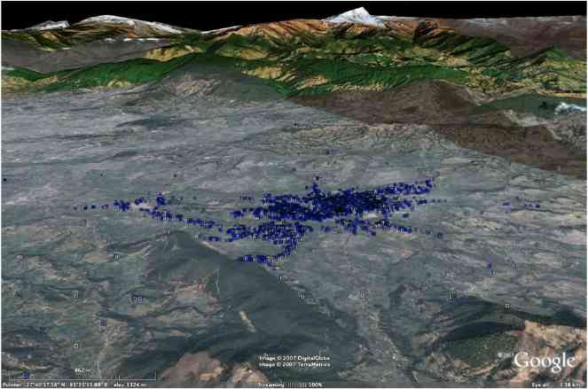

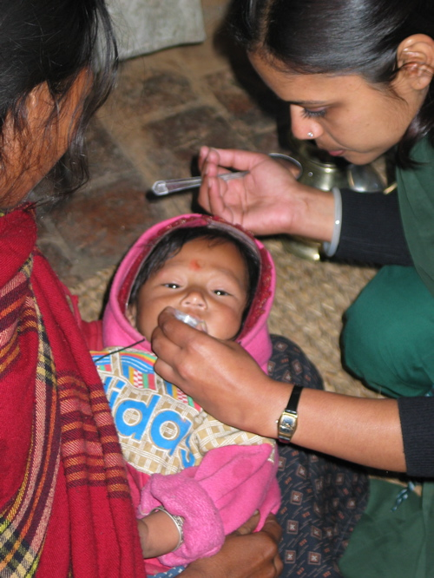  Field worker during a home visit, dispensing zinc or placebo. | 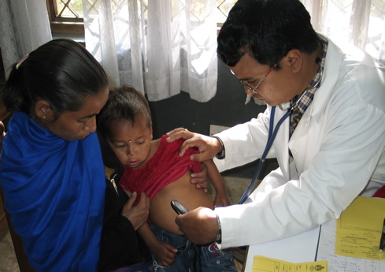  Dr. Ram K Chandyo enrolling a child

2.2 Work Package 2

2.2.1 Work package objectives
To purchase the appropriate equipment for ultrasonography of the thymus in young children.
To train the trial doctors in performing the ultrasonography technique.
To standardize and validate the method under field conditions.
To measure thymus size in children enrolled in clinical trial 1 by ultrasonography at 3 and 6 months follow-up.

2.2.2 Progress towards objectives
Most participants of WP 1 underwent the examination described in this work package. The last day of follow-up was 31st of December 2007 and the data are undergoing preparation for final analysis. Scientific personnel from IRD (Partner 6) visited Nepal to train two of the Nepali study physicians to perform the measurements of the thymic area in the community-based study and to assist the Norwegian Ph.D. student in developing the manual for the study component. The initial training lasted for about two weeks. After this training, inter-observer and intra-observer studies were carried out by the Ph.D. student to address reproducibility of measurements and bias (systematic differences) between the two measurers. For the intra-observer study, each doctor performed two measurements on each child in a group of 25 children that presented at the out patient department with various complaints. The children were in the same age group as the study children. The two measurements in the same child were done approximately five minutes apart with at least one other child in between. The measurements were blinded and written down by a third person. The inter-observer study was done under the same conditions, except that the doctors performed one measurement each in every child in another group of 25 children. Both doctors performed adequately in regards to reproducibility of the thymic area measurements and there was no bias between their measurements. Part of the variation observed can be attributed to the variation inherent in the method, as thymus size varies according to respiratory and cardiac cycle. After one year of running the thymic measurements in WP1, another study of reproducibility was carried out.

2.2.3 Deviations from the project work program, and corrective actions taken
None

2.2.4 List of deliverables in WP2

Del. no. | Deliverable name | WP no. | Date due | Actual/Forecast delivery date | Estimated indicative person-months *) | Used indicative person-months *) | Lead contractor
2.1 | Validation of the instruments | 2 | 4 | 2 | 2 | 2.5 | 6
2.2 | measurements of thymic sizes | 2 | 42 | After completion | 34 | 57.9 | 2

2.1 Validation of instrument for thymic ultrasound
Scientific personnel from the IRD together with the Norwegian Ph.D. student (Maria Mathisen) trained three of the study physicians in performing ultrasound measurements of the thymic area. Post-training inter-observer and intra-observer standardization exercises were conducted to address reproducibility of measurements and bias across the three different measurers.
D.2.2 measurements of thymic size in the children enrolled in clinical trial 1 (WP1) and report. This is the subject of a M.Sc student at the University of Bergen. She is expected to finalize her studies in June 2010.

2.2.5 List of milestones in WP2

Milestone  no. | Milestone name | WP no. | Date due | Actual/Forecast delivery date | Lead contractor
4 | Manual development and training | 2 | 7 | 4 | 6
5 | Thymic size measurements at follow-up dates ready to be analyzed for all children. | 2 | 37 | 37 | 2

Expected result
Reliable and consistent data of thymic sizes measured by ultrasonography of enrolled children at 3 and 6 months after enrollment.
Dr. Saihlendra Karmacharia during validation of the thymus scan December 2005.
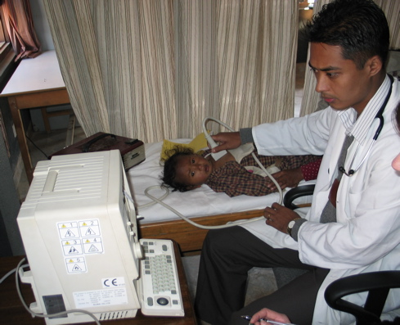

2.3 Work Package 3

2.3.1 Work package objectives
To identify viral agents in children with pneumonia to explore the efficacy of zinc in different subgroups based on viral etiology.

2.3.2 Progress towards objectives
Establishment of laboratory facility in Nepal
Manual for the nasopharyngeal aspirate collection was developed and all the doctors in the two trials in Nepal (WP1 and 4) were trained to collect a sample from the enrolled children. Along with that, instructions for transportation of the samples from the field clinic to the central laboratory and manuals for further processing and storage of the samples were also developed. The Department of Microbiology at Tribhuvan University Teaching Hospital in Kathmandu provided the location for the virus PCR laboratory as well as an experienced laboratory technician. In the actual analysis we decided to apply the highly sensitive and specific assay Hexaplex Plus®, a commercially available RT-PCR-kit developed by Prodesse, Inc. Technical support was sought at the Department of Microbiology at the University hospital of Northern Norway (UNN), where the Hexaplex Plus® assay was already established. The Norwegian Ph.D. student visited Prodesse, Inc. together with an UNN staff member to receive a three days intensive training in the assay procedures. The Nepali laboratory staffs went for RT-PCR training in All India Institute of Medical Sciences in New Delhi later on. Two of three aliquots were transported on a regular basis to Norway where they are stored in a –70 freezer at the UNN to provide a pool of samples for back up purpose and quality control analysis.

The first 162 samples collected during the first three months were stored at two different temperatures (2-8°C and -70°C), transported to Norway on ice and dry ice respectively and analyzed at UNN in parallel with Hexaplex®. There was a high degree of agreement between the frozen and the refrigerated aliquots. In addition to information about storage temperatures, it also showed that a virus was detected with this assay in more than one third of the samples. This comparative study is in manuscript.
All collected samples from children enrolled in WP1 and WP4 have been analyzed and results have been entered into a data entry system created for the purpose.

As a quality control, several samples have been analyzed in parallel at the University of Northern Norway

2.3.3 Deviations from the project work program, and corrective actions taken
None

2.3.4 List of deliverables in WP3
Del. No. | Deliverable name | WP no. | Date due | Actual/Forecast delivery date | Estimated indicative person-months *) | Used indicative person-months *) | Lead contractor
3.1 | Establishing a laboratory for detection of viruses | 3 | 6 | 9 | 4 | 3 | 1
3.2 | Virus analysis | 3 | 29 | 42 | 52 | 95.3 | 2
Comments to 3.2. The time spent for virus analysis was longer than anticipated and more person months were accordingly spent on this activity.

2.3.5 List of milestones in WP3
Milestone  no. | Milestone name | WP no. | Date due | Actual/Forecast delivery date | Lead contractor
6 | Laboratory facilities with manuals developed. | 3 | 6 | 9 | 1
7 | Virus assays running | 3 | 7 | 10 | 2
8 | Virus results from available | 3 | 29 | 42 | 2
Results:
A functional chain of specimen sampling, transportation, processing and interpretation for viral detection in children with pneumonia.
Detailed virology of children < 3 years of age with pneumonia in Nepal.
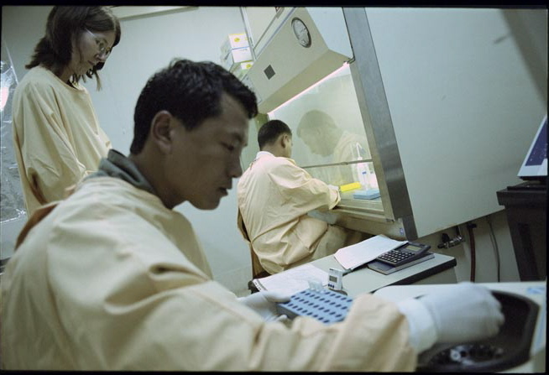
Maria Mathisen,
Govinda Gurung, and Biswa Sharma analyze the samples collected from the nose of the children in the clinical trial in Bhakapur.

The picture is from the laboratory at Tribhuvan University in Kathmandu, Nepal

2.4 Work Package 4

2.4.1 Work package objectives
In a double blind randomized controlled trial, measure the efficacy of giving 2RDA (10 or 20 mg) zinc orally in addition to routine antibiotics for treatment of clinically diagnosed pneumonia or severe pneumonia in 2 to 36 month old children.

2.4.2 Progress towards objectives
During the first five months of the project we established the infrastructure, the required staff was hired, forms were developed and pre-tested. The medicine for this study was purchased and the randomization list prepared. Ethical clearance as well as clearance from the Kanti children’s hospital, where the study was carried out was obtained in month 11. We undertook a pilot study in January and February 2006 where 31 children were enrolled. After this period, 2198 children with severe pneumonia attending Kanti Children Hospital were screened out of which 610 children were randomized to receive zinc or placebo. Eight hourly monitoring of enrolled children were done for, clinical examination, assessment of respiratory rate as well as Oxygen saturation. Training of Medical Officers as well as health assistants was done at regular intervals. This study enrolled its last child on June 15, 2008. Follow-up continued till July 1 2008. Double data entry has been done concurrently.

In addition, we assessed the oxygen saturation of 400 healthy children aged 2 to 35 months (the age group that was included in the trial of WP4). This was to establish the normal range of oxygen saturation in this population.

2.4.3 Deviations from the project work program, and corrective actions taken
The start of the trial was not possible during the first reporting year because the process of obtaining ethical clearance and clearance from the hospital required more time that expected. In 2006, the enrollment was rather low during the first six months because of the political instability in Nepal. We adjusted the required sample size from 500 to 600. This was done after analyzing the distribution of the outcome (duration of illness) that revealed that a higher sample size was required. This increase was possible within the allocated budget for this WP.

2.4.4 List of deliverables in WP4

Del. No. | Deliverable name | WP no. | Date due | Actual/Forecast delivery date | Estimated indicative person-months *) | Used indicative person-months *) | Lead contractor
4.1 | Detailed manuals and trained staff for the clinical trial. | 4 | 6 | 6 | 2 | 2 | 2
4.2 | 611 enrolled and followed up children, the results analyzed and a preliminary report written. | 4 | 19 | 42 | 174.05 | 267.05 | 2

  - Preparation of clinical trial 2 at Kanti Children’s Hospital, Nepal
The laboratory facility, as well as the system for inclusion and follow up of children enrolled from Kanti Hospital for WP4, was established by june 2005. The staff was hired, physicians and other staff were trained, forms were designed and pretested and manual of operations was prepared.

4.2 Sample size was adjusted from 500 to 600 children.

2.4.5 List of milestones in WP4

Milestone  no. | Milestone name | WP no. | Date due | Actual/Forecast delivery date | Lead contractor
9 | The first child enrolled in clinical trial 2 | 4 | 6 | 13 | 2
10 | Field work completed | 4 | 19 | 42 | 2

2.5 Work Package 5
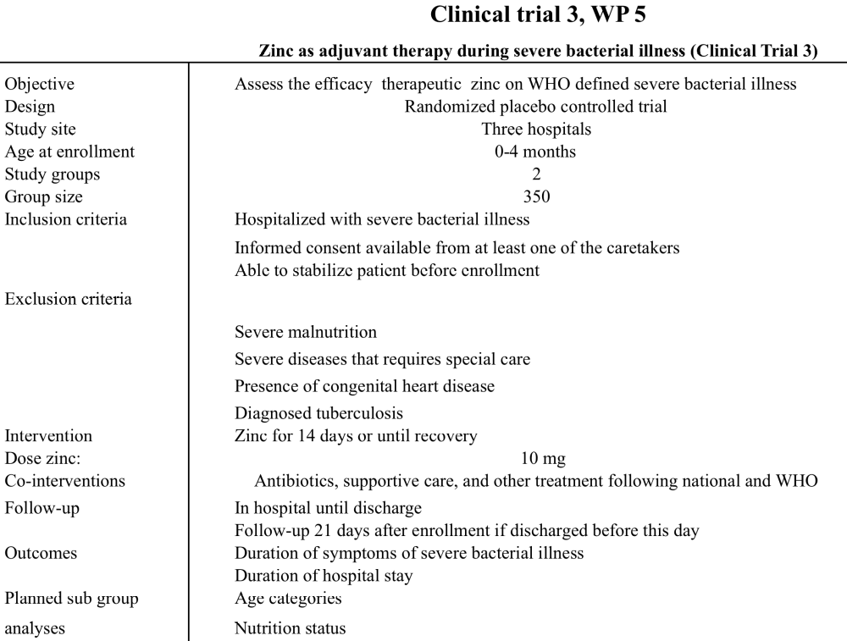

2.5.1 Work package objectives
In a double blind randomized controlled trial, measure the efficacy of giving 2RDA (10 mg) zinc orally in addition to routine antibiotics for treatment of clinically diagnosed systemic bacterial infections in infants > 7 days up to 4 months of age.

2.5.2 Progress towards objectives
The study was undertaken at Deen Dayal Upadhyaya Hospital (DDU), All India Institute of Medical Sciences (AIIMS), and Kalawati Saran Children Hospital (KSCH), all within New Delhi.

The intervention was provided by WHO and was received at the study site in June 2005. The zinc and placebo tablets were available as dispersible tablets (with a central groove) identical in color, taste, and appearance and were packed in identical looking blister strips. Each tablet contained 10 mg of elemental zinc (or placebo) and each blister strip contained 10 tablets. Five such strips were provided in one zip bag for each subject. The bags with either zinc or placebo blister strips were labeled with a unique number according to the randomization list. The blister strips within each bag also had the same serial number.

The doctors were trained to give the intervention by breaking the tablet along the central groove and dissolve it in 2 ml of water or expressed breast milk. The remaining tablet was placed back in the blister strip and wrapped in aluminium foil. The strip was put back in its marked bag and kept in a thermocol box. The remaining tablet was administered 12 hours later.

The enrollment of patients commenced in July 2005 at DDU and KSCH and in August at
AIIMS. All children aged 7 days and up to 4 months attending the emergency or the out patient services were screened by the research team. Those fulfilling the eligibility criteria
were enrolled in the study and managed as per protocol.

The principal investigator (PI) supervised and co-ordinated the three sites. A daily feed back form with details of the screened and enrolled patients was completed by the research team at
each site. This form was reviewed (and initialed) by the research officer, by the site
investigators and then by the PI on a daily basis. The completed forms were manually checked by the supervisor before they were sent for data entry.

The screening forms and the completed case recording forms were entered concurrently by two independent data entry operators. The two files were compared using Epi Info 5. The incorrect files were edited appropriately. The computer program to compare the files was run again and editing repeated till no errors were found.

After entry, the forms for each subject were put in a separate folder labeled with the name of the patient and the study code number and stored in racks in the data management office.
The PI had review meetings with the research officer and the data entry operators twice a week and with the site research team every fortnight. The PI and the site investigators met every month where the progress of the study was reviewed.

Amongst the 686 enrolled infants 56% (382/686) were younger than 2 months and 54% (369/686) had weight for age < -2z. The intervention was accepted well and vomiting was not reported for any infant. The treatment failure rate was 15.5% which is lower than the anticipated rate of 25% used for calculating the trial size. Twenty-seven infants died during the study and the predominant cause was septic shock. The overall case fatality rate of 3.9% and decreased from the initial 4.5% over the last one and half years of enrollment. It is better than usual seen in our clinical settings and reflects the good case management for enrolled infants in the study. Five hundred and thirty eight (78%) infants achieved overall recovery without change in initial antimicrobial therapy. Eighty-one infants were discharged after they had achieved clinical recovery but had not gained 10g/day for two consecutive days. An overall 6.1% rate of loss to follow up is much lower than seen in the initial months of enrollment. It reflects the good co-ordination of the research team at all times with the consultants and the residents on call to minimize early discharge before complete recovery has been achieved and to minimize loss to follow up. All enrolled infants had a CRP > 12 which was the cut off used for screening infants. The median (25 and 75 percentiles) CRP (mg/L) and PCT (ng/ml) concentrations (measured for the enrolled infants at the time of randomization) were 37.05 (20.5, 64.1) and 1.34 (0.43, 6.0) respectively. It further validates our screening procedure and also shows that all our study subjects had possible bacterial infection as indicated by the high CRP and PCT.

All measures for maintaining quality assurance for collecting clinical and laboratory data and for data management were taken. The Principal Investigator (PI) supervised and coordinated the three sites. A daily feedback form with details of the screened and enrolled infants was completed by the research team at each site. This form was reviewed (and initialed) by the Supervisor, the Site Investigators (SI), and then by the PI on a daily basis. The completed case recording forms were manually checked by the supervisor before they were sent for data entry.

A comprehensive microbiological evaluation for enteric pathogens was available at AIIMS. The blood (BACTEC) and urine culture (direct plating method Hi Media) from the three sites was being processed in the laboratory at AIIMS. The isolation rates of pathogens in blood culture were 14.5% and out of these 42.4% were due to Staphylococcus.

The PI had review meetings with the Supervisor and the data entry operators once a week, and with the site research team every month.

2.5.3 Deviations from the project work program, and corrective actions taken
Slow enrollment at increased sample size. In August 2008 the public raised suspicions regarding increased mortality in the study. A safety analysis was undertaken; this is described elsewhere in this report.

2.5.4 List of deliverables in WP5

Del. No. | Deliverable name | WP no. | Date due | Actual/Forecast delivery date | Estimated indicative person-months *) | Used indicative person-months *) | Lead contractor
5.1 | Preparation of trial, Detailed manuals and trained staff | 5 | 5 | 6 | 6 | 5 | 4
5.2 | 700 enrolled and followed up children, | 5 | 36 | 44 (or later) | 210 | 253 | 4

  - Preparation of clinical trial in children with bacterial infection at AIIMS
In addition to All India Institute of Medical Sciences, the study was conducted at two hospitals Deen Dayal Upadhyaya Hospital (DDU) and Kalawati Saran Children Hospital (KSCH). The staff was hired, physicians and other staff were trained, forms were designed and pretested and manual of operations prepared for the study. The enrollment commenced in July 2005 in DDU and KSCH and in August 2005 at the AIIMS.

5.2 700 enrolled and followed up children, the results analyzed and a preliminary report written. 686 children were enrolled and finished follow-up in month 44. Based on the preliminiary results from this component, we have chosen to continue enrollment.

2.5.5 List of milestones in WP5

Milestone  no. | Milestone name | WP no. | Date due | Actual/Forecast delivery date | Lead contractor
11 | Field infrastructure ready | 5 | 5 | 8 | 4
12 | first draft research report written | 5 | 36 | 44 | 4

Report regarding the preliminary results produced in August 2008. Mentioned elsewhere in this report.

2.6 Work Package 6

2.6.1 Work package objectives

To assess plasma specimens for copper and zinc concentration in the clinical trials described in WP1, WP4, and WP5.

2.6.2 Progress towards objectives
Plasma zinc samples from WP1 were analyzed in August 2008.
Plasma zinc samples from WP4 has not yet been analyzed.
Plasma zinc samples from WP5 has not yet been finished as this study still enrolls patients.

2.6.3 Deviations from the project work program, and corrective actions taken
Plasma zinc samples from WP4 will be analyzed in 2009. This is because more blood samples than initially planned have been collected. New methods for measuring plasma zinc that require less sample have become available. Thus, we choose the new methods where more of the specimens can be left for other purposes.

2.6.4 List of deliverables in WP5

Del. No. | Deliverable name | WP no. | Date due | Actual/Forecast delivery date | Estimated indicative person-months *) | Used indicative person-months *) | Lead contractor
6.1 | Zinc and copper analysis | 5 | 38 | 44 | 4 | 12 | 4

2.7 Work Package 7

2.7.1 Work package objectives
Management of the project to make sure that all objectives are achieved

2.7.2 Progress towards objectives
There have been monthly phone meetings to discuss the progress of the project and potential problems. A kickoff meeting was held in month 9 with participants from all partners except partner 4. The partners have meet approximately 3 times every year to discuss the progress of the WPs. Participants in these meetings depended on its purpose. For example, if WP3 was discussed, only participants from Partner 1 – 3 was required to participate.

2.7.3 Deviations from the project work program, and corrective actions taken
None

2.7.4 List of deliverables in WP7

Del. No. | Deliverable name | WP no. | Date due | Actual/Forecast delivery date | Estimated indicative person-months *) | Used indicative person-months *) | Lead contractor
7.4 | Final project report to the commission | 7 | 47 | 47 | 11.2 | 22 | 1

D.7.1 Final project report to the commission

2.7.5 List of milestones in WP7
Month: 44 (47) final project report to the commission

Section 3 – Consortium management
The principal investigators serve as members of the project steering committee.

The contract holder [partner 1 (Norway)] has been formally responsible for the project management and for the interaction with the European Commission. Prof. Ramesh Adhikari has been the Institutional coordinator in Nepal. However, it was the Nepalese Research manager and principal investigator, Prof. Prakash S. Shrestha, who took most of the decisions pertaining to the undertaking of the components in Nepal. Prof. Shrestha, who was the Head of the Dept. of Child Health at the Institute of Medicine, Tribhuvan University was also in charge of administrational aspects of logistics and the field staff in Nepal.

Principal investigator in India was (and is) Dr. Shinjini Bhatnagar, MBBS, Ph.D, she has been responsible for the undertaking of the clinical trial on severe bacterial illness in children up to 4 months of age (WP 5).

3.1 Summary of project status
WP1 – WP4 have been undertaken as planned. We have chosen to continue the work in WP5 after this project was finished (explained elsewhere in this report). For WP3 and WP6, we have used subcontractors to undertake some the analyses and to assess the quality of the laboratory work done by the project staff.

3.2 Management and follow-up activities

Meetings

After the Kick-off meeting in Durban, South Africa, we have had approximately 3 meetings in Nepal and India every year.

Monthly phone meetings
A monthly conference call was arranged from Norway to review the status of each work package.

Monthly reports to coordinators
All the partners have reported to the coordinator the progress of each work package in the format agreed to. These reports reach the coordinators by the 7th of each month (for work accomplished during the previous one month).

EXCHANGES
In 2005, two laboratory technicians from Nepal (Govinda Gurung and Biswa N Sharma) visited AIIMS (Partner 4) to learn PCR methodology to detect viruses from nasopharyngeal aspirate.

The Norwegian Ph.D. student was based in Nepal throughout this project, she was assigned the responsibility for the supervision of the ultrasonographic measurements of the thymus (WP2) and the establishment of the laboratory facility and running of the virus assay (WP3). She has also contributed to supervision of the fieldwork in the community-based trial (WP1).

The Danish partner lived in Nepal for several months to initiate WP1 and WP4 and to monitor and supervise field implementation of the trials of these WPs.

In 2006, two laboratory technicians from Nepal (Govinda Gurung and Biswa N Sharma) visited two laboratories in Norway. This was part of their training for undertaking the work of WP3 (PCR virus assays)

In October 2006, a lab technician from Norway was visiting Kathmandu and assisted the virus-PCR laboratory there.

The Nepalese Ph. D student Ram K Chandyo has stayed in Norway for one period during this project. Part of his Ph. D. thesis will be based on the results from WP1 (Clinical trial on zinc given during childhood pneumonia).

3.3 Consortium management tasks and their achievement

Partner 1 - Center for International Health, University of Bergen, Norway

Dr. Tor A Strand has dedicated 50% of his time to activities related to the planning, protocol and form development, initiation, implementation and management of the ongoing projects. He has also been responsible for data management of WP1,2,3, and 4.

Dr. Nita Bhandari also affiliated with the CIH has participated in the coordination of the ongoing WPs.

Partner 1 has been responsible for procurement of scientific equipment and data management for WP1, WP2,WP3 and WP4. Furthermore, partner 1 has prepared the randomization lists as well as the medicines used for WP 1 and WP 4 with the French pharmaceutical company Nutriset, (Nutriset, Malaunay, France). Partner 1 has also been responsible for transportation of samples from Nepal to India and Norway and for the transport of consumables to Nepal.

Partner 2 - Institute of Medicine, Tribhuvan University, Nepal

Community based clinical trial in Nepal (WP1)
Partner 2 with the principal investigator Professor Prakash S Shrestha has been responsible for the largest of the clinical trials. In Bhaktapur the team from the department of child health, Institute of Medicine, Tribhuvan University (Partner 2, IoM), established a pediatric ward at Siddhi Memorial Hospital in Bhaktapur Nepal. This ward had 10 beds and were staffed with six nurses and six physicians supervised by senior pediatricians. At the same location we established a pediatric outpatient department and the field office for WP1,2, and 3. The field offices were staffed with 21 fieldworkers, two supervisors as well as other technical staff.

The main office of the project was at the IoM, 45 -120 minutes drive (depending on traffic) away from the field. This office was staffed with four computer operators and one computer manager in-charge in addition to office assistants and was directly under the supervision of the Nepalese principal investigator. A bus was going from this office every day, bringing consumables and staff to the field and biological specimen back to the institute for storage at minus70 degrees Celsius at the department of microbiology. This bus was hired on a monthly basis throughout the project period.

Professor Shrestha was also responsible for the logistics within Nepal.

Dr, Ram K Chandyo was managing the research activities in the field and reported directly to professor Shrestha.

Dr. Manjushwori Ulak was managing the field clinic and also reported to professor Shrestha.
The staff in the field reported to Dr. Ulak and Dr. Chandyo.

Hospital based clinical trial on severe pneumonia in Nepal (WP4)
This trial was carried out in Kanti children’s hospital in Kathmandu, which is the leading pediatric hospital in Nepal. We targeted 5 to 10 enrollments per week.

Dr. Sudha Basnet, staff pediatrician at the Institute of Medicine lead the undertaking of this component. Physicians from Kanti children’s hospital were also involved. Facilities for interviewing the children and their families, for obtaining plasma specimens and for analyzing the samples for CRP and hemoglobin were established in this hospital.

Partner 3 – Statens Serum Institut, Denmark
Initially Palle Valentiner-Branth dedicated 100% of his time working with this project. He was based in Nepal until the end of July 2005. His main responsibility was planning, protocol and form development, initiation, and supervision of the field trial in WP 1. Most workdays were spent in Bhaktapur, and about one day per week in the computer office for data entry. Special care was taken to supervision of the fieldworkers. Exercises addressing interobserver variability were done on how to assess respiratory rate, lower chest indrawing, measurement of axillary temperature, height, weight, and mid-upper-arm circumference. For physicians, exercises addressing the count of respiratory rate, lower chest indrawing, assessment of crepitations and wheezing were performed regularly. Data cleaning was done continuously and care was taken to learn from the mistakes done. He was also responsible for preparation of the dataset and the report for the Data Safety Monitoring Board in July 2005 (WP1). Furthermore, he contributed substantially to the design and planning of the hospital based clinical trial at Kanti Children’s Hospital (WP4).

He continued to supervise WP1 from his base at Statens Serum Institut in Denmark until end of this project.

One year of salary has been covered by the project.

From February 1, 2006, Palle Valentiner-Branth has been employed as a Staff Specialist in
Epidemiology Section at Statens Serum Institut.

Partner 4 – Department of Pediatrics, All India Institute of Medical Sciences, India

This partner was responsible for WP 4 and WP5.

WP 5 consisted of a randomized controlled trial on the efficacy of oral zinc given to young infants with severe bacterial illness. The study was conducted at Deen Dayal Upadhyaya Hospital (DDU), All India Institute of Medical Sciences (AIIMS), and Kalawati Saran Children Hospital (KSCH) with AIIMS being the coordinating centre.

A micronutrient laboratory at AIIMS was prepared for evaluation of zinc and copper from all three sites.

AIIMS, DDU and KSC hospitals are large referral hospitals where an average of 10-20 young infants is referred daily to the outpatient or the emergency services. They have facilities for inpatient management of young infants with round the clock in house resident pediatric and paramedical staff. In addition, there is a system of outpatient departments and 24-hour emergency services.

The sites were prepared for the study with the support of the site investigators. At each centre a room was identified for the research staff, which had easy access to the clinical wards, outpatients and the emergency services. The electronic weighing machines and other material required for patient care were kept in this room. The adjacent room was prepared as a lab for conducting project related laboratory procedures.

Each clinical research facility had one doctor (senior research fellow) and one clinical attendant at all times of the day so that the subjects could be enrolled and monitored round the clock.

The medical research officer, medical senior research fellows, clinical attendants, data entry operator, and the technician were recruited after a stringent selection procedure consisting of a written and oral examination.

Partner 5 – Society for Applied Studies, Calcutta, India
Scientists and a senior administrator from the Society for Applied Studies contributed to the overall endeavor in the following ways:
- Assisted in initiation of the community and hospital based trials by providing feedback on technical issues, form designing and standard operating procedures and on administrative issues.
- Provided feedback on above through site visits
- Participated in monthly conference calls with the group
- Participation in review meetings

Partner 6 – Institute of Research for Devleopment, Montepellier, France

This partner was involved in WP2 (Thymic ultrasound scan), which was initiated in the beginning of the project. Because data collection continued till month 36 of the project and because the data from this component has not been available for analysis, this partner has been less involved than initially planned.

The coordinator at this site is co-supervisor for a Nepalese M.Sc student at the University of Bergen and will be involved in data analysis of WP2.

Scientific personnel from IRD visited Nepal to train two of the Nepali study physicians to perform the measurements of the thymic area in the community-based study and to assist the Norwegian Ph.D. student in developing the manual for the study component. The initial training lasted for about two weeks. After finalized training, inter-observer and intra-observer studies were carried out by the Ph.D. student to address reproducibility of measurements and bias (systematic differences) between the two measurers. For the intra-observer study, each doctor performed two measurements on each child in a group of 25 children that presented at the out patient department with various complaints. The children were in the same age group as the study children.

3.5 Project time table and status

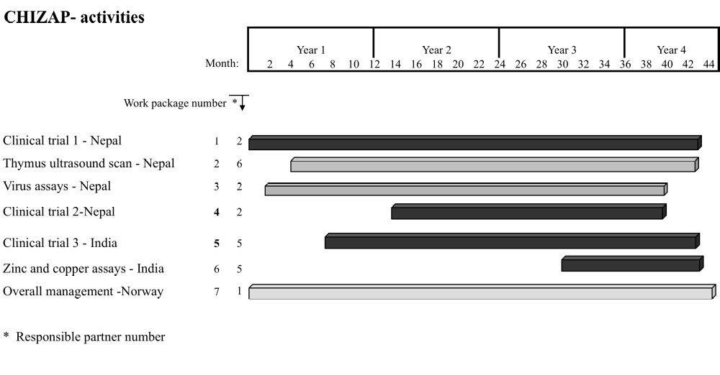

Section 4 – Other issues

4.1 Ethical issues
We have ethical clearance from the medical ethics committee at the overall coordinator institution (except for the study in India) and from the national medical ethics committees. All aspects of the studies are in agreement with the latest version of the Helsinki declaration and in accordance to the guidelines of the Consort statement. We also followed the UN convention on the Rights of the child and the Convention of the Council of Europe on Human Rights and Biomedicine signed in Oviedo on 4 April 1997. Participation was voluntarily, and once enrolled, the caretakers were allowed to withdraw from the study without giving any reason and without the withdrawal having any impact on the subsequent services offered to the child. Written, informed consent was sought, was read out loud to the caretakers of the eligible children in front of a witness. Those who were illiterate signed with a thumbprint. A register of witnesses was kept.

In August 2008 suspicions were raised by the public regarding increased mortality in the study described in WP5. The enrollment was suspended at all sites for a few days till the concerns were addressed. The Data Safety Monitoring Board (DSMB) called for a safety analysis, which was done by a neutral body. The results were shared with the DSMB and the other sponsors, Department of Biotechnology, Govt. of India. The results were as follows; Among the total 680 infants enrolled 349 infants were randomized to the group receiving the standard treatment for sepsis, and 339 infants to the group who received the same standard treatment for sepsis plus zinc (10 mg per day). In the group without zinc, 17 infants died (risk of death = 5.0%), while in the group with zinc only 10 infants died (risk of death = 3.0%). In conclusion, there was a 40% reduction in risk of dying (or deaths) in the group that got zinc supplementation. This reduction was not statistically significant but the data suggested that there were potential benefits in adding zinc supplementation to the management of infants with severe sepsis. It was therefore decided to extend the study as long as possible to gain enough power to look at mortality as an outcome. This will be possible with funds from Meltzer (Norway) and DBT (India).

Data and biological samples are stored according to the laws and regulations of the individual countries.

Safety. Zinc is safe and virtually non-toxic in doses far exceeding those that are to be used in the proposed trials. The methods for collecting biological samples and for examination of the children posed no additional hazard to the children.

Mitigation. For clinical Trial 1 (community based in Nepal, WP1-3), we have staffed and supported a local 24 hourly pediatric ward where all children less than three years of age were offered free examination and treatment for common conditions, including diarrhea and acute lower respiratory infections. We also ran an ambulance to ensure free and proper transport to larger hospitals.

Does your proposed research raise sensitive ethical questions related to: | Yes | No
Human beings | x
Human biological samples | x
Personal data (whether identified by name or not) | x
Genetic information |  | x
Animals |  | x

Annex – Plan for using and disseminating the knowledge

Section 1 – Exploitable knowledge and its Use
The results from the clinical trials will be published in international peer reviewed biomedical journals. There are, to our knowledge, no other trials on the same subject that are of the size of these studies. Thus these studies have the potential of influencing public health decisions.
Furthermore, WP3 is one of the largest studies of respiratory viruses in developing country children with ALRI. In addition to enabling us to explore whether there may be a different efficacy of zinc in children that have viral versus bacterial causes of ALRI, we believe that these results will contribute substantially to our understanding of the aetiology and epidemiology of ALRI in children in developing countries.

Section 2 – Dissemination of knowledge

Biomedical journals, please refer to the section “Results achieved so far” for a list of the upcoming publications.

Local and regional health authorities.

Section 3 – Publishable results
One manuscript on the effect of zinc on community-acquired pneumonia has been prepared (WP1)

One manuscript on the effect of zinc given during community-acquired pneumonia for the effect six months thereafter is under preparation (WP1)

One manuscript on the viral etiology of community-acquired pneumonia has been submitted. (WP3)

One manuscript on the Duration of storage of Nasopharyngeal aspirates and consequences for sensitivity of the Hexaplex assay has been drafted (WP3).

One manuscript on the viral etiology of severe pneumonia is under preparation. (WP3)

