**Main S&T Results**

The fundamental research related to the impact of impurities in CO2 on thermo-physical properties, fluid flow, corrosion and reservoir chemical reactivity was performed in SP1. Existing knowledge gaps were identified, and an experimental and modelling plan was designed. The experimental work and modelling conducted advanced the state of the art in the areas wh­­­­ere critical knowledge gaps were identified for allowing safe and economical design of CCS chains.

The experimental investigation of thermo-physical properties of mixtures relevant for transport and storage of impure CO2 was executed at three locations. Ruhr-University Bochum (RUB) performed density measurements in a dual sinker densitometer for the binary systems CO2-Ar, while CO2-H2 was measured in a single sinker densitometer. RUB used a re-entrant cavity resonator to measure dew points for the binary system CO2-Ar. Tsinghua University built a single-sinker densitometer and measured density for the systems CO2-N2, CO2-Ar, CO2-CH4, and CO2-Ar-N2. SINTEF conducted vapour-liquid equilibrium (VLE) measurements for the binaries CO2-N2 and CO2- O2. Based on the new experimental data, and other publicly available data, RUB developed new reference equations of state for exhaust gases (EOS-CG), based on the same principle as the GERG equations for natural gas. The pure fluids were described using the highly accurate Helmholtz based equation of state, and the interaction between different fluids were modelled using Helmholtz based binary interaction. The new IMPACTS data have improved the predictive capabilities of EOS-CG, especially for VLE in the critical region. EOS-CG has been distributed to the IMPACTS project members in its current version as TREND 2.0, including a graphical interface. The TREND 2.0 software is also a very important outcome of IMPACTS as it is also distributed from RUB to companies and external researchers for improvement of CO2 transport operations.

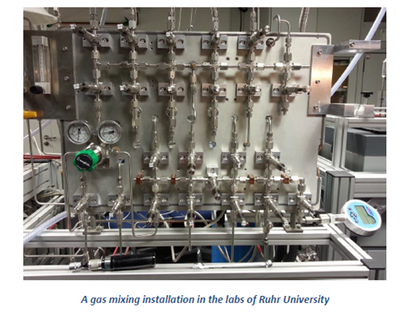

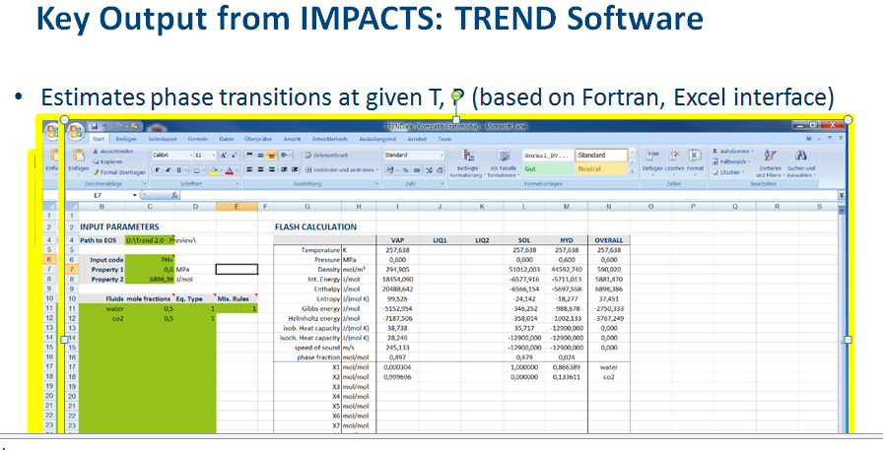The thermodynamic property model, EOS-CG, was coupled to the SINTEF in-house CO2 multiphase pipeline flow simulation tool. The simulation tool solves the flow equations in the conserved variables density and energy, giving a difficult flash problem. Inclusion of the detailed reference equation of state enabled comparison with the commonly used cubic equations of state, and the effect on different pipeline scenarios. This work shows the superiority of EOS-CG for prediction of density and speed of sound, which is important when simulating fast transients. The impact of volatile impurities relevant for CCS (CH4, N2, O2, H2, C2H6) on temperatures during depressurisation of pipelines was investigated. This is a main concern when depressurising (emptying) a pipeline is that very low temperatures can occur, potentially damaging the pipe. The volatile impurities improve the situation by giving a higher temperature than with pure CO2. A tool that allows easy calculation of pressure drop in a pipeline and the corresponding pump/compressor needs has been developed, to aid the techno-economic models.

Stress corrosion tests relevant for transportation of impure CO2 were conducted at Centro Sviluppo Materiali (CSM) using the four-point bend beam method. Four different pipeline materials were investigated, X60, X60 welded, X65 and X70. Experiments were executed for eight test environments to investigate the effect of water, H2 and H2S at different concentrations in liquid or supercritical CO2. The material samples were exposed for 720h and analysed for Sulphide Stress Corrosion Cracking (SSC) and Stress Oriented Hydrogen Induced Corrosion (SOHIC). Both SSC and SOHIC was observed, but not for all samples. Tsinghua University investigated uniform corrosion for X60, X65, X70 and X80 steels. Exposing the material samples to an environment of CO2, SO2, H2O and O2 for 72h in an autoclave, the corrosion rates were determined in 10 different experiments. The experimental parameters were temperature, pressure, moisture, and rotation rate of the sample.

The chemical and physical effects of impurities on CO2 storage was studied by focusing on rock and seal cement from the Ketzin site (Germany) and the Hontomín site (Spain).The Ketzin aquifer is sandstone and the Hontomín aquifer is a fractured carbonate reservoir. Batch experiments were concluded studying the physicochemical processes that take place in a rock/seal-brine system where 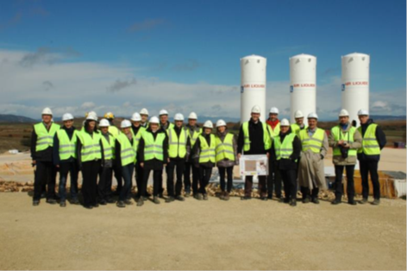CO2 with impurities was introduced. The impurities SO2 and NO2 were studied at different pressures and temperatures relevant for the reservoirs. Both a static test and a dynamic test were the fluid flow through the sample was executed. Effect of the density, porosity and permeability of the rock/cement samples were measured. The impact of impurities for the Ketzin and Hontomín site were investigated using a non-isothermal THOUGH code. The potential effect of SO2, N2, H2, CH4 and O2 on storage capacity, of N2 and O2 on flow behaviour during injection, and SO2 on geochemical reactions between the CO2 stream and the host rock, cap rock and wellbore cement, was investigated. The techno-economic impacts of CO2 mixture composition on the transport and storage infrastructure design and operation was performed by SP2. The results of fundamental experimental work from SP1 were used together with applied experiments on transport and storage and other public and partner knowledge in the techno-economic assessment. Possible consequences for HSE were established and an assessment framework was proposed.

The work determining operational and material effects of impurities relevant to the transport, injection and storage processes in CCS was divided into four parts. First the operational regimes and mixtures to be assessed for economic impact were determined. This established the scope of the experimental work to be done. The second part was a report on CO2 transport tests, giving details of the physical test rig and the testing program with different samples and CO2 mixtures and the test results. A third report was issued on lab tests to study the impurities effects under reservoir conditions. This gives information about the laboratory testing of various samples of reservoir rock, cap rock and sealing cement when subjected to a set of CO2 mixtures. A forth report on field tests studied the effects of impurities on CO2 storage behavior. Here the initial injection tests are described and the resulting measurements set out.

The impacts of CO2 impurities on the technical performance and costs of CCS chains elements were evaluated and economic trade-off proposals were proposed. Three key deliverables resulted from this part of the project: 1) Establishment of typical CCS chains and their parameters, which set out benchmark chains to be used for further analysis and illustration; 2) CCS chain element parameters and performance variations due to the impact of impurities in the CO2 stream, which draws together the fundamental findings from various work packages in the rest of the IMPACTS project and makes use of them to drive techno-economic sensitivities in the analysis work. This report also describes the techno-economic model and how it is used; 3) Techno-economic issues and trade-offs for CO2 purity in CCS chains, which uses the populated model to derive proposals for economic trade-offs in a full CCS chain under different conditions and illustrates these with the established Benchmark chains.

A framework was developed for CCS risk assessment taking HSE aspects, the impact of the quality of the CO2 and CCS chain integrity into account. Two reports were produced to cover this: 1) Existing risk assessment practice, which reviews the relevant current practice for similar risk assessments; 2) Framework for risk assessment of CO2 transport and storage infrastructure, which develops ideas for an approach to risk assessment for CCS with explanatory reasons and the sets out the proposed framework with suggestions for how to go about such a risk assessment in differing circumstances.

One of the key products from the project is the IMPACTS recommendations produced in SP3 utilizing input from SP1 and SP2. Here results related to parts of the CCS chain are synthesized into results that relate to the entire CCS chain. They cover such areas as impurity levels (the project does not propose standards or thresholds), trade-offs between impurity levels and CCS system costs, as well as overviews of the qualitative impact of impurities from an entire CCS system point of view. In a separate deliverable, the trade-off between purity of the CO2 chain and the complexity and cost of the capture installation is explored.

Another goal was to present the results from IMPACTS to users in an accessible way. Two key deliverables result from this part of the project: 1) software (TREND) to use accurate data on the thermo-physical properties of CO2 mixtures in computer models that simulate transport, injection and/or storage; 2) the IMPACTS Toolbox which gives an overview of key results, conclusions and recommendations. The TREND software provides an interface to the state-of-the-art thermo-physical set of data of CO2 mixtures. It enables all simulations of CO2 in CCS systems to model the true behavior of impure CO2 mixtures, thereby increasing the fidelity of the simulations. The Toolbox highlights results from all areas of research covered by IMPACTS and provides links to detailed reports, acting as a reading guide to the IMPACTS knowledge base for the consortium and CCS community alike. A results exploitation plan describes the role that IMPACTS results can play in the CCS community after the end of the IMPACTS project.

The following is a summary of the publicly available results from key parts of the IMPACTS work.

**An executive summary**

Fundamental research has been performed on the impact of impurities in CO2 on thermophysical properties, fluid flow, corrosion and reservoir chemical reactivity.

Ruhr-University Bochum (RUB) and Tsinghua University has executed density measurements on CO2-H2, CO2-N2, CO2-Ar, CO2-CH4, and CO2-Ar-N2 mixtures. SINTEF has conducted vapour-liquid equilibrium measurements for the binaries CO2-N2, CO2-O2 and CO2-Ar. RUB has developed new reference equations of state for exhaust gases (EOS-CG) and has been distributed to the IMPACTS project members in its current version as TREND 2.0. EOS-CG has been coupled to the SINTEF in-house CO2 multiphase pipeline flow simulation tool. Simulations show the superiority of EOS-CG for prediction of density and speed of sound, important when simulating fast transients.

Centro Sviluppo Materiali (CSM) has conducted stress corrosion tests for common pipeline materials. Different concentrations of water, H2 and H2S in liquid or supercritical CO2 were investigated. Both Sulphide Stress Corrosion Cracking and Stress Oriented Hydrogen Induced Corrosion were observed. Tsinghua University investigated uniform corrosion, exposing the material samples to various environments comprised of CO2, SO2, H2O and O2, the corrosion rates were determined.

Chemical and physical effects of impurities on CO2 storage rock and seal cement have been studied by GFZ and CUIDEN. Batch experiments with CO2 and the impurities SO2 and NO2 were studied at different pressures and temperatures relevant for the reservoirs. Both a static test and a dynamic test were the fluid flow through the sample was executed. Effect of the density, porosity and permeability of the rock/cement samples were measured. The impact of impurities for the Ketzin and Hontomín site were investigated using a non-isothermal THOUGH code by TNO.

**Description of project context and objectives**

**WP1.1 – IMPACTS framework**

The IMPACTS Project, financed by EU, is a study aimed at developing knowledge and technology needed for Carbon Dioxide Capture, Transport and Storage (referenced as CCS technology) pilots and large scale demonstrations. Internal workshops were held, and based on input from the IMPACTS partners, typical CO2 product mixtures were identified together with the typical operating conditions of the capture technologies. The integration of different expertise from various industries/research centers on capture, transport and storage within IMPACTS helped outline knowledge gaps on CCS and define strategies to fill them. Based on the actual experience of IMPACTS partners, literature, standards and experimental evidence, a framework for the assessment of the effects of CO2 impurities on transport and storage were defined. The framework formed a basis for the classification of CO2 impurities including thermodynamic effects, operational safety/issues, impact on materials and possible prevention/mitigation measures. The framework constituted a supporting tool to help identifying optimal operating conditions and parameters.

Further a workshop with research groups external to IMPACTS was organized to identify shortcomings of available experimental data sets and models, and to coordinate international efforts on thermophysical property measurements. 27 participants representing 16 research organizations from 11 countries discussed property needs for CCS. The status of the reference equations of state models entering IMPACTS is shown in Figure XX.

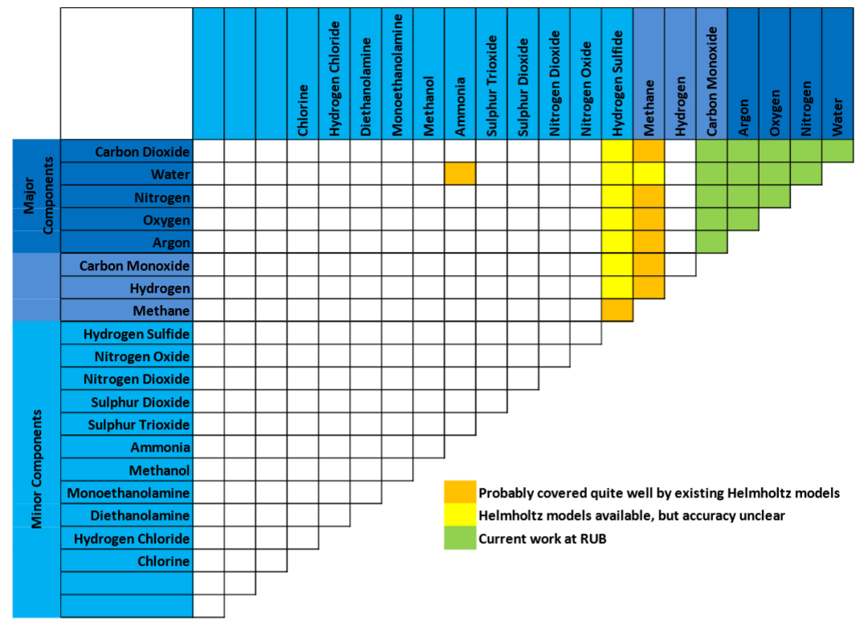

Figure 1: Matrix of CCS relevant binary mixtures, and status of reference models at the start of IMPACTS.

**WP1.2 – Thermophysical behaviour of CO2 mixtures**

An important part of IMPACTS was the experimental investigation of thermophysical properties of mixtures relevant for transport and storage of impure CO2 and on modelling of the corresponding properties. To achieve this experimental work have been executed at three locations.

Ruhr-University Bochum (RUB) executed density measurements in a dual sinker densitometer for the binary system CO2-Ar. Three isotherms (273.15 K, 298.15 K and 323.15 K), where measured at pressures up to 9 MPa. Three mixtures containing 50%, 75%, 95% CO2 where tested. CO2-H2 was measured in a single sinker densitometer. RUB used a re-entrant cavity resonator to measure dew points for the binary system CO2-Ar and CO2-H2.

Density measurements along three isotherms with pressures up to 9 MPa were planned. Industrial gases companies were not able to supply RUB with the binary mixture CH4-O2, with a methane mole fraction less than 0.95. CH4-O2 mixtures cold also not be created due to the probability to cross into the flammable region of the binary mixture. The experiments could therefore not be realized. Another planned mixture studied, CH4-CO reacted with nickel on the inner wall of the measurement cell.

Tsinghua University built a single-sinker densitometer and measured density for the systems CO2-N2, CO2-Ar, CO2-CH4, and CO2-Ar-N2. Density measurements were carried out at temperatures from 298.15 K to 423.15 K and with pressures from 2 MPa to 31 MPa. The relative combined expanded uncertainty in density was equal to or less than 0.20% (two standard deviations), except for points very close to the critical point. The new experimental data were compared to the GERG-2008 equation of state (EOS) for natural-gas mixtures as implemented in the NIST REFPROP database and to the EOS-CG as implemented in the TREND software package of Ruhr-University Bochum. Results have been published in leading international journals.

SINTEF has conducted vapor-liquid equilibrium (VLE) measurements for three binaries in an isothermal analytical method with a variable volume cell is used. The apparatus is capable of highly accurate measurements in terms of pressure, temperature and composition, also in the critical region. Vapor-liquid equilibrium (VLE) measurements for the binary system CO2+N2 are reported at 223, 270, 298 and 303 K. One of the isotherms is plotted in Figure 1, and it is seen when comparing the highly accurate IMPACTS data and GERG-2008 EOS that the current reference models have improvement potential in the critical region. Vapor-liquid equilibrium measurements for the binary system CO2+O2 are reported at 218, 233, 253, 273, 288 and 298 K.

All results have been, or are planned published in leading international journals.



Figure 2: Experimental VLE data for CO2-N2 at approximately 298.15 K. The IMPACTS data is labeled Westmann et al. A phase envelope is plotted for GERG-2008.

Based on the new experimental data, and other publicly available data, RUB has developed new reference equations of state for exhaust gases (EOS-CG), based on the same principle as the GERG equations for natural gas. The pure fluids are described using highly accurate Helmholtz based equation of state, and the interaction between different fluids are modelled using Helmholtz based binary interaction. The new IMPACTS data have improved the predictive capabilities of EOS-CG, especially for VLE in the critical region. EOS-CG has been distributed to the IMPACTS project members in its current version as TREND 2.0, including a graphical interface.

The thermodynamics group of RUB have developed new phase stability algorithm for up to three phases in equilibrium, enabling prediction of solid CO2 and solid H2O as well as of gas hydrates in equilibrium with fluid phases. For the first time, fluid phases in equilibrium with these solid phases can be described by means of Helmholtz equations of state. In TREND the user does not have to decide whether the calculation of a specified state point requires a hydrate or solid phase model but the algorithms automatically employ the adequate equations. This means a significant progress for the calculation of CCS processes where the prediction of such phase equilibria is one of the most challenging problems.

The complete mixture model, EOS-CG, now includes 14 components and consequently 91 binary mixtures. 55 new binary models were developed within this project whereas the remaining systems are described by published functions from EOS-CG and GERG-2008. See Figure XX for the current supported components of EOS-CG. Out of the new models 12 were described by fitting reducing parameters whereas the rest was implemented by means of simple combinations rules. The relatively high numbers of systems described with combination rules emphasizes the substantial need for accurate measurements. Without a significant extension of the experimental data base for CCS relevant mixtures a considerable improvement of the presented mixture model is not possible. A first Helmholtz explicit description for the reactive system of the nitrogen oxides nitric oxide (NO), nitrogen dioxide (NO2) and dinitrogen tetroxide (N2O4) was started. However, due to the complexity of this task, these components are not yet part of EOS-CG.

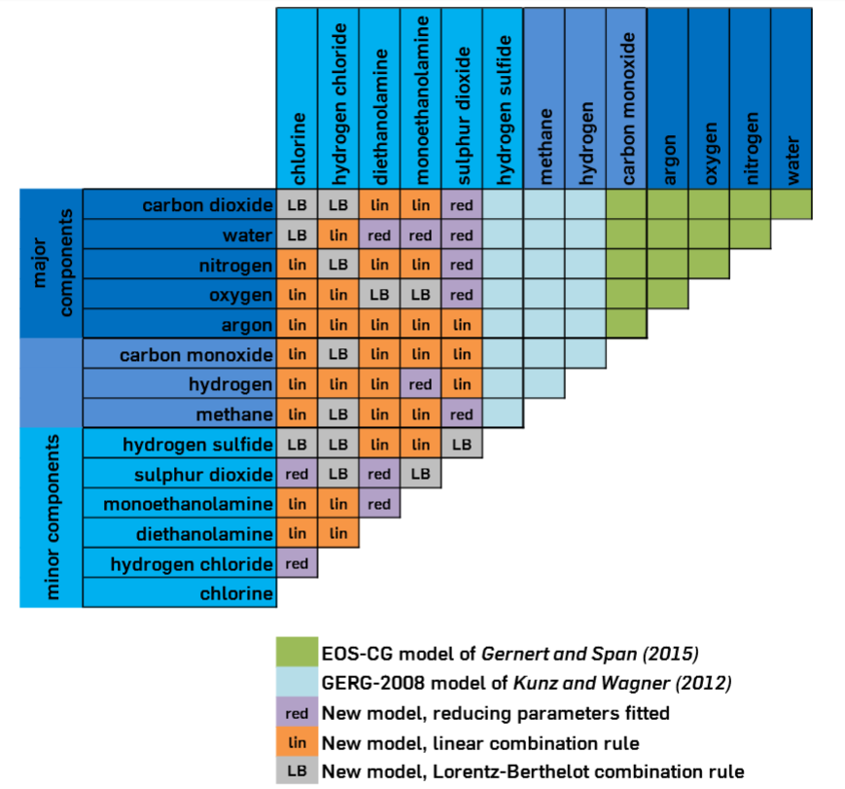

Figure 3: Current status of EOS-CG. EOS-CG can also calculate dry-ice, water ice and CO2 hydrates in equilibrium with fluid phases.

Existing models for transport properties (viscosity, thermal conductivity and diffusion) have been evaluated and compared with publicly available experimental data. The models where implemented and made available with an interface to MS Excel, enabling joint calculation with TREND. Since viscosity depends strongly on density, good predictions of viscosity require good prediction of density. Clear recommendations for the application of transport property models in engineering applications where given based on the model evaluation.

**WP1.3 – Transient fluid dynamics of CO2 mixtures**

The thermodynamic property model, EOS-CG, has been coupled to the SINTEF in-house CO2 multiphase pipeline flow simulation tool. The simulation tool solves the flow equations in the conserved variables density and energy, giving a difficult flash problem. Inclusion of the detailed reference equation of state has enabled comparison with the commonly used cubic equations of state, and the effect for different pipeline scenarios.

Three main flow scenarios have been studied for pipeline flow. Steady state pipeline flow, depressurisation of a pipeline to the atmosphere, and filling of a pipe previously at atmospheric pressure with a mixture of CO2 under pressure has been studied.

CO2 is most efficiently transported by pipeline in its liquid or supercritical form. This implies high operating pressures, in the order of 100 times atmospheric pressure. Steady state pressure drop in the super critical area is therefore important for CCS chain analysis and design of booster stations. In such a transport system, depressurisations may occur, either intentionally for shutdown or maintenance, or by accident due to leakage through a damaged section of the pipeline. In the event of such rapid depressurisations/expansions and boiling, a fluid will experience a rapid decrease in temperature (auto-refrigeration). Eventually, when all of the liquid has vaporized, and most of it has escaped the pipeline, the heat transfer from the surroundings will make the temperature start to increase again. The above implies that there is a certain minimum temperature occurring in the pipeline at some location and time.

The in-house code of SINTEF has been compared to the existing simulation tool OLGA, and to a three-dimensional simulation tool Fluent extended with the CSM in-house thermodynamics library for CO2 GASMISC. OLGA and the SINTEF code may serve overlapping purposes, while the three-dimensional tool is more useful for the study of local phenomena. The SINTEF code is designed to handle fast transients while OLGA is designed to capture slow moving transients.

The single phase pressure drop predicted for pure CO2 with the in-house SINTEF code and OLGA are similar, while Fluent predict a higher pressure drop. For levels of impurities below 2%, the differences in pressure drops are of the same order of magnitude as the uncertainties of the tools. Fluent is not able to calculate the two-phase cases for pipe depressurization or filling. OLGA and the SINTEF code give similar results for depressurization, but different results when filling the pipeline.

The results form depressurization experiments indicate that impurities do not increase the possibly harmful temperature drop experienced during pipeline depressurisation, see Figure 4. Still, the temperature drop during depressurisations is probably not a major concern when making techno-economic analysis/optimisation regarding impurities in the CCS chain.

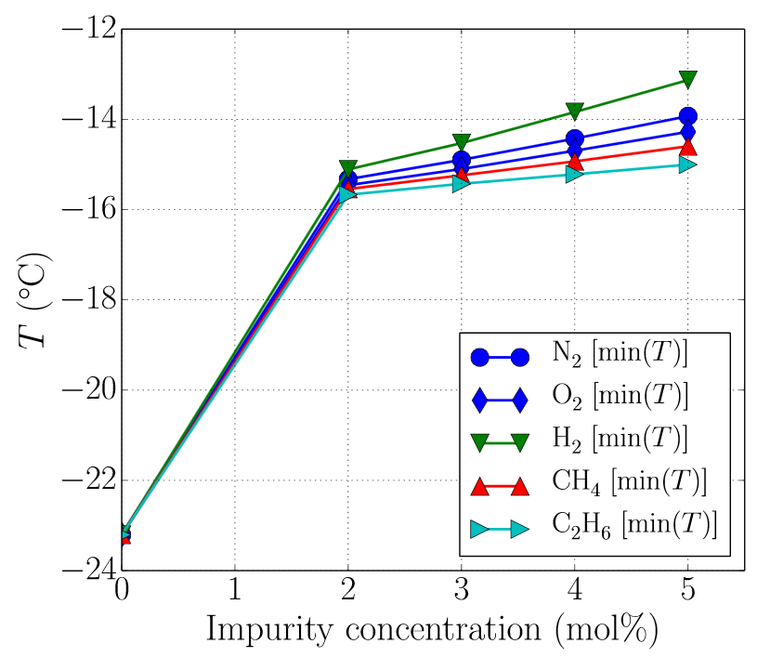

Figure 4: Minimum temperature during a controlled pipeline depressurization. Effect of impurity in the CO2 stream.

Results show that for decompression, the choice of thermodynamic model matters much less than the amount of other gases. When the amount of other gases is increased, the boiling pressure can increase significantly, which can increase the risk of running fractures, see Figure 5. For other CO2 pipeline considerations, however, the choice of thermodynamic model has larger impacts. This work also shows the superiority of EOS-CG for prediction of density and speed of sound, important when simulating fast transients, as with the initial rarefaction wave of a depressurization.



Figure 5: A comparison of the region where gas and liquid coexist as a function of temperature and pressure for pure CO2 (solid line), CO2 with 2% N2 (dotted fill), and CO2 with 2% H2 (hatched fill). Also shown is the temperature–pressure evolution of a decompression event from an initial liquid state of 100 bar and 20 °C. The saturation pressure is plotted with red dots. As seen, these impurities significantly increase the saturation pressure, and thus they increase the risk of running ductile fracture.

A tool that allows easy calculation of pressure drop in a pipeline and the corresponding pump/compressor needs has been developed to aid the techno-economic models. The tool utilizes EOS-CG and the viscosity models developed in IMPACTS.

**WP1.4 – Corrosion potentials in CO2 infrastructure**

To realize CCS, transporting large quantities of CO2 over long distances is required, and a likely scenario is pipeline CO2 transport. Carbon steels are the most economical materials for constructing pipelines, but corrosion issue should be further studied to assess their suitability to the purpose, in particular in wet CO2 streams containing different levels of impurities (e.g. O2, H2O, SOx, NOx, Ar, N2…).

A literature survey was conducted focusing on the experience of the oil and gas industry in environments containing CO2 and relevant impurities. Moreover a review of corrosion model was carried out, and an experimental plan was prepared.

Tsinghua University investigated uniform corrosion for X60, X65, X70 and X80 steels. Exposing the material samples to an environment of CO2, SO2, H2O and O2 for 72h in and 2.2L autoclave, the corrosion rates were determined in 10 different experiments. The experimental parameters were temperature, pressure, moisture and rotation rate of the sample. The SO2 and O2 impurity concentration was 3000 ppm and 1100 ppm, respectively. The H2O contents ranged from 1600 to 3000 ppm. And the temperatures ranged from 40 to 75 °C with pressures ranging from 8 to 12 MPa.

A weight loss method was applied to obtain the average corrosion rate. The samples product morphology was analysed by scanning electron microscopy (SEM) energy dispersive X-ray spectroscopy (EDS) and the elemental composition and crystallization of the corrosion product layers were detected by utilizing X-ray diffraction (XRD). 3D measuring laser microscope was also employed to examine sample surface and determine the localized corrosion after cleaning the product scale.

To investigate the resistance of materials and welds to the combined action of mechanical stress and corrosion environment an extensive stress corrosion testing campaign has been set up and carried out by Centro Sviluppo Materiali (CSM). CSM conducted stress corrosion tests using the four point bent beam method, see Figure 6. Four different pipeline materials, typically used for transport and storage of CO2, were investigated, X60, X60 welded, X65 and X70. Experiments were executed for eight test environments to investigate the effect of water, H2 and H2S at different concentrations in liquid or supercritical CO2. Water was present in all the environments (1000 or 3000 ppmv) while 100 ppmv of H2S were added in five out of the eight tests performed. H2 (100 ppmv) was also added in three tests and H2 (1000 ppmv) was added in one test. Temperature ranged from 25°C to 50°C and the pressure was equal to 120 bar.

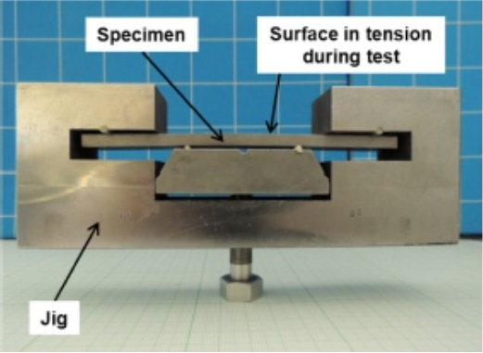

Figure 6: Example of stressed Four Point Bent Beam specimen.

The material samples were exposed for 720h and analyzed for Sulphide Stress Corrosion Cracking (SSC) and Stress Oriented Hydrogen Induced Corrosion (SOHIC). Both SSC and SOHIC was observed, but not for all samples. See Figure 7 for optical microscopy images showing SOHIC.

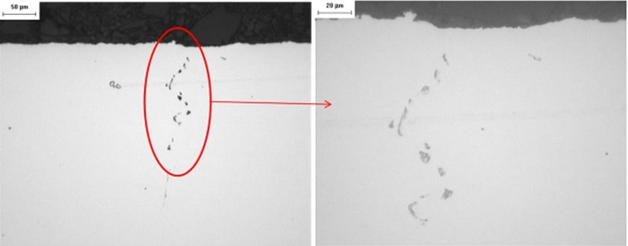

Figure 7: Optical microscopy images of the beam cross sections showing presence of SOHIC for an X60 steel.

**WP1.5 – Chemical and physical effects of impurities on CO2 storage**

Chemical and physical effects of impurities on CO2 storage in geological formations have been studied, with a focus on rock and seal cement from the Ketzin site (Germany) and the Hontomín site (Spain).The Ketzin aquifer is sandstone and the Hontomín aquifer a fractured carbonate reservoir. Batch experiments have been concluded studying the physicochemical processes that take place in a rock/seal-brine system where CO2 with impurities is introduced. The impurities SO2 and NO2 were studied at different pressures and temperatures relevant for the reservoirs. Both a static test and a dynamic test were the fluid flow through the sample was executed. Effect of the density, porosity and permeability of the rock/cement samples were measured.

The impact of impurities for the Ketzin and Hontomín site were investigated using a non-isothermal THOUGH code, extended with a new thermodynamics to handle CO2 with impurities. The potential effect of SO2, N2, H2, CH4 and O2 on storage capacity, of N2 and O2 on flow behavior during injection, and SO2 on geochemical reactions between the CO2 stream and the host rock, cap rock and wellbore cement, was investigated. The most important results showed that various impurities significantly lower the density of the gas, resulting in a potentially large decrease in storage capacity. This would imply that the costs for CO2 storage would increase. Yet, the effects of impurities on flow behaviour and geochemical reactions are small and most probably will not affect the efficiency or cost of CO2 storage.

**SP2 “Techno-economic Assessment of CO2 chains”** had the objective to use the results of fundamental experimental work from SP1, together with applied experiments on transport and storage and other public and partner knowledge, to assess the techno-economic impacts of CO2 mixture composition on the transport and storage infrastructure design and operation, and also to evaluate possible consequences for HSE and propose an assessment framework..

WP2.1 has the aim to investigate the operational and material effects of impurities relevant to the transport, injection and storage processes in CCS. Four reports were delivered by WP2.1: 1) Operational regimes and mixtures to be assessed for economic impact, which established the scope of the experimental work to be done. The report draws on the envelopes of anticipated operational regimes in the set of benchmark CCS chains which have been specified for the IMPACTS project. Within these conditions, specification of the range of impurities that could be expected to occur in operational CO2 mixtures has been carried out so that the impacts on flow or materials in the transport and in

the reservoir and storage parts of the chain can be assessed. The experimental and injection facilities available to the IMPACTS project are described. These

comprise injection facilities at both the Ketzin site in Germany and at Hotomin in Spain complemented by laboratory facilities in both countries, including specialist high-pressure permeameters and autoclaves with associated analytical equipment. A specially designed scale pipeline transport test facility is also to be used which includes a facility to include relevant material samples in the circuit. Carefully prepared CO2 with specific levels of impurities can be created and used in each facility. The conditions derived in the report will be used in the experimental work to derive actionable impacts data about the effects of impurities on transport and storage materials to other WP’s, in particular in the modelling and economic analysis in WP2.2.

2) Report on CO2 transport tests, giving details of the physical test rig and the testing programme with differing samples and CO2 mixtures and also reports the test results. One of the most relevant European R&D&d initiatives focused on Carbon Capture Utilization and Storage (CCUS) is the CIUDEN Carbon Capture and Storage Integral project, supported by the Spanish Government through the *Fundación Ciudad de la Energía* (CIUDEN). For the development of CCUS, once CO2 is captured it needs to be transported to the final location for its future use, or to the geological site where it will be safely stored. The most suitable way, from a technical and economical point of view, to transport high quantities of CO2 to long distances is doing it by pipeline, or ships in certain cases.

The transport by pipeline is usually performed in dense or supercritical phase. CIUDEN’s Technology Development Centre for CO2 Capture (es.CO2), holds the Experimental Facility for CO2 Transport. This rig is a pilot plant designed to be a reference for CO2 transport though pipelines. The facility aims to cover the aspects considered of interest in the field of CO2 transport and it intends to be a facility close to a real CO2 transport infrastructure. Within the IMPACTS Project it was performed a test campaign in the 1st quarter of 2015 for the study of the effects of impurities on the mechanical behaviour and corrosion of some materials, equipments and instrumentation.

There were also carried out depressurization tests. Different sessions were defined for varying main process parameters such as pressure, temperature and CO2 composition and considering different type of metallic materials for corrosion studies. The different CO2 qualities were prepared by doping several impurities (H2O, O2 and SO2) in the CO2 stream with a commercial quality, that is, of a CO2 purity > 99%. At CIUDEN’s facility it has been proved a reliable and safety operation of the transport rig when modifying the process parameters to meet the test conditions whatever the impurity was dosed in the CO2 stream. Corrosion rates measured by the rig’s instrumentation have been studied for different impurities mixtures in the system. It has been detected some difference in the trends between them but it is difficult to conclude clearly which are the tolerable levels of each impurity.

The data registered and the experiences gained during the campaign should provide basis for the development of large scale CO2 pipelines. However, in terms of material corrosion there would be recommendable to perform long-duration campaigns.

3) Report on lab tests to study the impurities effects under reservoir conditions, which gives information about the laboratory testing of various samples of reservoir rock, cap rock and sealing cement when subjected to a set of CO2 mixtures; 4) Report on field tests to study the impurities effects on CO2 storage behaviour, in which the initial injection tests are described and the resulting measurements set out. CIUDEN has performed short-term injection-extraction tests of CO2 with air (i.e. O2 and N2) in its Technology Development Plant located in Hontomín. Before the test campaign execution, CIUDEN simulated the results using its made-to-measure model previously developed in the frame of the IMPACTS project in order to interpret the experiments. In the field tests conducted in Hontomín Pilot , up to 150 tons of CO2 and synthetic air (5 % v of N2 and O2) were co-injected on fractured carbonates (i.e. Hontomín), comparing the operational parameters with the baseline where 1,500 tons of pure CO2 were injected during the reservoir hydraulic characterization. Besides this, the analysis of the geochemical reactivity of CO2 with impurities injected on the rock matrix and its correlation with the results from laboratory were done. To achieve these goals, during two months after injection, samples of fluids from reservoir were extracted using different DOT´s, being the gas phase analyzed in a MIR-FT whereas the liquid phase was analyzed using liquid chromatography.

Much of the information from the reports was an input to the techno-economic analysis in WP2.2.

WP2.2 had the aim to evaluate impacts of CO2 impurities on the technical performance and costs of CCS chains elements and produce economic trade-off proposals. Three key deliverables result from this part of the project: 1) Establishment of typical CCS chains and their parameters, which set out Benchmark chains to be used for further analysis and illustration; 2) CCS chain element parameters and performance variations due to the impact of impurities in the CO2 stream, which draws together the fundamental findings from various work packages in the rest of the IMPACTS project and makes use of them to drive techno-economic sensitivities in the analysis work. This report also describes the techno-economic model and how it is used.

**D2.2.2 and 2.2.3 CCS chain performance variations due to impurities**

This report draws together and presents results obtained within the IMPACTS project relating to the effects of impurities in the CO2 stream down a CCS chain in the areas of fluid flow, corrosion, injection, storage and safety. The focus is the application of these impurity effects on the design and operation of typical CCS transport and storage chains.

The report complements these technical results with estimates of the resulting changes to costs of equipment and operations of the Benchmark CCS chains adopted in the IMPACTS project. These Benchmark chains are designed to draw out important issues and illustrate the economic effects of impurities in certain typical conditions.

The Economic Model used in the IMPACTS project is described in order to explain how the model is used to look at the effects of varying the levels of impurities in the CO2 stream. A key element of this is the use of Cost Functions which essentially represent the way upstream or downstream costs are affected by the levels of impurity specified and the technical effects they create. Examples are given of how these Cost Functions are derived and used.

Below is a graphical representation of a complex CCS chain in the IMPACTS Economic Model. Cost functions related to the effects of impurities in each part of the chain can be defined by the user and are accumulated in the Model to arrive at overall CCS project costs.



IMPACTS Page iv

Public introduction (*)

The IMPACTS project is looking at the way various levels of impurity in the CO2 stream within a Carbon Capture and Storage (CCS) process affect the operation and cost of the whole system. Other reports from IMPACTS provide details of these fundamental effects.

The purpose of this report is to collect these effects together and look at their impact on the economics of the whole CCS process or chain. The chain consists of three basic elements: a capture process associated either with a power station or an industrial unit, a transport element to get the CO2 to where it will be stored – this may be a pipeline or ship transport or both - and a geological storage location where the CO2 is ultimately stored underground.

In order to look at the economics of the CCS chain, the report puts together costs associated with each of the CCS chain elements. Also, importantly, detailed costs are gathered relating to the effects that the various impurities have on various parts of the chain elements and their efficiencies and energy consumption. This is in order to allow an investigation of the change in costs associated with the impurities.

To establish economic effects on a CCS project a financial model is also required which can look for changes to the economics of a complete project over its full lifetime. This report provides an outline of the model used in IMPACTS and how it uses cost functions and flexes the impurity levels to look at the way the overall project costs vary with impurity level.

Below is a graphical representation of a complex CCS chain in the IMPACTS Economic Model. Cost functions related to the effects of impurities in each part of the chain can be defined by the user and are accumulated in the Model to arrive at overall CCS project costs.



This work is then the basis for looking at economic trade-offs to optimise the CCS chain operation. The results of this are contained in a further report.

(*) According to Deliverables list in Annex I, all restricted (RE) deliverables will contain an introduction that will be made public through the project Website

**D2.2.4 Techno-economic issues and trade-offs for CO2 purity in CCS chains**

|  |  |
| --- | --- |
| This report makes use of the effects of impurities in a captured CO2 stream which have been derived and collated elsewhere in the IMPACTS project. The financial consequences of these technical effects have also been derived in a previous report (D223) so that an analysis can be undertaken of the optimal financial level of impurities in a CCS (Carbon Capture and Storage) chain for any particular set of circumstances. This is called a Techno-economic (or TE) analysis.  The techno-economic analyses carried out within the IMPACTS project are performed using a specially written model derived from a standard economic model which has been adapted to include the detailed financial influences of impurities in the CO2 stream on typical CCS chains.  The IMPACTS CCS chain economic model is designed to allow the user to model the cost consequences of impurities in the CO2 stream flowing through a chosen CCS chain and to look at the economic consequences of varying the impurity levels within each capture module on the overall project economics for the chain. The model is written in Excel, chosen to make it readily accessible and adaptable by all partners and results are provided in tabular and graphical forms. The CCS chain to be modelled can be specified by the user and the model will do various continuity checks and provide a graphical representation of the chain for the user to check the model is correctly established. Typical outputs are standard economic measures such as the overall project return or the cost per tonne of capturing and storing CO2. These are derived for a range of level of impurity as specified by the user.  The main tool within the model to achieve this output is the use of Cost Functions which describe the way that the costs of each of the CCS chain elements change with differing levels of impurity in the CO2 stream. If the level of an impurity in the model varies from the standard benchmark level, the model uses the relevant Cost Functions to determine the changes in costs to be used and these are then incorporated into the overall project economic data. Cost Functions can reflect additional costs in providing a purer CO2 stream from the capture plant, or may also represent the costs of changing downstream materials or conditions to cope with impurities, such as using different qualities of steel, for example.  As an example, the graph below shows a trade-off curve for water content in the CO2. For the CCS chain used for this example lowest overall cost is obtained for a water level in the range of 250 – 350 ppmm. Reducing the water content to levels below this range leads to higher overall cost due to expensive water removal techniques, while more relaxed water level specifications require expensive corrosion resistant materials for transport and injection.     |  | | --- | | The results of running the model for a standard set of representative CCS chains are reported and resulting optimal economic balances between cleaning up the CO2 stream and dealing with the consequences optimal are set out. These optimised results and conclusions drawn from them contribute to the IMPACTS Toolbox and the overall IMPACTS project recommendations. | |

WP2.3 has the objective to develop a framework for CCS risk assessment taking HSE aspects, the impact of the quality of the CO2 and CCS chain integrity into account. Two reports were produced to cover this. The first report covered existing risk assessment practice, which reviews the relevant current practice for similar risk assessments;

The second report was on the framework for risk assessment of CO2 transport and storage infrastructure (D2.3.2) which develops ideas for an approach to risk assessment for CCS with explanatory reasons and the sets out the proposed framework with suggestions for how to go about such a risk assessment in differing circumstances. There is an urgent drive to implement Carbon Capture and Storage (CCS) on a commercial and global scale. For success this needs to be done in a demonstrably safe and responsible manner that gains widespread acceptance of stakeholders, most notably regulators and the public.

CO2 is a substance that has many everyday uses. However CO2, if inhaled in sufficiently high concentrations, can have toxicological effects on the human body. The hazardous aspect of CO2, combined with the very large quantities that will be contained within CCS systems create the potential that a leak from a CO2 system could pose a major accident hazard (MAH) (i.e. a hazard that could pose significant harm to humans or the environment). In addition, captured CO2 will not be 100% pure. The CO2 stream from capture plants will contain substances, referred to as stream impurities, such as CO, H2O, H2S, NOx, SOx, O2 and H2 that, although in very low levels, can change the properties of the CO2 stream and can change the likelihood and/or the consequences of CO2 system leaks.

The IMPACTS project looks into the impact of impurities in captured CO2, from power plants and other CO2-intensive industries, on CO2 transport and storage. The goal of this report is to provide a framework for risk assessment for CO2 transport, with particular focus on CO2 with impurities. As a first step in the development of the risk assessment framework an overview of guidelines, recommended practices, reports and projects related to the risk management within CCS was developed. Particular focus has been given to CO2 with impurities and to what extent the methods in use are sufficient for analysing and managing risk related to handling large quantities of impure CO2. The next step will be to utilise the framework assessing the impacts of impurities to the risk picture and ultimately to costs.

**SP3 "Syntheses and recommendations"** has the objective to synthesise the results of the project and to make them easily available to users, both the IMPACTS partners and the CCS community. SP3 covers Objectives 3 and 4 of the IMPACTS project. These objectives, as well as the project objectives of SP3, were all achieved during the second period of the IMPACTS project.

The report that can be seen as the final report from the IMPACTS project was completed in WP3.1: deliverable D3.1.2 ‘IMPACTS recommendations’ brings together results from SP1 and SP2 and derives recommendations for the handling of streams of captured CO2, given the impurities that are in the streams that affect the design and performance of elements of the CCS chain. In other words, D3.1.2 summarises and interprets the main results and deriving recommendations for safe and reliable design and operation of the CO2 infrastructure. Current industrial practice and recommendations for CO2 transport infrastructure exist, but these are often based on estimates and assumptions about the system. Better solutions and significant savings might be achieved if the knowledge base on CO2 mixture properties and behavior are improved. This is what IMPACTS aims to provide and the D3.1.2 report provides a number of general conclusions to this end. While the report does not aim to derive purity requirements or impurity limits, in line with the overall IMPACTS project, some guidelines regarding for example water content or hydrogen sulfide content were given. However, as a general conclusions, the report states that ‘*There is no easy, one-size-fits-all solution for how a CCS chain should be designed and how to set the limits for the concentrations of impurities*’. The synthesis of results obtained in the project also leads to the general conclusion that ‘*it is generally more economic to clean up the CO2 stream at capture (upstream) than to deal with significant downstream effects*’. This general conclusion is supported by specific results that were obtained in SP2 in the second period.

The setup of the report D3.1.2 was laid out in an earlier report, D3.1.1 ‘Framework for IMPACTS Recommendations’.

The third and final deliverable from WP3.1 is an investigation into the relation between CO2 purity and the capture side of a CCS project: D 3.1.3 ‘Impacts of impurities on capture side requirements’. This report presents input for a CCS chain-wide trade-off study by providing the relation between the purity of the CO2 delivered at the gate of the capture plant and the cost of achieving a certain level of purity. Three possible capture units (oxyfuel process, chilled ammonia process, advanced amine process) and one gas processing plant are considered. The relative cost savings or additional costs associated with a laxer or tighter CO2 product specification compared to the reference case are presented. The results can be used to establish the trade-off between the level of specific impurities (e.g., water), or a group of impurities (which are affected simultaneously by a purification process), and the cost of a CCS chain. (Such trade-offs are presented in the reports from WP2.2.) Interestingly, the report D3.1.3 also estimates the cost benefit, if any, of relaxing purity requirements. In some cases, such cost benefits do not exist.

In WP3.2 a second key deliverable from the IMPACTS project was delivered: the TREND software package. The IMPACTS project was initiated to understand the impact of impurities in CO2-rich mixtures on the CCS process chain. This aim requires various interdisciplinary contributions resulting from, e.g., process simulations, geological research, material science, or safety analyses. However, at a certain point all these efforts demand the knowledge of thermodynamic properties of the involved mixtures. Nowadays, the most accurate way to determine these properties is by means of empirical multiparameter equations of state. As a member of Work Package 1.2 (“Thermophysical behavior of CO2 mixtures”) the thermodynamics group of RUB (Ruhr-Universität Bochum) has been continuously developing an accurate equation of state for CO2-rich mixtures including components found to be relevant in CCS applications. In addition, new algorithms were developed to face the challenges of phase stability analyses and predictions of various phase equilibria including fluid phases as well as hydrates or solids of CO2 and water. It is not surprising that neither the application of these algorithms nor the calculation of thermodynamic properties from the equation of state can be individually handled by typical users. Consequently, a simple interface was generated that enables straightforward calculations based on these complex thermodynamic models and algorithms. While the technical work of generating the data on thermos-physical properties of CO2 mixtures was done in WP1.2, within Work Package 3.2 (“Technical knowledge base for CO2 transport and storage”) RUB has provided the software package TREND to the CCS community. Since 2009, this property package has been continuously improved and extended. The latest version 2.0.1 was generated within the IMPACTS project. It is available to the IMPACTS consortium, but also to the CCS community, through the RUB website. The TREND software has a user interface (for an example, see the figure below); the software can also be linked to other modelling software, so as to ensure the use of state-of-the-art knowledge of the properties of real or realistic CO2 mixtures in CCS chains or in elements of a CCS chain.



Figure 1: Example calculations of several relevant state properties within the TREND Excel interface for a multicomponent CO2 -rich mixture at given temperature and pressure.

Also developed in WP3.2 is the IMPACTS Toolbox. The IMPACTS Toolbox provides a comprehensive but accessible overview of the results of the project and its main conclusions. The IMPACTS Toolbox is an excellent starting point for further reading and research on the effects of impurities in the CO2 flow on the planning, design and operation of a CCS infrastructure. The toolbox shows highlights of new experimental data, thermodynamic reference models for CO2 mixtures relevant for CCS and the framework for CCS risk assessment taking into account HSE aspects, the impact of the quality of the CO2 and CCS chain integrity. The IMPACTS Toolbox is one of the main deliverables of the project, as far as dissemination of the results is concerned. It will be used by IMPACTS partners and other stakeholders in their daily business related to strategy, planning, design and operation of CCS. This deliverable has the form of a fully linked (with both internal and external links) pdf file, which allows for easy viewing. The pdf links to IMPACTS reports on the project website, for further in-depth reading on each of the highlighted results.

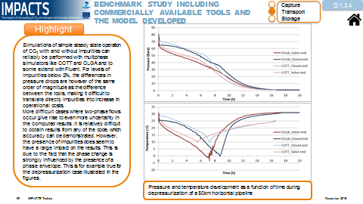

Figure 2: Examples of pages (slides) in the Toolbox. Typically, each page shows or describes one highlight, explains its background and relevance and provides links to the detailed report and contact details for further reference.

The focus of WP3.3 is active dissemination of results, through workshops and courses. The first deliverable from this WP was D3.3.1 and D3.3.2, the exploitation plan that describes the use of the results from the project by the project partners, after the project. D3.3.1

The purpose of this results exploitation plan is to enable an optimal dissemination and use of the results of the IMPACTS project. Publishing own results is a priority for all researchers. The purpose of this plan is to focus on joint activities for dissemination, knowledge sharing and utilisation of results. The plan describes the elements of results exploitation, including roles, responsibilities and timing.

The second part of WP3.3 was the organization of an IMPACTS workshop in parallel with the TCCS-8 conference in Trondheim, Norway, in June 2015. The aim of the workshop was to inform the CCS community on (most of) the final results from the project. Since the TCCS-8 conference is the largest CCS conference in Europe (held every two years), a workshop on the day just before the TCCS-8 event was assumed to be favourable for CCS stakeholders, preventing unnecessary travel. Representatives from the CCS industry attended the meeting.

The last element of WP3.3 was the organization of a CCS course in Romania. The course „The impact of the quality of CO2 on transport and storage behaviour” was held in Romania from 19 to 23 October 2015. The event was held at the International Conference Center and Central Library of the University Politehnica of Bucharest and was adjusted to the level of Master students. Nevertheless, the course was open for students, research institutes, regulatory authorities and people from industry.

The main objective of the course was to provide knowledge sharing to students and people from industry, based on the main results obtained during the implementation of IMPACTS project. In principle, all results from the IMPACTS project are relevant for CCS projects in Romania and surrounding countries.

The training course material was based on the IMPACTS toolbox, thermodynamic reference models for CO2 mixtures relevant for CCS and the framework for CCS risk assessment taking HSE aspects into account, the impact of the quality of the CO2 and CCS chain integrity, and finally the IMPACTS recommendations report.

The training sessions were organised in an interactive manner, facilitating a vivid dialogue with the audience; viewpoints and knowledge were exchanged between lecturers and trainees The IMPACTS CCS course was divided in ten (10) technical sessions based on the topics of the proposed lectures:

* Session 1: Models on thermodynamic properties and equilibrium;
* Session 2: Typical CO2 mixtures and operating conditions, transport and storage gap analysis, classification of CO2 impurities;
* Session 3: Typical CCS chains;
* Session 4: Corrosion of pipeline steels caused by CO2 mixtures;
* Session 5: The influence of CO2 mixture composition;
* Session 6: Techno-economic analyses of impacts of CO2 quality;
* Session 7: Operational and material effects of impurities in CO2 streams;
* Session 8: Chemical and physical effects of impurities on CO2 storage;
* Session 9: Risk assessment of CO2 transport and storage infrastructure;
* Session 10: IMPACTS recommendations.

A large number (43) of participants from Romania representing students and academia, research institutes, gas and oil industry, power sector and national regulatory authority formed the audience for the lectures kept by IMPACTS researchers from Ruhr-University Bochum (RUB), Germany; SINTEF Energy Research, Norway; Netherlands Organisation for Applied Scientific Research (TNO); Progressive Energy Ltd. (PEL), United Kingdom and Fundación Ciudad de la Energía (CIUDEN), Spain.