

Project no.043657

PAEPARD

Project title: Building up a platform for African –European Partnerships on Agricultural Research for Development

Instrument: FP6 Specific Support Action

Thematic Priority: Integrating and Strengthening the European Research Area, Specific Measures in Support of International Cooperation

Final project report

Period covered: from 1 April 2007 to 30 September 2008
Date of preparation: 26 August 2006

Start date of project: 1April 2008
Duration: 18 months

Project coordinator name: Monty P. Jones
Project coordinator organisation name: Forum for Agricultural Research in Africa
Report prepared by: Myra Wopereis-Pura and Jacky Ganry

Revision [draft 1]
Table of Contents
Introduction 5
Project Objective 6
Project approach and methodologies 7
Workpackage achievements 8
Workpackage 1: Assessment of European and African past and existing cooperation on ARD 8
Proposed activity 8
Results and discussions 9
WP1 Conclusions and recommendations 16
Workpackage 2: Consultation on priorities, opportunities and mechanisms for the building-up of the Platform for African-European partnership on ARD 17
Proposed activity 17
Results and discussions 17
WP2 conclusion and recommendations 19
Workpackage 3: Set-up and launch the Platform for African-European partnership on ARD 21
Proposed activity 21
Results and discussions 21
Workpackage 4: Develop an information and communication strategy for promoting participation of ARD stakeholders from Europe and Africa in the platform 27
Proposed activity 27
Results and Discussions 28
WP4 conclusion and recommendations 30
Conclusion and recommendation of PAEPARD phase 1 31

Executive Summary
The African (FARA) and European (EFARD) fora for agricultural research in Africa in recognizes the contributions of agricultural research in achieving of the Millennium Development Goals. Therefore a platform for African-European partnership on agricultural research for development (PAEPARD) was established. The general objective of the platform is to enhance collaboration among the European and African Agricultural research for development (ARD) stakeholders by enabling mutual learning and knowledge sharing and, increasing the number and the efficiency of joint research projects for African agricultural development financed through the incoming FP7 and EDF10. The specific objectives are; i) to analyze, assess and capitalize on past and existing European-African ARD cooperation and use of corresponding instruments of partnerships (i.e. EDF9, FP6,); ii) to identify between African and European stakeholders, priorities, opportunities and mechanisms for building-up a platform for the African-European partnership on ARD; iii) to set-up and launch a platform for the African-European partnership on ARD and; iv) to develop an information and communication strategy for promoting participation of ARD stakeholders from Europe and Africa in the platform.
The main partners/contractors are the Forum for Agricultural Research in Africa (FARA) and the European Forum on Agricultural Research for Development (EFARD), through two of its institutional networks, ECART and NATURA.
An assessment was made on selected African–European partnerships in ARD with EC-funding, complemented by an online survey of European and African stakeholders (PAEPARD report, 2007). The main findings indicate that partnerships are valued by the European and African partners as relevant and contribute to achieving their global institutional objectives. However, there are major constraints to ensure continued success and inclusiveness of ARD partnerships. The study shows that there is small number of EC-funded agricultural research projects focused on Africa, and these projects involve African institutions from only 2-3 countries. Most of these partnerships are driven by the European partners with limited contribution by African partners in priority setting and management. Under FP7 – where the former INCO-DEV component has disappeared – scope for such collaborations has decreased rather than increased. The full report is found at the project website.

Three consultation workshops were held in Africa. The first was a side-event at the FARA general Assembly in June 2007. . This consultation provided an opportunity for European and African potential partners to discuss and share their experiences on ARD partnerships, including the experience of the subregional research organizations (ASARECA, CORAF/WECARD, SADC-FANR) management of the EC competitive funding mechanism. The conclusion was that partnerships supported by the EC are appreciated but that competitive mechanisms is very limiting for weaker NARS who need extra support. Partnership with civil society organizations can ensure that research is relevant. Priorities atthe national/regional/continental levelshould be taken into consideration when responding to calls for research proposals.

Two other consultations were held at sub-regional level. Each combined two regions i.e. West, Central and Northern Africa and Southern, Central and Eastern Africa. Both consultations confirmed the value of PAEPARD. It highlighted the importance of PAEPARD as a platform to link Africa and Europe creating a community of practice among scientists, extension, farmers, NGO, private sector and government officials. Major restrictions identified by European and African stakeholders in ARD partnerships are (1) lack of information and knowledge on funding opportunities, difficulties in finding adequate partners, as well as full understanding of the complex and elaborate mechanisms of fund raising; (2) concentration of partnerships on only two institutional categories of actors (universities and national research institutes), with very limited participation from private sector, extension/advisory services and civil society organizations (CSOs) (e.g. farmer organisations); (3) existing EC funded coordination mechanisms are not maximizing their role in facilitating interaction between different stakeholders; (4) European institutes who are more familiar with the EC mechanisms are the initiators of the partnerships and tend to be the coordinators of EC-funded projects; (5) dissemination of innovations is valued least amongst the outcomes of research partnerships as compared to publications, training and access to funding; and (6) the EC instruments that support ARD are difficult to access by African partners, and their administrative and financial rules are difficult to follow. See workshop reports at the project website.

The project made good progress in identifying constraints to increase and strengthen African-European ARD collaboration through consultations, and in developing an “Information and Communication Strategy to promote partnerships of ARD stakeholders from Europe and Africa”. In terms of project management, the project suggests that (a) bringing on board non-scientist research stakeholders requires a concerted effort and involvement of relevant and experienced partners in building multi-stakeholder innovation platforms, and (b) a full-time project coordinator each in Africa and Europe is required to ensure that the proposed PAEPARD II can handle more complex arrangements which involve CSOs.

The lessons learnt from the project is a designof European-African platform, which strongly emphasise on more inclusive research partnerships with relevant non-research stakeholders. Findings of the projects including analysis of other initiatives have shown that real partnerships need neutral intermediaries, who can facilitate communication and assist in the formulation of inclusive and mutually beneficial initiatives. PAEPARD consultations identified the need for mechanisms and resources to facilitate dynamic partnerships, and effective information system that can deliver relevant and timely information on funding opportunities that the partnerships can utilise. A better coordinated European ARD community with well articulated programs easily understood by potential non-European partners, would make it easier to forge partnerships that have the relevant set of skills and knowledge to produce the much needed innovations for poverty reduction and environmental sustainability. Finally, successful partnership in agricultural research is not only a question of representation but also a question of how various research and non-research actors are involved in the research project conceptualization, implementation and evaluation.

The platform was launched in Accra on 30 September, where PAEPARD phase 2 was presented and discussed. The final product was submitted to the EC for support under the FSTP instrument. A PAEPARD website is current hosted by FARA at http://www.fara-africa.org/networking-support-projects/paepard/.

Introduction
With only 9 years to go, Africa is well behind schedule for achieving the Millennium Development Goals of halving poverty by 2015. This is partly due to the poor performance of the agricultural sector. The region’s average per capita income is among the lowest in the world; almost half of the continent’s 700 million people live on less than one dollar per day. The rural areas, where agriculture is the mainstay for all people, support around 70-80 percent of the total population. Improvement in agricultural performance has the potential to increase rural incomes and purchasing power for large numbers of people.

Research and innovation in agriculture is essential to increase African productivity through integrated and sustainable management of natural resources and for biodiversity conservation, which are essential for attaining MDG 7 (Ensure environmental sustainability).

Agricultural Research for Development (ARD) contributes indirectly to the attainment of MDG 2 (increased income), MDG3 (stronger political voice and greater income opportunities), MDG 4, 5 and 6 (improved nutrition, increased income and improved physical labour conditions).

This proposal is relevant also for MDG 8, in terms of the development of equitable multi-stakeholder partnerships and capacity building.

Africa could achieve this with African leadership through the New Partnership for Africa’s Development (NEPAD). NEPAD declared agriculture as the engine for economic growth and developed the Comprehensive African Agricultural Development Programme (CAADP), as a framework to achieve increased agricultural productivity. The Forum for Agricultural Research in Africa (FARA) is delegated by NEPAD to assist in coordinating ARD at the pan-African level (i.e. CAADP pillar 4: technology generation, dissemination and adoption).

In turn, the EU Strategy for Africa (Towards a Euro-Africa pact to accelerate Africa’s development) places emphasis on boosting economic growth and investing in people in the continent. African agricultural research is one of the key areas identified that could assist. The EU targets specific-support on increasing the competitiveness and productivity of African agriculture “through the strengthening of pro-poor, demand-driven agricultural research and extension, in particular by promoting research collaboration between the European and African research communities” and “by supporting regional research coordination mechanisms”. The strategy also indicates priority areas in the field of environmental sustainability which are relevant for ARD: improve sustainable territorial management, manage environmental diversity, stop desertification and improve sustainable land management, conserve biodiversity, support the sound management of chemicals.

The European Commission met representatives of African science academies, ministries and embassies on 6 February 2006 to address the practicalities of establishing closer cooperation in science and technology. The debate addressed the challenges of participation in EU programmes, capacity-building in Africa and ethical aspects of research in developing countries, as well as the opportunities represented by the Seventh Framework Programme (FP7). During the meeting, the European-South African Science and Technology Advancement Program (ESASTAP) was introduced as an example of an FP6 support action that facilitates the networking and partnership. There was a consensus that there is a demand to extend such initiative, with a broader geographic scope.

Europe has a long tradition and a great variety in international scientific and technical cooperation in African ARD. ARD activities are implemented either through bilateral or multi-lateral cooperation mechanisms. Cooperation is usually based on direct technical assistance, financial support to institutions and/or programmes, fellowships for graduate and professional training, technical support to develop information and communication technologies (ICTs) on a project and case-by-case basis. These activities made valuable contributions but there is a clear need for extending and enhancing the cooperation to gain more impact.

The main limitations to develop ARD cooperation were supposed to be: i) lack of awareness and information about the opportunities offered by different financial instruments; ii) non sufficient commitment of key African and European actors; and iii) absence of comprehensive and effective consultation and coordination mechanism between the African and European ARD communities.

The project was to confirm and address these limitations by facilitating and advocating for “concentrated support towards regional research structures addressing common problems in an efficient manner” as recommended by the EU strategy for ARD and EU’s Strategy for Africa.

Learning from the Global Forum for Agricultural Research (GFAR) experience that a multi-stakeholder approach is key to have impact, the proposed platform goes beyond research institutions to include civil societies as key partners in ARD. It will also include small and medium enterprises with grass root connections at the village, local and national level. It will also tap the resources of European private sector business with interests in African agriculture. This kind of diverse partnership requires harmonization of efforts and resources to achieve a common goal and attain high impact.

Project Objective
The purpose is to enhance collaboration among the European and African ARD stakeholders by enabling mutual learning and knowledge sharing and, increasing the number and the efficiency of joint research projects for African agricultural development aimed at achieving the MDGs, financed through the incoming FP7 and EDF10.

The specific objectives are;
- to analyze, assess and capitalize on past and existing European-African ARD cooperation and use of corresponding instruments of partnerships (i.e. EDF9, FP6,);
- to identify between African and European stakeholders, priorities, opportunities and mechanisms for building-up a platform for the African-European partnership on ARD;
- to set-up and launch a platform for the African-European partnership on ARD;
- to develop an information and communication strategy for promoting participation of ARD stakeholders from Europe and Africa in the platform.

Project approach and methodologies

The project was coordinated by the Forum for Agricultural Research in Africa (FARA) with the European Forum for Agricultural Research in Africa (EFARD). Activities were implemented by FARA and with 2 designated European network mandated by EFARD i.e. European partners European consortium for Agriculture Research in the Tropics (ECART) and Network of European Agricultural (Tropically and Subtropically oriented) Universities and Scientific Complexes Related with Agricultural Development (NATURA).

The expected outcomes of the present proposals are:
- Closer and more strategic cooperation between Africa and Europe on Science and technology, particularly on ARD, for addressing the MDGs
- African ARD stakeholders participating effectively in European initiatives geared towards Africa’s economic development i.e. EU Strategy for Africa, FP7 and EDF 10.
- More effective implementation of European programmes for Africa’s economic development
- More effective implementation of NEPADs CAADP.

The implementation plan was articulated in four workpackages for support actions, plus one workpackage for management activities, for a total of five workpackages:

- Assessment of European and African past and existing cooperation on ARD
- Consultation on priorities, opportunities and mechanisms for the building-up of the Platform for African-European partnership on ARD
- Set-up and launch the Platform for African-European partnership on ARD
- Develop an information and communication strategy for promoting participation of ARD stakeholders from Europe and Africa in the platform
- Management and coordination activities

Activities related with workpackages 4 and 5 was carried out in parallel during the entire duration of the project. Activities related to workpackages 1, 2 and 3 were carried out in sequence.

The overall methodology for the implementation followed some guiding principles:
- ownership: following the EU commitment to the principle of ownership of development strategies;
- partnership: sharing of responsibilities between the two main partners (FARA and EFARD)
- in-depth policy dialogue: continuous dialogue between the partners, their constituencies, the European Commission and EIARD;
- participation of civil society: broad participation of non-research and non-state ARD stakeholders;
- gender equality: promotion of gender equality in setting up the partnership agenda

The project through FARA and EFARD collaborated with the main regional organizations for ARD in Africa and Europe. These fora have stakeholders covering not just research institutions, but also include universities, the civil society organizations such as NGOs, private enterprises and farmer’s organizations. Each of the fora has formal and informal communication networks or systems. FARA has biennial general assemblies, regular thematic consultation with the SROs and its stakeholders, as well as regular publication materials such as FARA News, annual reports. EFARD has several networks including ECART and NATURA who in turn have their General Assemblies and publications materials. The project used these fora websites and channels of communication, as well as publications to share its outputs and knowledge acquired.

The knowledge created during the project is contributing to the FARA’s networking support function focused on partnerships and strategic alliances and improving access to knowledge and technology dissemination. The knowledge and understanding of each of the continent’s ARD landscape increased the capacity to form and develop new partnerships as well as influencing the EC ARD program planning for 2009. The report of the African-European consultation on ARD program planning for EC can be found at the project website.

After 18 months of execution, the project has achieved all its objectives which are presented here according to its designed workpackages.

Workpackage achievements

Workpackage 1: Assessment of European and African past and existing cooperation on ARD

The objective of the workpackage is to analyze, assess and capitalize on past and existing European –African ARD cooperation and use of corresponding instruments of partnerships such as EDF9 and FP6.

Proposed activity
The Assessment will be carried out through the analysis of a selected number of case-studies, useful to draw lessons for the building-up of the platform, taking into account different geographic and thematic areas. The specific terms of reference of the study will be formulated through an electronic consultation involving the interested stakeholders. The assessment will start taking stock from other studies such as the NARS assessment of FARA, the Inter-Academy Council (IAC) report on African ARD, the ERA-ARD Mapping exercise of national ARD programs financed by European member states, the FP6 and EDF9 data-bases, the INCO evaluation report. The assessment will make use of existing directories and networks that list ARD institutions, experts and programmes.

The study will look at:
- the EU funded activities through different instruments and programs (framework programs, EDF, etc), including the competitive grants schemes at the subregional level to enhance regional collaboration in the ASARECA, CORAF and SADC/FANR regions . An analysis of how this mechanism is impacting research programmes or making the national system more competitive in initiating collaboration with partners out of the region, could also inform the design of the proposed European-African platform;
- the SubSaharan Africa Challenge Program which is designed to build-up an innovation system approach in the region;
- the actual level of mobility of researchers in the two directions and the potential risk of brain drain;
- the needs, gaps and opportunities in the field of capacity development, at the scientific and technical level and at the research management level, including monitoring and evaluation systems and impact assessment.

The assessment will develop recommendations focusing on the proposed platform mechanism. The Specific Programme “Cooperation” for the implementation of the 7th Framework Programme (2007-2013) of the European Community for research, technological development and demonstration activities, the European Strategy for Africa: towards a Euro-African pact to accelerate Africa’s development, the EDF10 (2008-2012) should be seen as guides on how the mechanism could work, coupled with the NEPAD’s Comprehensive African Agricultural Development Programme (CAADP). These documents will be seen as the framework to guide the proposed platform. The newly launched European-South African Science and Technology Advancement Programme (ESASTAP) will be looked at as a possible model.

As the assessment report is drafted and finalized, it will be presented to both European and African partners at a trans-continental consultative workshop. The workshop will be convened by FARA and EFARD, with participation of representatives of their respective constituencies (research, universities, NGOs, private sector, farmers organizations, etc). Where the assessment identifies ongoing successful partnerships or potential models for the platform, the participants will be invited to share their experiences and lessons learnt and discuss the final recommendations of the study.

Results and discussions

Online survey
The assessment was initiated through an online consultation and survey conducted from 1 July 2007 – 15 December 2007. The online survey was posted using online survey software called surveymonkey. A message was sent using FARA and EFARD database of its stakeholders, such as the Infosys+ which contains both the European and African ARD stakeholders. In addition, FARA members who attend its General Assembly were included in the list. Other networks linked to FARA and EFARD were also used.

Two questionnaires were formulated to fit into the African and European perspective. It distinguishes the stakeholders into two, those who had history of cross-continental partnership and those who are yet to find partnerships. The survey further look into the depth of engagement in partnerships, it’s efficiency, quality and value addition. Respondents were further asked to share their challenges and solutions taken during the partnership implementation.

There were 113 respondents from 600 addresses in Africa and 94 respondents out of 300 in Europe. Africa got only 19% responses while Europe got 31 % of their total target population. The respondents were spread through 14 European countries and 30 African countries (see Figure 1). The respondents were equally spread in Africa (Figure 1a). While in Europe majority of the responses were from the France, Netherlands, Denmark, UK and Belgium (Figure 1b). In Africa most of the respondents were from research (50%) and universities (19%), although there were few from private sector, farmer’s organizations, network and NGOs (See Table 1). In Europe majority of the respondents were from the Universities (36%) and research (22%). There was a significant number from the private sector at 19%, followed by NGOs with few farmer’s organization and government bodies.

Of the total respondents, 23% from Europe did not yet have partnerships while 32% from Africa. Partnership is quantified as having conducted an activity with another institution across the continent (Europe and Africa) to achieve their own institutional objectives.

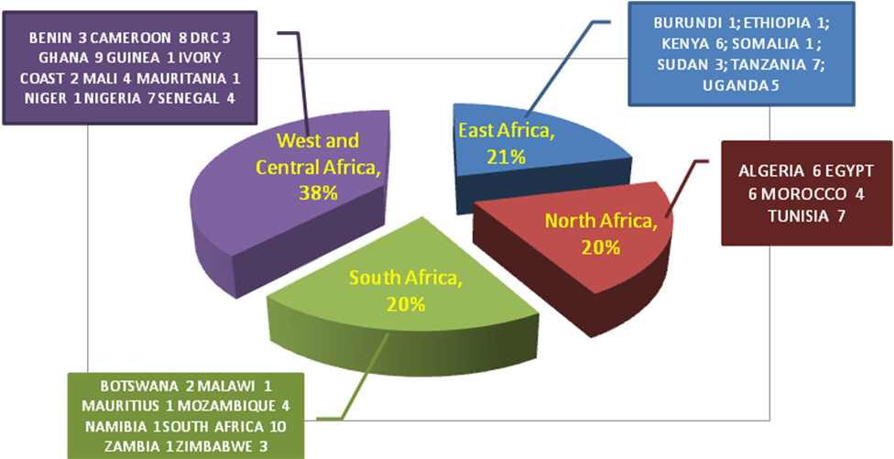
Figure 1a. Spread of respondents in Africa.

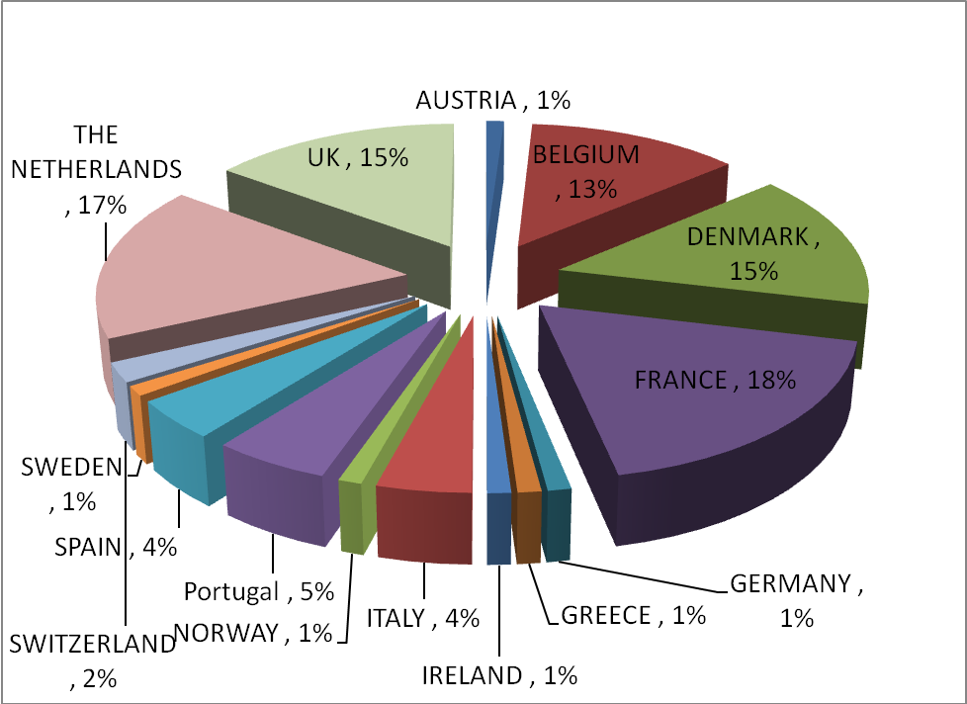

Figure 1b. Spread of respondents in Europe.

Table 1. Categories of online survey respondents.
Category | Africa | Africa (%) | Europe | Europe (%)
NGO | 8 | 7% | 10 | 11%
University | 21 | 19% | 34 | 36%
Research Institute | 56 | 50% | 21 | 22%
Private sector | 11 | 10% | 18 | 19%
Farmers' association | 4 | 4% | 1 | 1%
Network | 8 | 7% | 4 | 4%
Government bodies | 4 | 4% | 5 | 5%
Others | 1 | 1% | 1 | 1%
Total | 113 | 100 | 94 | 100

The respondents who are engaged in partnership with Europe and vis versa, were commonly advancing African agricultural development which is aligned to its institutional objectives (49%). Majority had already long institutional tradition (35%) of partnership with Europe or Africa. European respondents see the partnership as a means to disseminate their research products while most of the African respondents see the partnership as a source to acquire funding. Most are engaged in bilateral partnerships between research-research (40%) or university – university (39%) and sometimes mixed between the two categories. There were very rare occasion of partnerships engaging NGOs (17%), Private sector (14%) and farmer’s organization (11%).

The respondents in their individual capacity contacted partners thorugh their institutional linkages (35%) and personal contacts (42%). At the time of the survey, very few acknowledged the role of facilitating institutions to find the right partners. The facilitating organizations were seen as too general lacking the specialized knowledge to engage in negotiation between institutions. See Table 2 for details.

Table 2. Channels of finding partners.
Means of contacts | Europe (%) | Africa (%)
Use of traditional institutional linkages | 33 | 31
Use of existing Personal contacts | 39 | 35
Contacted by European/African institutions | 19 | 23
Use of internet search | 2 | 2
Use of facilitation organizations or brokers | 11 | 11

The common reasons in Europe and Africa for entering into partnerships are to generate new knowledge or knowledge exchange, degree training and source of funding. A significant number of European respondents entered into partnerships for social and economic benefits. See Figure 2. The research themes were mostly on crop management and genetic and livestock improvement. There were few research on policies and market, socio-cultural science and economics/markets. The outputs of the partnership were mainly increased research publications (46% Europe for and 48% for Africa), knowledge and adaptation of tools and methodologies (28% for Europe and 35% Africa for), degree training (35% Europe, 42% Africa) and increased access to funding 28% Europe and 36% Africa).

Most of the partnerships were supported by project funding coordinated by European partners. The African respondents felt they were engaged more at the proposal development and not at the final submission of the proposals. Although all the respondents confirmed that in all partnerships, its objectives were aligned to their own institutional objectives. Most of the proposals developed were successfully funded. In cases where projects were not successful, the main reason was rejection in the selection process by the donors.

At the project implementation stage, communication exchange were maintained adequately all throughout. Most respondents use email (35%) to communicate almost in a monthly basis, with quarterly (14%) and yearly (22%) face to face meetings. Video conferencing is very rare and use of telephone is once a month (17%). Although not all objectives of the partnerships are always achieved. In most cases (32%) results indicate further research or extension of projects. All unanimously confirm the added value of cross-continental partnership and willingness to continue collaboration.

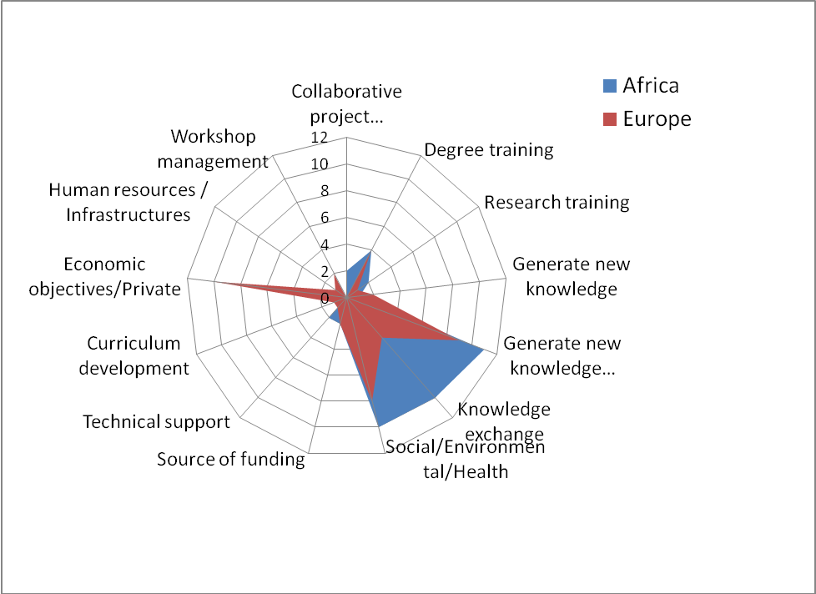
Figure 2. Objectives for entering partnerships.

The respondents saw PAEPARD as a platform to facilitate communication with donors (40%), linkages with the right partners (39%) and capacity building support to write proposals (34%). There were few respondents (23%) who expect PAEPARD to strengthen their capacity to address research themes or maintain resources. Both the European and African respondents agree that funding can be improved if there is better definition of priorities and distribution of tasks. Other areas that can be improved to increase resources include, better coordination and harmonization of partnerships, improve proposal development skills (proposal writing) and ability to respond to calls for proposal. Support should be given to long term partnerships taking into account time required to settle institutional arrangements in cross-continental partnerships. Sometimes donors are pressed for results when research requires longer time to achieve results.

Respondents who did not have any cross-continental partnerships are mainly due to unawareness of opportunities. Given the opportunity, they have the same objectives for entering partnerships as described above.

Desk review and analysis

A desk review was conducted looking into existing and relevant studies and reports on ARD in Africa. All the studies showed that agriculture, dominated by small-scale farmers, is contributing at least 20% to the African countries GDP. Various studies highlighted the importance of agriculture in economic development in Africa as well as the high rates of return of ARD. Despite such findings, agriculture and agricultural research are very poorly considered in FP6 and EDF9. Generally investments are still very low from the African governments, development partners and private sector. Such poor investments results to limited capacities in research (density of researchers per population more than 65 times smaller compared to the North European countries) and fragmented African ARD.

The studies call for interventions that can create centres of excellence linked to appropriate knowledge sources outside Africa, and particularly in Europe, but with reduced dependency, promote joint research actions and demand – driven approach linked to the Millenium Development Goals (MDGs), capacity strengthening at all levels and in all areas and improved networking and facilitation of partnerships.

A further analysis was conducted on FP6, EDF9 and FSTP support to African ARD within the period of 2005-2007. Data were derived from EC Cordis information system, internal project database of DG Research and interviews with officers in Directorate Research and EuropeAid/AidCo of the European Commission.
The European Commission through its funding mechanisms on research (i.e. Framework 6) and development (EDF9, EDF10 and FSTP) allocates very small amount to African Agriculture and Agricultural research.

The total amount of projects in FP6 is more than 10,000 but only 3,856 projects are potentially relevant for sectors concerning Africa. The analysis did include the 4,630 Mobility Projects as they were not opened to Africa.

Under these 3,856 projects, International cooperation (INCO) supported 387 projects but only 114 (30%) were for Food, Agriculture and Biotechnology (FAB) and within FP6 INCO FAB only 58 (15% of total) projects are giving direct support to Africa. The total financial support for INCO FAB of which the data was analyzed was 67 million euros. The average contribution per project varies from 80,000 to 4.9 million euros with an average of 1.1 million euros. Out of INCO within the FP6 FAB, Africa gets only 61 projects which is an almost negligible percentage of 1.6%. In this case, the average project fund is 2 million euro with a maximum 6 million euros, but with numerous partners including African partners who are a minority. Most of these projects are coordinated by European countries, mainly the France (20), Denmark (18), UK (17) and Italy (14). The participating countries are more spread across Europe including Eastern European countries. See Figure 3.

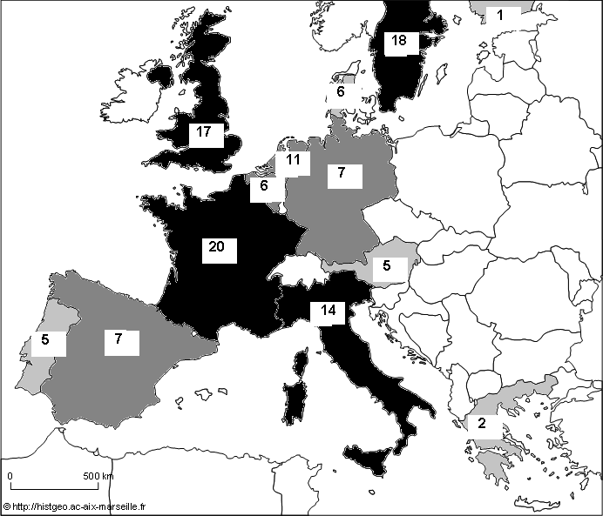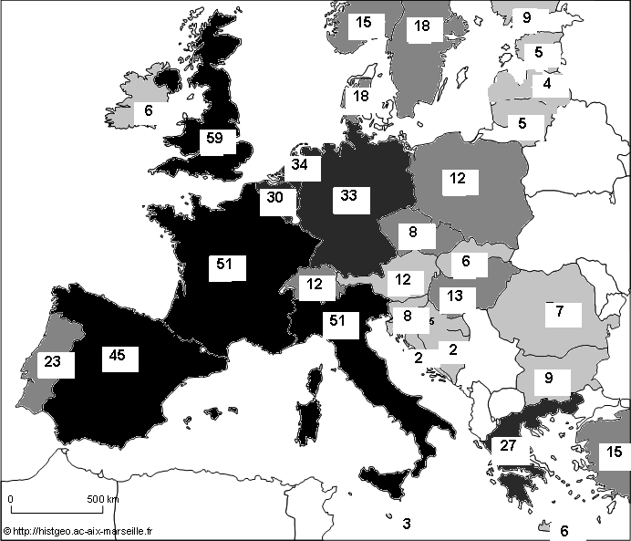
Figure 3a. Number of European countries coordinating EC funded projects in FP6 | Figure 3b. Number of European countries participating in FP6.

- There has been no African institution, except one from South Africa, that led any FP6 FAB or INCO projects based on the data analysed. Participating African countries vary based on the funding mechanisms used. There is marked increased in numbers through the international cooperation support (See Figure 4a and 4b).
- There is an unbalanced participation of African countries The top African countries participating were South Africa, Morocco, Tunisia and Egypt. The second group of countries were Kenya, Uganda, Tanzania, Senegal, Mali and Ghana. The others are still too low in numbers to compete.
- When it exists, the participation of institutions is unbalanced inside the countries. The same institutions are often in several projects when at the same time other institutions and universities are never present ( it was verified during the FAFB brokerage Meeting on 28-30th Nov, 2007 in Brussels for countries like Tunisia, Egypt, Morocco.
- There are very few SMEs or civil society’s members in existing projects

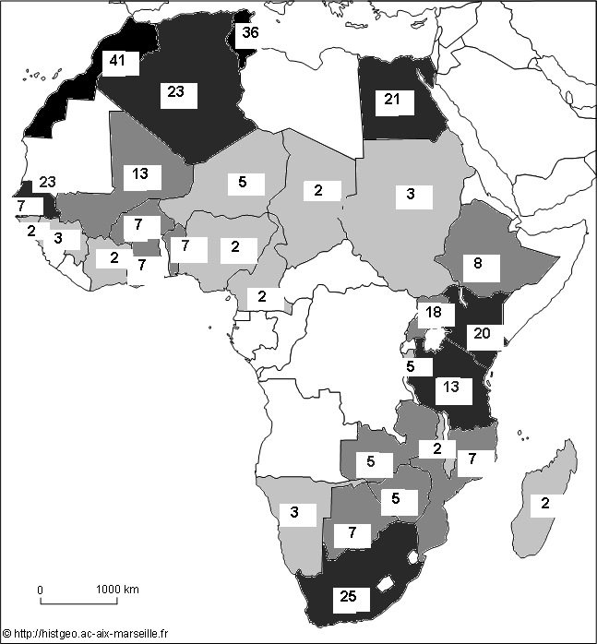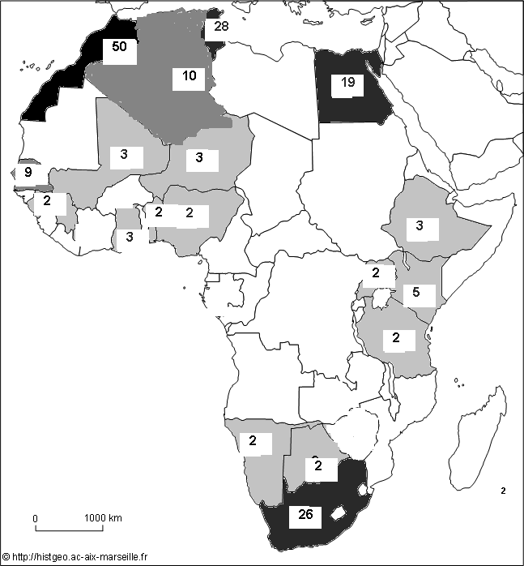
Figure 4a. Number of African countries participating with INCO in FP6. | Figure 4b. Number of African countries participating without INCO in FP6.

- The themes of the projects supported are shown in Table 3. Majority of is supporting sustainable development in agriculture in particular natural resource and crop management. Other areas of support are in plant and crops improvement, animal science and food security and safety. But there is a lack of themes properly dealing with the needs of African countries out of INCO

The EDF9 funding mechanisms support projects at various levels (See Table 4). Some information were taken to show the spread of investments at various levels. There is increased support at regional level through the competitive funding mechanism.
Support to the CGIAR centres are through their global funding mechanism under Food Security Budget Line (FSBL) which has now been changed to Food Security Thematic Program (FSTP). Looking specifically at the CGIAR contribution, 35% goes to Africa.

At the time of PAEPARD phase 1, the EC funding mechanisms were undergoing an evolution. The European Union recognized the importance of Africa and its agriculture (European consensus, 2005; EU strategy for Africa, 2007 and Communicating on Advancing African Agriculture - AAA, 2007). In all instances, agricultural research for development is recognized as a key component of innovation and driver for development (Joint Africa-EU Strategy adopted in Lisbon in December 2007; 8th Priority on Science, Technology and Space; Communication from DG-AIDCO, “Agricultural research for development - tools and perspectives”, June 2008).

To implement such commitment, various instruments were put in place such as: FP7 specific research areas, Food Security Thematic Program (FSTP) at continental and subregional level and the 10th European Development Fund (EDF), which includes support to ACP countries on agriculture mostly at the national level.

In FP7 three areas are open for support to Africa, i.e. cooperation (FP7-KBBE –SICAs), capacities (CaastNet) and people (Marie – Curie Fellowships and open ICPC without S&T agreements).

The FSTP is provided through thematic and geographic component with a total budget of 233 million euro for 3 years (2007-2010). It is intended support to research and development, and capacity development at global (CGIAR and non-CGIAR), regional/continental (FARA) and subregional level (SROs).

The EDF supports to ACP-EU Science and Technology Programme implemented by the ACP Secretariat: the theme covered are health: traditional practices, biodiversity, biotechnology; biodiversity, desertification, deforestation, sea level; Energy: renewable energies, biomass; Transport, Agriculture and agro-industry: productivity, security, added value/all chain and Sustainable trade: impact of International Trade Agreement and Protocol on development.

Table 3. Samples of EC funded projects classified by themes.
Main Theme | Specific themes | % of total | %
Plants and crops | Breeding | 8.1 | 11.3
Plants and crops | New crops and products | 6.4 | 11.3
Sustainable Development in agriculture | ICM | 5.6 | 46.0
Sustainable Development in agriculture | Water management | 22.6 | 46.0
Sustainable Development in agriculture | NRM | 17.7 | 46.0
Food Security and Safety | Food Chain & Quality | 8.1 | 14.5
Food Security and Safety | Nutrition & Health | 5.6 | 14.5
Food Security and Safety | Processing | 0.8 | 14.5
Animals | Animal Science | 7.2 | 16.9
Animals | Fisheries | 9.7 | 16.9
Economics and Policy | Marketing & Policy | 4.0 | 4.0
 | FAB in general / capacity building | 7.2 | 7.2

Table 4. Samples of targeted EC funding using EDF9 and FSBL for the year 2006-2007.
Categories | Institutions | Project title | Amount (million euros)
National | KARI | Kenya Arid and semi-arid land research program | 7.9
National | NARO | Support to Uganda NARO for Modernisation of Agriculture | 8.0
National | DRC | Strengthening research in agriculture and forestry in DRC | 8.0
Regional | SROs | CORAF ARD competitive grant mechanism | 12.0
Regional | SROs | ASARECA ARD competitive grant mechanism | 29.3
Regional | SROs | SADC-FANR ARD competitive grant mechanism | 17.4
Regional | Central Africa | CARBAP | 2.0
Regional | Southern Africa | Water Management in Southern Africa | 4.8
Global under the (Food Security Budget Lines (FSBL) | CGIAR | Annual contribution | 23.0
Global under the (Food Security Budget Lines (FSBL) | CGIAR | Africa | 8.0

WP1 Conclusions and recommendations
The results of the online survey and desk review provide complementary data on the final support provided by the European countries to Africa. The top recipient countries of EC funding were also the countries with most respondents of the online survey. The online survey confirms the desk study findings that cross-continental partnerships were mainly through traditional partnership (former colonies). The desired themes of African institutions are not directly linked to the final support provided by the European Commission. There is very limited participation by the small-medium enterprises. The success of projects depends on the capacity of institutions to compete in proposal development and to provide solid institution to coordinate a project.

The EC contribution to African ARD remains weak. Existing support is focused on research and universities alone. There is very limited interaction between research and civil society that could encourage local innovations. But recent trends show considerable changes in providing support. Although most of the support will be on competitive basis of which the African institutions do not have a comparative advantage.

The analysis shows that the major restrictions identified by European and African partners in ARD partnerships are:
- A lack of information and knowledge on funding opportunities, difficulties in finding adequate partners, as well as full understanding of the complex and elaborate mechanisms of fund raising.
- A concentration of partnerships on only two institutional categories of actors (universities and national research institutes), with very limited CSOs participation i.e. the private sector.
- Existing coordination mechanisms are not maximizing their role in facilitating interaction between different stakeholders.
- European institutes more familiar with the EC mechanisms are the initiators of the partnerships and tend to be the coordinators of EC-funded projects.
- Dissemination of innovations is valued least amongst the outcomes of research partnerships as compared to publications, training and access to funding.
- The EC instruments that support ARD are difficult to access by African partners. The administrative and financial rules are difficult to follow.

Workpackage 2: Consultation on priorities, opportunities and mechanisms for the building-up of the Platform for African-European partnership on ARD

Proposed activity

Three subregional workshops was to organized ( i) West and Central Africa, ii) Eastern Africa, and iii) Southern Africa, possibly back-to-back with other meetings (e.g as side events on the occasion of assemblies of the subregional organizations).
The workshops were to give the opportunity to:
- present the outputs of the assessment;
- identify priorities, areas of excellence, existing networks, at the African subregional level (and those of the potential corresponding European partners);
- raise the awareness about the new opportunities for ARD offered by the incoming FP7 and EDF10;
- discuss about the implementation of the platform in terms of its practical organization, mode of functioning, financial sustainability.

Results and discussions
Three consultations were held within June 2007 to February 2008. Instead of three for each subregion as stated above, one consultation was held at the continental level and 2 at subregional level (i.e. one for West, Central and Northern Africa and second for East and Southern Africa). The transcontinental workshop took the opportunity of the FARA General Assembly which was a gathering the intended audience of PAEPARD. The workshop received presentations from FARA and EFARD as well as experiences of the SROs in managing the competitive funding mechanism of the European Commission. The major outcome of the discussions emphasized on strategies to encourage increased participation and competitiveness of African NARS. The competitive funding mechanism is seen as prohibitive for weaker NARS. Most winning projects are still led by national research institutes. Language skills as well as soft skills of individuals are crucial to win grants. Clear understanding of procedures can facilitate implementation of projects.

In dissemination of information about funding opportunities, internet can be used but should be complimented with face-to-face consultations or interactions either through formal or informal meetings.

Multi-institution and multi-disciplinary consortia facilitate project management of competitive funds. It reduces the number of contracts handled at the continental and subregional level. The civil society such as farmers and private sectors should be involved in this process. They should be given support to improve their skills to compete or participate in any consortia formed.

Funding for Africa should support the priorities of the region either at national or continental level. A balance between the interests of different stakeholders such as research institutes, universities and civil society organizations. Matching African and European institutions to create partnerships requires balance on resource contribution and distribution.

Involvement of policy makers is crucial in agriculture development. A strategy on approach to provide them with adequate information to guide in their decision making process. But feedback mechanisms are also crucial to assess how the advice from research community is used by the policy makers.

Brain drain going out of Africa is a problem, but there is also brain drain from national research institutes to universities. Competitiveness of African institutions to offer better facilities as well as individual benefits should be enhanced.

Support for African agriculture development is increasing; ARD should focus on results with immediate impact to development. Effective partnerships require time and resources not just financially but also people that are involved.

Two subregional workshops were held one in Dakar, Senegal in 13-14 February 2008 for West, Central and Northern Africa, the second was held in Pretoria, South Africa on 3-4 April 2008 for East and Southern Africa. Participants included representatives from research, universities, farmer’s organizations, NGOs and private sector. The objective is i) to create space for PAEPARD potential partners to discuss on how to build an effective and sustainable platform for African – European partnership on ARD and ii) to identify and define the mechanics for the a responsive and dynamic partnership platform. The workshops were designed into three sessions;
- Session 1. Setting the scene with 2-3 cases of African-European partnerships presented by the relevant SROs and its national partners. This allowed reflections on lessons learnt matched with similar experiences from other participants.
- Session 2. Presentation of WP1 results and reflection on current needs and opportunities for African ARD in Africa and Europe. Key national partners shared how they prioritize research activities and how PAEPARD could assist or facilitate actions at the subregional level.
- Session 3. Discussions on PAEPARD mechanics to guide formulation of appropriate interventions for its members.

In West, Central and Northern Africa, the first session received presentations from CORAF’s experience in managing the competitive grant mechanism provided by the EC (PARAO), and, CARBAP experience on European support. Other participants shared their experience from Africa this was made by Cameroon’s IRAD experience in partnership building and Europe on Denmark’s experience in its partnerships with Latin America and Africa.

The discussions confirmed the study that EC funding to be more effective has to take into account the national, regional and continental priorities, research institutions supported to be competitive in proposal development and partnerships formed based on recognized gaps within the institutions.

Sustaining dynamic and pragmatic partnership depends on its conceptualization and individual institutional assessments. Partnership has to be demand-driven. Institutional engagement is based on institutional internal assessment i.e. SWOT and involvement of the right people. The civil society organizations can be engaged if there are appropriate mechanisms for their contributions and accountability. Core values for platform operation include transparency, accountability, trust, collective responsibility, teamwork, integrity/mutual respect, equity, excellence and gender equity.

In East and Southern Africa, the session received presentation from ASARECA competitive grant mechanism. This was followed by experiences from Africa-Europe partnerships such as Uganda-Denmark partnership on livestock system research program and the East African Regional programme and research network for biotechnology biosafety and biotechnology policy development (Bio-ERN). Discussions confirmed the findings of the WP1 study and partnership values and principles identified at the CORAF meeting were also highlighted.

Additional concepts to sustain dynamic and pragmatic partnership include, use of scientists twinning using database of scientists profile, regular exchange of information and sharing of resources. Adequate inception period can ensure that all concerned partners understand their roles and responsibilities which could be stated through a Memorandum of Understanding.

The challenges that is usually faced in such partnerships include varying capacity of participating institutions to operate or implement activities, use of adequate instrument best suited to the operation and conditions of recipients, mismatched of commitments, policies and actions and inclusion of the right partners such as farmer’s organization.

WP2 conclusion and recommendations

Ten characteristics of partnerships were considered as shown in Figure 1. Each is linked to monitoring and evaluation indicators.
- Sustainability. Partnerships that goes beyond the project lifespan or funding, in which members continue to relate with each other and activities are integrated into their own organization.
- Institutional commitment. Resources contributed by each partner beyond the human resources ensured that the institution is fully committed.
- Coverage of all interests, priorities and objectives. Although not all interests and objectives of each partners cannot be met by any partnerships, each individual partner should still meet their own institutional objective
- Synergy and leverage. Increasing challenges and complexity of agriculture in Africa can not be solved by any single insituttion. A single institution itself cannot acquire all the required knowledge and technology to respond.
- Statement of rules and procedures at the beginning creates clear expectations from each partner.
- Cost sharing, risk sharing and efficiency of implementation measures commitment and ownership of the project among partners.
- Recognition of all partners’ contributions based on their own capacity and resources. It is not a measure of quantity but rather of quality of contributions.
- Communication strategy to ensure that appropriate information and message are delivered to diverse partners and beneficiaries as well as investors.
- Dissemination of outputs and delivery of end-users measures how effective partnership. The more and wider span of the outputs shows the potential and impact of the research project.
- Accountability, responsibility and transparency creates trusts among partners, as well as spontaneity to resolve unexpected challenges in the course of the partnership.

Platforms can operate following certain guidelines such as
- Joint identification of problems and prioritization
- Use parity of the organization
- Well defined roles and responsibilities based on the characteristics and strengths of partners
- Have an agreed time plan
- Forward planning for R+D opportunities
- Access/intelligence to and sharing information on donor needs
- Enhance partners capacity and motivation to participate
- Multi-stakeholder partnership should have guiding principles that encourage openness
- Have multidisciplinary projects that take care of the interests of the different partners
- Relationship among partners should be bound by the characteristics of good partnership
- Adapt communication tools to match stakeholders capacities
- Agreed upon communication plan
- Organizing regular interaction forums

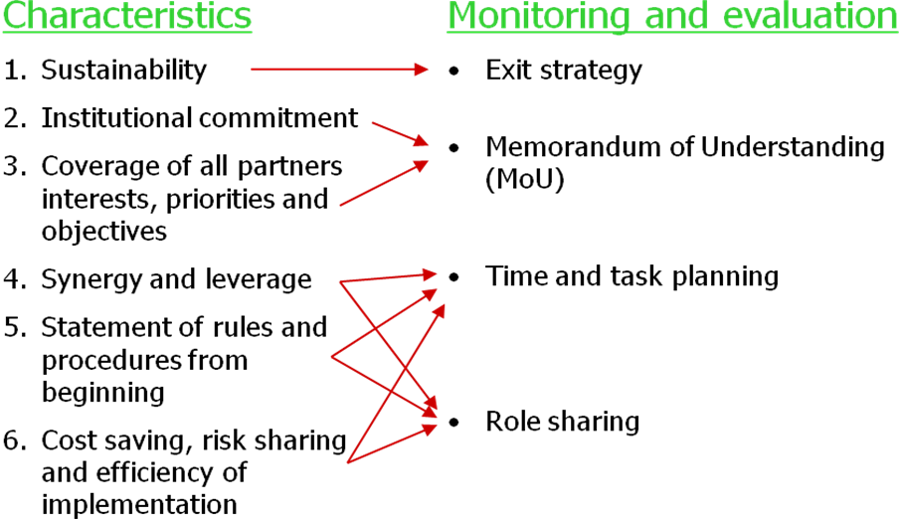

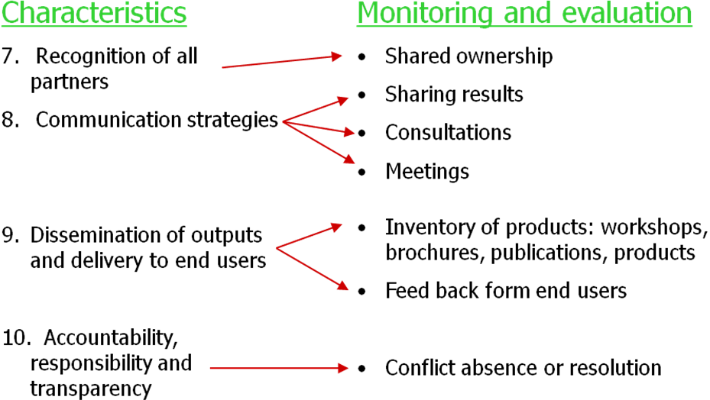

Workpackage 3: Set-up and launch the Platform for African-European partnership on ARD

Proposed activity
The results of WP1 (assessment) and WP2 (consultation) will be utilized for setting-up the platform and launch it. The concrete set-up of the platform (terms of reference, location, facilities, human resources) will be defined according to the outputs of the consultation process, and will be translated into a workplan. The Project Facilitation Unit will be responsible for the implementation of the work-plan.

The platform is to support:
- consultation and dialogue between the stakeholders;
- the priority setting exercise, focusing on specific subregional priorities and potential areas of excellence on ARD;
- awareness raising of research institutions and ARD stakeholders on the available instruments (i.e. FP7 and EDF10) and their thematic priorities;
- awareness raising about existing information and communication systems and building capacity on how to access and use them in an effective way;
- strengthening of capacities to develop joint project proposals.

The platform is a tool to secure a sustainable European-African partnership on ARD.

For financial sustainability, the following options were explored:
- opportunities offered by the Specific Programme “Cooperation” implementing the Seventh Framework Programme;
- accompanying measures of the implementation plan of the EU Strategy for Africa;
- opportunities offered by the ARD programs of EU member states;
- direct participation of African countries

Results and discussions

FARA and EFARD consultation on FP7-FSTP priorities
A Stakeholder workshop was organized by the European Commission in collaboration with CTA for FARA & EFARD to hold a Consultation on Agricultural Research Programming for FP7-FAB and FSTP on 14-16 April 2008. Forty experts from Africa and Europe including the European Commission met to recommend ARD priority research topics and activities for enhancing S&T cooperation between Africa and Europe within the framework of 10 broad priority areas¹ defined under two EU instruments; FP7-FAB² and FSTP³. The objective of the Africa-EU ARD cooperation is to increase the impact of agricultural research and knowledge systems on rural productivity, poverty reduction, food security and sustainable management of natural resources, as well as addressing global issues involving Africa (e.g. climate change), through the delivery of global public goods. The face to face meeting was preceded by an e-consultation which provided a wealth of information on targeted research areas and identified modalities and policies for ensuring synergy, coherence between FP7-FAB and FSTP. The experts produced a 26 page document which provides a brief description of 2-3 research priorities and related activities for each of the 10 broad priority areas including climate change, bio-energy and traditional knowledge.

The experts agreed that strengthening African and EU S&T collaboration on ARD through FP7-FAB and FSTP instruments should contribute to:

- Improving national ARD capacity and research systems within Africa and Europe;
- Building complementarity and synergy for shaping global ARD agenda which contribute to addressing Africa’s priority issues;
- Maximizing use of available knowledge within Africa and Europe to develop public goods and support an African and EU S&T think tank;
- Building and strengthening effective platforms (local - sub-regional - regional – global) for mobilizing the S&T community and civil society within Africa and EU to improve the sensitivity and responsiveness of the research / scientific community to national / global challenges, crises and priorities (e.g. rising food price) i.e. predict, design, and develop strategies for countering any potential negative impact of emerging challenges / crises and take advantage of opportunities.
- Promoting the relevance of global ARD agenda to Africa’s and Europe’s socio-economic development and competitiveness;
- Mobilizing sustainable long term financing for ARD that addresses the production of public goods;
- Better integration of development issues into research priorities; and
- Increased ownership of the ARD agenda by African and EU institutions.

Additional Issues

The experts noted the need to continuously:

- Strive to achieve scientific excellence, and relevance concerning development issues bearing in mind that FP7 focuses on competitiveness through international S&T partnerships and FSTP focuses on development issues within the framework of research relevance.
- Consider the impact of research on the livelihoods of all stakeholders across the value chain including traders / middlemen.
- Learn from failures as well as past successes to guide policy implementation and avoid past pitfalls such that good policies and strategies result in action that contributes to innovation for improved agricultural performance.

Way forward

- Mainstream ARD into the broader S&T agenda in Africa and Europe and enhance CAADP’s Pillar 4 links and synergies with AU/NEPAD Africa’s Consolidated Plan of Action for S&T (AMCOST).

- Strengthen the role of higher education institutions in national agricultural research systems (NARS).

- Harness principles of best practices from Africa & EU S&T Cooperation and build on outputs to serve local communities.

- Twin African and European ARD institutions to deliver the expected results.

- Integrate traditional / indigenous science and knowledge, as well as innovation systems approach, in frontier ARD science initiatives.

- Ensure that the African - EU research collaboration under FP7–FAB and FSTP results in tangible measurable outcomes with respect to enhancing the knowledge and skills of African and EU researchers and strengthening the NARS in Africa.

- Encourage researchers to keep in mind horizon 2010 and beyond in setting and implementing the research agenda to address present and future needs. For example, the price of fuel is expected to increase further with consequences on food prices and international trade and ethical trade issues require research to guide policy interventions especially with respect to the food miles debate.

- Strengthening local markets in Africa remains a research and development priority.

- Build on PAEPARD momentum and strengthen regional mechanisms especially EFARD and FARA.

The experts noted that this consultation was a good process and should be supported on a regular basis and against this background proposed the following:

Context

PAEPARD provides a `community of practice’ for strengthening ARD cooperation between Africa and Europe. It links stakeholders in Africa (through FARA) and Europe (through EFARD) to facilitate exchange of good practice, knowledge and expertise. Regional PAEPARD consultations in Africa and the Brussels workshop demonstrated how the PAEPARD community might add value and impact to specific ARD projects funded by FP7-FAB and FSTP. Whilst individual projects will have discrete objectives and specific deliverables, there are opportunities for developing cross linkages across generic (e.g. indigenous knowledge) or specific (e.g. climate change modelling) aspects of some or all of the individual projects. By creating a network of expertise across the FP7-FAB and FSTP programmes, PAEPARD can provide valuable inputs to achieve project deliverables and/or generate new `programme’ outputs such as:

- Sharing of experience, good practice, data or resources
- Staff exchange and human capital mobility
- Exchange of contacts, training and dissemination materials
- Development of new linkages, proposals and projects
- Identification of priorities, gaps in knowledge and demand
- Maximising programme impacts over and above project impacts

Crucially, the PAEPARD network can serve as a case study in the design, management and execution of a research programme that seeks to deliver high quality research that is demand-informed, scientifically relevant, innovative and genuinely equitable.

It is therefore recommended that the EC considers:

- Including an additional `PAEPARD’ work package (PWP) as a contractual output for all FP7-FAB and FSTP projects. The purpose is to link the projects across the two programmes and provide transparent, freely available and measurable outputs linked to some or all of (a) to (f) above. Each PWP will be externally evaluated to assess;
  - Specific additional outputs that the PAEPARD Network provided to the implementation of the FP7-FAB and FSTP programme;
  - Innovative mechanisms that the network developed as examples of good practice for project management in other subjects and activities;
  - Synergies and linkages to maintain momentum and critical mass.

- Supporting future PAEPARD consultations which are alternately hosted by EFARD and FARA at which synergies and cross-cutting activities in ARD cooperation can be developed either in plenary session or as peer-peer exchanges. The frequency of these consultations can be defined subsequently.

PAEPARD phase 2 concepts

In order to compile the information and knowledge gathered through WP1 and WP2, a writeshop was organized in Montpellier, France and a stakeholder workshop in September 2008. Both the workshops provided the ingredients for the PAEPARD phase 2 as explained below.

In the second phase, PAEPARD should target an increase of the scope, number and the efficiency of joint research projects for African ARD aimed at achieving the MDGs, to be financed through FP7 and EDF10. Increasingly PAEPARD will contribute to alignment and harmonization with other bilateral funding opportunities from European member countries. PAEPARD will also benefit from program coordination of ERA-ARD.

The ARD partnerships will go beyond research institutions and networks. They will include universities and other scientific academies or networks to fully integrate the capacity development dimension. They will expand to include non-traditional research stakeholders (i.e. farmers’ organisations, advisory / extension services, non-governmental organisations, private sector and consumers) as key partners. Civil society such as farmers and private sector will be encouraged to be active partners in ARD projects and in particular contribute to prioritisation. They will be given support to improve their skills to compete or take the leadership role in any consortia formed. Research institutes and universities will be encouraged to accept the leadership role of non-traditional research stakeholders where this is of advantage in achieving the objectives of ARD initiatives.

There is a need to strengthen a more demand-based programming, building partnerships between science institutions and public and private sectors with equitable participation of smallholder farmers and other key stakeholders in the agricultural value chains to maximize direct and indirect impact on various domains related to the MDGs, like food security or poverty alleviation. PAEPARD will advocate farmers and associated professionals to play a more central role in innovation systems approaches by actively involving organisations from the agricultural sector (both in Africa and Europe) in the platform through mechanisms to be designed during this phase. It will contribute to an enhancement of rural and agricultural innovation systems which link public and private sectors with farmers, civil society organisations and the scientific community.

Furthermore, to encourage demand-driven and impact-oriented activities, PAEPARD will focus on strengthening North-South partnerships and South-South partnerships in ARD. African ARD institutions should be more strongly involved in these partnerships, and take the lead when justified, to better reflect the ARD priorities as set by FARA and the SROs.

The overall objective of the PAEPARD will be to catalyze demand-driven and impact-oriented European and African partnership on ARD enabling mutual learning and knowledge sharing to promote agriculture innovations.

In order to achieve the overall objective of the PAEPARD platform, three interlinked components have been identified, so that each outcome or output feeds into each component, contributing to the improvement of ARD partnerships.

Component 1. Facilitation of impact-oriented and entrepreneurial ARD partnerships for agricultural research, training and innovation
This component will focus on enhancing linkages and facilitating partnerships between European and African research institutes, the private sector, universities and civil society organisations to enable them to access research funding instruments from the EC and other donors. Partnerships will be multi-stakeholder and multi-disciplinary, demand-driven, and recognize farmer’s knowledge and innovations towards increasing agricultural productivity. Partnerships are expected to vary according to the types of research to be conducted, i.e. basic research or applied and adaptive research, to include those partners who are most appropriate for the particular objective. These partnerships will focus on actions with added value at the regional and sub-regional levels, reflecting the ARD priorities set by SROs, and NARS. They will focus on reversing roles in partnerships, i.e. priority setting and management from Europe to Africa.

Expected results
- Multi-stakeholder (including civil society, research organisations, private sector organisations – including the African diaspora) European and African partnership operational, which develop and undertake joint research projects responding to regional and sub-regional priorities
- Strengthened capacities of private sector and civil society organizations to identify researchable priorities and influence the agenda of research organisations and universities, as well as an increased ability and willingness of research organisations to accept and respond to these priorities by providing the required research services
- Improved Africa’s capacity to build its own capacity and ensure continued interest of youth in agriculture by providing high quality training programmes for multi-tasks and multi-skilled agriculture graduates.

Component 2. Information and knowledge exchange

The second component focuses on the importance of providing adequate and appropriate information to the African and European stakeholders involved and interested in ARD partnerships. It aims at disseminating relevant information on ARD funding opportunities, relevant partnership experiences and interested partners with specific offer and demand on research topics and training. It will catalyze partnerships with non-traditional partners such as private sector, advisory services and other civil society organizations. Special attention will be given to the large pool of African researchers and professionals living and working in Europe (African Diaspora).

Expected results

- African ARD stakeholder better understanding and participation in EC funding instruments and those of other European donors (e.g. DFID, AFD, Danina, SIDA, … )
- Increased number of African-led partnerships supported through European funding instruments as well as its EC member states.
- Increased involvement of the african diaspora in ARD partnerships for Africa.
- Increased awareness of EFARD stakeholders and constituency of African ARD research priority setting, needs for collaboration, capacity-strengthening needs, training capacities and educational needs as well as funding requirements.
- Better targeting of EC funding instruments on the needs of multi-stakeholder innovation partnerships.
- Improved use of research outputs or outcomes from African – European partnerships in policy – advocacy in Africa.

Component 3. Advocacy on alignment of priorities to resource allocation for African and European ARD
Advocating the research priorities set by African stakeholders through FARA and the SROs needs to be carefully reflected and integrated into funding opportunities and priorities of various European multilateral and bilateral organisations including EC funding instruments. Calls for proposals from FP7, FTSP and other EC programmes should include the priorities set by Africa. Special attention will be given to the proposition of agricultural education and training opportunities.

Expected results
- Cohesive and demand-driven post graduate degrees programs offered by european universities.
- Increased awareness of Africa-specific research themes that might have commonalities with european interests.
- EC calls towards ARD are responsive to african ARD regional and sub-regional priorities.
- Priorities of african institutions and relevant frameworks established and understood in Europe.
- Alignment of Africa’s ARD resources and external development partner’s initiatives to contribute to the achievement of regional and sub-regional priorities.

Workpackage 4: Develop an information and communication strategy for promoting participation of ARD stakeholders from Europe and Africa in the platform

Proposed activity
A communication and information strategy is essential for the building-up of the platform at all stages, in order to allow the participation of concerned stakeholders.

The information and communication strategy will be built on what has been achieved through EARD-Infosys+, exploring the possibility to make the same system serve the two continents and be improved to fit the requirements of the proposed partnership.

Other systems that are in-place will be reviewed, to create linkages where that is desirable and to capture best practices that could be incorporated into the design of the partnership mechanisms.

The information and communication system will be built on the Internet technology, through a website of the platform, and will make use also of other means of information and communication because internet connectivity in Africa is not as advanced as in Europe. Internet connectivity in Africa is still very expensive and slow because of inadequate infrastructure.

The information and communication system will serve to:
- present the platform, its context, objectives, activities and expected outcomes
- provide information about the opportunities offered by the incoming FP7 and EDF10
- link to the relevant websites of the European Commission, FARA and EFARD
- link to European and African information systems on ARD
- browse directories of African and European ARD organization
- inform on events
- present case-studies of successful cooperation
- find partners for presenting proposals
- help and assist in building joint African-European project proposals

Results and Discussions
Through the combined information and knowledge acquired from WP1, WP2 and WP3 with supplement desk studies, the information and communication system for PAEPARD gathered its concepts. It is expected that the communication strategy will “be built on what has been achieved through EIARD-Infosysplus, an information system funded by the European Commission that collates information on European experts, programmes and funding events”. Other systems with similar objectives are worth review to facilitate linkages and capture best practises. Actual information systems such as Infosys+ were reviewed on the information seen as relevant to start a partnership through the consultation mechanism of ARD stakeholder and e survey. An assessment of available and expected information to facilitate partnership development was conducted.

However, the e-survey undertaken in WP1 shows that very few partnerships were developed through web searches alone. Both European and African research institutions who participated or lead research projects prefer face to face discussions or use their current networks to find new partners.

The consultation process from WP1 and WP2 raised important issues related to the information needed to initiate, fund, implement and evaluate (i.e. manage) a partnership. Based on the main findings of this consultation process and an analysis of available information and needed information to better manage partnership development, a strategy is proposed below.

A short term coordination process between two or several institutions to respond to a funding call shall be clearly distinguished from a partnership that is seen as a long term. It is assumed that short-term coordination process between two or several institutions will be called agreement, and long term coordination process between different institutions will be called partnership.

The consultation process main finding concerning partnership initiation indicates that entering into a new partnership requires
- Information on individual or institutional strength;
- Background on former project management and
- Capacity to manage complex funding mechanism.

Organization profile, documentation on successful partnerships and peer review of those partnerships is seen as critical to facilitate partnership kick off.
It is expected that this kind of information would be available on an information system web site. Personal contacts or face to face discussions will be used to identify potential relevant institutions to partner with while web site research should provide additional information on past project management experience.

The consultation process also stressed that partnership development requires funding continuity. The information system shall give easy to find information on funding opportunities to avoid funding gap and be able to respond to evolving partnership requirements.
Web sites will be reviewed on their availability and easy to find funding information.

It is expected that the information system shall be able to file and organize thematic information on core issues and that relevance of this information to build and develop a network shall be reviewed.

Three web sites that could support part of the activities of the information system have been reviewed. Some innovations that could help improvement of the system have been picked up in other web sites such as inter reseaux or D groups

Table 5 : An analysis of three ARD information systems
 | Infosysplus | Wisard | Interdev
Languages | English and French | English | English and French
Documentation on Project management experience | Yes for institutions but often lacking | Yes, for experts and institutions, but often lacking | Documentation on case studies best practises
Total number of institutions registered | 3678 | 5400 approved | 24
number of institutions registered in 4 African countries | 133 | 54 | 3
Background information on institutions competences | Available on a short description and web site if available (to review) | Available on a short description and web site (reviewed) | Available on a short description and web site (reviewed)
Information on experts | Yes, but limited number of African experts , thematic fields to limit (review) | Yes, but limited number of African experts, | No
Information on funding opportunities | Yes (sorting process to fine tune) | No | No
Focus on | Institutions (research and universities predominant) | Institutions and experts | Case studies
Information feeding system | Free without review | Free but reviewed before publishing | Through a focus person for each thematic

WP4 conclusion and recommendations
Based on the outcome of above studies and analysis, PAEPARD phase 2 information and communication system should focus on facilitating impact oriented and entrepreneurial agricultural research, training and innovation through three areas of interventions:
- Identification of thematic areas and commodity chains that respond to regional and sub regional priorities and relevant public private partnerships in ARD
- Facilitate linkages among diverse networks and organizations from Europe and Africa to enhance partnerships among research institutes, the private sector, universities, advisory services, and CSO’s that can address these priorities through (i) facilitation of dialogue among different interested parties, ‘ii) identify, rationalize and assess example of public private partnership with a clear inter linkages among European and African institutions (iii) assessment and analysis of African “pole of excellence” or “innovation platforms” as potential mechanism to implement regional, sub regional and national ARD partnerships.
- Strengthen the capacity of non traditional research stakeholders to identify and prioritise researchable constraints, develop research proposal, implement research projects in partnership with other stakeholders and influence the research agenda of research organisations.

Specifically, the information and communication system will have the following components;
- Advertise, improve and maintain an information system to disseminate funding opportunities and facilitate partnership management. Based on upgraded Infosys+ and in addition of new tools, the system should feature;
  - Network and community of practise tools to facilitate discussion groups, posting and management of draft information, information letter
  - E-mail alerts on funding opportunities and conduct of video conferences to share information on emerging new funding opportunities organized
- Communication tools development to expand market-oriented collaborative approaches on ARD. New collaborative market-oriented approaches on ARD need personal and institutional investments from different stakeholders to develop trust and confidence among partners. Collaborative film production to document engagement of non-research partners. These tools can be used in promoting partnerships or at negotiation phase of partnerships.

Conclusion and recommendation of PAEPARD phase 1
Gathering the lessons learnt from various ARD investments and Africa – Europe ARD partnerships, combined with the knowledge acquired from Workpackages 1-4, below are the summaries of our findings:
- African agricultural research has not been a priority for the FP6, with only 2% projects supported, and only half of the 10 percent INCO projects supported in FP6 relating to Africa. Most of these projects are coordinated by European research institutions and universities, and most of the African partners are research institutions and universities.
- EC grants in the form of SRO competitive grant schemes were appreciated by ARD stakeholders, but the management of such grants involves high transaction costs, and EDF procedures appeared inappropriate for these.
- Inter-continental partnerships are valuable, but mechanisms need to be improved to maximize benefits. Most partnerships are currently geared towards training and writing scientific papers, with very few focusing on dissemination, adoption and adaptation of innovations.
- A multi-stakeholder approach is key in fostering ARD in Africa, and PAEPARD I made an effort to involve participants from the civil society, namely farmers organizations and NGOs, the private sector, and other non-research stakeholders in its consultations. PAEPARD II needs to develop mediation mechanisms to move beyond joint consultation to joint project development and implementation.
- The analysis focused on the agricultural sector, and did not consider EC-funded research activities in other sectors (such as health, environment and education). A wider analysis of experiences from these sectors is proposed to be part of PAEPARD II, as ARD needs to take into account the strong links between sectors for addressing critical challenges of Africa
- Sufficient time and resources for coordination (both in Africa and Europe) need to be available to ensure that PAEPARD results are achieved.

These lessons lead to the current project design of PAEPARD II, which strongly emphasises the need for partnerships to include not only research organisations, but also relevant non-research stakeholders. This cannot be achieved through representation in fora such as FARA and EFARD alone – PAEPARD I and other initiatives have shown that real partnerships need intermediaries, who facilitate communication and assist in the formulation of initiatives that provide benefits to all partners. PAEPARD consultations identified the need for mechanisms and resources to facilitate the evolution of such partnerships, and for relevant and timely information about funding opportunities for ARD that these partnerships can utilise. A better coordinated European ARD landscape, which presents itself more clearly to potential partners, would make it easier to forge partnerships that have the relevant set of skills and experiences to produce the much needed innovations for poverty reduction and environmental sustainability.

Such ARD partnerships clearly add value to existing EC assistance for agricultural research, technology and dissemination in Africa, which is provided at different levels:
- Support to the agricultural research at the global level, including the Consultative Group on International Agricultural Research (CGIAR): 130 M€ is allocated under the global component of research of the FSTP for 2007-2010, of which 50% is allocated for Africa.
- Support, in this AAP, to other organisations at the continental level such as continental-level coordination of ARD through FARA (Forum for Agricultural Research in Africa), Agricultural Advisory Services, Farmers Organisations, AUC and RECs on CAADP related issues.
- Support to sub-regional agricultural research organisations. Support is provided to Eastern and Central Africa, and to Southern Africa, through EDF. Support might continue in the future under the FSTP, including also Western Africa.
- Strengthening national agricultural research systems. In the 9th EDF assistance was provided to three sub Saharan countries. In the 10th EDF, 20 countries have agriculture/food security /rural development as focal sector; total value about € 890 million.
- EIARD is proposed to be supported by the EU with a grant over 1.3 M€ to facilitate coordination and donor harmonisation on ARD in Europe.
- Current support through on-going and future FP6 and FP7 projects, specific support actions, and ERA-NETs (e.g. INCO-DEV, Specific International Cooperation Actions, INCO-NETs, ERA-ARD, etc)

E.g. the Sub-Saharan African Challenge Programme (SSP CP), aims to demonstrate that multi-stakeholder innovation platforms operating in a paradigm of Integrated Agricultural Research for Development (IAR4D) can more effectively address constraints to agriculture in Africa than conventional research approaches.
http://www.fao.org/documents/show_cdr.asp?url_file=/docrep/005/y6831e/y6831e00.htm
http://europa.eu.int/comm/development/body/communications/docs/eu_strategy_for_africa_12_10_2005_en.pdf#zoom=100
http://www.esastap.org.za/
According to the International Centre for development oriented Research in Agriculture (ICRA), ARD is “research that responds to the needs of clients and beneficiaries, contributes to wider and often conflicting development needs and uses systems perspectives to integrate diverse perspectives”.
Both FARA and EFARD are key pillars of the Global Forum for Agricultural Research (GFAR), which has a worldwide mandate of facilitating inter-regional cooperation. GFAR is a multi-stakeholder initiative that contributes to eradicating poverty, achieving food security, and conserving and managing natural resources. It enhances national capacities to generate, adapt and transfer knowledge. http://www.egfar.org/home.shtml
Under the impulse of EFARD, some EIARD members (Austria, Belgium, Denmark, France, Germany, Hungary, Italy, Lithuania, Netherlands, Poland, Slovenia, Spain, Switzerland, United Kingdom) joined their forces to map their national ARD programmes aiming at improving cooperation and synergies. The programme, called ERA-ARD (the ARD dimension of the European Research Area), funded by the European Commission under FP6, started in April 2005 and is currently on-going.
Economic Development Fund
Food Security Thematic Program
ESASTAP – the South Africa – Europe platform for Science and Technology
The European Commission has invested in the European Information System on Agricultural Research for Development (EARD Infosys+)?, which collates information on European experts, programmes, funding and events, and could be adopted to fit the requirements of the partnership http://www.infosysplus.org/.
http://www.infosysplus.org/
http://www.infosysplus.org/ , http://www.wisard.org/wisard/home.asp , http://www.interdev-net.org/
http://www.inter-reseaux.org/
http://web.worldbank.org/WBSITE/EXTERNAL/WBI/0,,contentMDK:20305800~menuPK:795577~pagePK:209023~piPK:207535~theSitePK:213799,00.html
On a sample of 4 ACP countries 25% of the institutions have registered their project management experience
Algeria, Benin, Namibia, Kenya, .
Several experts are listed in all the field of competences and having an experience on more than thirty countries
Different kind of funding opportunities such as PhD and post doc are mixed, short comment on objectives and target countries would be useful to facilitate rapid research.
E.g. the Sub-Saharan African Challenge Programme (SSP CP), which aims to demonstrate that multi-stakeholder innovation platforms operating in a paradigm of Integrated Agricultural Research for Development (IAR4D) can more effectively address constraints to agriculture in Africa than conventional research approaches.

