t


Project no. NMP2-CT-2004-505689

ICON-HISIM

Intelligent Controls for High-Speed Injection Moulding Machines

Integrating and strengthening the ERA
Specific Targeted Research Project

Publishable final activity report

Period covered: from 10/2004 to 06/2008 Date of preparation: September 2008
Start date of project: 01/10/2004 Duration: 45 Month
Project coordinator name: Univ.-Prof. Dr.-Ing. S. Helduser
Project coordinator organisation name: University of Technology Dresden Revision draft: 1
Contents
1 Project execution 3
2 Dissemination and use 8

1 Project execution
Introduction and objective. Plastics production is one of the main industries in Europe with sales exceeding 135 billion Euro per annum. To achieve, hold and consolidate the European technological leadership in the field of industrial goods plastic processing is of capital importance for the competitiveness of converting industry and consequently in the whole manufacturing industry. European manufacturers of plastics producing machinery have produced about 17.000 machines in 2000, representing a market volume of 1.500 million Euro.
ICON-HISIM wants to strengthen the competitiveness of this important European industry sector. Therefore it proposes the development of a high-speed injection moulding machine prototype:
- with increased productivity without increasing the costs,
- reduced environmental impact,
- high reliability and reduced set-up expenditure.
To reach these aims the solution course of the project requires integration of different models and different modelling tools to realise a virtual prototype for simulation of the global machine-mould-process system so to provide optimal use and high reliability of the production machinery, reduced set-up expenditure, condition monitoring and teleservice to reduce downtime, easy maintenance, user-friendliness, to substantially reduce oil volume, noise emission, energy consumption and cooling water needs.
Solution method. The requirements for the new prototype have been defined in the specifications in the early stage of the project. According to the requirements the modelling of the subsystems and systems started. Already the subsystems allow to evaluate the dynamic performance and to take changes of requirements on the components into account. Experimental investigations have been performed to identify unknown parameters like efficiencies of components, friction parameters of actuators but also static and dynamic properties. These comprehensive investigations allow deriving validated models to provide significant results. Furthermore, experimental investigations performed on an available test rig (injection moulding machine 1600 kN class) have been used to validate the overall models.
The derived non-linear simulation models could be simplified and be linearized for controller design. Therefore, three different solutions have been developed. First: linear and non-linear control system for the drive systems of the clamping unit and the injection unit that are the dynamically critical ones. Second: semi-linear and non-linear adaptive control of the clamping unit to provide maximum dynamic performance and accuracy due to self adaptation. Third: iterative learning control of the injection velocity to provide reproducible and high quality parts.
Structural optimisation of the clamping unit could be performed by use of the virtual prototype. By means of the multi-body simulation tool a new clamping unit concept has been developed that is providing an increased compactness and thereby a reduced machine footprint. The drive system is based on volume flow rate control instead of resistance control and thereby provides an increased efficiency. The control concept for the clamping unit and a fitted reference trajectory ensure keeping the physical system limitations (maximum pressure, maximum torque and maximum speed). A dry cycle time of DCT = 1,3 s of a 3000 kN and DCT = 1,0 s of an 1600 kN injection moulding machine could be achieved. Figure 1 depicts the non-linear simulation model (left) and the mechanic design layout. Figure 2 shows the results of the dry-cycle simulation for the developed compact electric-hydrostatic clamping unit.
Figure 1: Simulation model and clamping unit of the new high-speed injection moulding machine
Figure 2: Simulation results of the new clamping unit with toggle and with linear controller
The realistic simulation of the injection unit (virtual prototyping) requires knowledge about drive layout and drive parameters but also of the injection moulding process. Therefore, a co-simulation has been established and tested. The co-simulation comprises a coupling of the system simulation software ITI SimulationX® and the field simulation software Cadmould®. The coupling is realised by the use of a standard communication protocol (TCP/IP), Figure 3.
Figure 3: Structure of the co-simulation (virtual prototyping plastic components)
Different solutions of the drive system have been developed and investigated for the injection unit. Finally a 3/3-way servo valve with meter out volume flow rate control was chosen. Therewith, the energy efficiency could be increased due to strongly reduced heating of inlet oil that allows energy recovery during plasticizing. The designed injection unit is able to achieve an injection velocity of 1,2 m/s and does provide high response characteristic, Figure 4.
Figure 4: Response characteristic of the valve controlled hydraulic actuator
The movement of the injection unit is realized by a non-linear control system that is adapting the control parameters depending on position. The control parameters have been developed by the use of numerical optimisation and the feed forward control has been designed due to inversion of the plant characteristic.
In addition the requirements on energy efficiency have been realised by means of a pressure adaptive accumulator system. The supply pressure requirements differ from part to part. In standard injection moulding technology the supply pressure is constant and depending on the flow and pressure demands the energy losses are changing. A new technology is adapting the supply pressure value considering the process pressure demands. Simulations confirm the reduction of energy consumption and a efficiency of approximately 50 percent could be achieved.
Figure 5: Simulation results of the energy requirements with/without accumulator pressure adaptation
To achieve an optimal plastic component an iterative learning injection controller has been developed and tested in simulation. The controller is evaluating the cavity pressure course and generates an optimised injection velocity profile that leads to a constant pressure gradient, Figure 6. The controller operates iterative and provides a cycle-to-cycle optimisation. A cycle-to-cycle off-line optimisation is required due to the very short injection time of several milliseconds that do not allow an on-line calculation.
Conclusion. The aim of developing, designing and test of the prototype has been reached by use of simulation in the development process to provide performance information in the early stage of the project. The methodology of technical-scientific computation is very powerful but a multidisciplinary activity is required for gathering all competences. Virtual prototypes have been derived and used for the development of different options for the drive systems for a high-speed injection moulding machine. These virtual prototypes allow to evaluate and to optimise the dynamic performance, the structure and the control system of the drive systems and so to improve the overall machine performance. The non-linear system simulation allows the investigation of complex structures and due to simplification and linearization the control design for different drive system. Besides the linear control system an adaptive non-linear control system has been developed for the clamping unit of a high-speed injection moulding machine.
The co-simulation package is a tool that considers two complex domains: the drive system domain and the plastic injection moulding domain. A coupling of both simulation systems has been used to investigate the dynamic performance of the drive system, to determine the requirements and to reduce the power consumption of the electro-hydraulic injection unit. The simulation has been used to develop an iterative learning controller that assures constant filling conditions due to the adaptation of the injection velocity.
Figure 6: Results of the self-adaptive injection controller a) first cycle; b,c) optimised cycle
Compared to available injection moulding machines the dry-cycle time (DCT) of 1,3 s is an excellent value. Typical values of 3000 kN machines are 1,8 s to 2,5 s. The possibility of energy recovery and reduction of energy consumption for the injection demonstrates a completely new technology in the field of injection moulding. The virtual prototype of the injection moulding machine allow adjusting system parameters and machine parameters that are relevant for developers but also for operators. In conclusion it can be said that virtual prototypes allow improving the development process, the design and the operation of complex machines moreover this methodology can be transferred to different applications. These virtual prototypes are modern tools and the result of interdisciplinary interaction of different domains that prospectively seen will be more intensive used and exploited.
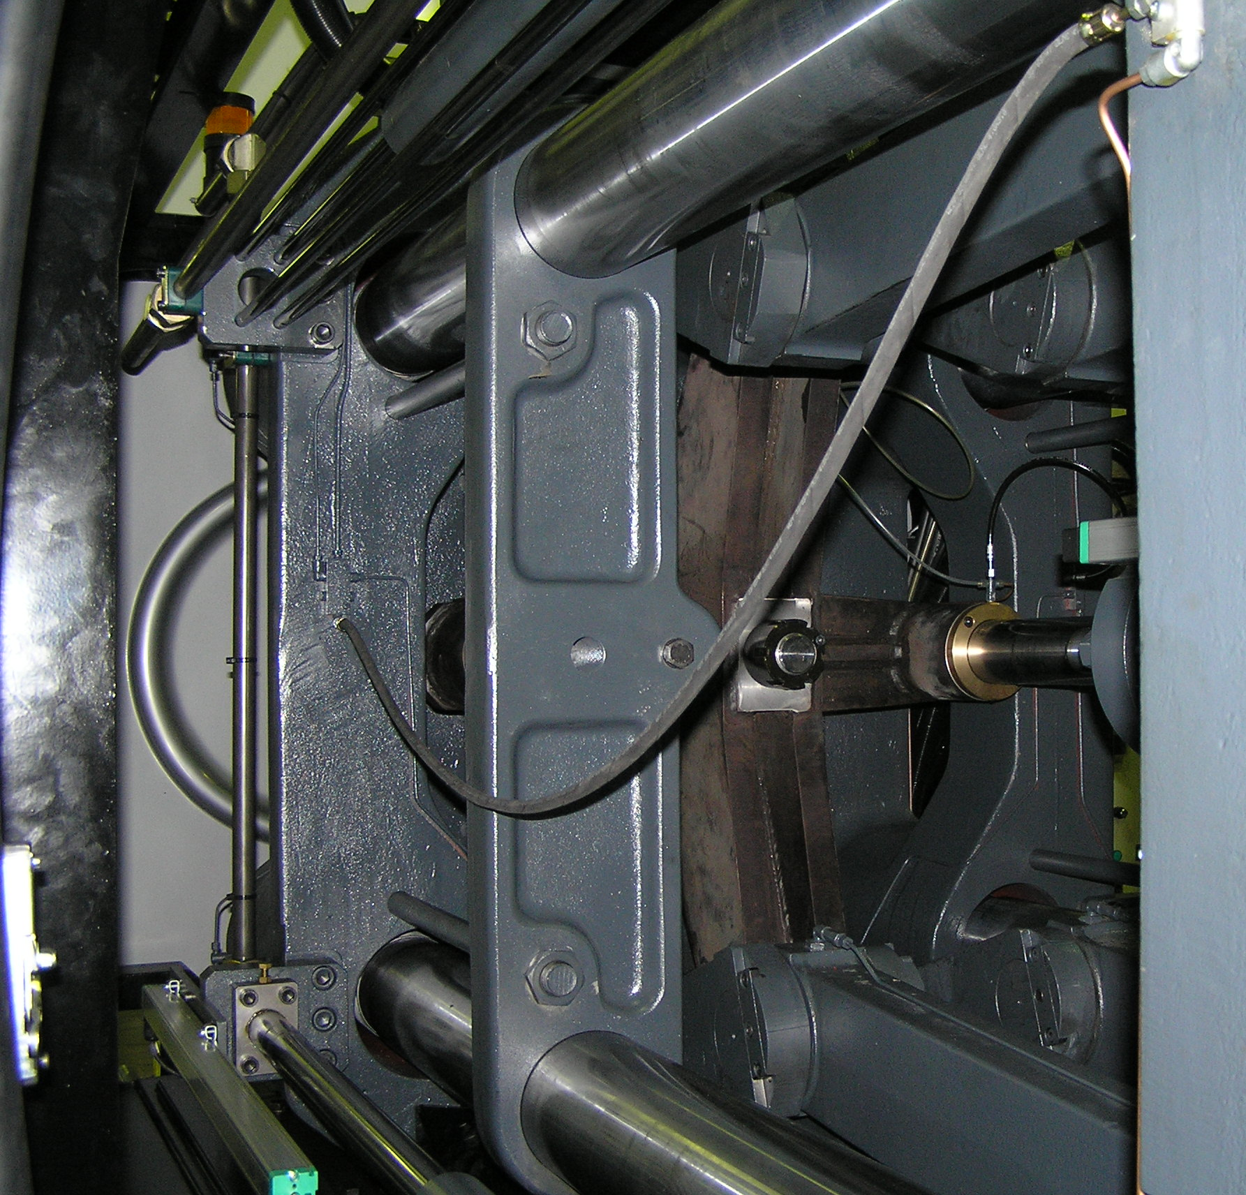
Figure 7: Pictures of the prototype located at the plant of Betapack
left) view of the injection unit; right) view of the clamping unit (toggle system)

2 Dissemination and use
Planned/  actual Dates | Type | Type of audience | Countries addressed | Size of audience | Partner responsible/ involved
2005 | Press/radio/TV | General | PL |  | 9
2005 | Conference | Industry/ Research | CZ,PL,SL | 90 | 9
2005 | Conference | Industry/ Research | PL | 50 | 1/9
2006 | Conference | Industry/ Research | D | 150 | 1
2006 | Conference | Industry/ Research | D | 300 | 1/7
2006 | Conference | Industry/ Research | D | 200 | 6
2006 | Conference | Industry/ Research | D | 50 | 1/7
2006 | Press | General | PL | 120 | 9
2006 | Conference | Industry/ Research | PL, SL | 120 | 9
2007 | Press/radio/TV | General | PL |  | 9
2007 | Publications | Industry/ Research | D |  | 1/6/7/9
2007 | Conference/  Paper | Industry/ Research | AUT,D,FIN,  GB,RO, SE | 50 | 1
2007 | Conference | Industry/ Research | D | 100 | 1
2007 | Conference | Industry/ Research | D | 50 | 1/6/7
2007 | Conference | Industry/ Research | PL | 150 | 9
2007 | Conference | Industry/ Research | PL | 120 | 9
2007 | Conference | Industry/ Research | CZ,PL, SL | 80 | 9
2008 | Press/radio/TV | General | PL |  | 9
2008 | Conference/  Paper | Industry/ Research | AUT,C,D,FR, FIN,GB,NL,  PL,RO,SE,USA | 550 | 1/6/7
2008 | Conference/  Paper | Industry/ Research | AUT,C,D,FR, FIN,GB,NL,  PL,RO,SE,USA | 550 | 9
2008  (planned) | Newspaper | Industry/ Research | D | 200 | 1
2008  (planned) | Newspaper | Industry/ Research | D | 5000 | 1, 6
Table 3: Plan for using and disseminating the knowledge

