

Project no.: 509187

Project acronym: ADEG

Project title: Advanced Decentralised Energy Generation Systems in Western Balkans

Instrument: Specific Targeted Research Project (STREP)

Thematic Priority: Specific Measures in Support of International Cooperation (INCO)

Publishable Activity Report

Period covered: from 01/05/2004 to 30/04/2007 Date of preparation: 20/07/2007

Start date of project: 01/05/2004 Duration: 36 months

Project coordinator name: Prof. E.Kakaras
Project coordinator organisation name: National Technical University of Athens
Revision [0]

1. Project execution

Projects scope and objectives

The aim of the project was to formulate promising solutions for decentralised systems in the area of Western Balkans based on the utilisation of renewable energy sources and hybrid systems. The project’s objectives were:
- To map the potential for Renewable Energy Sources exploitation in Decentralised Energy Generation in Western Balkans,
- To create a standard modelling procedure for decentralised system selection allowing the the identification of best possible solution in a given area,
- To identify specific concepts for DEG in the examined countries and their integration into multi-technology systems for the achievement of stable and high efficiency power production,
- To increase the efficiency and competitiveness of Renewable Energy and hybrid stand alone power supply in decentralised areas in the Western Balkans and to improve their environmental performance.

The work was focused on Bosnia-Herzegovina, Croatia and Serbia and Montenegro, while Albania and FYROM were included in RES potential assessment. The technological concepts which were examined within the project deals with biomass utilisation and biomass gasification, solar energy, wind energy, co-generation technologies, small hydro plants, as well as H₂ production and Fuel Cell applications. In addition hhybrid systems of the technologies examined where also assessed.

The project is undertaken by six contracting partners, namely the following:
- National Technical University of Athens, School of Mechanical Engineering, Laboratory of Steam Boilers and Thermal Plants (NTUA-LSBTP), Greece - Coordinator
- Instituto de Engenharia Mechanica (IDMEC-IST), Research Group on Sustainable Energy Development, Mechanical Engineering Department, Instituto Superior Técnico, Lisbon, Portugal
- University of Stuttgart (USTUTT), Stuttgart, Germany
- Faculty of Mechanical Engineering and Naval Architecture, University of Zagreb (FSB-UZ), Zagreb, Croatia
- Institute for Nuclear Science Vinca (VINCA), Serbia and Montenegro
- University of Sarajevo, Mechanical Engineering Faculty Sarajevo (USa), Bosnia and Herzegovina

Project Structure and technical approach

The work was divided in 5 work packages. In WP1, the Renewable energy sources potential were examined in terms of availability and specific characteristics of each type taking into account biomass, wind, hydro and solar for the development of regional maps of power production sources and technologies used focusing on decentralised energy systems. In WP2, technological concepts were investigated for the identification of prospects and barriers of each technology according to the local particularities. Moreover, experimental work involves biomass combustion, co-combustion and gasification was carried out. The WP3 was related to the identification of the most promising configurations for the advanced utilisation of renewable energy in decentralised systems aiming to the efficiency increase of the system for power production and hydrogen as energy carrier and the establishment of reliable and low cost energy generation for stand alone grids and applications with advanced security of supply. In WP4 the most promising concepts were optimised based on the detailed characteristics of selected areas and the relevant economic and environmental aspects will be assessed. Finally WP 5 was devoted to Management and Dissemination activities.

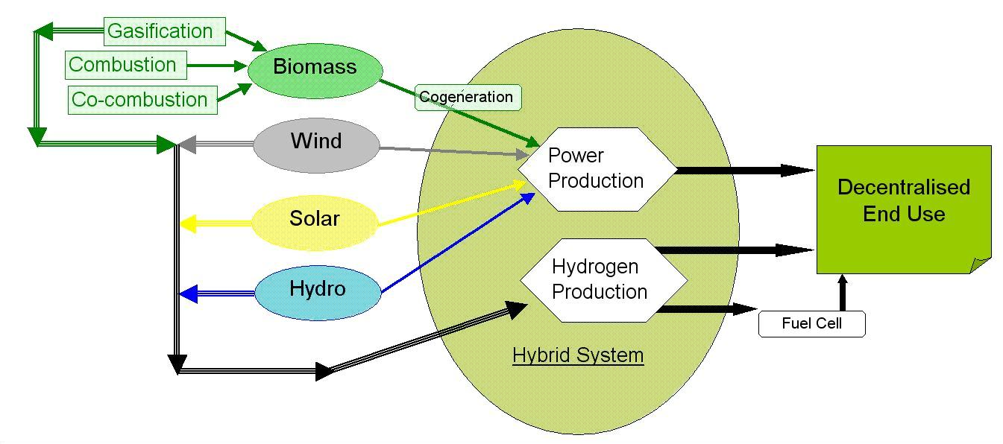
Figure 1 : Project approach to Advanced Decentralized Energy Generation

Work performed

The work related to the identification of DEG systems potential in Western Balkans, has been performed based on selection of information required, collection of data based on a formed questionnaire and evaluation of findings. The analysis was carried out for Bosnia-Herzegovina, Croatia and Serbia and Montenegro, as well as Albania and FYROM and was made based on 44 selected parameters on RES availability and other data such as energy supply and demand, demographic and economical. Characteristics important to the identification of end-users requirements were also collected and evaluated. Moreover, a thorough examination of the legal and regulatory background has been made in order to prepare the ground for further evaluation of the RES and DEG potential in five WB countries. FSB-UZ was coordinating the activity and has analyzed and prepared the map of DEG and RES potential in West Balkan, based on information provided by VINCA and USa based on the questionnaire prepared by NTUA.

In addition, the evaluation and analysis of different technological options identified on three levels, namely: State of the Art of technologies, Commercial available technologies on EU level, and local schemes of interest according to local particularities was performed. Technologies examined were related to biomass utilisation and biomass gasification, solar energy, wind energy, co-generation, small hydro plants, H₂ production and Fuel Cell applications, as well as Hybrid Systems. Information was gathered through an extensive survey and data were processed in a homogeneous manner for all technologies for the presentation of the main components of the different technology configurations. The assessment of the suitability of each technology examined was made, based on technical, environmental, economic & financial, social, market, regulatory parameters and selected test case were examined related to the current utilisation of technological concepts in WB region. NTUA has prepared the different technologies reports based on information provided by all partners.

Experimental work was also performed regarding biomass gasification. The biomass used was selected among the available biomass types in the WB region as the most promising option in terms of availability and with high utilisation potential (spruce from Bosnia & Herzegovina performed by USTUTT and Soya Straw from Serbia performed by USTUTT and NTUA)

According to the determined decentralised potentials in WB, different cases were selected with respect to rural region or industrial/agricultural complex applications. Different configuration schemes were developed by the organizations of WB countries towards the advanced utilisation of RES. Various scenarios that have been calculated by UZ-FSB include direct energy consumption and indirect energy storage and all calculations are based on a H₂RES computer model that was developed within RenewIslands project. The H₂RES model which was designed for balancing between hourly time series of water, electricity and hydrogen demand, appropriate storages and supply, was expended by UZ-FSB including calculations of grid connection with links to power system (electricity import/export), heat demand and biomass energy supply. A standard modelling procedure for the selection of DEG concept in West Balkans was developed by UZ-FSB and IST. Further to the modelling related to the energy balancing and financial analysis, the security of supply and fulfilment of demand side requirements, stability of the grid was calculated by USTUTT’s model of Western Balkan transmission networks. Power systems were modelled using the simulation tool “POSIM” (POwer System SIMulations). The specifications of optimisation of grid penetration were developed by USTUTT with collaboration of the partners. Information from UZ-FSB, VINCA and USa were provided, related to the most promising concepts after the evaluation of local particularities.

Work has been conducted also on the identification of opportunities and barriers of DEG technological schemes for Croatia, Bosnia-Herzegovina and Serbia-Montenegro, based on the advanced utilisation of Renewable Energy Sources. The availability of primary sources and energy demand issues were examined as well as the legislative framework, financing schemes, governmental support, the role of the local industry and the cost of technologies. Barriers of technologies were also examined. The most promising options for further development of DEG systems were identified and future projects were determined as well as possible political supporting schemes. The work was coordinated by NTUA was information and local level analysis provided by UZ-FSB, VINCA and USa. A survey dealing with the identification of existing projects within 13 EU countries and Norway was conducted by IST with the collaboration of NTUA, UZ-FBS, VINCA and USa, related to the advanced utilisation of RES sources for decentralised energy generation providing the relevant European experience and achievements on the field.

End Results

The development of the energy sector of the West Balkans is under liberalisation process in line with EU specifications and primary legislation has been developed dealing with the establishment of electricity regulatory bodies and the formulation of internal market. The South East Europe Regional Electricity Market (SEE-REM) has been formed by Albania, Bosnia and Herzegovina, Croatia, FYROM and Serbia and Montenegro. Croatia, Serbia and Montenegro and Bosnia and Herzegovina have specified the market opening structure and timetable as well as the definition of eligible customers. The most important issue for regulators deals with the development of secondary legislation, mainly tariff methodologies for power generation, transmission and distribution. The electricity demand is increasing during the last years, in west Balkans resulting into enhanced potential for stand alone applications for advanced utilization of local renewable sources and a significant potential for RES development in isolated areas of the WB is available.

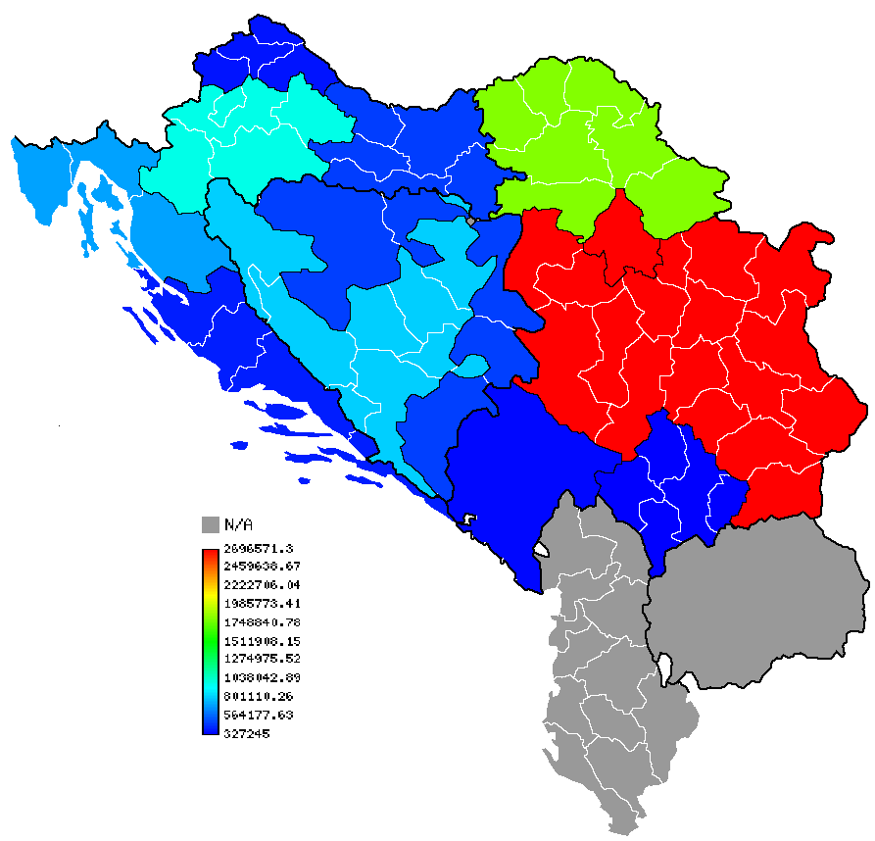 |  | 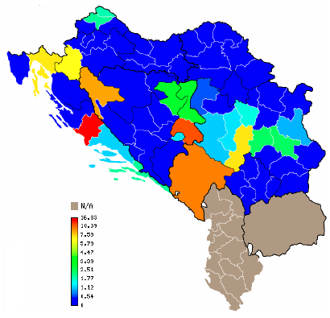 |  | 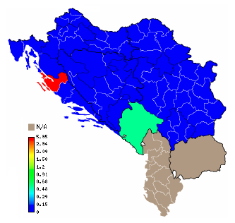
Figure 2: Electricity consumption at MV (MWh) |  | Figure 3: Max Load Capacity potential (existing) – Small Hydro (MW) |  | Figure 4: Max Load Capacity potential (existing) – wind (MW)
 |  |  | 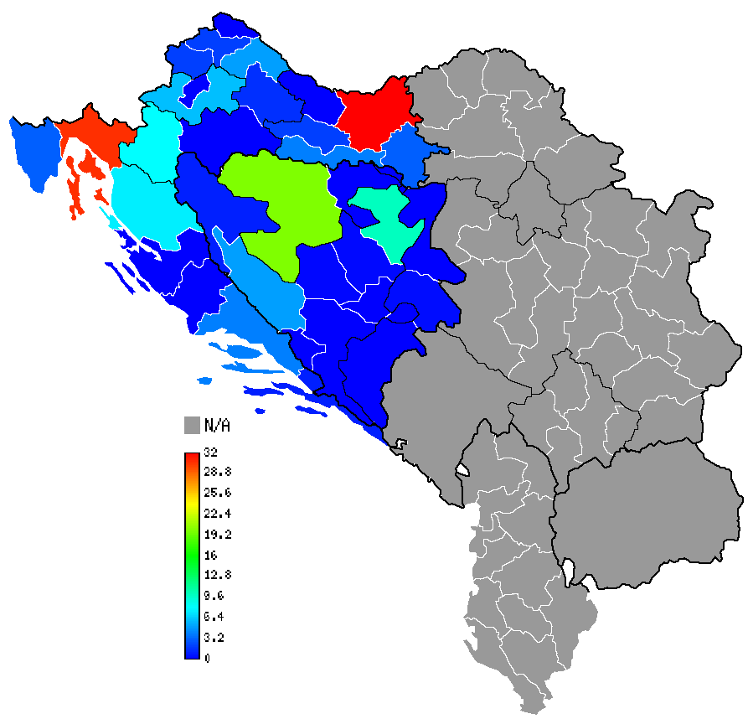
 | Figure 5 :Max Load Capacity potential – PV (MW) |  | Figure 6: Max Load Capacity potential – biomass (MW)

Concerning the biomass utilisation for heat production facilities under 1 MW the applied technologies are dealing with conventional combustion as well as gasification processes. Biomass co-firing is also available for different types of application. The type of Biomass fuel, which is available, the relevant equipment and the feeding process are key parameters for the selection of technologies. Agricultural biomass waste is expected to have a significant role for biomass utilisation, which has a high potential. Biomass combustion is a quite developed option in the WB region. There are commercialised concepts incorporating gasification but manufacturers are mainly involved in boilers and stoves. Biomass gasification could be a viable solution depending on the subsidies related to its market penetration. For the fuel supply system, lack of pellet manufacturers in the WB regions is a barrier for the use of wood residues of the WB region. Specific technical solutions by local manufacturers comprise relatively low capital costs, suficient expected lifetime and efficiencies ranging from 80 –95%.

In relation to wind utilisation local companies, representatives of EU manufacturers, are active in the WB region. Wind farm construction recoils in comparison to the actual potential in the WB region. The lack of financial supporting measures are the main barriers for the penetration of wind energy production schemes in the WB region, despite the fact of the potential of viable application in several locations. The further investigation of wind potential based on wind measurements is expecting to facilitate the penetration of this technology to WB energy market.

Photovoltaic and solar thermal technologies are available to the WB area and there are companies active in the field of solar& PV manufacturing and system design services. A future option for the field development for decentralised schemes is related to the coverage of building energy needs. Concepts, which currently and in the near future, seem mostly applicable in the WB area are low temperature collector installations and possibly PV systems for specific applications.

Small-scale hydropower is also an option for RES utilization. Especially for Serbia and Montenegro, where the most of potential locations are suitable for 400-600 kW and 1.5-4.5 MW units in mostly grid-connected schemes but also stand-alone systems and Bosnia and Herzegovina in which several SHP plants are in the process of construction, all funded by private investments.

The impact of decentralised electric power generation on the grid in the WB was analysed in global and local perspectives. In the first perspective, the analyzed scenarios of WB extra-high voltage transmission system, show that under the given boundary conditions a high penetration of decentralised power generation does not affect a stable transmission system operation. In local perspective analysis of the WB distribution systems on high and medium-high voltage level, the analysed case studies show that under the given boundary conditions a high penetration of decentralised power generation can affect the stability of distribution system operation. To integrate decentralised power generation within distribution systems, a detailed analysis of the local grid structure is essential.

The most promising configurations for the advanced utilisation of renewable energy in decentralised systems in the Western Balkans have been identified trough analysis of different cases. Four case studies have been assessed for selected rural region or industrial/agricultural complex in each WB country whose organizations participate in the project. Each case is represented with different scenarios of possible future development. Scenarios that have been calculated include direct energy consumption and indirect energy storage and all calculations are based on a H₂RES computer model that was developed within RenewIslands project and has been upgraded for the purpose of ADEG project including possibility to calculate grid connection with bigger power system (electricity import/export), heat demand and biomass energy supply. The security of supply and fulfilment of demand side requirements, the stability of the grid was calculated by POSIM model, which has been expanded to WB transmission networks.

2. Dissemination and use
The Plan for Using and Disseminating knowledge is an updating process related to the whole period of the implementation of the project. The target group is focused on technology manufacturers and end-users in the WB countries, as well as key actors on EU level. The main elements to be published/ disseminated are:
- The main public website of the project: http://www.ntua.gr/lsbtp/adeg.html and the http://powerlab.fsb.hr/adeg/
- Publications on Journals/Conferences
- Information to WB and EU contacts including recommendations for RES and hybrid systems in the WB decentralized energy system.
- Recommendations on next steps for further exploitation of results in the WB area.
The contact details of the Coordinator are: Prof. E. Kakaras, National Technical University of Athens, School of Mechanical Engineering - Thermal Section, Laboratory of Steam Boilers and Thermal Plants, Heroon Polytechniou 9, Zografou Campus, GR 15780, Athens, Tel.: +30 210 772 3604, Fax: +30 210 772 3663, email : ekak@central.ntua.gr, URL:www.ntua.gr/lsbtp

Section 1 - Exploitable knowledge and its Use

Overview table
Exploitable Knowledge (description) | Exploitable product(s) or measure(s) | Sector(s) of application | Timetable for commercial use | Patents or other IPR protection | Owner & Other Partner(s) involved
Map of Decentralised Energy Generation in West Balkan Countries | Studies | Further research |  |  | ADEG Consortium
Technologies for Decentralised energy generation | Studies | Further research |  |  | ADEG Consortium
Upgraded methodology for advanced decentralised energy generation | Studies | Further research |  |  | FSB-UZ, IDMEC-IST
Grid analysis of WBC on decentralised energy production | Studies | Further research |  |  | USTUTT

Map of Decentralised Energy Generation in West Balkan Countries: Aim of the work was to identify the energy demand and supply patents of WB region as well as the administrative and legislative framework of the energy sector, the availability of renewable energy sources and the market characteristics towards the advanced utilisation of decentralise energy production schemes.
FSB-UZ was the lead participant of the work. VINCA and USa have provided all relevant information required. NTUA has formulated the main contexts of the data required. The further exploitation of the results provided is foreseen through further research activities on the West Balkan region energy sector characteristics as well as on further evaluation and/or development of decentralised energy concepts.

Technologies for decentralised energy generation: Evaluation of technological, economical and environmental aspects of energy concepts related to the advanced utilisation or renewable sources for decentralised energy production. The technologies evaluated deals with biomass, solar and PV, wind, small hydro, cogeneration, hydrogen and hybrid systems. NTUA was the lead participant of the work. IST and USTUTT contributed to the identification and description of technologies. FSB-UZ , VINCA and USa have contributed also and furthermore, have provided all relevant information dealing with local particularities of these technologies in WB. Exploitation of the results can be made through further research activities on technical, economical and environmental specifications of technologies evaluated as well as on the assessment of market evolution to the West Balkan region.

Upgraded methodology for advanced decentralised energy generation : The result of the work carried out deals with the development of an upgraded ADEG methodology based on a multi criteria analysis tool for the identification of the most promising final options for decentralized systems. The methodology takes into consideration biomass utilization technologies (combustion, co-combustion, gasification), wind turbines and their characteristics, solar, hydro, geothermal, and fossil fuel technologies but also storage technologies like reversible hydro, batteries, hydrogen, and hot water thermal tanks (boilers). All chosen technologies are used for hourly energy balancing in relation to the site-specific/local or regional electricity, heat and fuel demand.FSB-UZ was the lead participant of the work. IDMEC-IST was also involved. FSB-UZ, VINCA and USa have provided data for the evaluation of specific test cases in WB countries. Further test cases and different energy concept configurations can be assessed through the use of the methodology developed within further research activities.

Grid modeling analysis of WBC on decentralised energy production : The outcome of this work was the assessment of the integration of decentralised power generation within distribution systems in West Balkan regions based on the detailed analysis of the local grid structure which was also carried out. The work was carried out by USTUTT. Selected cases were identified by FSB-UZ, VINCA and Usa. Development and assessment of alternative test cases and various energy concepts within further research activities.

Section 2 – Dissemination of knowledge

Overview table

Planed/ actual Dates | Type | Type of Audience | Countries adressed | Size of Audience | Partner responsible / involved
2006 | Journal Publication | All types | World-wide |  | FSB-UZ, IST
2006 | Journal Publication | All types | World-wide |  | FSB-UZ
2006 | Conference proceedings / Publication | General Public & Higher Education | WB & EU |  | FSB-UZ, IVD
2006 | Conference proceedings / Publication | General Public & Higher Education | World-wide |  | FSB-UZ
2006 | Conference proceedings / Publication | General Public & Higher Education | World-wide |  | FSB-UZ, IST
2006 | Conference proceedings / Publication | General Public & Higher Education | World-wide |  | FSB-UZ, IST
2006 | Conference proceedings / Publication | General Public & Higher Education | World-wide |  | VINCA
2006 | Conference proceedings / Publication | General Public & Higher Education | World-wide |  | FSB-UZ
2006 | Conference proceedings / Publication | General Public & Higher Education | World-wide |  | FSB-UZ
2006 | Conference proceedings / Publication | General Public & Higher Education | World-wide |  | VINCA
2006 | Conference proceedings / Publication | General Public & Higher Education | World-wide |  | VINCA
2007 | Journal Publication | All types | World-wide |  | FSB-UZ, IST
2007 | Journal Publication | All types | World-wide |  | FSB-UZ
2007 | Journal Publication | All types | World-wide |  | FSB-UZ
2007 | Journal Publication | All types | World-wide |  | FSB-UZ, IST
2007 | Conference proceedings / Publication | General Public & Higher Education | World-wide |  | FSB-UZ
2007 | Conference proceedings / Publication | General Public & Higher Education | World-wide |  | NTUA, IST, IVD, FSB-UZ, VINCA, USa
2007 | Conference proceedings / Publication | General Public & Higher Education | World-wide |  | IST
2007 | Conference proceedings / Publication | General Public & Higher Education | World-wide |  | IVD
2007 | Conference proceedings / Publication | General Public & Higher Education | World-wide |  | VINCA
2007 | Conference proceedings / Publication | General Public & Higher Education | World-wide |  | USa
2007 | Conference proceedings / Publication | General Public & Higher Education | World-wide |  | FSB-UZ, IST
2007 | Conference proceedings / Publication | General Public & Higher Education | World-wide |  | FSB-UZ
2007 | Conference proceedings / Publication | General Public & Higher Education | World-wide |  | FSB-UZ
2007 | Conference proceedings / Publication | General Public & Higher Education | World-wide |  | FSB-UZ
2007 | Conference proceedings / Publication | General Public & Higher Education | WB & EU |  | FSB-UZ
2007 | Thesis | Academic | Croatia |  | FSB-UZ
2007 | Thesis | Academic | Croatia |  | FSB-UZ
2007 | Journal Publication | All types | World-Wide |  | VINCA
2007 | Book | All types | World-Wide |  | VINCA
2007 | Book | All types | World-Wide |  | VINCA
2007 | Seminar | Academic | Portugal |  | Usa
2007 | Conference proceedings / Publication | All types | Serbia |  | Usa

Web-Site
The project’s main website [ http://www.ntua.gr/lsbtp/adeg.html ] created and maintained by the coordinator is aimed at including all information, and major conclusions of the project. While in the frame of mainly the first deliverable of the project which is aimed at being publicly available WP 1 & WP 3 leader (FSB-UZ) has set up a website ( http://powerlab.fsb.hr/adeg/ ) which is going to be used also for the dissemination of results.

Communication of Results:

Communication of results was carried out through :
- Available information on web sites http://www.ntua.gr/lsbtp/adeg.html and http://powerlab.fsb.hr/adeg/
- Participation of partners in the International Seminar on Advanced Decentralised Energy Generation and course on local biomass-to-energy applications (Setúbal 29 to 30th March 2007), where a specific part of the event was organized and devoted to the ADEG project results.
- Participation at the opening of the Sarajevo project meeting of Mr Vahid Heco, Minister of energy, mining and industry of Federation of Bosnia and Herzegovina
- Local communications of results and use of knowledge gained from ADEG projects by FSB-UZ in work dealing with the formulation of Croatian government legislation on reformation of energy sector.

Publications - Participation in Conferences:

List of publications in Journals
Date: | Title: | Author: | Publication type: | Publication title: | Publisher: | Volume (Issue) Pages:
2005 | Possibilities for utilization of renewable resources for electricity generation in Bosnia and Herzegovina | BegićF., KazagićA | Journal | International Scientific Journal Thermal Science |  | vol. 9, No. 3, 2005.
2006 | Sustainability assessment of cogeneration sector development in Croatia. | Lipošćak, Marko; Afgan, Naim; Duić, Neven; Carvalho, Maria Graça. | Journal | Energy | Elsevier Ltd. | 31 (13) 2276-2284
2006 | Improvement of the cogeneration plant economy by using heat accumulator. | Bogdan, Željko; Kopjar, Damir | Journal | Energy | Elsevier Ltd. | 31 (13) 1949-1956
2006 | Multikriterijalna procjena održivosti energetskih postrojenja | BegićF., Afgan N., KazagićA | Journal | TERMOTEHNIKA, 2006 | Društvo Tehnicara Srbije, Beograd
2007 | Two energy system analysis models: A comparison of methodologies and results | Lund, Henrik; Duić, Neven; Krajačić, Goran; Carvalho, Maria Graça. | Journal | Energy | Elsevier Ltd. | 32 (6) 948-954
2007 | Power system optimization | Bogdan, Željko; Čehil, Mislav; Kopjar, Damir. | Journal | Energy | Elsevier Ltd. | 32 (6) 948-954
2007 | Mapping the potential for decentralized energy generation based on renewable energy sources in the Republic of Croatia. | Schneider, Daniel Rolph; Duić, Neven; Bogdan, Željko. | Journal | Energy | Elsevier Ltd. | Article in press
2007 | Renew Islands methodology for sustainable energy and resource planning for islands. | Duić, Neven; Krajačić, Goran; Carvalho, Maria Graça. | Journal | Renewable and Sustainable Energy Reviews | Elsevier Ltd. | Article in press
2007 | Hydrogen as an Energy Vector in the Islands Energy Supply | Krajačić, Goran; Duić, Neven; Busuttil, Antoine; Martins, Rui; | Journal | International journal of hydrogen | Elsevier Ltd. | Paper in revisionprocess
Article in press | Renew islands—Renewable energy solutions for islands | Chen, Fengzhen; Duic, Neven; Alves, Luis Manuel; Carvalho Maria Graça; | Journal | Renewable and Sustainable Energy Reviews | Elsevier Ltd., Lawrence L. Kazmerski Editor-in-Chief

List of publications in Conferences
Nº | Conference | Place | Date: | Title: | Author: | Conference proceedings  Publisher:
1 | International Conference on New and Renewable Energy Technologies for Sustainable Development | Evora, Portugal | 28 June -1 July 2004 | H₂RES, Energy Planning Tool for Increasing the Penetration of Renewable Energy Sources in Island Energy Supply | Lerer, Maria; Duic, Neven; Alves, Luis Manuel; Carvalho, Maria Graça | CD Proceedings of the International Conference on New and Renewable Energy Technologies for Sustainable Development; Lisbon: IST; 2004
2 | 8th International Conference: Trends in the Development of Machinery and Associated Technology – TMT 2004 | Neum/ BiH | September 15-19, 2004 | Energy potential and possibility of energy conversion of the wooden waste in Bosnia and Herzegovina | Petrović, S., Smajević, I., Hodžić, N. | Proceedings, pages 811-814
3 | ENERGY AND THE ENVIRONMENT 2004 | Opatija, Croatia | 27 -29 October 2004 | Hydrogen from Renewable Energy as Energy Carrier in Island Energy Supply | Duic, Neven; Krajacic, Goran; Lerer, Maria; Firak, Mihajlo; Carvalho, Maria Graça | ENERGY AND ENVIRONMENT 2004; Frankovic, B. (editor.); Tisak Zambelli (press); 149-158. (pages)

Nº | Conference | Place | Date: | Title: | Author: | Conference proceedings  Publisher:
4 | Power Plants 2004 | Vrnjacka Banja, Serbia and Monte Negro | 2 -5 November 2004 | Cogeneration in European energy legislation and national models of implementation | Duic, Neven; Liposcak, Marko; Zilic, Tihomir; Raguzin, Igor; Loncar, Drazen; Petric, Hrvoje; Bogdan, Zeljko | CD Proceedings of Power Plants 2004 / Stefanovic, Predrag (editor.); Drustvo termicara Srbije i Crne Gore(press); 2004
5 | 3rdDubrovnik Conference on Sustainable Development of Energy, Water and Environment Systems | Dubrovnik, Croatia | 5 –10 June 2005 | Two Sustainable Energy System Analysis Models. A comparison of methodologies and results | Lund, Henrik; Duic, Neven; Krajacic, Goran; Carvalho, Maria Graça; | CD proceedings, ISBN 953-6313-70-7
6 | 3rdDubrovnik Conference on Sustainable Development of Energy, Water and Environment Systems | Dubrovnik, Croatia | 5 –10 June 2005 | Mapping the potential for Decentralised Energy Generation based on RES in Western Balkans | Lekic, Alija; Bogdan, Zeljko; Duic, Neven; Rolph Schneider, Daniel; Grubor, Borislav; Delalic, Nijaz; | CD proceedings, ISBN 953-6313-70-7
7 | 3rdDubrovnik Conference on Sustainable Development of Energy, Water and Environment Systems | Dubrovnik, Croatia | 5 –10 June 2005 | Increasing the Penetration of Renewable Energy by Merging Energy and Water Supply Systems: case study Corvo Island, Azores | Duic, Neven; Fonseca, Jose Pedro; Carvalho, Maria Graça; | CD proceedings, ISBN 953-6313-70-7
8 | 3rdDubrovnik Conference on Sustainable Development of Energy, Water and Environment Systems | Dubrovnik, Croatia | 5 –10 June 2005 | Power System Optimization | Bogdan, Zeljko; Cehil, Mislav; | CD proceedings, ISBN 953-6313-70-7
9 | 3rdDubrovnik Conference on Sustainable Development of Energy, Water and Environment Systems | Dubrovnik, Croatia | 5 –10 June 2005 | Multicriteria sustainability assessment - a tool for evaluation of new energy systems on Sustainable Development of Energy | BegićF., KazagićA., Afgan N. H | CD proceedings, ISBN 953-6313-70-7
10 | The World Sustainable Building Conference in Tokyo - SB05 | Tokyo/ Japan | 27-29 September 2005 | The role of renewable energy resources in sustainable development of Bosnia and Herzegovina. The current situation and possibilities in future with biomass | Petrović, S., Smajević, I.: | CD; Abstracts: Hard Copy
11 | 14thEuropean Biomass Conference and Exhibition | Paris/ France | 17-21 October 2005 | Biomass resources in Bosnia and Herzegovina | Petrović, S., Hodžić, N., Smajević, I | CD

Nº | Conference | Place | Date: | Title: | Author: | Conference proceedings  Publisher:
12 | 12thSymposium of Serbian Thermal Engineering Association | Sokobanja, Serbia | 18-21 October 2005 | Methodology of Wind Energy Assessment on Micro/Mezo Locations | Zarko Stevanovic, Predrag Zivkovic and Maja Studovic | Paper proceedings
13 | 14thCroatian Energy Forum organized by Croatian Energy Society | Zagreb, Croatia | 25 November 2005 | Map of Decentralized Energy Potential Based on Renewable Energy Sources in Croatia | Rolph Schneider, Daniel; Ban, Marko; Duic, Neven; Bogdan, Zeljko; | Energy perspectives today and tomorrow WORLD-EUROPE-CROATIA, Croatian Energy Society, Zagreb, 2005, ISBN 953-7096-03-03
14 | BPC 2006 - 6th Balkan Power Conference | Ohrid, FYR Macedonia | 31 May -02 June 2006 | Croatia´s RES Potential for Decentralized Power Production | Rolph Schneider, Daniel; Duic, Neven; | CD proceedings, ISBN:961-243-040-3
15 | AGRENER GD 2006, 6thInternational Congress on Distributed Generation and Energy in Rural Environments | Campinas, SP, Brazil, | 06-08 June 2006 | Ethanol Programs in Europe - Policy and markets | Duić, Neven; | Invited lecture
16 | ENERGEX 2006 | Stavanger, Norway | 12-15 June 2006 | Maximization of Renewable Energy Sources in Energy Supply of the Island of Mljet | Krajacic, Goran; Duic, Neven; Carvalho, Maria Graça; | CD proceedings, Elsevier Ltd.
17 | ECOS 2006 | Crete, Greece | 12-14 July 2006 | Advanced Decentralized Energy Generation a Step towards Sustainable Development of Croatian Islands | Krajačić, Goran; Duić, Neven; Carvalho, Maria Graça; | Proceedings of the 19th International Conference on Efficiency, Cost, Optimization, Simulation and Environmental Impact of Energy Systems / pages 1275-1282
18 | World Renewable Energy Congress IX (WREC IX), | Florence, Italy | 19-25 August, 2006 | Advanced systems for sanitary landfill gas application in the region of Sarajevo | DelalićN. , SadovićT., LekićA. | Accepted for presentation
19 | World Renewable Energy Congress IX (WREC IX), | Florence, Italy | 19-25 August, 2006 | Possibility of solar energy utilization in Bosnia & Herzegovina | LulićH., LekićA., KulićF., MetovićS.
20 | Power Plants 2006 Symposium | Belgrade, Institut Vinča | 19-22 September 2006 | Renewable Energy Sources in Croatia, Potential, Markets and Policy | Schneider, Daniel Rolph; Duić, Neven; Lončar, Dražen; Bogdan, Željko. | CD Proceedings of Symposium Power Plants 2006 / Editor: Stefanović, Predrag

Nº | Conference | Place | Date: | Title: | Author: | Conference proceedings  Publisher:
21 | IUC & ANUBIH Conference on Advances in New and Sustainable Energy Conversion and Storage Technologies | Dubrovnik, Croatia | 23-25 September 2006 | Potential and Policy for Renewable Energy Sources in Croatia | Schneider, Daniel Rolph; Duić, Neven; Lončar, Dražen; Krajačić, Goran; Bogdan, Željko | Proceedings of IUC & ANUBIH Conference on Advances in New and Sustainable Energy Conversion and Storage Technologies Sarajevo, Bosnia and Herzegovina ANUBIH , 2006.
22 | 2ndInternational forum on renewable energy sources | Dubrovnik, Croatia | 04-06 October 2006 | Energy planning of the Island of Mljet in the context of maximization of renewable energy sources (in Croatian) | Krajačić, Goran; Duić, Neven | Dubrovnik 2006, Energetska i procesna postrojenja, Zagreb / Publisher ENERGETIKA MARKETING , 2006.
23 | International Seminar on Advanced Decentralized Energy Generation and Course on Local Biomassa to-energy Application | Setúbal, Portugal | 29 - 30th March 2007 | Decentralized wind-power systems | Krajačić, Goran; | e-book proc. Decentralized Generation Solutions and Case-Studies
24 | 4th Dubrovnik Conference on Sustainable Development of Energy, Water and Environment Systems | Dubrovnik, Croatia | 4 –8 June 2007 | Contribution of The Renewable Energy Sources in the Azorean Energy Mix- Applying the H2RES Model to Terceira Island | Martins, Rui; Krajačić, Goran; Duić, Neven; Alves, Luís; Carvalho, Maria Graça; | CD proceedings, ISBN 13: 978-953-6313-87-7
25 | 4th Dubrovnik Conference on Sustainable Development of Energy, Water and Environment Systems | Dubrovnik, Croatia | 4 –8 June 2007 | Modeling the Energy Potential of Biomass - H2RES | Fowler, Pat; Krajačić, Goran; Duić, Neven; | CD proceedings, ISBN 13: 978-953-6313-87-7
26 | 4th Dubrovnik Conference on Sustainable Development of Energy, Water and Environment Systems | Dubrovnik, Croatia | 4 –8 June 2007 | Energy Scenarios for Malta | Busuttil Antoine, Krajačić, Goran; Duić, Neven; | CD proceedings, ISBN 13: 978-953-6313-87-7
27 | 4th Dubrovnik Conference on Sustainable Development of Energy, Water and Environment Systems | Dubrovnik, Croatia | 4 –8 June 2007 | Analysis of legal and market framework of cogeneration sector in Croatia | Lončar, Dražen; Duić, Neven; Bogdan, Željko | Book of abstracts, ISBN 987-953-6313-86-0
28 | 9th IAEE European Energy Conference “Energy Markets and Sustainability in a Larger Europe” | Florence, Italy | 10-13 June 2007 | Renewable Energy Policy in Croatia | Duić, Neven; Schneider, Daniel Rolph; Raguzin, Igor; Krajačić, Goran; Lončar, Dražen; Bogdan, Željko | Proceedings of the 9th IAEE European Energy Conference

Nº | Conference | Place | Date: | Title: | Author: | Conference proceedings  Publisher:
29 | International Conference on New and Renewable Energy Technologies for Sustainable Development - Renewables 2004 (held on 28 June - 1 July 2004, Evora, Portugal) |  | 2007 | Sustainability Assessment as a Basis for the Decision Making in Selection of Energy System | BegićF. and Afgan N.H | International Conference on New and Renewable Energy Technologies for Sustainable Development / Scientific Publishing Company PteLtd., Singapore
30 | International Conference on New and Renewable Energy Technologies for Sustainable Development - Renewables 2004 | Evora, Portuga | 2007 | Possibilities Assessment for wind energy utilisation in Bosnia and Herzegovina | BegićF., KazagićA., Afgan N | International Conference on New and Renewable Energy Technologies for Sustainable Development / Scientific Publishing Company PteLtd., Singapore
31 | International Seminar on Advanced Decentralised Energy Generation and course on local biomass-to-energy applications (Setúbal 29 to 30th March 2007) | Portugal | 2007 | Utilisation of small hydro power - Bosnia and Herzegovina Case | Đugum A., DelalićN., LekićA
32 | Alternative energy sources and their future utilization | Budva | 2007 | Hydropotential for small hydro power plants in B&H | Đugum A., DelalićN., DžaferovićE., LekićA | CANU
33 | International Seminar on Advanced Decentralised Energy Generation and course on local biomass-to-energy applications (Setúbal 29 to 30th March 2007) | Portugal | 2007 | The ADEG project key result – maximizing opportunities for renewable energy sources | E. Kakaras, D. Giannakopoulos, Ch. Hatzilau,L. Alves, M. Nogueira, R. Berger, J. Lehner, D.R. Scheider, N. Duic, Z. Bogdan, B. Grubor, M. Studovic, P. Stefanovic, A. Lekic, N. Delalić
34 | As above | Portugal | 2007 | Small-hydro generation integration potential | Mr. Adnan Djugum, Prof. Nijaz Delalic, Dr. Fahrudin Kulic
35 | As above | Portugal | 2007 | Biomass potential for integration in rural and urban areas | Dr. Borislav Grubor, Dr. Dejan Djurovic, Dr. Maja Studovic

Nº | Conference | Place | Date: | Title: | Author: | Conference proceedings  Publisher:
36 | As above | Portugal | 2007 | Decentralized power generation within distribution grids | Prof. Joachim Lehner
37 | As above | Portugal | 2007 | Decentralised Energy Generation Systems in Europe | Eng.ª Raquel Segurado

List of Books :
Date: | Title: | Author: | Publication type: | Publisher: | Mentor:
May 2005 | Wind Power Assessment on Mezo/Mikro sites of complex Orography Terrain – Comparative analize of Methodologies, (published in Serbian) | Predrag Zivkovic | Master Degree Thesis | Univerzity of Nis, Faculty of Mechanial Engineering, Serbia
February 2006 | Optimization and preliminary layout design of wind farm for electricity production up to 10 MW rate power (published in Serbian). |  | Graduation thesis | Univerzity of Belgrade, Faculty of Mechanial Engineering, Serbia,
May 2007 | Implementation of Renew Islands methodology on energy planning of the Island of Losinj | Boris Hemetek | Graduation thesis | Faculty of Mechanical Engineering and Naval Architecture | Prof. Neven Duić
July 2007 | Structuring and informatization of the project register for renewable energy generation and cogeneration | Kata Sušec | Graduation thesis | Faculty of Mechanical Engineering and Naval Architecture | Prof. Neven Duić, Prof. Željko Bogdan

Workshop
Partners were also presented results of the ADEG project during the “International Seminar on Advanced Decentralised Energy Generation and course on local biomass-to-energy applications” (Setúbal 29 to 30th March 2007) organized by IST. The event was dedicated to progresses on decentralized generation are closely associated to renewable energy, energy efficiency, co-generation, diversification of sources and hybrid systems integration.

The strategies identified by the Seminar for the promotion of decentralized energy generation combine :
- promotion of technologies able to accommodate local decentralized generation project specificities;
- local business environment able to support energy projects, in special when endogen bioresources are involved.

The International Seminar was part of the effort of researchers, technologists and promoters to disseminate concepts, achievements and results. Results and experiences from four European projects, among them the ADEG project, was shared with those willing to join the opportunities in decentralised energy generation markets.

The presented works deals with :
- “The ADEG project key result – maximizing opportunities for renewable energy sources” Dr. Dionysios Giannakopoulos – National Technology University of Athens
- “Decentralized wind-power systems” Dr. Goran Krajacic – University of Zagreb
- “Small-hydro generation integration potential” Mr. Adnan Djugum, Prof. Nijaz Delalic, Dr. Fahrudin Kulic – Sarajevo University
- “Biomass potential for integration in rural and urban areas” Dr. Borislav Grubor, Dr. Dejan Djurovic, Dr. Maja Studovic – Vince Institute, Belgrade
- “Decentralized power generation within distribution grids” Prof. Joachim Lehner – University of Stuttgart
- “Decentralised Energy Generation Systems in Europe” Eng.ª Raquel Segurado – IDMEC / IST - rgESD

Section 3 - Publishable results

Results :
Map of Decentralised Energy Generation in West Balkan Countries: Identification of the energy demand and supply patents of West Balkan countries namely Bosnia-Herzegovina, Croatia and Serbia-Montenegro as well as the administrative and legislative framework of the energy sector, the availability of renewable energy sources and the market characteristics towards the advanced utilisation of decentralise energy production schemes.
Possible applications:
The further exploitation of the results provided is foreseen through further research activities on the West Balkan region energy sector characteristics as well as on further evaluation and/or development of decentralised energy concepts.
Stage of development :
Study
Collaboration :
Information exchange, research
Collaborator details :
Lead participant : Faculty of Mechanical Engineering and Naval Architecture, University of Zagreb (FSB-UZ), Zagreb, Croatia. Participant : Institute for Nuclear Science Vinca (VINCA), Serbia and Montenegro and University of Sarajevo, Mechanical Engineering Faculty Sarajevo (USa), Bosnia and Herzegovina
IPR granted :
No
Contact details :
Prof.dr.sc. Neven Duic, Head of Power Engineering and Energy Management Chair, Department of Energy, Power Engineering and Environment, Faculty of Mechanical Engineering and Naval Architecture, University of Zagreb, Ivana Lucica 5, HR-10000 Zagreb, tel: +385 1 6168126 mob: +385 91 5285443 fax: +385 1 6156940, email: Neven.Duic@fsb.hr URL: http://PowerLab.fsb.hr/nduic/

Results :
Investigation of the effects of an increasing decentralised electric power generation on the grid of the Western Balkan Countries (WBC) based on the assessment of the global effects on the entire extrahigh voltage transmission system and on evaluation the local effects on local distribution
Systems.
Possible applications:
Development and assessment of alternative test cases and various energy concepts within further research activities.
Stage of development :
Study
Collaboration :
Information exchange, research
Collaborator details :
The work was performed by the University of Stuttgart (USTUTT), Stuttgart, Germany. Data on specific cases were provided by Faculty of Mechanical Engineering and Naval Architecture, University of Zagreb (FSB-UZ), Zagreb, Croatia, Institute for Nuclear Science Vinca (VINCA), Serbia and Montenegro and University of Sarajevo, Mechanical Engineering Faculty Sarajevo (USa), Bosnia and Herzegovina
IPR granted :
No
Contact details :
Dipl.-Ing. Anja Schuster, Abteilungsleiterin Dezentrale Energieumwandlung, Head of the Department of Decentralised Energy Conversion, Universität Stuttgart, Institute of Process Engineering and Power Plant Technology, Pfaffenwaldring 23, D-70569 Stuttgart, Germany
Tel.: +49-(0)711/685-68935, FAX: +49-(0)711/685-63491, E-mail: schuster@ivd.uni-stuttgart.de, http://www.ivd.uni-stuttgart.de

Dipl.-Ing. Joachim Lehner, Abt. Stromerzeugung und Automatisierungstechnik, Institut für Verfahrenstechnik und Dampfkesselwesen (IVD), (Institute of Process Engineering and Power Plant Technology), Universität Stuttgart, Pfaffenwaldring 23, D-70569 Stuttgart, Germany, Tel.: (+49)(0)711/685-66207, Fax: (+49)(0)711/685-66590, Email: lehner@ivd.uni-stuttgart.de, Internet: http://www.ivd.uni-stuttgart.de

