

513661

ICES-FishMap

Update and revision of the ICES Atlas of North Sea fishes: a web-based application

SSP8

Sustainable management of Europe’s natural resources

Final Report ICES-FishMap

Period covered: 01-10-2004 to 30-11-2005 Date of preparation: 11-01-2006

Start date of project: 01-10-2004 Duration: 14 months

Project coordinator:
Henk J.L. Heessen
Netherlands Institute for Fisheries Research
RIVO
IJmuiden, The Netherlands Revision: draft-1

TABLE OF CONTENTS

1. Project objectives and major achievements during the reporting period . . . . . . . . . . . . . . . . . 5
2. Workpackages
Work-package 1: Framework for online Atlas . . . . . . . . . . . . . . . . . . . . . . . . . . . . . . . . . . . . 5
Work-package 2: Maps and text . . . . . . . . . . . . . . . . . . . . . . . . . . . . . . . . . . . . . . . . . . . . . . . 9
Work-package 3: Coordination . . . . . . . . . . . . . . . . . . . . . . . . . . . . . . . . . . . . . . . . . . . . . . . 10
3. Consortium Management . . . . . . . . . . . . . . . . . . . . . . . . . . . . . . . . . . . . . . . . . . . . . . . . . . . . 10
4. Use and dissemination . . . . . . . . . . . . . . . . . . . . . . . . . . . . . . . . . . . . . . . . . . . . . . . . . . . . . . 10

ANNEX 1: Report of the kick-off meeting for ICES-FishMap

ANNEX 2: PDF’s of the background information provided on the ICES-FishMap webpage

1. About ICES-FishMap
2. Introduction
3. Research vessel surveys
4. Factors affecting the distribution of North Sea fish
5. The North Sea fish community
6. Limitations of the data
7. Glossary

ANNEX 3: PDF’s of the detailed species accounts provided on the ICES-FishMap webpage

1. Spurdog (Squalus acanthias)
2. Thornback ray (Raja clavata)
3. Herring (Clupea harengus)
4. Sprat (Sprattus sprattus)
5. Cod (Gadus morhua)
6. Haddock (Melanogrammus aeglefinus)
7. Whiting (Merlangus merlangius)
8. Saithe (Pollachius virens)
9. Norway pout (Trisopterus esmarki)
10. Horse mackerel (Trachurus trachurus)
11. Red mullet (Mullus surmuletus)
12. Mackerel (Scomber scombrus)
13. Grey gurnard (Eutrigla gurnardus)
14. Plaice (Pleuronectes platessa)
15. Sole (Solea solea)

1. Project objectives and major achievements during the reporting period

ICES-FishMap is a 12-months project that has created an interactive, web-based North Sea Fish Atlas focusing on the main commercial species. The Atlas has become available to the public through the ICES internet website (http://www.ices.dk/marineworld/ices-fishmap.asp).

The project was coordinated by RIVO (IJmuiden, The Netherlands). Participants were RIVO, CEFAS (Lowestoft, United Kingdom) and the ICES Secretariat (Copenhagen, Denmark).

The website of ICES-FishMap provides information in three different ways:
1. Basic pages: an introductory overview for each of the 15 selected species.
2. PDF pages: 7 chapters with back-ground information
15 species accounts with detailed information
3. Advanced access: here the user can make his own choice between years, quarters, surveys, for which he wants to map the data, either by length or (if available) by age.

In section 2 the achievements in each of the three work-packages defined in the project will be discussed.

The idea behind the current ICES-FishMap project is that it represents the first phase of a potential two-phase programme.

Phase 1 should be considered as a pilot project that has created an interactive, web-based North Sea Fish Atlas focusing on a selected number of important species.

Phase 2 could be a much larger project that uses the same framework to:
1) widen the species coverage of the interactive North Sea Fish Atlas to include all species caught in North Sea surveys;
2) widen the area coverage of the interactive North Sea Fish Atlas to cover the NE Atlantic shelf from the southern Iberian Peninsula to Iceland and Norway (the majority of the OSPAR area) and extending where possible into the Baltic and Mediterranean Seas and
3) produce a colour report "NE Atlantic Fish Atlas"

2. Workpackages

Work-package 1: Framework for online Atlas

Technical components of the ICES-FishMap map server: System architecture

ICES-FishMap has been developed using three software systems: Microsoft SQL Server, MapInfo Spatialware, and MapInfo MapXtreme 2004. Microsoft SQL server houses all of the data used by ICES-FishMap, namely trawl data from DATRAS along with ICES rectangles and 1/9th rectangles. The trawl data are an unmodified copy of two solitary data tables held in the DATRAS datawarehouse: tblCHA and tblCHL. These tables contain, respectively, age and length based catch rates (numbers per hour) for the 15 species included in this pilot phase. The SQL server database also stores the queries and procedures required to create the individual species maps. MapInfo MapXtreme 2004 is the web mapping engine used to visually display the data once extracted from the database. MapXtreme also contains functions common to desktop GIS, such as panning, zooming, and selecting data based on spatial and attribute queries. MapInfo Spatialware is a middleware that allows spatially oriented data to be manipulated within a non-spatially structured Relational Database Management System (RDBMS), such as SQL server. Spatialware sits in between the SQL server database and the MapXtreme mapping engine and allows spatially-oriented queries to be performed of the kind necessary to map Datras trawl data by ICES rectangles or 1/9th rectangles.

The ICES-FishMap system resides on a server at the UK Centre for Environment, Fisheries, and Aquaculture Science (Cefas) in Lowestoft, and comprises of two components: basic pages providing an introductory overview for the species, and an advanced system allowing highly flexible user-defined queries to be performed. Both the basic pages and the advanced system are accessed through iframes on the ICES-FishMap webpage, which resides at ICES Copenhagen. An iframe can be thought of as a ‘window’ on a webpage through which information held on another webserver can be viewed. A schematic of the ICES-FishMap system architecture is shown in Figure 1.

ICES-FishMap database

Spatialware
MapXtreme mapserver

Lowestoft, UK
ICES HQ
ICES-FishMap webpage

Figure 1. Schematic of the ICES-FishMap system

Basic pages

The mapping component of the basic pages of ICES-FishMap provides a general overview of the distribution of the 15 species, in the form of average distributions over a 14 year period from 1991-2004. Clicking on a species name on the left hand side of the webpage activates a predefined query string aimed at the live map server in Lowestoft. The query then dynamically extracts the necessary data and plots them in the map view. A legend and map title summarising the query parameters are also returned and presented in the map view. This process takes approximately 15 seconds to complete and the map to appear. To improve response times to a level deemed acceptable to potential users of ICES-FishMap, static images produced by the map server were instead loaded directly into the basic page webpages (Figure 2).

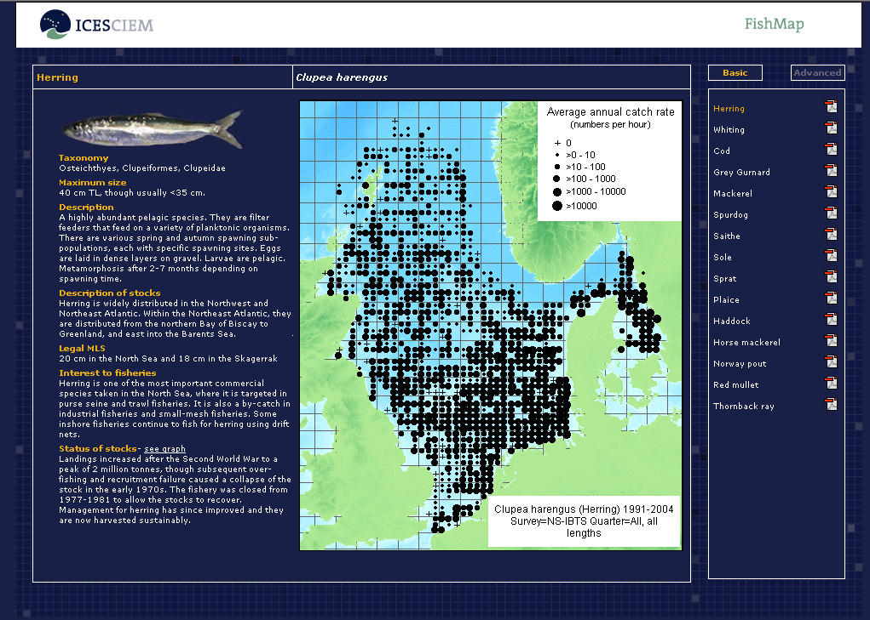

Figure 2. ICES-FishMap basic page for herring.

Advanced system

As with the basic pages the advanced system (Figure 3 and 4) resides on a server in Lowestoft and is interacted with through an iframe located on the ICES-FishMap webpage. Instead of presenting the user with a series of maps based on predefined database queries, the advanced system allows users to define their own queries dynamically. First, a species of interest is selected from the explorer on the right hand side of the webpage. The user is then given the option of creating a map based on fish lengths or fish ages. Having made a selection, a dialogue window (Figure 3) opens allowing the query to be defined based on year range, length or age range, survey type, and quarter when the survey was conducted. The user can also select whether to map the data based on ICES rectangles or 1/9th rectangles. Mapping on 1/9th rectangles is not allowed, if only one year or quarter have been selected. Once the extracted data have been added to the map view, the user can use a number of common GIS tools to explore the data further. Data subsets can be selected and presented in tabular view using geographic and attribute select tools, and the map can also be prepared for printing.

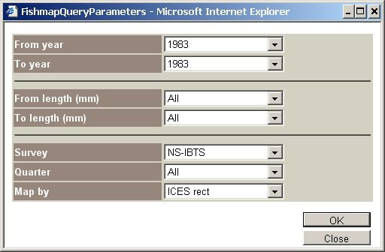

Figure 3. Frame to select the range of years, length or age classes, survey type, quarter and rectangle size (1 or 1/9th ICES rectangle).

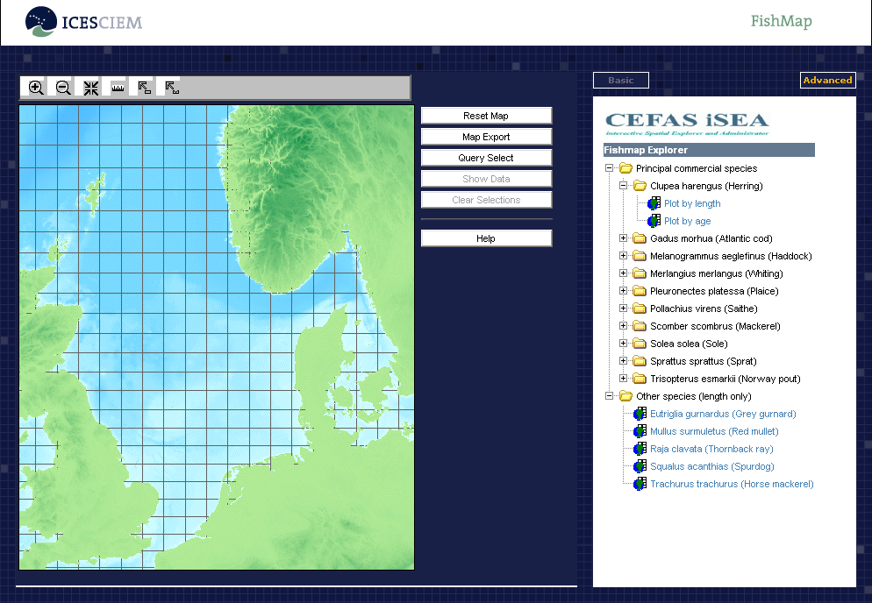

Figure 4. ICES-FishMap advanced system.

Work-package 2: Maps and text

The main objective of this work-package was to produce the text for a number of general introductory chapters and species specific information for the 15 selected fish species and to decide which maps will be shown on basic and Pdf pages.

The 1993 Atlas contained a number of introductory chapters to explain what recruit surveys are, which factors affect the distribution of North Sea fishes, what the limitations of the data are, etc. These chapters have been partly updated and modified. The following “chapters” can be downloaded as PDF’s:

1. About ICES-FishMap
2. Introduction
3. Research vessel surveys
4. Factors affecting the distribution of North Sea fish
5. The North Sea fish community
6. Limitations of the data
7. Glossary

Survey data from the International Bottom Trawl Survey (IBTS) and Beam Trawl Survey (BTS) were used to provide the distribution maps. If significant, seasonal changes in distributions are shown based on the quarterly IBTS surveys 1991-1996.

Where possible, the information on life history, population and exploitation provided for each species has been updated. Length frequency plots were prepared, as well as graphs showing length-at-age and maturity-at-age.

Detailed species accounts can be downloaded for the following speices:

1. Spurdog (Squalus acanthias)
2. Thornback ray (Raja clavata)
3. Herring (Clupea harengus)
4. Sprat (Sprattus sprattus)
5. Cod (Gadus morhua)
6. Haddock (Melanogrammus aeglefinus)
7. Whiting (Merlangus merlangius)
8. Saithe (Pollachius virens)
9. Norway pout (Trisopterus esmarki)
10. Horse mackerel (Trachurus trachurus)
11. Red mullet (Mullus surmuletus)
12. Mackerel (Scomber scombrus)
13. Grey gurnard (Eutrigla gurnardus)
14. Plaice (Pleuronectes platessa)
15. Sole (Solea solea)

The text from the introductory chapters and from the 15 species accounts is provided in Annex 2 and 3.

Work-package 3: Coordination

In the first month of the project a 2-day meeting was organised at CEFAS in Lowestoft to discuss and make final agreements on each partners' tasks. The report on this meeting was prepared by the coordinator and provided as Annex 1 to this report.

Throughout the project period there have been regular contacts between the partners, to discuss the approach and help to solve possible problems. Shortly after the preparation of the interim report (after 6 months) it turned out that it was unlikely that the project team could stick to original project period. A request was sent to the Commission to extend the project period by 2 months. This request was granted and the project period extended to 30 November 2005.

Toward the end of the project it would have been helpful if a short second meeting of all participants had been planned. This would have been particularly helpful to sort out a variety of small items and to evaluate the whole project.

The ICES-FishMap webpage was activated at the ICES webpage on 2 December 2005.

3. Consortium Management

See Section 2, Work-package 3.

4. Use and dissemination of the knowledge

The website which is the main deliverable of the project, has become operational on 2 December 2005, and can be accessed by the general public.

The outline of the ICES-FishMap project was announced in the ICES Newsletters of September 2004 and September 2005.

ICES FishMap will be prominently advertised on the ICES homepage, it will be promoted on other websites such as MARBEF and a press release about FishMap will be produced at the end of January 2006 and sent out to fishing industry press and selected national newspaper journalists.

