

PEOPLE
MARIE CURIE ACTIONS

Final REPORT

“THERMOPC”
(Thermomechanical Modelling of Powder Compaction)

Dr. Alexander Krok
Prof. Chuan-Yu Wu

Website: www.surrey.ac.uk/thermopc



R1 RESEARCH

THERMOPC employs an inter-disciplinary approach to understand the fundamental mechanisms of powder compaction processes and to develop predictive computational tools for modelling the thermomechanical behaviour during powder compaction. During the two years, significant progress on research as well as personal development were made and summarized below.

R1.1 THERMOMECHANICAL MODELING OF POWDER DIE COMPACTION
A FEM model was developed to predict the thermo-mechanical behavior of powders during compaction, for which the commercial FEM software, ABAQUS, was used and the Drucker Prager Cap model was implemented. In order to calculate the relative density of the powder during compaction, a user-defined subroutine USDFLD was developed. Die compaction with various shaped punches to produce flat-face (FF), shallow convex (SC) and standard convex (STC) tablets at different compression speeds was then analysed. Evolutions of density and temperature distributions during compaction were examined. The effect of die wall friction on thermo-mechanical behaviours was also explored. It is shown that the punch shape, the compression speed and die-wall friction significantly affect the thermo-mechanical behaviour. The maximum temperature and temperature distribution of the compressed powder changes dramatically when different shaped punches are used. The maximum temperature of the tablet upon ejection can be reduced by decreasing the die-wall friction or the compression speed. Based on this work, two papers were published: an invited paper published in a book (48th Course of the International School of Crystallography: from Molecule to Crystal to Functional,) and a paper published in the journal of Chemical Engineering Research and Design.

R1.2 EXPERIMENTAL INVESTIGATION OF THERMOMECHANICAL BEHAVIOR OF POWDER DURING DIE COMPACTION
During pharmaceutical powder compaction, temperature rise in the compressed powder can affect physiochemical properties of the powder, such as thermal degradation and change in crystallinity. Thus, it is of practical importance to understand the effect of process conditions and material properties on the thermal response of pharmaceutical formulations during compaction. The aim of this study was to examine the temperature rise of pharmaceutical powders during tableting, in particular, to explore how the temperature rise depends on material properties, compression speed and tablet shape. Three grades of microcrystalline cellulose (MCC) were considered: MCC Avicel PH 101, MCC Avicel PH 102 and MCC DG. These powders were compressed using a compaction simulator at various compaction speeds (10 - 500 mm/s). Flat faced, shallow convex and normal convex tablets were produced and temperature distributions on the surface of theses tablets upon ejection were examined using an infrared thermoviewer. It was found that an increase in the compaction speed led to an increase in the average surface temperature. A higher surface temperature was induced when the powder was compressed into a tablet with larger surface curvature. This was primarily due to the increasing degree of powder deformation (i.e. the volume reduction).

The density distribution in the tablet was also measured using X-ray computer tomography. Radiographs with high resolution were collected for reconstruction. The reconstruction of three-dimensional object was carried out with Nikon metrology-CT Pro 3D and all images were analysed using the ImageJ software. Six tablets of microcrystalline cellulose (lubricated with magnesium stearate) with different relative density were prepared to performed the calibration. Whereas, the tablets had the same diameter and they were compress with different compression force. In the centre of tablets, the relative density was higher compare to density on the edge of tablets. The density slightly decreased with increase of compaction speed. This is induced by the prolonged compaction period when the compaction speed is low.

R1.3 THERMOMECHANICAL MODELING OF ROLL COMPACTION
A FE model was also developed to predict the mechanical behavior of the powder during roll compaction, which was solved as a dynamic/explicit type of task. The FE model of roll compaction was defined as a Lagrangian - Euleria, and was used to calculate the distribution of stress, density and temperature of compacted pharmaceutical material. It was believed that the conductive heat transfer prevails between the compacted powder as well as the walls and the rolls of compactor. The the effect of roll speed on the temperature distribution in the material was invesigated. From the results, it was shown that with the increasing the roll speed, the temperature of the ribbon at the narrowest gap increased, but the density decreased.

R1.4 Thermal properties of pharmaceutical powders
To ensure accurate FE simulations it is very important to measure the thermal properties of powders. Therefore, different analytical methods were used for measuring the thermal properties of common pharmaceutical excipients in this study. Experimental setup to measure the thermal conductivity of the materials was developed, as shown in Fig.1.

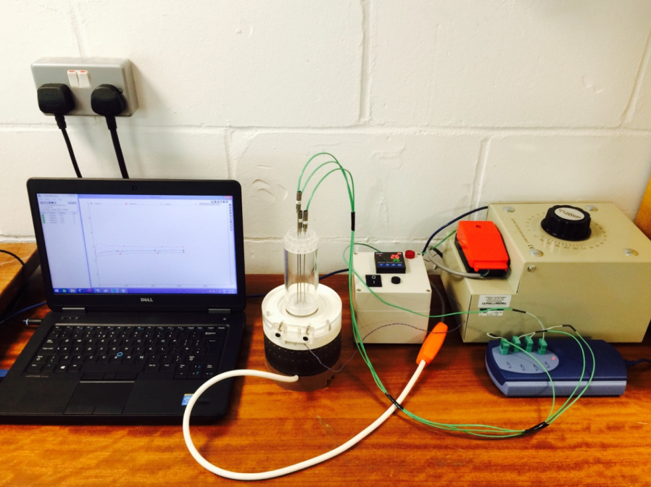
Fig. 1 An experimental system for measuring thermal conductivity of powders.

Moreover, differential thermal analysis (DTA) was performed for three different grades of microcrystalline cellulose (MCC Avicel PH 101; MCC Avicel PH 102 and MCC Avicel DG) and for lactose and mannitol in a temperature range from 20 °C to 200 °C. It was intended to explore the possibility of endothermic or exothermic events in the temperature range that these materials can be expected to endure during typical pharmaceutical processes, such as tabletting or roll compaction. Also thermogravimetric analysis (TGA) was employed to investigate the differences in moisture content for all of these materials. Finally, using thermal conductivity analyses (TCA) the thermal conductivity and specific heat were measured. It can be concluded that for the microcrystalline cellulose based powders, almost no change in morphology or structural changes were observed. The MCCs all showed that an increase in relative density or temperature increases the thermal conductivity, the specific heat on the other hand increased with an increase in temperature but decreased with an increase in relative density. Of the entire cellulose compact, Avicel DG showed the highest increase in thermal conductivity and specific heat but deviated from the other MCCs by exhibiting an increase in specific heat that was not dependent on the increase in temperature. For lactose and mannitol using DTA/TGA in the temperature range from 142°C to 173°C some endothermic events occurred. The thermal conductivity increased with an increase in temperature or relative density for both compacts. The specific heat on the other hand, was found to be independent of temperature increases but inversely proportional to increases in relative density.

In order to predict the thermal conductivity of particulate materials, several models were developed. Most of them have been applied to metal powders or plastic polymers. However, so far there has not been a published model to predict a change in the thermal conductivity or specific heat for different temperatures of tablets at various densities of compressed materials. The interpolation approach employed in this study proposes a model to predict changes in the thermal properties as a function of the relative density and the temperature of pharmaceutical powder.

